VM3COP20.30 – UK Order Processing – Viamed

Things to remember:

- Every order NEEDS a hospital/company name, department (for hospitals), street name, town/city and postcode
- Applicable memos typed in the notes section on the order processing screen.
- All NHS orders must have a purchase order number
- If pre-payment has been made, make sure you attach copy to ‘Payment Notification if applicable’ and click ‘Order Prepaid’.
- Should the customer wish to pay for an order by Debit/Credit Card/Visa Card (we do NOT accept American Express) then you need to click the box next to ‘Card Payment’, this notifies Goods Out that payment needs to be taken before dispatching.
If a card payment is required to be taken for a Proforma or Quotation, this box needs to be ticked and Goods Outs notified by Skype to process payment. Once payment is confirmed by Goods Out and the Proforma/Quotation can be turned into an order, the ‘Order Prepaid’ button needs to be ticked and notes added. The order should then be processed as per the following procedures.

See VM3.COP03.02 Filling In Credit cards slips, on how to complete the credit cards slips.

Orders most frequently arrive via email, but they may also be faxed, sent through an e-procurement system or sent in the post; some customers also order over the telephone or upload directly to our website.

E-procurement System Orders
When an order is sent to Viamed through an e-procurement system, an email will be received. Follow procedures VM3COP03.06 for Cardea, and VM3COP27.30 for Catalog360 Circle.

Telephone Orders
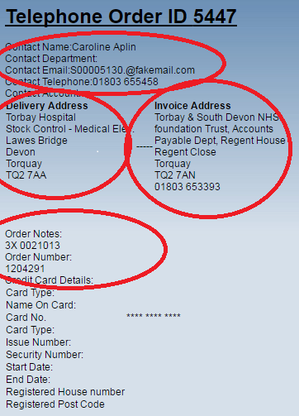
A telephone order will appear as shown to the left. The delivery and invoices addresses are noted, as are the contact name, order number and product details.
If you have taken the order yourself, this needs to be printed to PDF before processing.
Please see VM3COP27.29 for details on how to take a telephone order.

Fax Orders
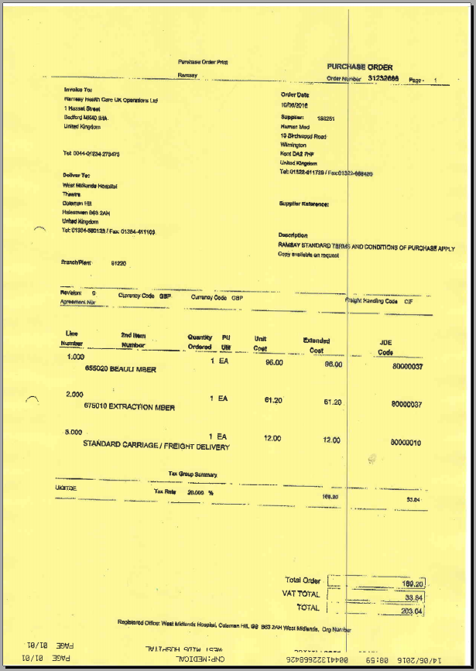
Orders which arrive via fax will appear the same way as an email PDF order and should be processed normally. They are sent to fax@viamed.co.uk

Please remember to acknowledge the order and advise of expected dispatch date by email if an email address has been supplied, or by fax if no email address is available on the purchase order or IntraStats Customer Relationship Management (CRM) system.

Email Orders

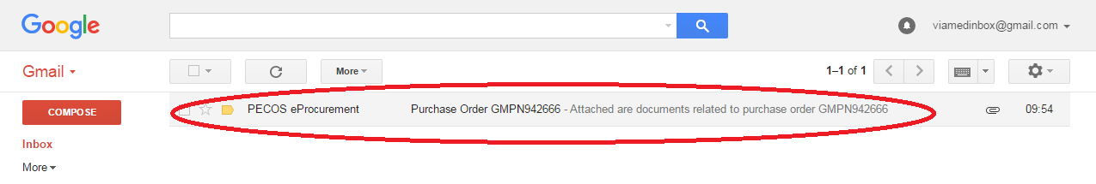
When an order is received in the main inbox, click on it to open it.

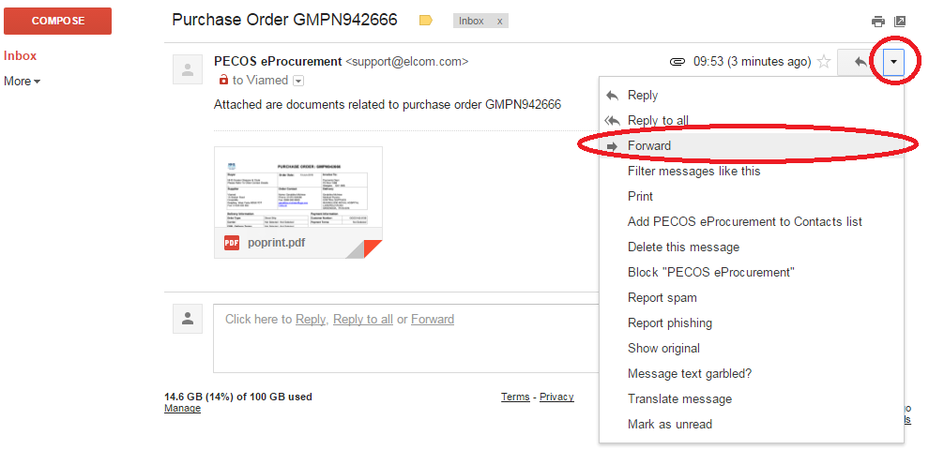

Click the arrow on the right and click forward.

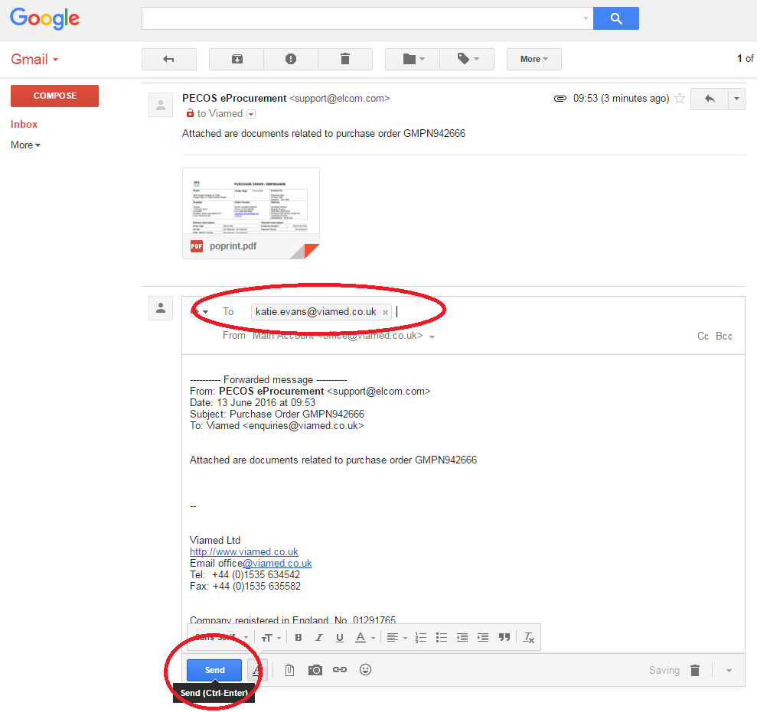
Type your vmsecure into the ‘To:’ field and click send. E.g. firstname.lastname@vmsecure.me.uk

When the email arrives in your inbox, click on it to open it
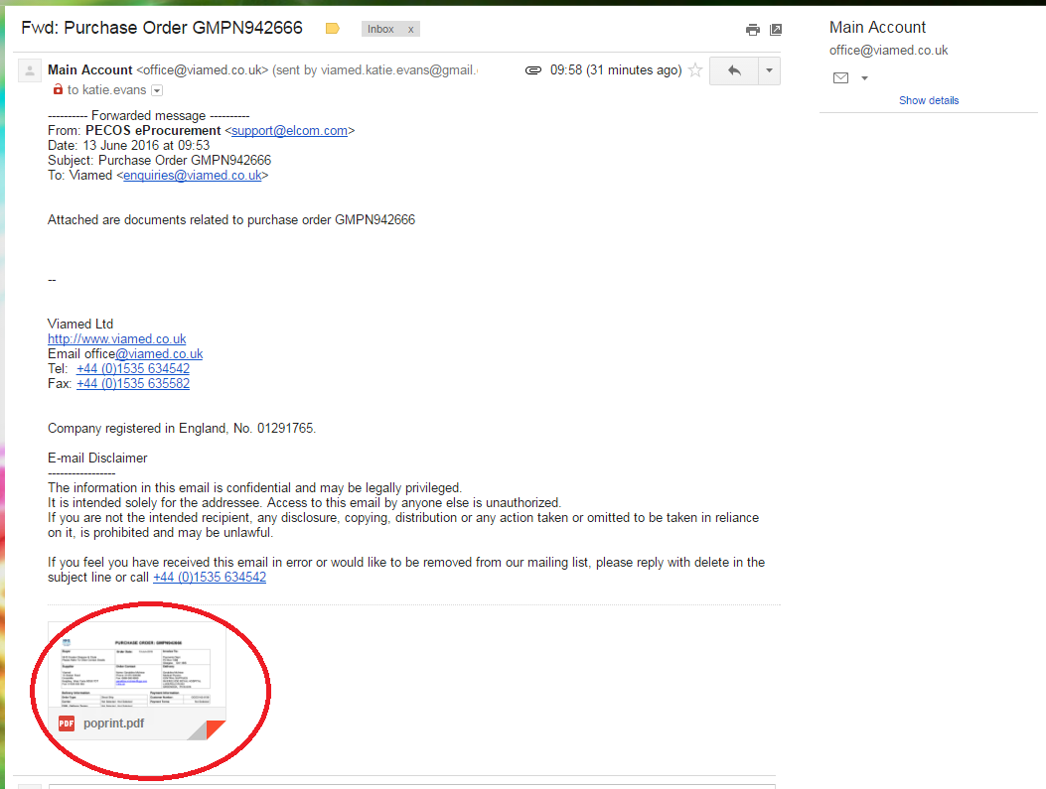
Click on the attachment, where provided, to open it.


Click the download button at the top of the page and open to view contents. Please be aware of where this is downloaded to as you will need it later to upload to the order processing page.

Follow the steps on VM3COP20.16 for eBay for downloading the documents then following the order processing procedure below.

Order Processing

From IntraStats, using the drop down menu at the top right of any screen, click the arrow and select ‘Contacts’, in the Search box type the name of the Company you wish to process the order for. Use the following buttons to open in current tab, new tab or to look up search histories or saved searches.
Current Tab
New Tab

Search History
and
Saved Searches

Click the hospital/company name you are processing the order for. Any line highlighted in green is an account which has been used recently within the new system.

For example Airedale Hospital…

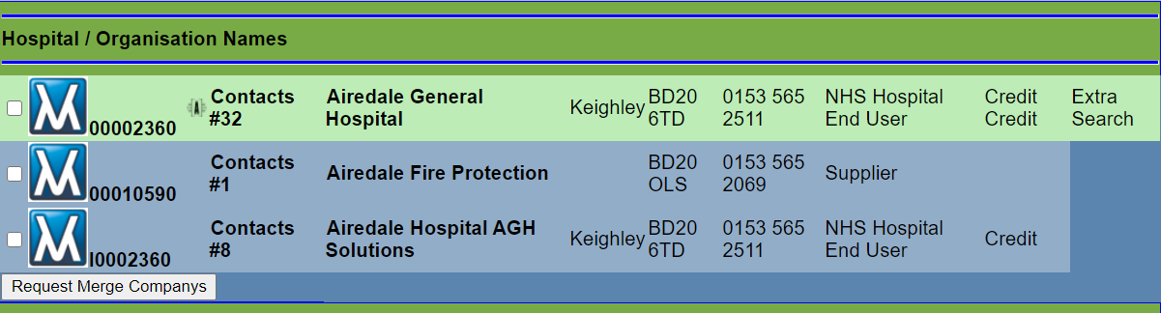
This will open up a page similar to this:
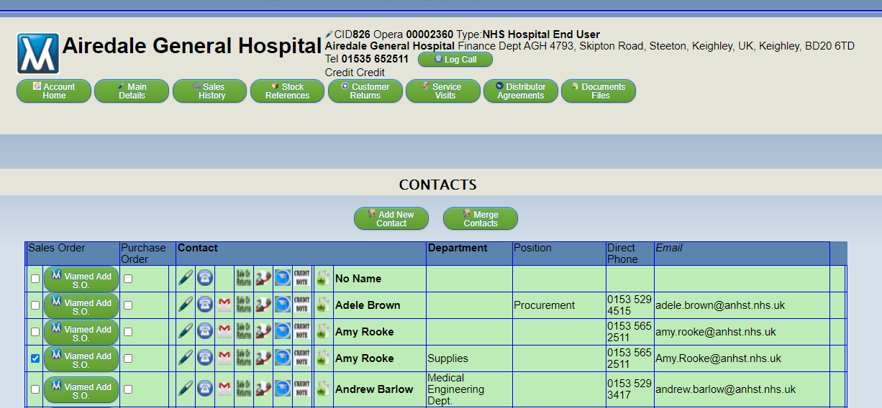

Account Memos - Check if there are any account memos for this order, this can be found by clicking the Account Memos button below the main address.
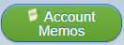

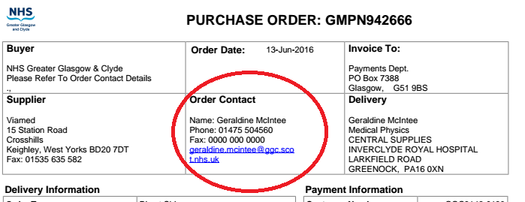
On the order PDF, find the contact name. Then find this name on the company/hospital list on Intrastats and click the Add S.O. button to the left of the name.

This opens the customer order processing page, it will also show you the order number beginning, CVM (for Viamed orders)
CAN (for Vandagraph orders)
CST (for VST orders)

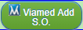
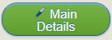
If the ‘Add S.O.’ button does not show,
please follow these steps:
1. Go to Main Details page, and check that there is a ‘Price List to Use’ selected.

2. Edit the contact who you want to assign the order to, scroll to the bottom of the page and check that ‘Allow Sales Order’ is ticked.
3. Scroll to the top of the page and click ‘Update Details Below’ button.

Depending if this account has been used before, you may be required to fill in some additional information, see below:

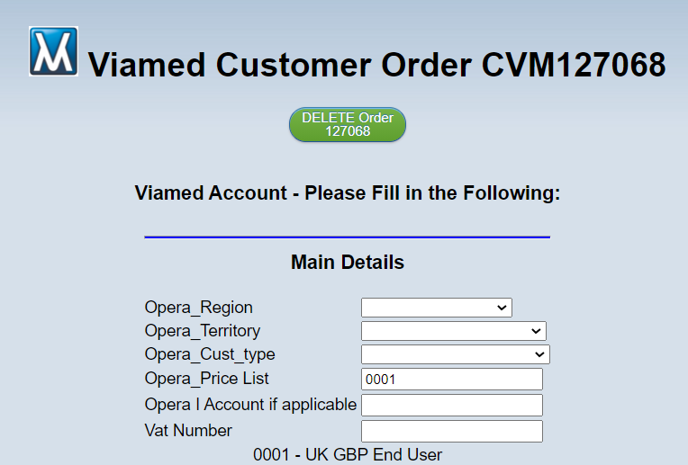

Returning to /create the order you are processing, please make sure all fields are completed:
This can be Order,
Proforma or Quotation
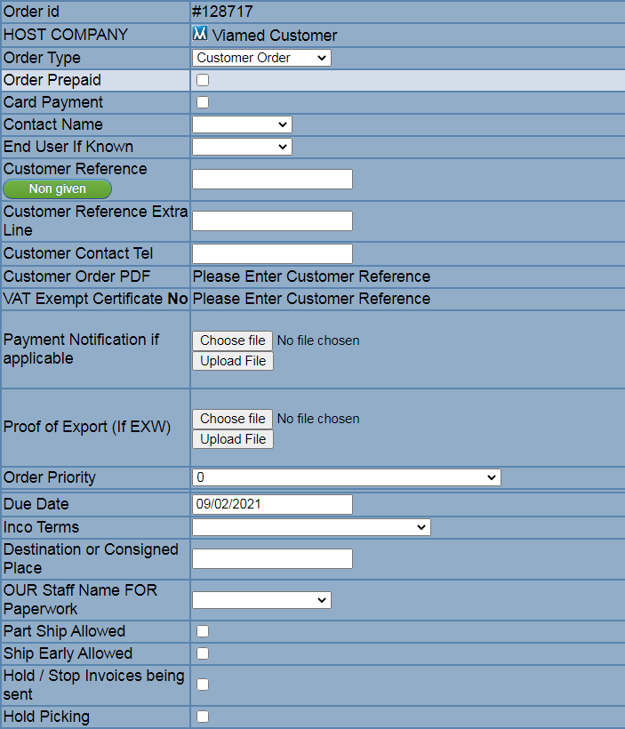

Click this if
payment has
been received,
make sure you
upload document
below

Click this if
a card payment is
required

When a customer
reference is added,
the below will appear:

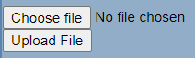
Upload document
here, if payment
Has been received

See page 13

See VM3COP03.04 for definitions

See the following
page for definitions

IncoTerms Destination (see following page)

Select the person
processing theorder

Make sure any telephone numbers above do not have any spaces.

Note: All NHS customers MUST provide a valid purchase order number.

Incoterms
EXW – Ex-Works
These are shipments which once they have been collected by the courier and have gone over the threshold of our premises they are the responsibility of the buyer, for example UPS (own account only), DHL, Kuehne + Nagel. Destination is the location the courier is to collect i.e. Viamed Ltd.
“Destination or Consigned Place”: Viamed Ltd.
CPT – Carriage Paid to
Any liabilities are passed to the buyer as soon as it leaves Viamed’s premises with the appointed courier. Examples of this type of shipment are UPS and Royal Mail where Viamed has contracted the courier and is paying the invoice from the courier for the service.
This is where we list a carriage cost on the order, unless already included in the price of the product i.e. Posey Wraps within the UK.
“Destination or Consigned Place”:
Place of Destination (agreed location to which a shipment is expected to arrive).
e.g. Barcelona, Spain or Leeds Bradford Airport, United Kingdom
CIP – Carriage and Insurance Paid
Any risks are passed to the buyer as soon as it leaves Viamed’s premises with the appointed courier. Examples of this type of shipment are UPS and Royal Mail where Viamed has contracted the courier and is paying the invoice from the courier for the service.
This is where we list a carriage cost on the order, unless already included in the price of the product i.e. Posey Wraps within the UK.
The difference between CPT and CIP is that insurance is listed and charged to the customer on the invoice to cover the shipment. (Stock code INS is 1% of total of goods).
“Destination or Consigned Place”:
Place of Destination (agreed location to which a shipment is expected to arrive).
e.g. Barcelona, Spain or Leeds Bradford Airport, United Kingdom
Carriage / Delivery Codes
From the products ordered, establish which courier is suitable utilising the Customer Postage Pricing documents VM3COP03.011 and VM3COP20.34. If the customer would like to use their own courier, enter the ‘Priority’ as ‘2’ and enter the ‘Due’ date as per cut-off times listed on the Customer Postage Pricing document VM3COP03.011 and VM3COP20.34.

This document also advises if the appropriate courier is UPS or Royal Mail for the most popular products; alternatively, check the Intrastats Stock page. Enter the appropriate ‘Priority’ code and ‘Due’ date as per cut-off times.

Priority 1 – Urgent order to be processed immediately (only to be used when the purchase order/customer states it is urgent or MUST be shipped same day)
Priority 2 – Courier other than UPS or Royal Mail
Priority 3 – UPS – all services
Priority 4 – Royal Mail – all services

Invoice and Delivery Address
From the purchase order please select, using the white circle radio button to the left of the line, the correct invoice and delivery addresses from the list provided.
Should the relevant address not be included please click ‘Add Invoice Address’ or ‘Add Delivery Address’, this will refresh the page and provide you with fields to input.

Check Stock Quantities
Using the drop down menu to the top right of any Intrastats screen. Click the arrow and select ‘Stock’, in the search box for the part number and click the relevant icon, as below.
Current Tab
New Tab
Search History
and
Saved Searches


When you have found the product code you require, click on the BOX icon to display the current stock levels.
If there is no stock, please make sure you inform the customer and provide a lead-time, where possible. If alternatives are available you may provide them with these options also.

You should also check the ‘£’ page and check if the item requires a carriage charge. Currencies and customers that qualify for free carriage have a statement highlighted in blue next to their price.

For distributor and automotive carriage charges, see VM3COP20.34

Check these details for all products listed on the purchase order.

If these details are incorrect or if applicable carriage charges have not been added to the purchase order, return to the order processing page and change the priority to ‘8’, please contact the customer before proceeding. Contact the customer by telephone, if possible, but email if they are unavailable. Please add any correspondence or notes to goods out on the notes section.

Order Notes
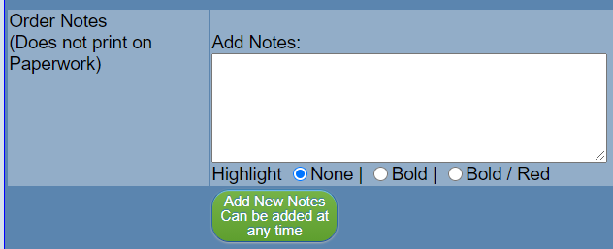
Add any notes in the orders notes text box on the order processing page of any contact you have had with the customer and their response. If the customer accepts the changes and is happy to proceed, change the priority back to the appropriate number and proceed to checking.

Note: ALL orders must be entered into IntraStats even if awaiting action so please continue adding the order by following this procedure but leave on a priority 8 until agreed with the customer to proceed.

Adding Stock

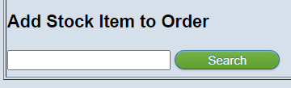
When you are satisfied that all the prices and carriage charges are correct, return to the customers CVM in IntraStats and proceed as follows. Make sure you leave on a priority 8 if you are still waiting for confirmation from the customer.

Enter the part number in the ‘Add Stock Item to Order’ box.
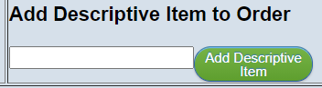
Should there be no part number, items can be added in the ‘Descriptive Item’ box.

Enter the quantity required, please note the price should change accordingly if quantity discounts are available. Leave the due date unless you have different requirements per line. As this is set by the overall ‘Due Date’ at the top of the page.

Ensure the pricing and quantities are correct before proceeding. When confirming a price discrepancy on a purchase order, we must ensure that we advise the customer whether the price is simply incorrect or whether a price break applies to the quantity that they have ordered.

Once happy all information is correct, click ‘Add to Order’.

When all items on the purchase order have been entered, the carriage must be added.
All Viamed orders must include a carriage line.
Carriage Charges and Codes

To establish which courier to use, check the ‘UK Postage Pricing Guide’ document VM3COP03.011 and VM3COP20.34 for automotive and distributor postage pricing.

For example, for Royal Mail, enter ‘PPRD’ into the ‘Add Stock Item to Order’ box; for UK UPS, enter ‘PPUPS1’ into the ‘Add Stock Item to Order’ box.

In some circumstances, customers may request express or special deliveries, refer to VM3COP03.01 to choose the correct reference number. Quantity should always be 1 unless advised otherwise by Goods Out.

Enter the required price into the ‘Unit Price’ box, leave blank if the order qualifies for free carriage, click ‘Add to Order’ to complete the line.

If you are unsure of which courier to use or of how much carriage to charge, check the IntraStats memos or check with colleagues in the office / Goods Out department.

Stock Memos
To check a stock memo, use the drop down menu to the top right of any screen. Click the arrow and select ‘Stock’, in the search box for the part number and click the relevant icon, as below.
Current Tab
New Tab
Search History
and
Saved Searches

Type in the part number or description required and click the new tab icon so that it opens the stock search in a separate tab.


Click the large M for ‘Memo’ against the part number you require and you will be presented with additional information regarding the product. Locate carriage information and add this information to the order accordingly.

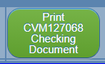
Proofing / Checking Order / Error Amends
When you have all of the products and one carriage line entered into IntraStats, click ‘Print CVM****** Checking Document’, this will generate a PDF of the order. Check that all information is displayed correctly.

Should there be any errors click the back button on your browser and amend then repeat the step.

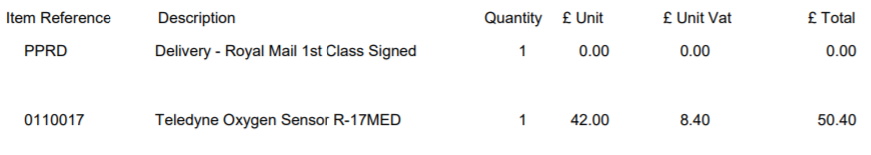

If the carriage line is not situated below all the products on the order, return to the order processing screen and click the arrow at the end of the carriage line, this will move that line to the bottom of the order.

Once happy that the PDF is all displayed correctly, click the back button and this shall return you to the order processing page.

Submit for Checking

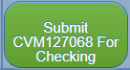
Now the order is ready for checking, click the ‘Submit CVM****** for Checking’ button and this will add the order to the list for checking.
Send a Skype message to ‘Viamed Order Checking’ or ‘Viamed Employees’ group stating the CVM number and ask for someone to check. See VM3COP30.32 Order Checking for this process. Once checking has been completed, it will appear on the ‘Active List’ for goods out to process.

Large Value Order
If the order totals £10,000 or more, a director’s sign off is required. Locate a director and ask them sign off on the system.

Credit Card Payments
If the customer is paying with a credit or debit card, add a BOLD/RED note on the order processing page for Goods Out to contact the customer. Should it be a different contact number than the one added previously, please add this also.

If you are processing a quotation or proforma which require prepayment, please ask Goods Out to process the payment so that you can turn it into an order. See page 12 for how to do this.

Order Acknowledgement
Acknowledge the order and advise customer of dispatch date, if requested or provide lead time should the items be currently out of stock.

Should an item be out of stock, check if there is an outstanding PO with supplier. This can be found in “Suppliers Back Order Status”.

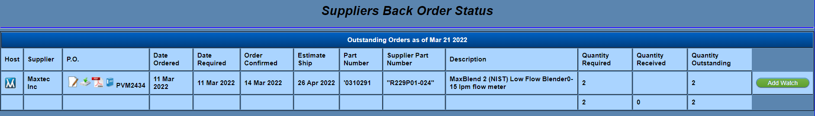
If you click “Add Watch” you will be notified should the delivery date be amended. Please inform the customer of any estimated delivery date and updates, where necessary.

If there is no stock on order, please raise a warehouse request. Click
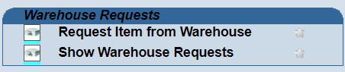
Go to “Request Item from Warehouse”
List items requested, also include order number in notes box. Click “Add”.


Editing an Order
If an order needs editing, for example, if the priority needs to be changed, click the ‘Opera Data’ icon in IntraStats and click ‘Outstanding Customer Orders’. This will take you to a full list of orders being processed through the system.

Locate the order you want to edit and click the ‘Details’ button, this will open the order processing page as before.

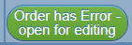
To be able to edit, click the ‘Order has Error – open for editing’ button. Enter the reasoning for editing the order and click ‘Confirm Open Order for Editing’. This opens the page so it is now editable then make amends as required. Should you wish to remove a line from the order, you must amend the quantity to 0 and refresh the page.

If the date on an order is changed, please check that the product lines have also updated. For example, if an order is put on as a forward date and then you edit the date after, the date will remain the same and Derek has to change this.

Once an order has been edited, it must be rechecked – following the steps in section ‘Submit for Checking’ section (page 11).

VAT
If an order is VAT exempt, you will need to ensure you have acquired a VAT exemption certificate from the customer before proceeding. A new VAT exemption certificate is needed for each order. Process the order on IntraStats but ensure the priority is stated as ‘8’ until the certificate is received. Once received, pass to the accounts department to ensure it is valid and ask them to sign it off.

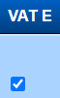
Once validated and signed off, upload the VAT certificate to the ‘VAT Exempt Certificate’ section at the top of the order processing screen. Once uploaded it will state ‘Yes’ next to the title.

Ensure the VAT is removed from product and carriage lines. To do this, click the box in the ‘VAT E’ column against the relevant line.

Carriage
If the order contains products that have both free and chargeable carriage, the carriage is free unless the courier service needs to be upgraded due to the chargeable items.
E.g. If a customer orders 1 box of flow sensors (free carriage), they would normally be sent free via Royal Mail (1 box only), but if they order an MySign O (chargeable carriage) which does not have free carriage and must be sent via UPS, the courier would need to be upgraded from Royal Mail to UPS and would be chargeable.

Priority 1
If the purchase order states that the order is urgent, ensure stock is available and call the customer to ask which date they need the order for. If they need it the next day or you are unable to contact them, set the priority as ‘1’. Ask a director to sign off on the system. Add memo to the order stating: ‘When order picked inform:’ *Your name*.

Once checked, inform Goods Out that there is a priority 1 order on the system.

Discounts
If an order has a discount applied or has any free of charge items/carriage (lines which would normally be chargeable), ask a director to add note to the order notes before proceeding to the checking stage.

PayPal
On occasion, a customer may wish to pay via PayPal. Should this occur, add a line above the carriage line. Use reference ‘PAYPAL’, and calculate 6% of the total cost of the order including VAT (excluding this PayPal charge). Add this calculated charge to the ‘Unit Price’ box.

E.g. Products totalling £650 with a £10 carriage charge would equal £792 including VAT. The PayPal charge would be 6% of the total including VAT therefore the PayPal charge in this example is £47.52.

Should you need to insert a line you will need to reorder the lines click the arrow at the end of the line, this will move that line to the bottom of the order.

If no PO number is provided click the ‘Non given’ button next to customer reference and the system will automatically generate one for you.

Western Union Payments (Check with accounts before offering to customers)

On occasion, a customer may wish to pay via Western Union. Should this occur, add a line above the carriage line. Use reference ‘BC’, amend the description to ‘Western Union Charge’. The charge is £15, add this to the ‘Unit Price’ box.

Note: The customer will need the full name, including any middle names, of the person who collects the payment; this would normally be Helen. Helen’s full name is Helen Jean Lamb, please ensure the customer uses this when making their payment.

Additional Notes

If a PO has two or more lines of the same part number, the system will automatically group them together per sales value, for example an order for 2 x R-17MED plus 3 x R-17MED (chargeable) plus 1 x R-17MED (free of charge) will show on the invoice as 5 x R-17MED (chargeable) and 1 x R-17MED (free of charge).

For orders that are solely for calendars or posters, add notes to order processing page stating to ship with next order unless agreed by director.

Converting Proforma/Quotation to Order


Once payment has been received or quotation accepted with a purchase order being received, find the order on the ‘Customer Sales Orders’ page and click the details button. This will open the order processing page. Scroll down the page until you see the green buttons and click ‘Convert to Order’. Check all information is correct and re-submit the order for checking.

Deleting Orders
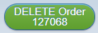
Should a quotation/proforma/order need to be deleted, please be aware these are not retrievable and would require re-entering should you delete it. At the top of the customer order page click the ‘DELETE Order *****’ button. Please enter the relevant reason for deletion and click ‘Delete *******’. Once deleted you will need to start a new sales order.

Proof of Export
Proof of export can be added at any stage:
- Goods Out can upload shipping document
i.e. airway bills or proofs of collection
- From the customer or shipping company.
The CVM can have documents added even after it has been invoiced.
Customers who want EXW with companies we do not deal with often will need to send proof of export.
- UPS: We do not require this as we have an account from them.
- TNT / FEDEX: We have an airway bill and proof the driver has picked up.

