VM3COP27.52 How to export payments and
transaction information from Shopify

- Login via the admin page:
www.vandagraph.com/admin
Email: info@vandagraph.co.k
Password: Vandagraph17!
http://viamed-ltd-online.myshopify.com/admin
Email: catrin.hollings@viamed.co.uk
Password: Viamed17!

- Click ‘Settings’ in the bottom left hand corner
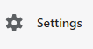

- Click ‘Payments’ in the left hand menu


- Click ‘View payouts’
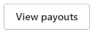

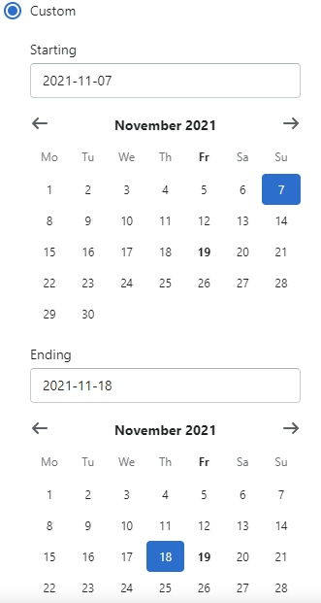
- Use the filter function to determine the dates in which you want the information to show.
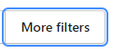

Click ‘More filters’, ‘Payout date’, ‘Custom’.

- Click ‘Export’ in the top left corner
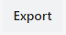

- Click ‘Current Page’ then click the ‘Export payouts’ button
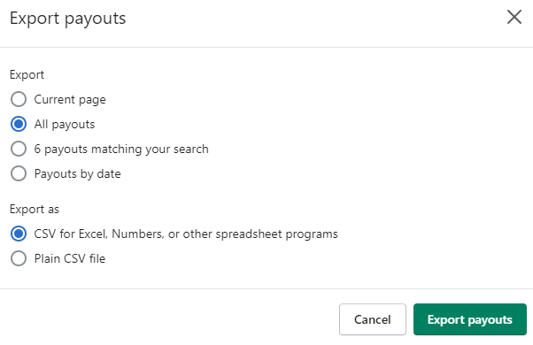

This will either export a CSV file to your downloads folder or it will be emailed directly to the designated email address in which you logged in with.

- Click the ‘Transactions’ button in the top right of the page
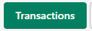

- Click the ‘Filter’ button, select ‘Payout date’, select ‘after’ and then put the same date as the start date you included for the payouts export. Then click ‘Add filter’.
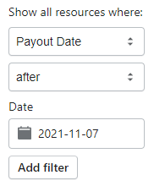

- Click the ‘Export’ button on the top right of the screen.
Make sure that ‘Current page’ and ‘CSV for Excel…’ are selected and click ‘Export items’.
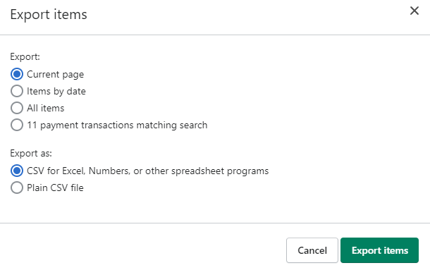

This will either export a CSV file to your downloads folder or it will be emailed directly to the designated email address in which you logged in with.

