2022 Draft Postal Marketing Schedule

January

Neonatal Flowsensors – Disposable & Reusable
(Letter Appendix 9 - Leaflet to be signed off #221608 (All Flowsensors leaflet or #216486 Flowsensors & R-23V/Vi)

February

Oxygen Monitors – VM-3160
(Letter to be written)

TOF 3D Neuromuscular Monitor
(Theatres/General letter signed off from August 2021, letter for ICU to be written – awaiting feedback from SN/SJH)

March
Oxygen Sensors.
Revised UK oxygen monitoring catalogue to be printed, queries require review
(Letter Appendix 1 - Leaflet document index TBC)

April

Flowsensors and R-23V/Vi
Updated Flowsensors and R-23V/Vi leaflet – enough for mailing plus a few for in orders.
(Letter Appendix 2 – Leaflet awaiting sign off on issue #216486)

MD300 Catalogue
(Letter Appendix 3 – Catalogue awaiting sign off on issue #209148)

May

Posey Products
(Letter Appendix 4 – Leaflet document index 31885)

Neonatal Flowsensors – Disposable only
(Letter Appendix 9 - Leaflet to be signed off #221608 (All Flowsensors leaflet or #216486 Flowsensors & R-23V/Vi)

June

Maxtec MaxVenturi
(Letter Appendix 5 - Leaflet document index 31261)

Oxygen Sensors (if RoSH in force)
(Letter Appendix 6 - Leaflet queries outstanding 167333/196848/212011)

July

AlcoTrue M – Hospitals
(Letter Appendix 7 - Leaflet document index 18092)

AlcoTrue M – Emergency Services
(Letter Appendix 8 – Leaflet document index 18092)

Automotive Grey

September

Eye Masks – Neomask and EyeMax
(Letter Appendix 8 - awaiting sign off on issue #230036 – Leaflet document index 31251/30634 – potentially print back to back)

Temperature Probes

Oxygen Sensors

October

VM-2160 SMARTsat

November

V1000 Test Equipment

Appendix 1
Oxygen Sensors

Department Manager
«DEPARTMENT»
«COMPANY»
«ADDRESS1»
«ADDRESS2»
«ADDRESS3»
«CITY»
«STATE»
«ZIP»

March 2021

Dear Sir or Madam,

The Leading Medical Oxygen Sensor Supplier

The extended range of Medical Oxygen Sensors, now incorporating RoHS compliant lead-free alternatives, from Viamed provides the Widest Range and the Latest Technology to allow you to get the best value for money when using OEM and compatible oxygen sensors.

Viamed provides an oxygen sensor quantity discount pricing structure, there is no minimum order value, free of charge delivery and the NHS credit facility is offered on our entire range of oxygen sensors. I am sure you will find that this makes ordering easier and provides an extremely competitive package on quality, price, delivery and support.

Please find enclosed full details on our oxygen monitoring range including analysers and monitors. Should you require further information on applications and compatibility, please visit our website – www.viamed.co.uk or go straight to our cross reference www.viamed.co.uk/xref

Also…
We continue to provide an oxygen sensor disposal service, as part of our Waste Management Policy. Should you wish to return any of your oxygen sensors (even if you have not purchased them from us) we will be pleased to dispose of them on your behalf in accordance with our ISO standards. Please contact us should you require information on how to send your depleted sensors to us.

Should you wish to place an order, or cannot find your oxygen sensor or equipment listed on the online cross reference, then please contact a member of our sales team on 01535 634542 (between the hours of 09:00 and 17:30) or via email info@viamed.co.uk

Yours faithfully



Catrin Hollings
Sales & Marketing

Should you no longer wish to receive marketing material via post,
sign-up to our email mailing list at www.viamed.co.uk/sign-up

Appendix 2
R-23V/Vi and Flowsensors A and APC

Department Manager
«DEPARTMENT»
«COMPANY»
«ADDRESS1»
«ADDRESS2»
«ADDRESS3»
«CITY» «STATE»
«ZIP»
???? 2021
Dear Sir or Madam,

Viamed: The Leading Medical Oxygen Sensor Supplier

The extended range of Medical Oxygen Sensors from Viamed provides the widest range and the latest technology to allow you to get the best value for money when using OEM and compatible oxygen sensors. The range includes original Viamed Oxygen Sensors, including the R-23V which is compatible with the Dräger 6850645, Maxtec MAX-11 and Analytical Industries PSR-11-915-2 oxygen sensors and the R-23Vi which is for use with the I8000 incubators.

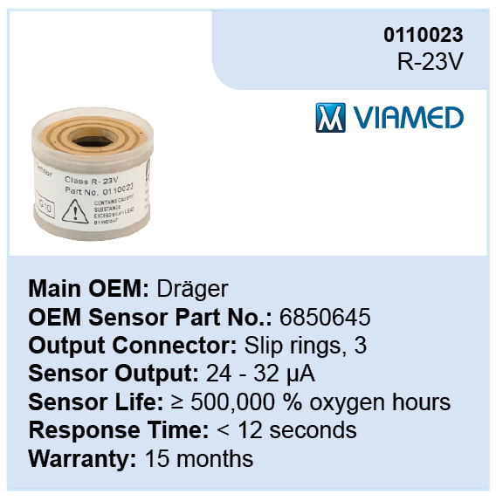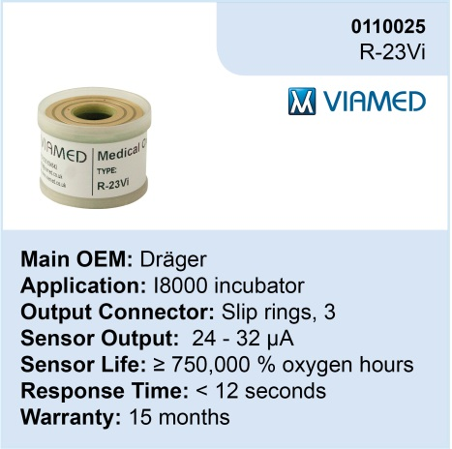

£36

from

Viamed continues to provide an oxygen sensor quantity discount pricing structure, there is no minimum order value, free of charge delivery and the NHS credit facility is offered on our entire range of oxygen sensors. I am sure you will find that this makes ordering easier and provides an extremely competitive package on quality, price, delivery and support.

Please find enclosed the R-23V/R-23Vi Oxygen Sensors and Flowsensors leaflet which you may find of interest. Should you require further information on applications and compatibility, please visit our website – www.viamed.co.uk or go straight to our Oxygen Sensors cross reference www.viamed.co.uk/xref or our Flowsensor cross reference www.viamed.co.uk/flowsensors-xref

Should you wish to place an order, or cannot find your oxygen sensor or equipment listed on the online cross reference, then please contact a member of our sales team on 01535 634542 or email sales@viamed.co.uk
Yours faithfully

Catrin Hird
Marketing
Should you wish to unsubscribe from our mailings
please email unsubscribe@viamed.co.uk

Appendix 3
MD300 Catalogue
Department Manager
«DEPARTMENT»
«COMPANY»
«ADDRESS1»
«ADDRESS2»
«ADDRESS3»
«CITY» «STATE»
«ZIP»
April 2021
Dear Sir or Madam,
Low Cost Finger Pulse Oximeters
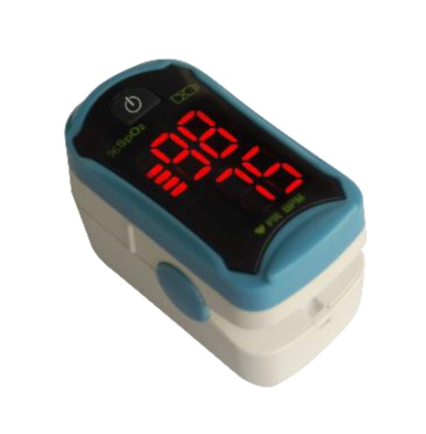
Viamed has a range of ultra-compact, lightweight, low cost finger pulse oximeters to suit a variety of applications, for use in hospital, GP surgeries, clinics and dental surgeries, through to spot-checking before, during and after exercise. Can also be used by patients to assist in COVID-19 assessments.
Viamed are offering the following finger pulse oximeters at fantastic prices and are now available ex-stock.
MD300-C19 LED Finger Pulse Oximeter
- LED Display
- Easy to use; 1-button operation
- Automatic power-off when finger is removed
£25
(£30.00 inc VAT)

- Part Number: 2810049

MD300-C29 OLED Finger Pulse Oximeter
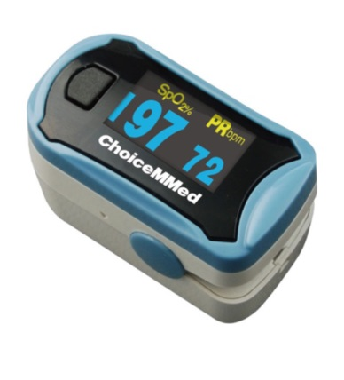
£25
(£30.00 inc VAT)
£25
(£30.00 inc VAT)
- Clear, bright colour OLED display
- Display can be viewed in 6 rotations
- Adjustable brightness: 10 levels
- Pleth waveform, displayed in 2 formats
- Signal strength indicator
- Automatic power-off when finger removed
- Suitable for paediatric and adult patients
- Part Number: 2810050
We also have other models available including MD300-C2 (MD300-D) and MD300-C15D. Please find enclosed our low cost oximeters catalogue for further information.
Should you have any further questions regarding, please do not hesitate in contacting our sales team on 01535 634542, email info@viamed.co.uk or visit our website www.viamed.co.uk.
Yours faithfully
Catrin Hollings
Marketing
FREE DELIVERY • NO MINIMUM ORDER CHARGE
Should you wish to unsubscribe from our mailings
please email unsubscribe@viamed.co.uk

Appendix 4
Posey Products

Department Manager
«DEPARTMENT»
«COMPANY»
«ADDRESS1»
«ADDRESS2»
«ADDRESS3»
«CITY» «STATE»
«ZIP»
May 2021
Dear Sir or Madam,


The Posey range available from Viamed

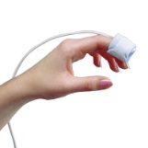 | 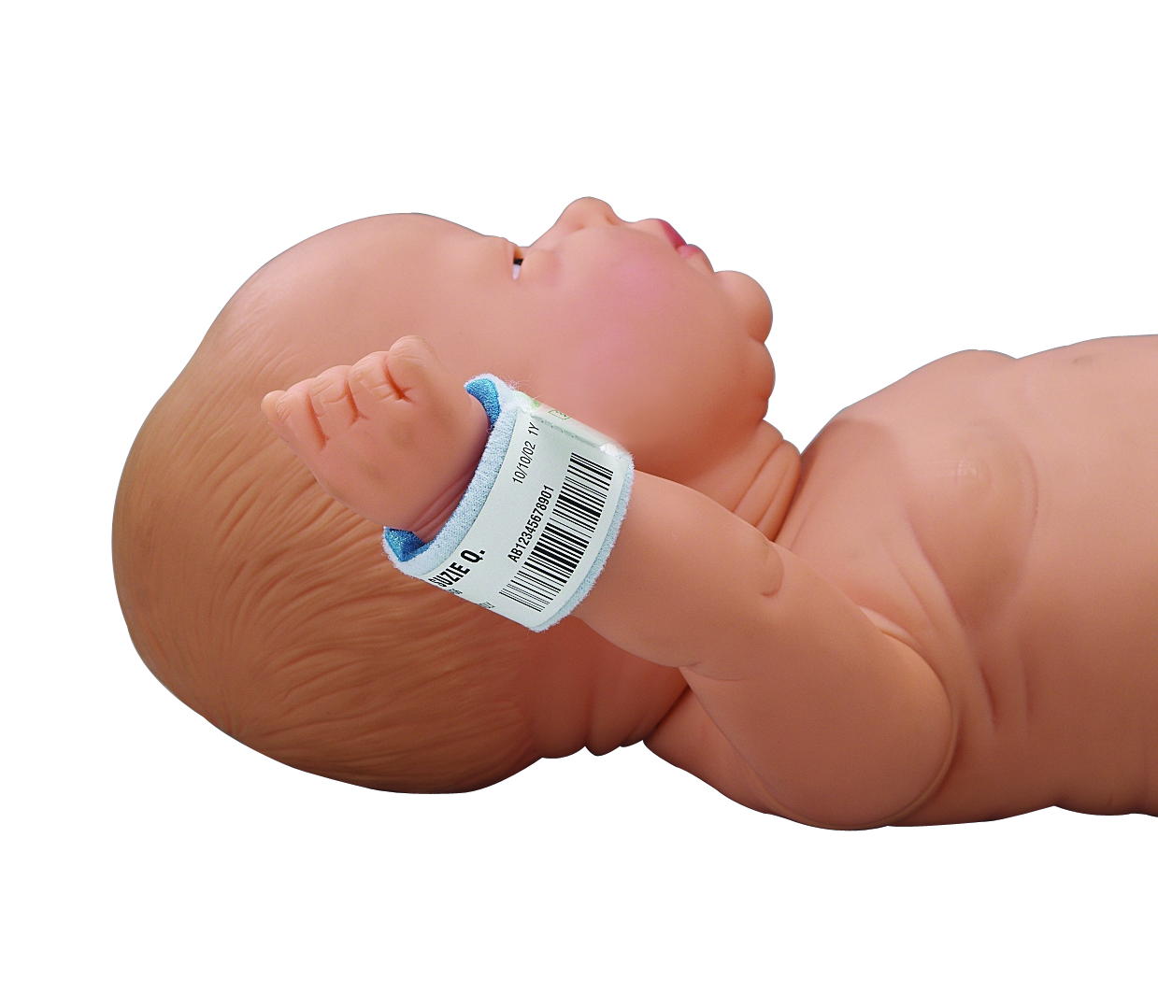 | 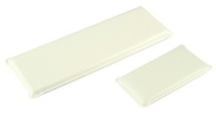 |  |  | 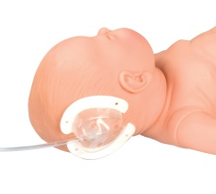
Pulse Oximetry Sensor Wraps | Removable I.D. Bracelets | I.V. Armboards  Whilst Stocks Last | Secure Sleeve  Whilst Stocks Last | Elbow Splints  Whilst Stocks Last | I.V. Shield

FREE DELIVERY &
QUANTITY DISCOUNTS AVAILABLE*

*All prices quoted include standard carriage free of charge, making it simpler for you to order.

Please find enclosed leaflet detailing the Posey range of products currently available through Viamed and price list (overleaf). Should you be unable to find the product you require or would like further information, please do not hesitate to contact a member of our sales team on 01535 634542, email info@viamed.co.uk or visit our website www.viamed.co.uk/posey.

Yours faithfully
Catrin Hollings
Marketing

Should you wish to unsubscribe from our mailings
please email unsubscribe@viamed.co.uk

Appendix 5
Maxtec MaxVenturi

Department Manager
«DEPARTMENT»
«COMPANY»
«ADDRESS1»
«ADDRESS2»
«ADDRESS3»
«CITY» «STATE»
«ZIP»
June 2021
Dear Sir or Madam,

MaxVenturi
To mix ambient air and oxygen
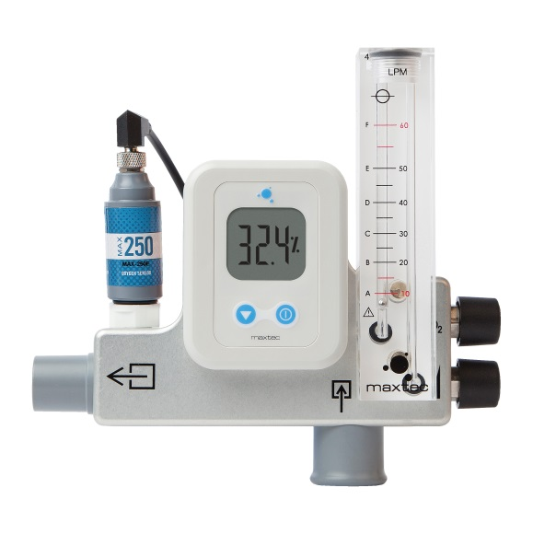
Viamed is pleased to introduce the MaxVenturi to its range of air/oxygen blenders and accessories range.

The MaxVenutri has been specifically designed to interface with high-flow humidification systems. Using the well-established Venturi principle, this unit allows users to mix ambient air and oxygen without the need for piped medical-grade air. This is the perfect solution for adult high-flow oxygen therapy in almost any environment.

Part Numbers
MaxVenturi 0 - 60 lpm with Pole Mount (DISS) | 0310225
MaxVenturi 0 - 60 lpm with Pole Mount (NIST) | 0310226
MaxVenturi 0 - 60 lpm with Locking Pole Mount (DISS) | 0310227
MaxVenturi 0 - 60 lpm with Locking Pole Mount (NIST) | 0310228

Please find enclosed a leaflet concerning the Maxtec MaxVenturi for further information.

Should you have any further questions regarding this or lead-times for this or any of our products, please do not hesitate in contacting our sales team on 01535 634542 or email maxventuri@viamed.co.uk

Yours faithfully
Catrin Hollings
Marketing

* Please note: the is current a long leadtime, please contact us for more information.
Should you wish to unsubscribe from our mailings
please email unsubscribe@viamed.co.uk

Appendix 6
Oxygen Sensors (if RoHS enforced – dates to be amended)


Department Manager
«DEPARTMENT»
«COMPANY»
«ADDRESS1»
«ADDRESS2»
«ADDRESS3»
«CITY» «STATE»
«ZIP»
*Date*
Dear Sir or Madam,

Viamed: Leading Medical Oxygen Sensor Supplier
including RoHS Compliant Lead-free Oxygen Sensors

Viamed has extended its range of Medical Oxygen Sensors to include RoHS Compliant Lead-free sensors, whilst still providing the Widest Range and the Latest Technology to offer the best value for money when using OEM and compatible oxygen sensors.

Due to the revised RoHS directive (see overleaf) exemption ceasing as of the 22nd July 2021, lead anodes in electrochemical oxygen sensors have will no longer be granted exemption status. Therefore, in preparation of this Viamed has released a range of RoHS Compliant Lead-free alternatives and will continue to expand the range and phase-in additional sensors.

Viamed continues to provide an oxygen sensor quantity discount pricing structure, there is no minimum order value, free of charge delivery and the NHS credit facility is offered on our entire range of oxygen sensors. I am sure you will find that this makes ordering easier and provides an extremely competitive package on quality, price, delivery and support.

Please find enclosed full details on our oxygen sensor range. Should you require further information on applications and compatibility, please visit our website – www.viamed.co.uk or go straight to our cross reference www.viamed.co.uk/xref
Also…
We continue to provide an oxygen sensor disposal service, as part of our Waste Management Policy. Should you wish to return any of your oxygen sensors (even if you have not purchased them from us) we will be pleased to dispose of them on your behalf in accordance with our ISO standards. Please contact us should you require information on how to send your depleted sensors to us.

Should you wish to place an order, or cannot find your oxygen sensor or equipment listed on the online cross reference www.viamed.co.uk/xref, then please contact a member of our sales team on 01535 634542 or email info@viamed.co.uk
Yours faithfully
Catrin Hollings
Marketing

Should you wish to unsubscribe from our mailings
please email unsubscribe@viamed.co.uk

Appendix 7
AlcoTrue M (Hospitals)

Department Manager  «DEPARTMENT»  «COMPANY»  «ADDRESS1»  «ADDRESS2»  «ADDRESS3»  «CITY» «STATE»  «ZIP»  19 October 2021  Dear Sir or Madam, | 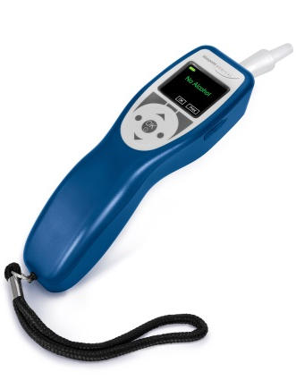

AlcoTrue M Breathalyser provides rapid and accurate

determination of breath alcohol concentration

The AlcoTrue M is a handheld professional medical breathalyser intended for quick and accurate determination of breath alcohol concentration in the exhaled breath of patients with clinical suspicion of alcohol intoxication.

The AlcoTrue M displays measurement of breath alcohol of a patient when there are concerns regarding blood alcohol level or alcohol consumption, for example in: emergency medicine, psychiatry, addiction clinics or at a methadone maintenance clinic to avoid side effects.

The main benefits include:
- Fast warm-up time < 6 seconds; allowing for quick and easy diagnosis.
- Rapid, precise and reliable clinically accurate measurements
- Easy to read display.
- This high spec product provides up to five measurement modes, ideal for any situation;
  - Active mode – To determine the precise alcohol level in the end-expiratory breath of the person to be tested after achieving a minimal breath volume from 1.2 L. It is ensured that only deep lung breath (alveolar breath) is analysed.
  - Fast mode – Intended for persons suffering from COPD, Asthma or reduced lung capacity, whom might not be able to provide the standard minimum sample volume.
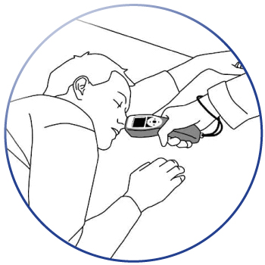
  - Passive mode* - To obtain a precise measurement, the sample uptake must be triggered when the person is breathing out. The measurement mode is to determine the quantitative value of alcohol concentration.
  - Scan mode* – Qualitative testing of the ambient air alcohol content, qualitative determination of alcohol content in exhaled air of a person who is not able to provide a breath sample (e.g. unconscious person), qualitative test of “non-alcoholic” drinks for alcohol content.
  - Mouth alcohol mode* - Consists of two tests with a determined waiting period between first and second measurement.
* Measurement modes only available if activated.
- Also available with a portable printing system.

Please find enclosed further information regarding the AlcoTrue M. Should you wish to discuss this in further detail please do not hesitate to contact a member of our sales team on 01535 634542 or by emailing alcotrue@viamed.co.uk.

Yours faithfully
Catrin Hollings
Marketing

Should you wish to unsubscribe from our mailings
please email unsubscribe@viamed.co.uk

Appendix 7
AlcoTrue M (Emergency Services)

Department Manager  «DEPARTMENT»  «COMPANY»  «ADDRESS1»  «ADDRESS2»  «ADDRESS3»  «CITY» «STATE»  «ZIP»  Dear Sir or Madam, | 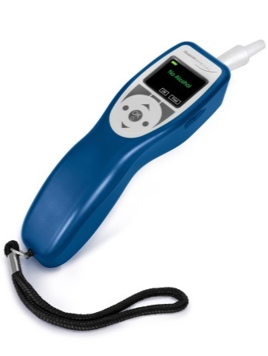

AlcoTrue M Breathalyser provides rapid and accurate

determination of breath alcohol concentration

The AlcoTrue M is a professional handheld medical breathalyser for accurate determination of breath alcohol concentration closely matches evidential devices.

The AlcoTrue M is designed for diagnostic use and it displays measurement of breath alcohol when there are concerns regarding blood alcohol level or alcohol consumption.

The main benefits include:
- Fast warm-up time < 6 seconds; allowing for quick and easy diagnosis.
- Rapid, precise and reliable clinically accurate measurements even at sub-zero ambient conditions; can be used on-site or in the field.
- Easy to read display.
- This high spec product provides up to five measurement modes, ideal for any situation;
  - Active mode – To determine the precise alcohol level in the end-expiratory breath of the person to be tested after achieving a minimal breath volume from 1.2 L. It is ensured that only deep lung breath (alveolar breath) is analysed.
  - Fast mode – Intended for persons suffering from COPD, Asthma or reduced lung capacity, whom might not be able to provide the standard minimum sample volume.
  - Passive mode* - To obtain a precise measurement, the sample uptake must be triggered when the person is breathing out. The measurement mode is to determine the quantitative value of alcohol concentration.
  - Scan mode* – Qualitative testing of the ambient air alcohol content, qualitative determination of alcohol content in exhaled air of a person who is not able to provide a breath sample (e.g. unconscious person), qualitative test of “non-alcoholic” drinks for alcohol content.
  - Mouth alcohol mode* - Consists of two tests with a determined waiting period between first and second measurement.
* Measurement modes only available if activated.
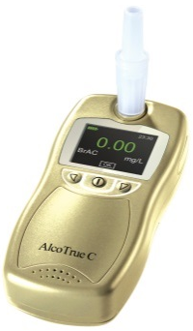
- Also available with a portable printing system.

Please find enclosed further information regarding the AlcoTrue M. Should you wish to discuss this in further detail please do not hesitate to contact a member of our sales team on 01535 634542 or by emailing alcotrue@viamed.co.uk.

There is also a smaller alternative breathalyser called the AlcoTrue C.
Go to www.viamed.co.uk/alcotrue-c for more information.

Yours faithfully
Catrin Hollings
Marketing

Should you wish to unsubscribe from our mailings
please email unsubscribe@viamed.co.uk

Appendix 8
EyeMax and Neomask Phototherapy Eye Masks (awaiting sign off)

Department Manager
Paediatrics
Royal Albert Edward Infirmary
Wigan Lane
Wigan
WN1 2NN

September 2021
Ref: 0491002/20180807/358

Dear Sir or Madam,

EyeMax2TM and NeoMask Phototherapy Eye Masks
The soft, safe and secure solution for eye protection during neonatal phototherapy

- Adjustable band for optimum comfort and a secure fit
- Easy to use design
- Ergonomically designed eye protection pads to reduce pressure and increase light protection

The range of Phototherapy Eye Masks have been designed to assure optimum comfort and eye protection for neonates during phototherapy treatment. Both compromise of a single-piece, wrap-around design.

The EyeMax is secured at two points on either side of the neonate’s head, whereas the NeoMask is adjustable at the top and at the back of the head. These points can be independently adjusted to prevent unwanted movement and allows a comfortable and secure fit.
 | 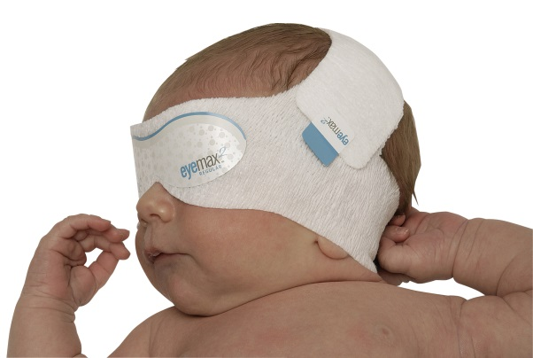
Neomask Phototherapy Eye Mask | EyeMax Phototherapy Eye Mask
The large eye protection pad has been ergonomically designed to reduce pressure and increase light protection. The headband however allows blue light to penetrate, so that the head continues to receive phototherapy treatment.
I hope you find the enclosed of interest, please find pricing overleaf; should you require a free of charge sample of either design or further information, please do not hesitate to contact a member of our sales team on 01535 634542 between 09:00 and 17:30 or email eyemasks@viamed.co.uk

Yours sincerely
Catrin Hollings
Marketing

Should you wish to unsubscribe from our mailings
please email unsubscribe@viamed.co.uk

EyeMax2TM Phototherapy Eye Masks

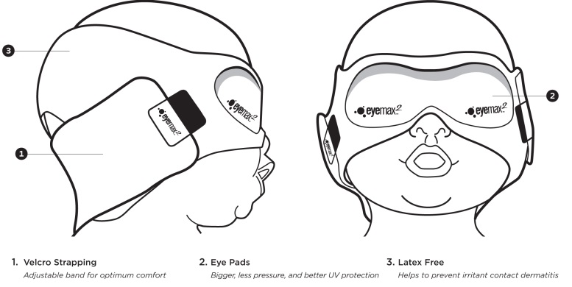

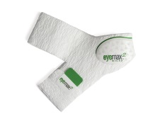 | 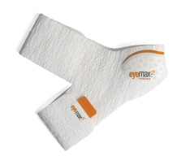 | 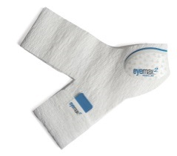

 |  |  |  |  |  | Delivery Charges
Part Number | Size | Occipital -  Frontal Circumference | Prices as of  4th October | Pack Qty |  | Boxes | Delivery Type
1114005 | Regular | 32 – 38 cm | £43.70 | 20 |  | 1 pack | £6.00  Royal Mail 1st Class Signed For
1114006 | Premie | 26 – 32 cm | £41.90 | 20 |  | 2 – 4 packs | £8.00  Royal Mail 1st Class Signed For
1114007 | Micro | 20 – 26 cm | £37.80 | 20 |  | 5+ packs | £10.00  UPS Courier

NeoMask Phototherapy Eye Masks

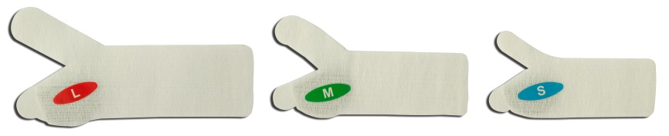

 |  |  |  |  |  | Delivery Charges
Part Number | Size | Occipital -  Frontal Circumference | Prices as of  4th October | Pack Qty |  | Boxes | Delivery Type
1114015 | Large | 32 – 38 cm | £34.50 | 20 |  | 1 pack | £6.00  Royal Mail 1st Class Signed For
1114016 | Medium | 26 – 32 cm | £33.00 | 20 |  | 2 – 4 packs | £8.00  Royal Mail 1st Class Signed For
1114017 | Small | 20 – 26 cm | £31.50 | 20 |  | 5+ packs | £10.00  UPS Courier

Appendix 9
ST-BLR Neonatal Flow Sensor (awaiting sign off)

Department Manager
Neonatal Unit
****
****
****
****
****
Ref: 20215104310004/???
19 October 2021
Dear Sir or Madam,

Introducing the ST-BLR Neonatal Flow Sensor

For flow measurement of respiratory gas flow delivered in Dräger neonatal ventilators

The ST-BLR flow sensor is a reusable cost-effective neonatal hot wire anemometric flow sensor with insert, for measuring gas flow in Dräger neonatal ventilators.

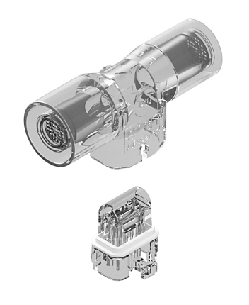
Each ST-BLR flow sensor comes with a reusable outer housing and an installed reusable insert. Additional inserts can be purchased.

The ST-BLR flow sensor is a direct compatible to the Dräger neonatal flow sensor ISO 15, REF 8411130 and the ST-BLR INSERT is a direct compatible to the Dräger neonatal flow sensor INSERT, REF 8410179.

Also available, the disposable ST-BL flow sensor comprising of an outer housing with integrated insert.

4310004 | ST-BLR Neonatal Flow Sensor with reusable housing and insert
4310005 | ST-BLR-INSERT Insert for ST-BLR Neonatal Flow Sensor (Box of 5)
4310006 | ST-BL Disposable Neonatal Flow Sensor with fixed insert

Please find enclosed full details on our flowsensor range including price list overleaf.

Viamed also has a wide range of oxygen sensors and flow sensors compatible with most of the commonly used ventilators.

Should you require further information please contact a member of our sales team on:
(01535) 634542 or email flowsensors@viamed.co.uk

Yours faithfully

Catrin Hollings
Marketing
Trusted supplier to the NHS for over 40 years
Free Delivery ● No minimum order

Appendix 10
ST-BL Neonatal Flow Sensor (awaiting sign off)

Department Manager
Neonatal Unit
****
****
****
****
****
Ref: 20215104310004/???
19 October 2021
Dear Sir or Madam,

Introducing the ST-BL Neonatal Flow Sensor

For flow measurement of respiratory gas flow delivered in Dräger neonatal ventilators

The ST-BL flow sensor is a disposable cost-effective neonatal hot wire anemometric flow sensor with fixed insert, for measuring gas flow in Dräger neonatal ventilators.

The ST-BL flow sensor is a disposable compatible to the reusable Dräger neonatal flow sensor ISO 15, REF 8411130.

4310006 | ST-BL Disposable Neonatal Flow Sensor with fixed insert

Please find enclosed full details on our flowsensor range including price list overleaf.

Viamed also has a wide range of oxygen sensors and flow sensors compatible with most of the commonly used ventilators.

Should you require further information please contact a member of our sales team on: 01535 634542 or email flowsensors@viamed.co.uk

Yours faithfully
Catrin Hollings
Marketing

Trusted supplier to the NHS for over 40 years
Free Delivery ● No minimum order

