VMCOP3.??.?? Snipping Tool or Snip & Sketch
- Click the Windows icon on your toolbar  or tap the Windows key on your keyboard
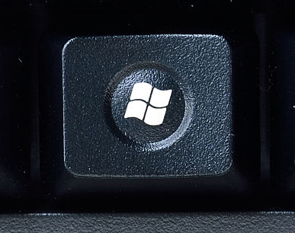
- Type ‘Snip’ and click either ‘Snipping Tool’ or Snip & Sketch
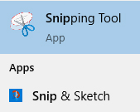
- To create a new screen shot, click the ‘New’ button
Snipping Tool:

Snip & Sketch:

- Click and drag to select the part of the screen you wish to screenshot. When the mouse button is released your chosen screenshot will show in the chosen snipping tools program window:
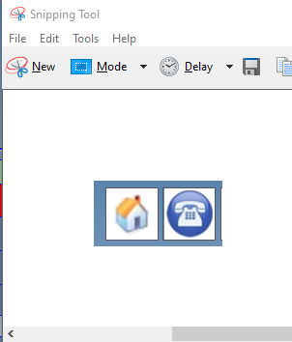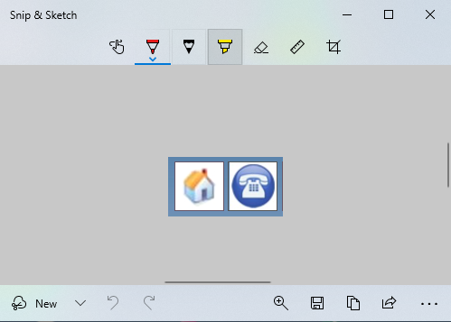

- To copy and paste, click edit then Copy or press Ctrl+C on your keyboard. This will cope it to your clipboard and you can paste to a document or emails.
- If you wish to save the image, click File then Save as and save there required.

