VM3COP20.13 - Sending SOR’s

Checklist
☐ Director authorisation uploaded to linked issue
☐ SOR Terms and Conditions signed by customer
☐ SOR number
☐ Items been scanned to SOR
☐ Quotation
☐ Signed MIA Delivery Note/shipping invoice
☐ Second copy of first page of MIA Delivery Note/shipping invoice
☐ Feedback form
☐ Cover letter on letterhead
☐ Relevant leaflet and price list
☐ Relevant business card
☐ Schedule an issue for follow-up

Paperwork Checklist

To attach to issue | To Ship
Copy of MIA Delivery Note /  shipping invoice | Signed MIA Delivery Note /  shipping invoice
Customer SOR request paperwork | Cover letter
Quotation | Viamed product feedback form
Signed Terms & Conditions | Price list
Director authorisation | Leaflet
Cover letter | Quotation
Viamed product feedback form | Relevant business card
Price list

VM3COP20.13
Sending Sale or Return Orders

Beginning the Process

- If not already created, create a “Sale or Return” Folder in your documents folder.
- Create a sub folder in your “Sale or Return” Folder your documents folder called
“Sale or Return *Hospital Name* SOR***”.
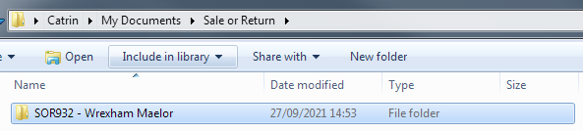
- Print the Sale or Return request to PDF, if requested by email, and save in the above folder.
If the request was verbal/telephone, please add a telephone order as per VM3COP27.29 and print to PDF.

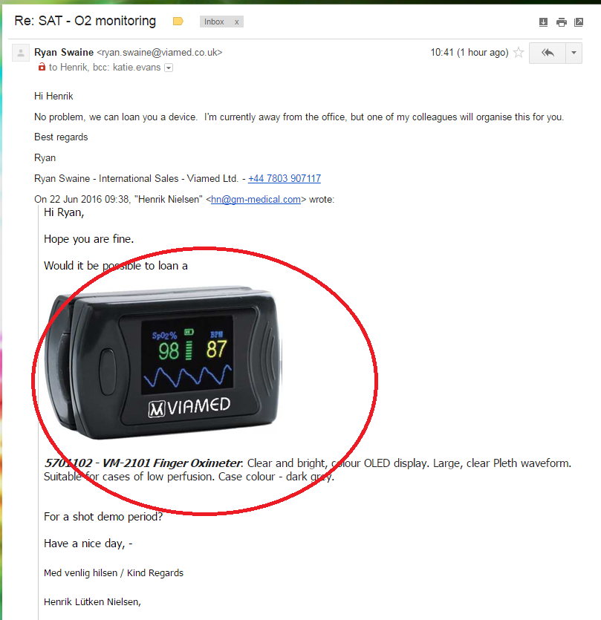

- From the top right dropdown menu, click ‘Contacts’ and type your query in the search box.
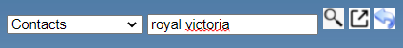
To search, click the magnifying to search in the same tab or the box with an arrow to open in a new tab.
- Click the correct account
(Please be aware any accounts which are highlighted in green have been used in the new ordering system i.e. since January 2020)
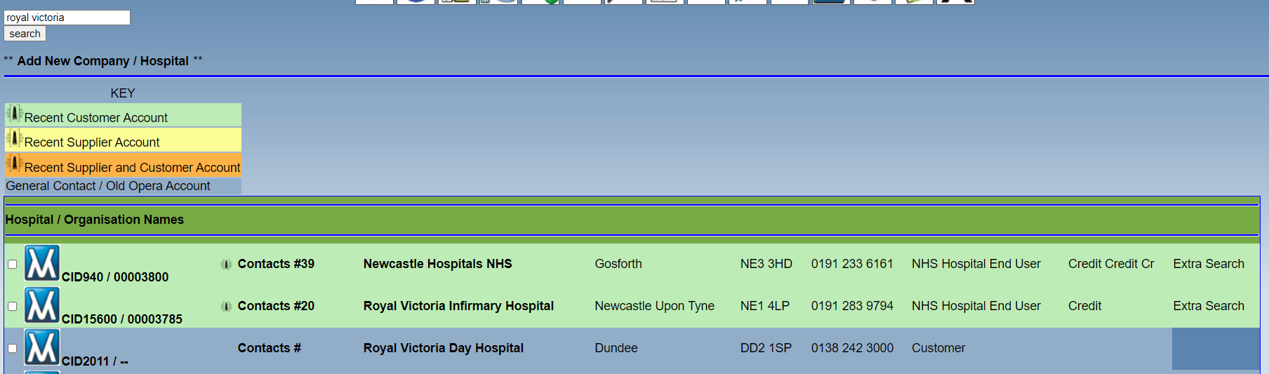

- Gain authorization from a director and upload against the customers contact record in the CRM. This can be a PDF of an email, PDF of an issue or screenshot of a Skype conversation (VM3COP27.46 Using the Snipping Tool in Windows 10). Save to the relevant folder created in step 2.

Click the ‘Upload Document’ button
Choose file
File Description: Sale or Return Authorisation
File Type: Sale or Return Document
Security: Internal Use Only
Click ‘Upload File’
Sending Request for Signed Terms and Conditions
- Locate the Sale or Return page.
 then 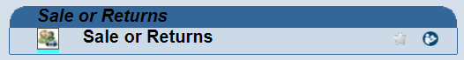

- Click ‘Product Trial – Sale or Return Terms and Conditions’
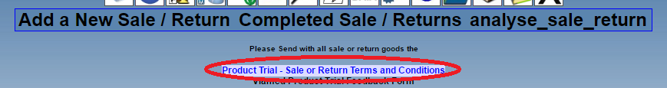
- Click the PDF icon to open the file and download from there (see the following steps) or click the green arrow icon which will download the file to your Downloads folder and move this to your designated folder created in step 2.
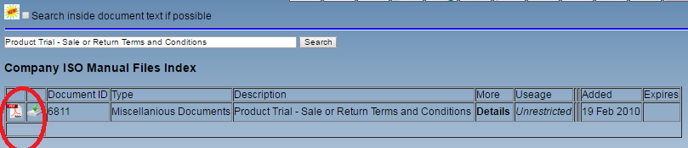

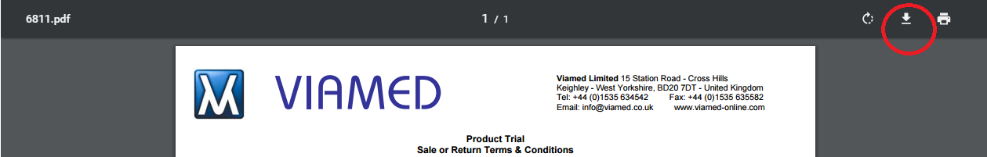

- When the Save window opens, click ‘Documents’, and locate your newly created folder, as per step 2. Change the document ‘File name’ to:
‘Sale or Return Terms and Conditions’ and click ‘Save’.
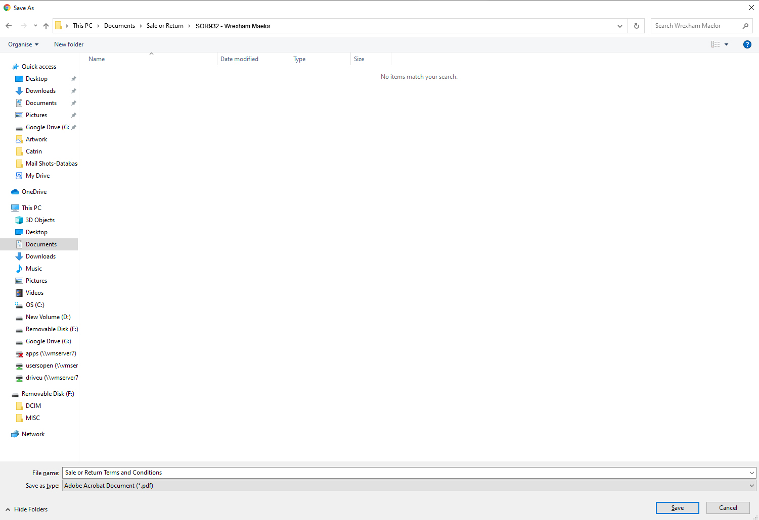

- Return to the request email, attach the Sale or Return Terms and Conditions from the saved location and reply to the customer using the template email (VM3COP27.47) and click ‘Send’.

Once terms and conditions received - Create a new SOR

- In the contact management, find the correct account and click on the SOR icon to the left of the required contact name
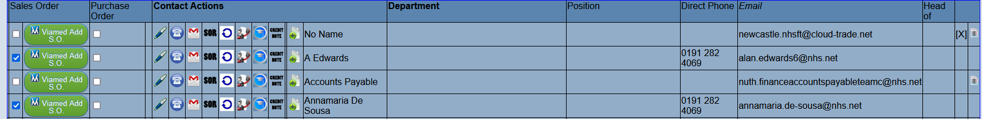

- Click, ‘Add New Sale/Return’’
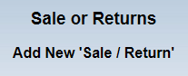

This will redirect you to the main sale/return page and create a new record for the company/hospital contact.

Requesting Stock Movement
- When the terms and conditions have been received return to Intrastats and click on the stock box icon. From this page, click on ‘Sale or Returns’
then

- Scroll to the bottom of the page and click
‘Request new stock item to be scanned to Sale or Return’.

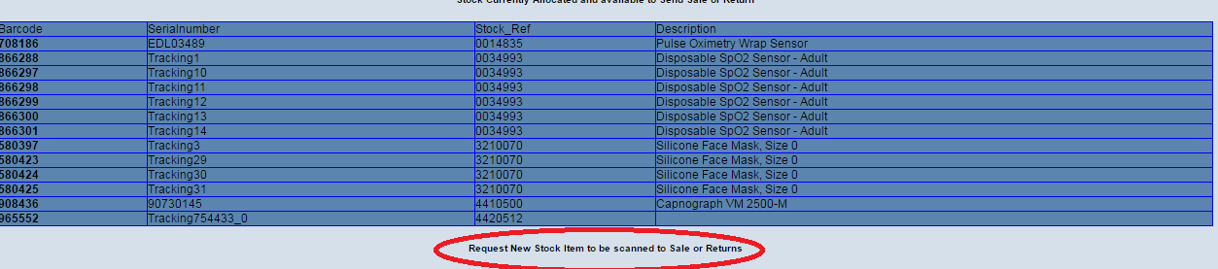

- Fill in the issue detailing the part number(s), description and quantity required. Include the SOR number and Hospital/Company the goods are going to, for reference.
Send this issue to the person in Goods Out, fill in the CID / account number and click ‘Add Issue’.
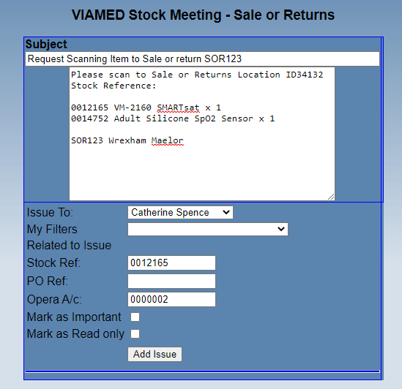
Note: if the item is urgent, also inform Goods Out verbally.

Generating Quote

When you have received the completed Terms and Conditions from the customer and once you have confirmation from Goods Out that the items have been scanned, you need to add them to the SOR record and create a quote.

Confirmation from Goods Out will come in the form of an issue, in reply to the issue sent to Goods Out.

Take note of the ID number(s) provided for the product(s) scanned.

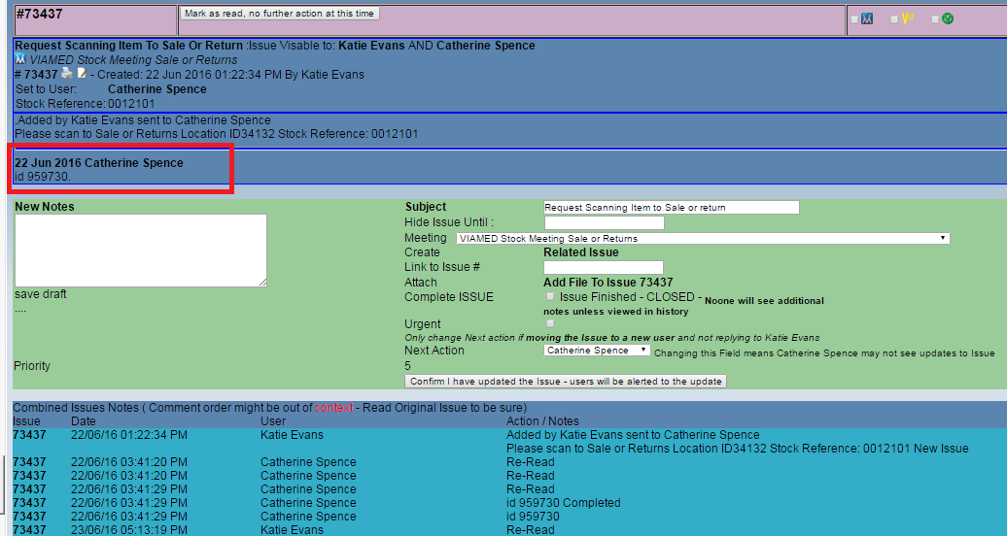
- In Intrastats, follow the quote procedure VM3COP27.31 to create a quote for the item(s) requested, ensuring any quotes for over £/$/€10,000 are signed off by a director.

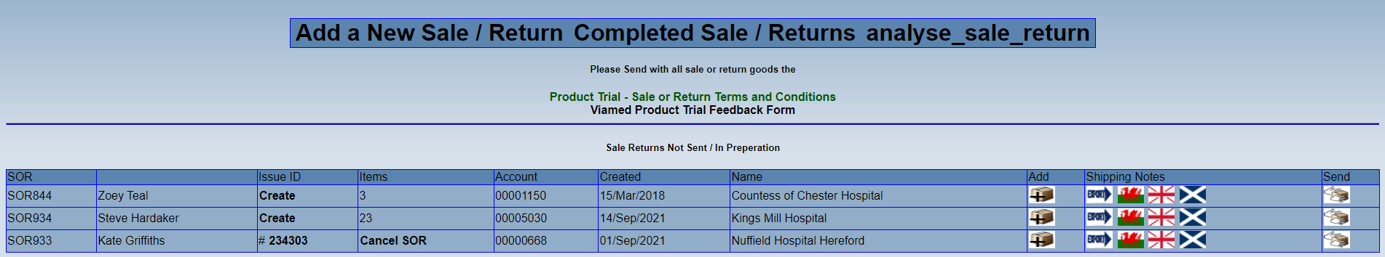

Use the SOR number as the ‘Customer Reference’ unless an order number for the quote has been received.
In the notes section state ‘Goods already supplied on SOR***’

Next, the serial numbers need to be typed in the memo for each item sent.

- Click in the memo box next to the product number/description.
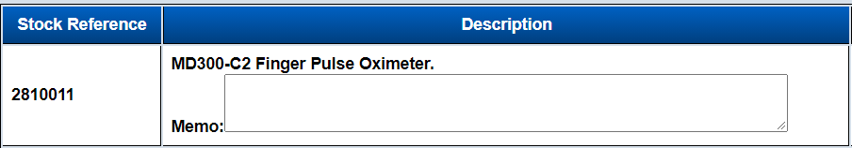

- Type the serial number(s) in the format ‘S/N: ???’.
There may be additional notes here, if so, add the serial number beneath them.

- Once all details have been entered, click ‘Print QVM******* checking document’ and check details are aligned and correct.

- Once all completed, go back to the main processing back and click ‘Submit QVM****** for checking’

- Add message to the ‘Office Order Checking’ Skype group or ‘Viamed Employees’ (if you are not included in the main checking group) and ask for your quote to be checked.

Writing Sale or Return Letter

- Open the Sale or Return letter from the top of the sale or return screen, amend all the details as indicated in the example below, to include the product description, part numbers, SOR number and serial number.

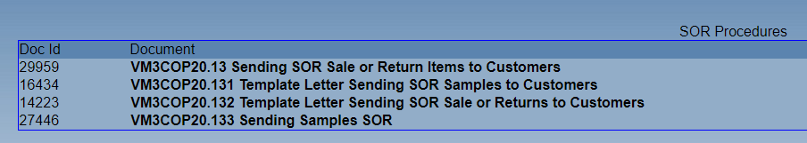

When complete, read through the letter and ensure the grammar is correct, i.e. if there is more than one item, the words, ‘This product is’ may need to be changed to, ‘These products are’ and remove the word, ‘Trust’ if not for the NHS.
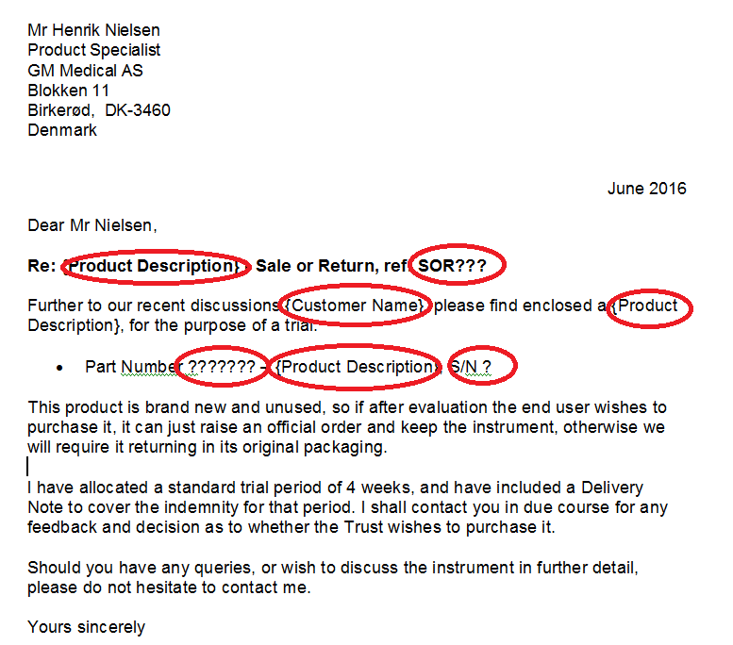

- When complete, print the letter to PDF and save on your designated folder, created in step 2 in documents, with the following format:

Sale or Return - *customer name* - SOR*** - *date backwards*
e.g. ‘Sale or Return – GM Medical – SOR729 – 160622’
Adding Stock to SOR

- Return to the main SOR page located in Intrastats > Stock icon > ‘Sale or Returns’
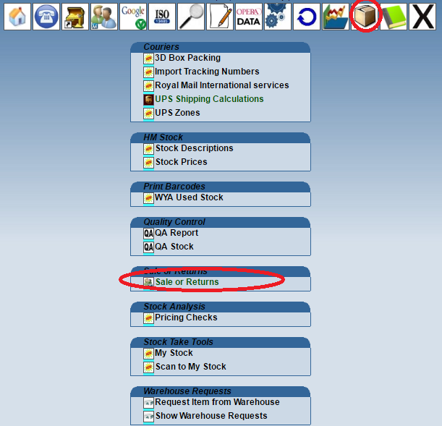

- In the top list ‘Sale Returns Not Sent / In Preparation’ click the icon in the ‘Add’ column for the correct customer/SOR number.

- Ensure the name and address details at the top of the screen are correct.
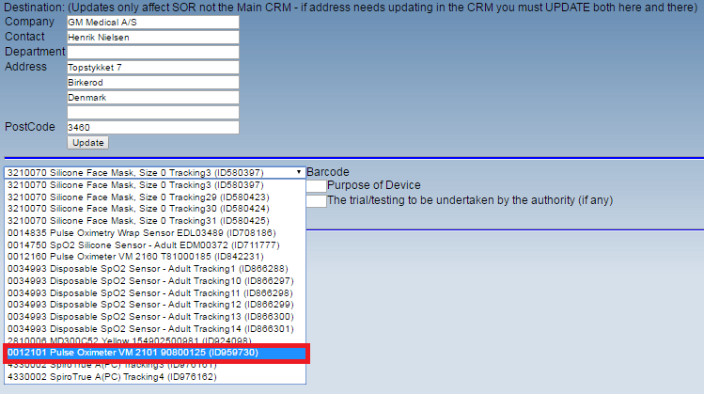
- From the ‘Barcode’ drop-down on the next page, select the item you want to send.

Ensure you choose the item with the correct ID number as per the Goods Out confirmation issue.

- In the field entitled ‘Purpose of Device’, enter a brief explanation of the use of the item (if unsure, the stock description will suffice), for example ‘SpO2 sensor for Viamed pulse oximeter’ or ‘Measuring concentration of oxygen’.

- In the field entitled ‘The trial/testing to be undertaken by the authority (if any)’ type a brief summary, for example ‘Sale or Return trial to determine suitability prior to purchase’

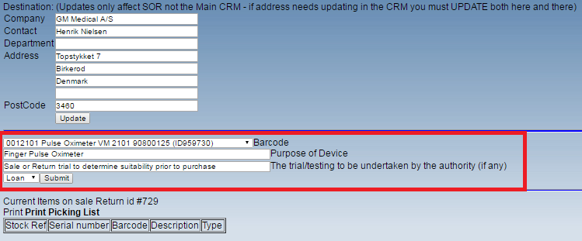
In the drop-down box next to the ‘Submit’ button, select ‘Loan’.

- Should the items be disposable, select ‘Giving’ from the dropdown menu.
- Repeat for all items required.

- If the Sale or Return is for an export customer then a value needs to be entered in the, ‘Value for Customs if applicable’. Consult with the International Sales Manager or the Commercial Director for the customs value to use.
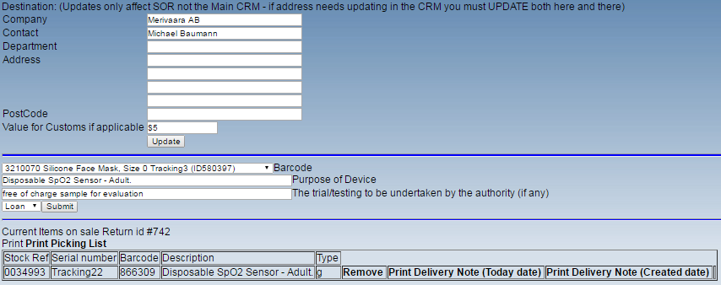
- Return to the main Sale or Return screen and click the appropriate flag icon for the customer to generate an MIA Delivery Note depending upon the location of the customer (England and Northern Ireland use the same form, Scotland and Wales have their own) or export for non-UK customers.


- Save the PDF to your designated folder, created in step 2 in documents, in the following format:

Export: ‘SOR Shipping Invoice - *Customer Name* - SOR*** - date backwards’
UK: ‘SOR Delivery Note - *Customer Name* - SOR*** - date backwards’
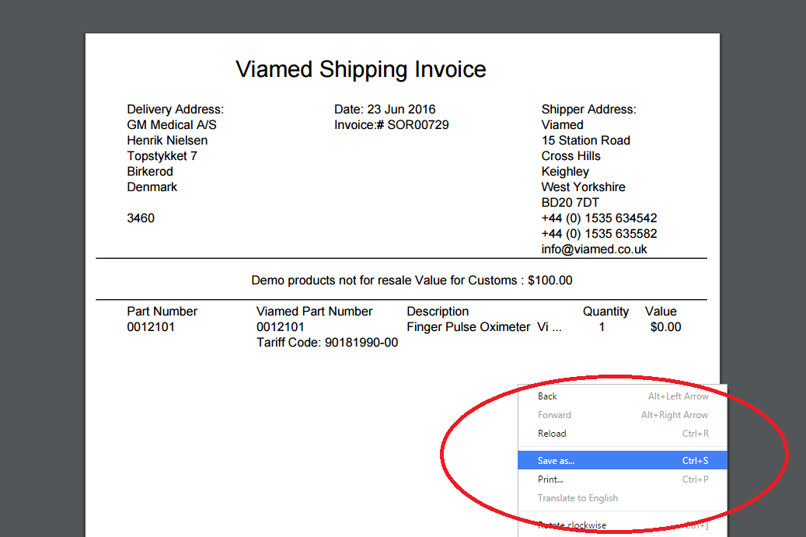

- On the main Sale Or Return screen, click the link `Viamed Product Trial Feedback Form`
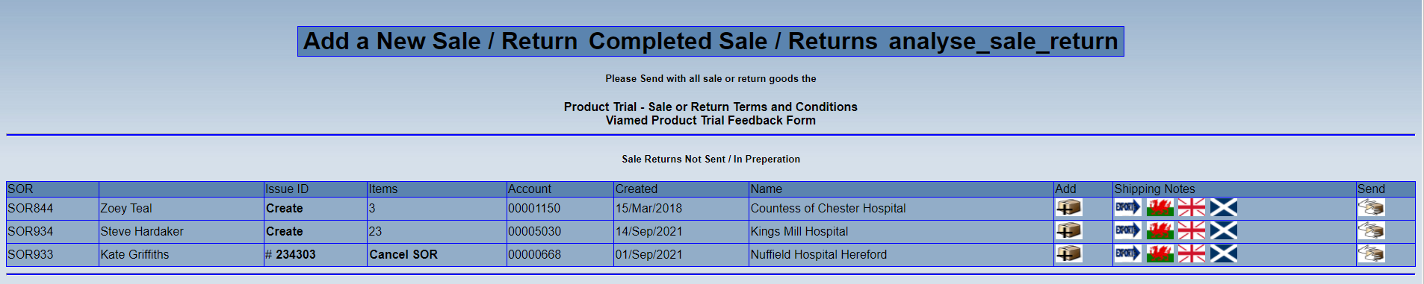

- Click on the PDF icon
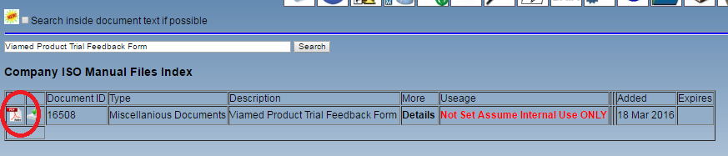

- This will open the feedback form; save the PDF to your designated folder, created in step 2 in documents. Save as “Viamed Product Trial Feedback Form”.

Providing paperwork to Goods Out
When signed terms and conditions have been received back from customer, Goods out have confirmed stock has been scanned to SOR shelf and stock has been linked to the SOR:
- Collate the following and create issue associated with the SOR and attach to the issue, then send to Goods Out.
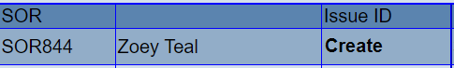
- Sale or Return Letter (to be printed onto letterhead by Goods Out)
- MIA Delivery Note (If the SOR is for a UK customer, a director or manager will need to digitally sign page 2 to ensure that ownership of the unit does not pass to the customer. If the goods are disposable and we have stated ‘Giving’ then by signing it we are passing over ownership to them. Goods out need to print the MIA delivery note/shipping invoice and a second copy of the first page.)
- Viamed Product Trial Feedback Form
- Relevant price list in the correct currency, as found on the customer’s account, from the stock page.
- Quotation for goods being sent.
- Request for SOR paperwork
- Signed terms and conditions
- Director authorisation

Checking an SOR

- Ensure the items listed on the MIA Delivery Note/shipping invoice match the items requested by the customer.

- Ensure the paperwork to ship with the items have been attached to issue ID on the sale or return page. All files attached to the linked issue will automatically be linked to the CRM system and show in the ‘Document Files’ tab in the customers CRM record.

The issue should contain:
MIA Delivery Note note/shipping invoice
Cover letter (to be printed to letterhead by Goods out)
Viamed product feedback form
Price list for products being sent
Quotation for products being sent
Additional paperwork to be added by Goods Out to shipment:
Leaflets for products being sent
Relevant business card

Paperwork also attached to the issue will be file against customer CRM:
Copy of MIA Delivery Note/shipping invoice
Director authorisation uploaded to linked issue
A copy of the quotation for products being sent
Terms & Conditions signed by the customer
Copy of Cover Letter

Once checked and complete, send issue to Goods Out.

Following up an Evaluation and to Determine the Success of the Sale or Return

- The sender needs to schedule themselves a follow up issue 2 weeks ahead, to discuss the product with the customer, obtain feedback and determine the progress of the evaluation.
The standard loan time for SOR is 4 weeks.
In the first instance, this follow up should be done via telephone call, with a follow up by email if the contact is not available.
Please aim to close it off and either have the items returned to us within the 4-week period or an official purchase order received for them to purchase.

- If following up by email, please also direct the customer to the online feedback form: http://www.viamed.co.uk/trial-feedback unless a specific product feedback form is available. This will show on the stock memos/FAQs screens.

- When the recipient has been followed up, return to the main Sale or Return page by clicking on the ‘Stock’ icon and clicking, ‘Sale or Returns’.

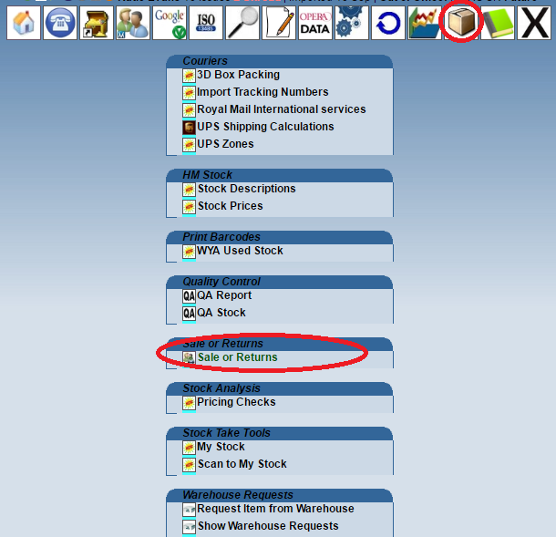
- Click, ‘analyse_sale_return’ .

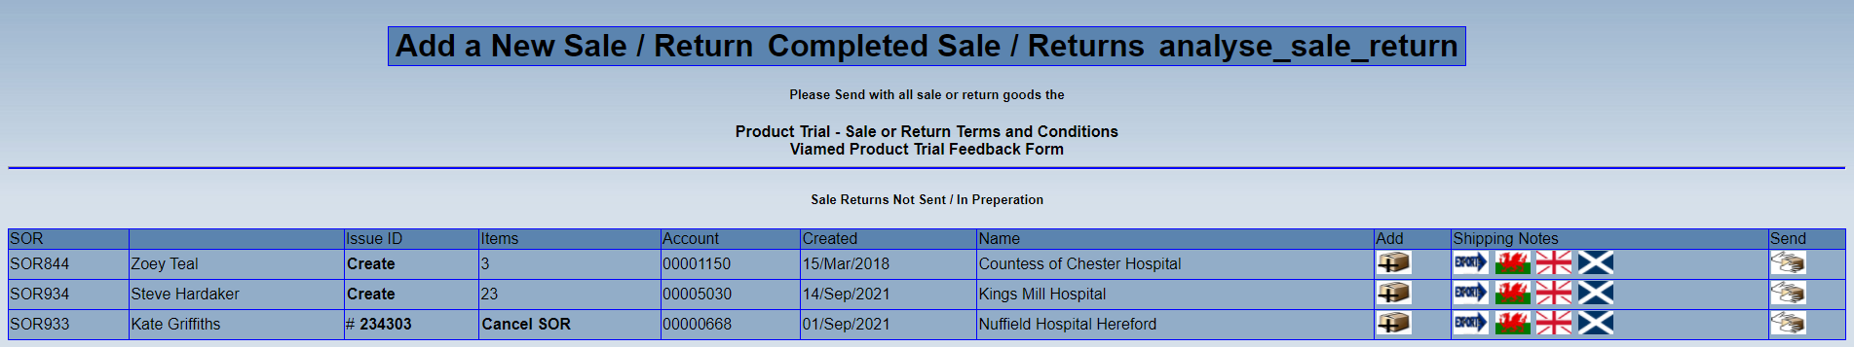

- Locate the SOR number for the customer you are following up, this can be identified by the SOR number on the left. Click the button on the corresponding line named, ‘I’ve chased this up’, this will then display the name and date of the person who dealt with it.

- Once the initial feedback/evaluation status is requested, the sender should schedule themselves another issue to contact them again in 1 week, should a response have not been received. In the first instance, this follow up should be done via telephone call, speaking with the original contact who requested the SOR or signed the trial paperwork, with a follow up by email if the contact is not available.

- Repeated attempts should be made to get a decision from the customer.
Should a response still not be received by the expiry date of the trial, contact the customer that requested the Sale or Return along with any other contacts that were involved (e.g. if the initial request came from Theatres but the goods were sent via the EBME Department) using the email template for notifying expiration of the loan period. (VM3COP27.49 Template Email Sale or Return Loan Period Expired).
If no response is received within 5 working days, escalate to the relevant sales manager or a Director.

Received Feedback

- When product feedback is received, add an issue as per ‘Issues Overview’ under the ‘Feedback’ meeting name, and select either ‘Product Feedback Negative’ or ‘Product Feedback Positive’ as appropriate.
If the feedback relates to our service, add an issue as per ‘Issues Overview’ under the ‘Feedback’ meeting name, and select either ‘Customer Feedback Negative’ or ‘Customer Feedback Positive’ as appropriate.

Include SOR reference in the notes for easy reference/searching.

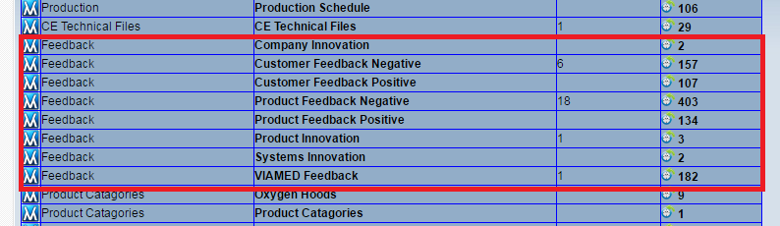

SOR Purchase

If the customer chooses to purchase the SOR items, they will need to provide you with an official purchase order; if they have only provided an email agreement to purchase, please request an order number and an official purchase order.

- Once received, locate the quotation on the ‘Outstanding Customer Orders’ page.


- Click on the  button against the correct quote line.
- Click ‘Convert to Order button’ 
Check the delivery address against the PO; it is not always known at the point of quotation but this must match the PO.
- Amend the ‘Customer Reference’ box to the purchase order number and change the ‘Due’ date to the next available shipping day.

- A note should have been added at the quote stage, in the ‘Notes’ section ‘Goods already supplied on SOR***’. Ensure it is still there, if not, add this note.

- Once checked information against the purchase order, click ‘Submit CVM****** for checking’

Note: If the customer chooses to add any additional items to the order, add notes to the order stating which items need shipping and which only need to be invoiced. Skype or Call Goods out to confirm notes have been added.
E.g. ‘1 x 0012160 and 1 x 0014750 already supplied on SOR***, please ship other items’.

SOR Return

If the customer chooses to return the SOR items, issue the customer with a returns reference number (SRS) as per VM3COP20.03 Repair Intrastats Procedure. When the item is received by Goods In, you will receive an issue.

- When this issue is received, print to PDF. Locate the quote on the outstanding customer orders page.
Open the order for editing 
Then click ‘DELETE Order *******’ 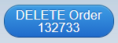
Reason for Deletion:
Write a note to say that the customer did not want to purchase the goods and has returned them on SRS*****.

