The EU Waste Electrical and Electronic Equipment (WEEE) Directive requires all Member EU countries to maximise the separate collection, reuse and recycling of WEEE. The UK WEEE Regulations (derived from this Directive) applies to all Electrical and Electronic Equipment (EEE) placed on the market in the UK covered by the scope of these Regulations.

Under the UK WEEE Regulations, “Producers” are required to mark all relevant EEE with a “crossed-out wheelie bin” symbol to remind consumers not to discard WEEE in the domestic waste stream. [The company] encourages all of its customers to make note of this symbol and avoid putting any WEEE in your domestic waste bin(s) or container(s).

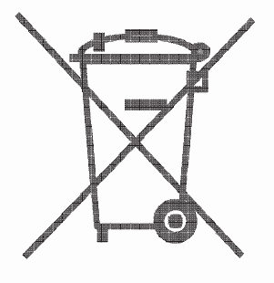

[The company] supports the reuse and recycling of WEEE as there are several environmental benefits of doing so, such as: Reduction of raw material and energy usage, prevention of landfill, prevention of hazardous and/or toxic materials present in some WEEE contaminating the environment.

As a Producer under the UK WEEE Regulations, [The company] complies with its Producer Obligations by being registered as a Member of the WeeeCare Compliance Scheme and obtaining the WEEE Producer Registration Number – [insert WEEE PRN]



[Delete or include, as appropriate, for B2B PRODUCERS AND/OR DISTRIBUTORS]

Under the UK WEEE Regulations, “Distributors” are required to provide a “take-back” system which allows customers (end users) the opportunity to return (or “take-back”) their WEEE to a Distributor free of charge, when supplying new EEE on a like-for-like basis.

As a B2B Producer and/or Distributor under the UK WEEE Regulations, [The company] allows for end users of the EEE placed on the market in the UK to return WEEE back to us free of charge on a like-for-like basis for new EEE purchased. Such WEEE can be returned to the following location: [insert location] or contact WeeeCare.

If you would prefer us to collect your WEEE from your premises, please contact us as there will be a transport charge for such WEEE from your premises and delivery of such WEEE to an Approved Authorised Treatment Facility (AATF). The charge will only cover the cost of transportation and handling and will not include any cost in relation to the treatment or reprocessing of WEEE as defined by the Regulations.

Alternatively, there is a network of recycling centres across the UK where consumers of WEEE can also take WEEE free of charge to be discarded, reused and/or recycled. The complete list of locations can be found at: www.recyclenow.com

In addition, if a retailer supplying new EEE from retail premises with a sales area relating to EEE of at least 400m², the retailer must provide for the takeback of very small WEEE free of charge to the end user, who has no obligation to buy EEE of an equivalent type.

