Theatres Department
Theatres Manager
«COMPANY»
«ADDRESS1»
«ADDRESS2»
«ADDRESS3»
«CITY»
«ZIP»
Ref: 20210706/555
August 2021
Dear Sir or Madam,
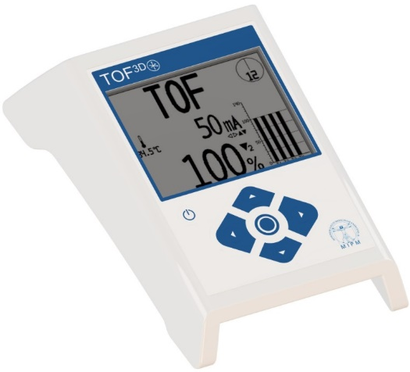
Introducing the TOF^{3D} Neuromuscular Monitor
Supersedes the Viamed Microstim DB3 Supramaximal Peripheral Nerve Stimulator as a means of assessing the depth or degree of muscle relaxation achieved during anaesthesia

By means of 3 dimensional acceleromyography the TOF^{3D} quantitatively monitors the level of neuromuscular transmission during surgery or in the intensive care unit. The new TOF^{3D} is easy to use and in addition to the standard TOF and PTC modes, there are alternative objective and subjective modes of stimulation available. The monitor’s functions and modes of stimulation can be quickly customised to meet your specific requirements.

- TOF - Train of Four - Single stimulation or continuous every 15 seconds.
- PTC - Post Tetanic Count
- TOFs - Train of Four - Stimulation interval between 1 minute to 60 minutes.
- Single Twitch - 1Hz or 0.1Hz - Single stimulation or continuous.
- DBS - Double Burst Stimulation - Ratio 3-2 or 3-3.
- TET – Tetanic - 50 Hz or 100 Hz.
Please find enclosed the leaflet for the TOF^{3D} Neuromuscular Monitor. Should you require any further information on this product, please do not hesitate to contact a member of our sales team on 01535 634542, between 09:00 and 17:30, or email tof3d@viamed.co.uk.

Yours sincerely

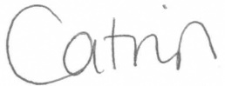

Catrin Hollings
Marketing

