Theatres Department
Theatres Manager
«COMPANY»
«ADDRESS1»
«ADDRESS2»
«ADDRESS3»
«CITY»
«ZIP»
Ref: 20210706/555
August 2021
Dear Sir or Madam,

Are you struggling to find a monitor which determines the depth of muscle relaxation under the effects of anaesthesia for your patients?
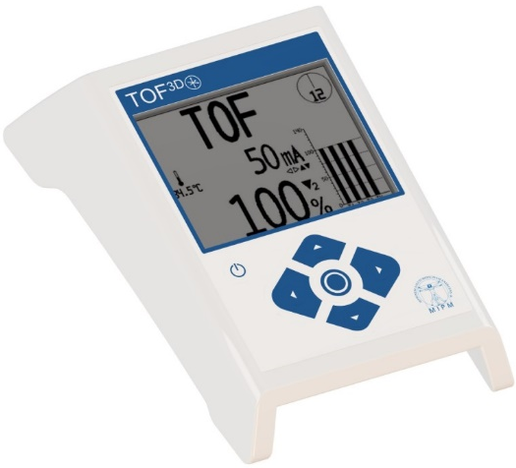
Introducing the TOF 3D Neuromuscular Monitor
A quantative nerve monitor designed for use during anaesthesia

The NEW TOF 3D Neuromuscular Transmission Monitor, manufactured by MIPM, providing a means of assessing and displaying the depth of muscle relaxation achieved during the induction, maintenance and recovery of anaesthesia.

The TOF 3D already meets the requirements of the European Medical Devices Regulations (MDR)*.

The TOF 3D is easy to use, reliable and portable with integrated downloadable trend memory. It has the flexibility of having the following convenient modes of stimulation to program and select from, allowing you to customize the device for your requirements:
- TOF - Train of Four - Single stimulation or continuous every 15 seconds.
- TOFs - Train of Four - Stimulation interval between 1 minutes to 60 minutes.
- PTC - Post Tetanic Count
- Single Twitch - 1Hz or 0.1Hz - Single stimulation or continuous.
- DBS - Double Burst Stimulation - Ratio 3-2 or 3-3.
- TET – Tetanic - 50 Hz or 100 Hz.
Please find enclosed the leaflet for the TOF 3D Neuromuscular Monitor. However, should you require any further information on this product, please do not hesitate to contact a member of our sales team on 01535 634542, between 09:00 and 17:30, or email tof3d@viamed.co.uk.

Yours sincerely

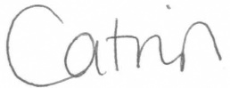

Catrin Hollings
Marketing

