«DEAR» «CONTACT»
«TITLE»
«DEPARTMENT»
«COMPANY»
- Easy to use
- Large display
- Measures body temperature
- Integrated downloadable trend memory
«ADDRESS1»
«ADDRESS2»
«ADDRESS3»
«CITY» «STATE»
«ZIP»

August 2021
Dear «UPOSITION»,
TOF 3D Neuromusclar Monitor
Quantative nerve monitor designed for use during anaesthesia

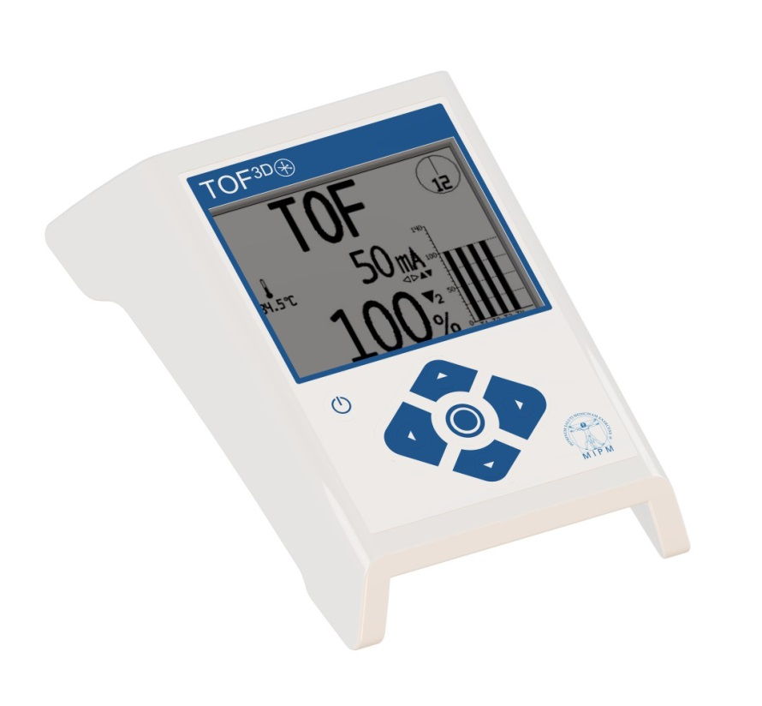Introducing the NEW TOF 3D Neuromuscular Transmission Monitor from MIPM, providing a means of assessing and displaying the depth of muscle relaxation achieved during the induction, maintenance and recovery of anaesthesia. The TOF 3D already meets the requirements of the European Medical Devices Regulations (MDR).

The TOF 3D is easy to use, reliable and compact with a large 4.4” LCD display. It has the flexibility of having the following convenient modes of stimulation to select from:
- Train of Four (TOF)
- Double Burst Stimulation (DBS)
- Post Tetanic Count (PTC)
- ?? Tectanic (TET)
- Single Twitch 1Hz

Please find enclosed the leaflet for the TOF 3D Neuromuscular Monitor. However, should you require any further information on this product, please do not hesitate to contact a member of our sales team on 01535 634542, between 09:00 and 17:30, or email tof3d@viamed.co.uk.

Yours sincerely

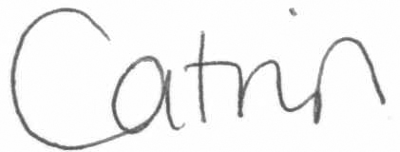

Catrin Hollings
Marketing

