Department Manager
Neonatal Unit
****
****
****
****
11 January 2022
Dear Sir or Madam,
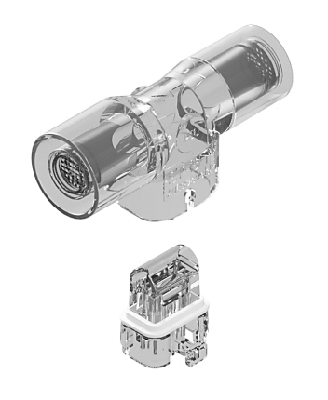
Introducing the ST-BLR Neonatal Flow Sensor

For flow measurement of respiratory gas flow delivered in Dräger neonatal ventilators

The ST-BLR flow sensor is a reusable, cost-effective, neonatal hot wire anemometric flow sensor with replaceable insert, for measuring gas flow in Dräger neonatal ventilators.

Each ST-BLR flow sensor comes with a reusable outer housing and an installed reusable insert. Additional inserts can be purchased in boxes of 5.

The ST-BLR flow sensor is a direct compatible to the Dräger neonatal flow sensor ISO 15, REF 8411130 and the ST-BLR INSERT is a direct compatible to the Dräger neonatal flow sensor INSERT, REF 8410179.
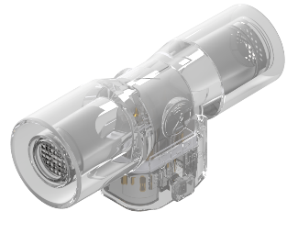
Also available, the ST-BL disposable flow sensor comprising of an outer housing with integrated fixed insert.

4310004 | ST-BLR Neonatal Flow Sensor with reusable housing and insert
4310005 | ST-BLR-INSERT Insert for ST-BLR Neonatal Flow Sensor (Box of 5)
4310006 | ST-BL Disposable Neonatal Flow Sensor with fixed insert

Please find enclosed full details on our flow sensor range including price list overleaf.

Viamed also has a wide range of oxygen sensors and flow sensors compatible with most of the commonly used ventilators.

Should you require further information please contact a member of our sales team on:
(01535) 634542 or email flowsensors@viamed.co.uk

Yours faithfully

Catrin Hollings
Marketing
Trusted supplier to the NHS for over 40 years
Free Delivery ● No minimum order

