Department Manager
Neonatal Unit
****
****
****
****
****

11 January 2022

Dear Sir or Madam,

Introducing the ST-BL Neonatal Flow Sensor

For flow measurement of respiratory gas flow delivered in Dräger neonatal ventilators

The ST-BL flow sensor is a disposable cost-effective neonatal hot wire anemometric flow sensor with integrated fixed insert, for measuring gas flow in Dräger neonatal ventilators.

The ST-BL disposable flow sensor is compatible with the reusable Dräger neonatal flow sensor ISO 15, REF 8411130.
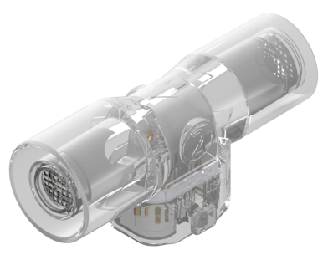
4310006 | ST-BL Disposable Neonatal Flow Sensor with fixed insert

Please find enclosed full details on our flow sensor range including price list overleaf.

Viamed also has a wide range of oxygen sensors and
flow sensors compatible with most of the commonly used ventilators.

Should you require further information please contact a member of our sales team on:
01535 634542 or email flowsensors@viamed.co.uk

Yours faithfully

Catrin Hollings
Marketing

Trusted supplier to the NHS for over 40 years
Free Delivery ● No minimum order

