Department Manager
Neonatal Unit
****
****
****
****
****
Ref: 20215104310004/???
12 May 2021
Dear Sir or Madam,

Introducing the ST-BLR Neonatal Flow Sensor

For flow measurement of respiratory gas flow delivered in Dräger neonatal ventilators

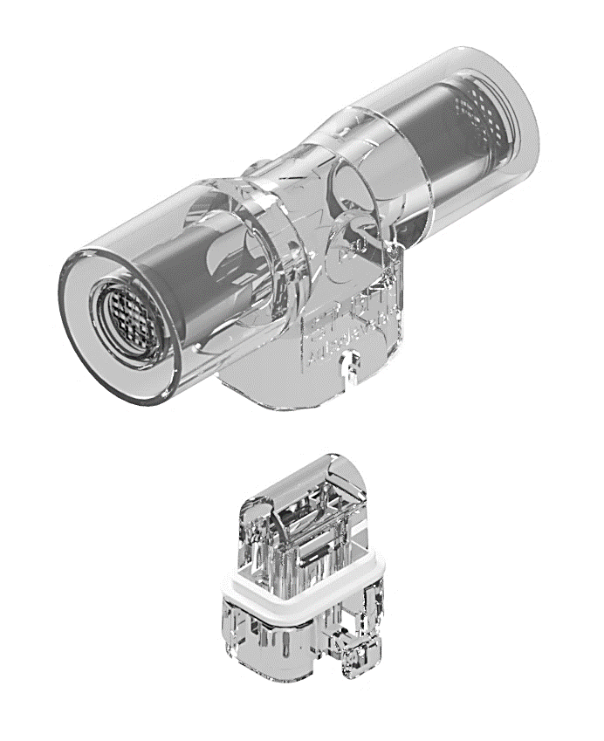
The ST-BLR flow sensor is a cost-effective neonatal hot wire anemometric flow sensor, for measuring gas flow in Dräger neonatal ventilators.

The ST-BLR flow sensor is a direct compatible to the Dräger neonatal flow sensor ISO 15, REF 8411130 and the ST-BLR INSERT is a direct compatible to the Dräger neonatal flow sensor INSERT, REF 8410179.

Please find enclosed full details on our flowsensor range including price list overleaf. Viamed also has a wide range of oxygen sensors and flow sensors compatible with most of the commonly used ventilators.

Should you require further information please contact a member of our sales team on: (01535) 634542.

Yours faithfully



Catrin Hollings
Marketing

Trusted supplier to the NHS for over 40 years
Free Delivery ● No minimum order

