Department Manager
Neonatal Unit
****
****
****
****
****
Ref: 20215104310004/???
10 May 2021

Dear Sir or Madam,

Introducing the ST-BLR Neonatal Flow Sensor

For flow measurement of respiratory gas flow delivered in Dräger neonatal ventilators
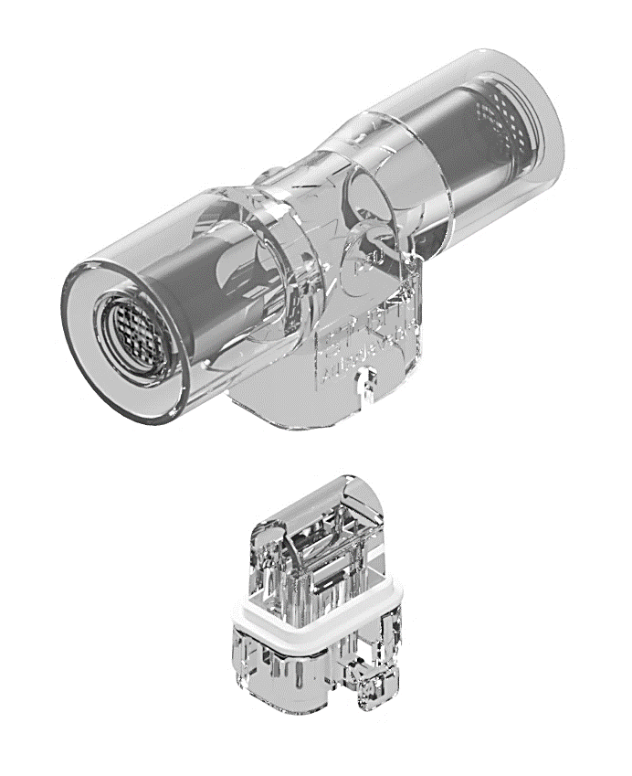
The ST-BLR flow sensor is a cost-effective neonatal hot wire anemometric flow sensor, for measuring gas flow in Dräger’s neonatal ventilators.

The ST-BLR flow sensor is a direct compatible to the Dräger neonatal flow sensor ISO 15, REF 8411130 and the ST-BLR INSERT is a direct compatible to the Dräger neonatal flow sensor INSERT, REF 8410179.

Please find enclosed full details on our flowsensor range including price list overleaf. Should you require further information please contact a member of our sales team on: (01535) 634542.

Yours faithfully



Catrin Hollings
Marketing

