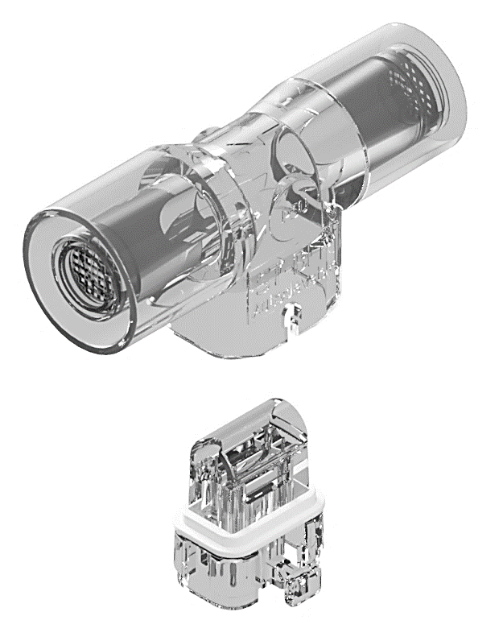
ST-BLR
Neonatal flow sensor

de | Gebrauchsanweisung | en | Instructions for use
fr | Mode d’emploi | es | Instrucctiones de uso
it | Istruzioni per l'uso | nl | Gebruiksaanwijzing
pl | Instrukcja użycia | ru | Инструкция по применению
zn | 使用說明 | ja | 使用説明書

Table of Contents
en ST-BLR Instructions for use 3
de ST-BLR Gebrauchsanweisung 17
ST-BLR Marking and symbols explanation 18

en ST-BLR Instructions for use
  - Intended use and medical purpose of ST-BLR
Intended use:
ST-BLR is a neonatal hot wire anemometric flow sensor, for measuring gas flow in Dräger’s neonatal ventilators. ST-BLR flow sensor is compatible to:
- Dräger neonatal flow sensor ISO 15, REF 8411130

ST-BLR INSERT is compatible to:
- Dräger neonatal flow sensor INSERT, REF 8410179

Intended medical indications:
Neonatal flow sensor for measuring respiratory gas flow in neonatal ventilators.
Intended user profile:
Healthcare professional, trained for the application
Intended patient groups:
premature and newborn babies and infants

Clinical environment:
Professional healthcare facility

Contraindications:
Not intended to be used with flammable anaesthetic mixtures.
  - General warnings and safety notices
Safety symbols used in this document:
Indicates potential harmful conditions that may lead to serious injury.
Important information on a topic or procedure, or conditions that may lead to damage or malfunctions of the device.

General warnings:
Do not use this medical product if it appears or is suspected to be damaged. Damage to the product may result in degraded performance.
Do not use this product if its packaging has been open before. Risk of infection, cross contamination!
No modification of this medical product is allowed.
Strictly follow the instructions for use. Handling of the device requires full understanding and strict observation of the operating instructions of basic device (ventilator) and these instructions for use.
The flow sensor must be calibrated within basic device (ventilator) and system check must be performed prior to patient use.
Due to fire risk - do not introduce any medicaments or other substances based on combustible solvents, such as alcohol, into the patient system.
Do not use explosive anaesthetic agents (e.g. ether or cyclopropane.

General safety notices:
The medical device is intended only for the application described herein.
Serious incident that has occurred in relation to this medical device should be reported to the manufacturer and the competent authority of the Member State in which the user and/or patient is established.
To report patient safety related events, send an email to the following manufacturer’s address:
prrc@bluepoint-medical.com with at least following information:
- order number and product name
- batch number of the product
- date of the serious incident
- description of the serious incident affecting the patient or any injuries
- your contact data (institution, address, contact person/representation, title and telephone number)

  - ST-BLR Sensor overview
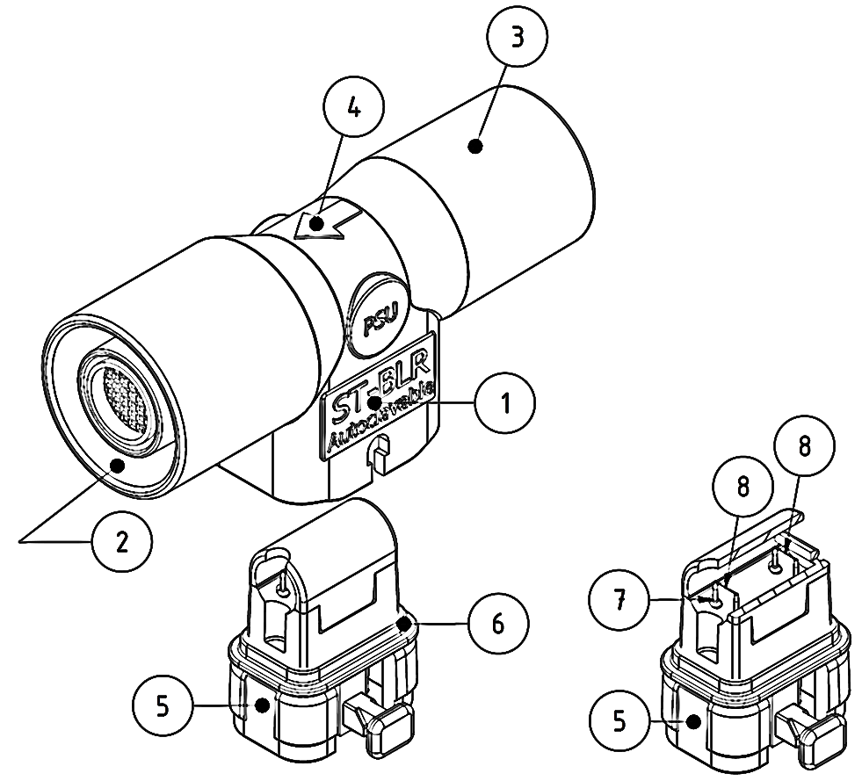
- Product name | 5. Sensor Insert
- 15F sensor connector | 6. Gasket
- 15M sensor connector | 7. Sensor pins
- Sensor installing position  (inspiratory flow direction) | 8. Sensing wires

ST-BLR flow sensor is delivered with installed sensor insert. The sensor insert by ST-BLR neonatal flow sensor is exchangeable. It can be order separately and replaced if damaged. See ordering information at the end of this manual.

  - Change, install the sensor insert
Remove ST-BLR INSERT from flow sensor body
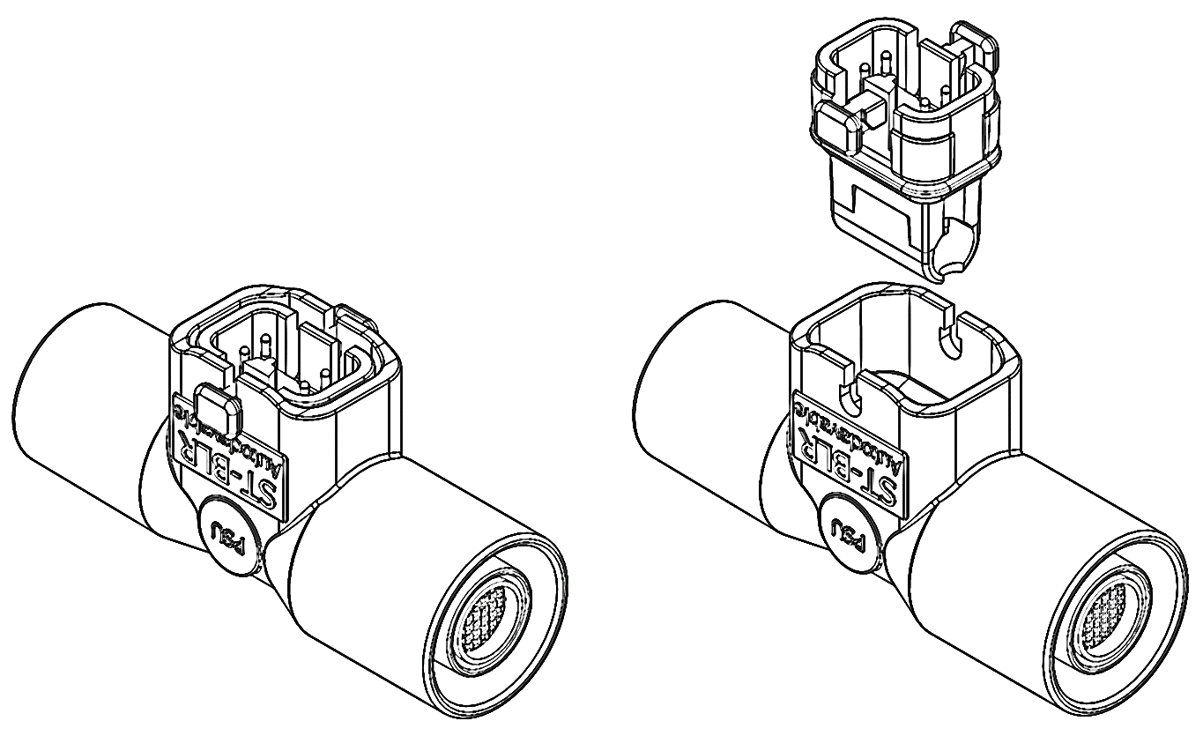
A
A
To remove the sensor insert, gently press the both locks “A” and in same time pull out the insert from flow sensor body.

Installing ST-BLR INSERT into flow sensor body
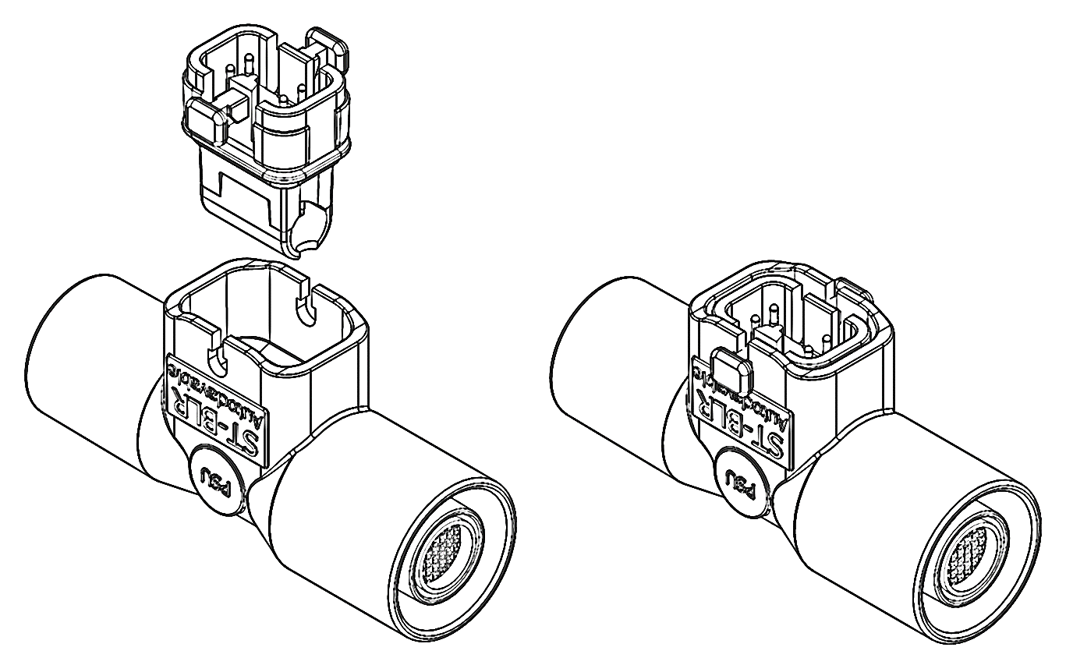
B
B
Consider the position of the sensor insert before installing it into sensor body. Gently press the sensor insert into flow sensor body and locked it.
The sensor insert must be securely locked (both sides ”B”) into flow sensor body. Risk for leakages and faulty operation!
  - Installing, calibrating and operating of the flow sensor
This medical product must be connected/installed to the basic device (ventilator) according to the instructions for use of basic device. Risk for faulty operation!
Ensure correct positioning and secure connection of this product to the basic device (electrically, mechanically, flow direction). Risk for leakages and faulty operation!
The flow sensor and Y-piece must be angled approximately 45° downwards to prevent collecting of condensing water into flow sensor. Risk for faulty operation!
The flow sensor cable plug of the basic device has to be securely connected to the flow sensor plug. The sensor cable must be positioned along the breathing hoses laid free and not causing any mechanically stress to flow sensor plug during operation. Risk for leakages and faulty operation!
The flow sensor must be calibrated within basic device (ventilator) prior to patient use.
The flow sensor calibration must be performed in accordance with instructions for use of basic device (ventilator).
A preoperational device system check must be performed according to the instructions for use of basic device (ventilator) prior to patient use. If a malfunction is detected, do not operate the device! Patient hazard!
Due to fire risk – do not use this product with medicaments or other substances based on combustible solvents.
Before medication nebulization, disconnect the flow sensor completely from the basic device. Follow the instructions for use of basic device for operating with deactivated flow monitoring and use an independent monitoring. The patient may otherwise be jeopardized.
Life cycle of the flow sensor is limited. It can be used depending on hospital’s hygiene regulations and as long as calibration in basic device (ventilator) is possible.
  - Cleaning and disinfecting of the flow sensor
Reusing the flow sensor may affect patient safety due to the possible contamination of the sensor.
Reusable products must be cleaned and disinfected after every use.
Use only validated procedures for reprocessing of this medical product and consider the hospital’s hygienic regulations.
Use only certified cleaning agents and disinfectants with good compatibility to the materials of medical device.
Strictly follow the manufacturer’s instructions on cleaning agents and disinfectants.
Ensure particle-free cleaning and disinfecting procedure.
Do not clean and disinfect this medical product in automated cleaning or disinfecting equipment!
Do not clean with compressed air, water jets, brushes etc.
Do not use ultrasound cleaning to clean the flow sensor.
Do not use a thermal disinfection to disinfect the flow sensor.
Validated reprocessing procedure for ST-BLR:
Classification of ST-BLR neonatal flow sensor for reprocessing according Spaulding: | Semi-critical

Manual cleaning and disinfection procedure of ST-BLR by immersion at room temperature:
Validated cleaning agents and disinfectants for ST-BLR flow sensor
Cleaning agent / Disinfectant | Manufacturer | Concentration | Contact time
Neodisher MedicClean Forte | Dr. Weigert GmbH & Co. KG | 0,5% | 10 min
Korsolex Extra | Bode Chemie GmbH | 5% | 15 min
Isopropyl alcohol | Höfer Chemie GmbH | 70% | 1 min

Manual cleaning by immersion:
Step No. /Description – Cleaning procedure
- Remove ST-BLR INSERT from flow sensor body. | 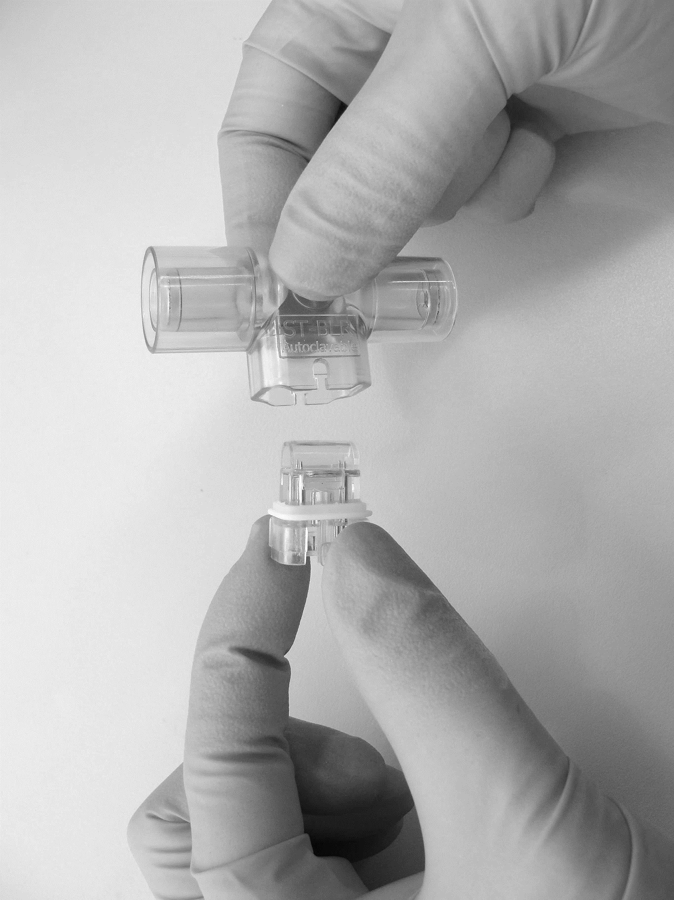
- Prepare at least 500ml of a cleaning solution:  5% Neodisher MediClean Forte | 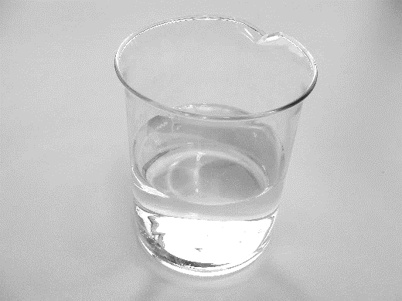
- Immerse the ST-BLR sensor body and sensor INSERT completely and bubble-free in the cleaning solution for at least 10 minutes. Make sure the cleaning solution reaches all surfaces inside/outside of the items. | 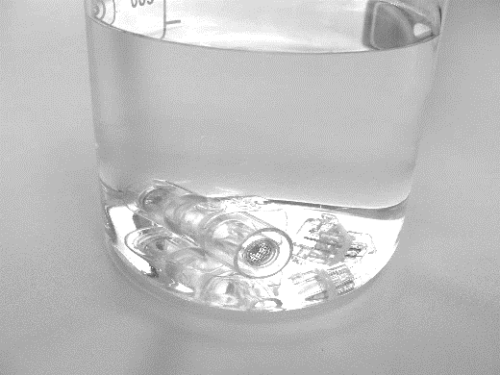
- Swirl/Move the both items back and forth in the cleaning solution for at least 1 minute.  Remove and place the items on a clean surface and let them drain completely. | 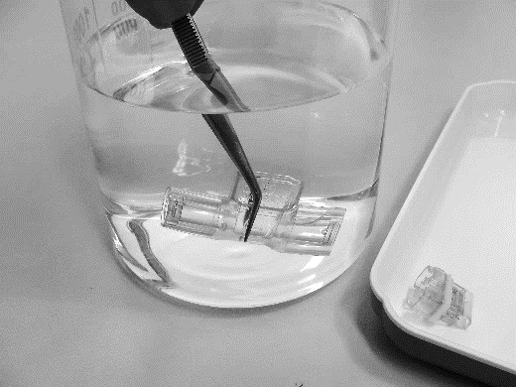
- Rinse the both items in minimum 500ml water (preferably fully demineralized water);
Swirl/Move the both items back and forth for at least 1 minute.
Remove and place the items on a clean surface and let them drain completely.

Inspect the ST-BLR components for visible soiling and repeat the cleaning process if necessary. (until no more soiling can be seen)
Inspect the ST-BLR components, especially the sensing wires and sensor pins for visible damages as for cracks and deformations of the plastic parts. Change replaceable items if damaged.

Manual disinfecting by immersion:
Step No. / Description – Disinfecting procedure
- Prepare at least 250ml of a disinfectant:
5% Korsolex Extra
- Immerse the ST-BLR sensor body and sensor INSERT completely and bubble-free in the disinfectant solution for at least 15 minutes. Make sure the disinfectant solution reaches all surfaces inside/outside of the items.
- Swirl/Move the both items back and forth in the disinfectant solution for at least 1 minute.
Remove and place the items on a clean surface and let them drain completely.
- Rinse the both items in at least 500ml water (preferably fully demineralized water);
Swirl/Move the both items back and forth for at least 1 minute.
Remove and place the items on a clean surface and let them drain completely.
Repeat the rinsing process TWO (2) more times with fresh sterile water.
THREE (3) separate washes are required!
Discard the water after each rinse!
Step No. / Description – Disinfecting procedure
- A final rinse with a 70% isopropyl alcohol solution can accelerate the drying process.  After final rinse, remove and place the both items on a clean surface and then allow them to dry in air for at least 30 minutes. Risk of fire due to residual vapors of easy flammable disinfectants |  | 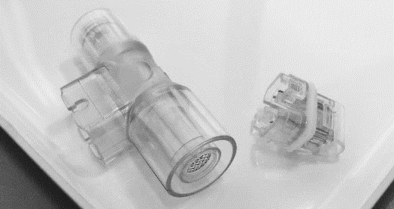

After cleaning and disinfection, allow ST-BLR to dry in air for at least 30 minutes. Ensure the residual vapors of easily flammable disinfectants and deposits are been removed during reprocessing. Risk of fire!
Inspect the flow sensor for completeness and check it for visible damage and soiling. Check the sensing wires and sensor pins for visible damages as for cracks and deformations of the plastic parts. Change replaceable items if damaged, soiled or non-particle free.

  - Sterilization/Steam autoclaving of the flow sensor
ST-BLR neonatal flow sensor and its parts cannot be sterilized using ethylene oxide! Patient hazard!
Only specified and validated procedure for autoclaving of ST-BLR neonatal flow sensor can be used.

Validated procedure for sterilization/autoclaving of ST-BLR:
The ST-BLR neonatal flow sensor can be autoclaved (134°C)
Use a steam sterilizer with fractional vacuum processes (e.g. Webeco A30-B).
Strictly follow the instructions for use of the sterilizer.
Pay attention to the water quality for steam generation.
The flow sensor must be cleaned and disinfected before sterilization.
The flow sensor must not be covered during sterilization. The flow sensor must not touch the chamber walls of the sterilizer.
Steam sterilization parameters:
134°C with pre-vacuum and an exposure time of 3.5 minutes.
Inspect the ST-BLR components after autoclaving, especially the sensing wires and sensor pins for visible damages as for cracks and deformations of the plastic parts. Change replaceable items if damaged.
  - Disposal
The flow sensor must be disposed of as infectious waste.
  - Technical information
Measuring principle: | Hot wire anemometry
Measuring range: | 0 to 30 L/min, depending on ventilator(evaluation electronics)
Accuracy: | DIN EN ISO 80601-2-12,  Typically ±10% of measured value under calibration conditions depending on ventilator(evaluation electronics)
Sensor connectors: | 15F/15M acc. DIN EN ISO 5356-1
Recommended operating conditions:
Temperature: | 10°C to 40°C
Relative humidity: | 5% to 95%, non-condensing
Atmospheric pressure: | 700hPa to 1060hPa
Recommended storage and transport conditions:
Temperature: | -20°C to 50°C
Relative humidity: | 5% to 95%, non-condensing
Atmospheric pressure: | 700hPa to 1060hPa

  - Ordering information
Product name | UDI number | Order number
ST-BLR neonatal flow sensor, (1pcs per Box) | 24251679601740 | 9030132004
ST-BLR –INSERT (5pcs per Box) | 24251679601733 | 9030132003

de ST-BLR Gebrauchsanweisung

ST-BLR Marking and symbols explanation
de: Katalognummer
en: Catalogue number
de: Chargennummer
en: Batch code
de: einmalige Produktkennung
en: Unique Device Identification
de: Medizinprodukt
en: Medical device
de: Stückzahl
en: Number of units
de: Herstellungsdatum
en: Date of manufacture
de: Ablaufdatum
en: Expiry date
de: Hersteller
en: Manufacturer
de: CE-Kennzeichnung. Kennnummer der benannten Stelle
en: CE-European Conformity authorization mark.
de: Gebrauchsanweisung beachten
en: Consult instructions for use
de: Die Warnhinweise in der Gebrauchsanweisung beachten!
en: Observe the warnings in the instructions for use
de: nicht steril
en: non-sterile
de: Bei geöffneter oder beschädigter Verpackung nicht mehr verwenden
en: Do not use if package is damaged and consult instructions for use.
de: Bei der Herstellung wurde kein DEHP verwendet
en: Does not contain Phthalates
de: Bei der Herstellung wurde kein Naturkautschuklatex verwendet.
en: Does not contain Latex
de: Von Hitze und Sonnenlicht fernhalten
en: keep away from heat and sunlight
de: Lagertemperaturbegrenzung
en: Storage temperature limitation
de: Feuchtigkeitsgrenzwerte
en: Humidity limitation
de: Grenzwerte des atmosphärischen Drucks
en: Atmospheric pressure limitation
de: Nicht mit dem Hausmüll entsorgen
en: Do not dispose of with domestic waste

ST-BLR – Instructions for use
Multilingual version: en, de

Information within this document may be subject to changes. Amendments and alterations shall remain reserved without prior notices.
Copyright © bluepoint MEDICAL GmbH & Co. KG.
The content and works published in this document are protected by copyright.
All rights and liabilities are reserved. Without written consent of the bluepoint MEDICAL GmbH & Co. KG the information, work and intellectual property contained in this document must not under any circumstances be circulated, reproduced, duplicated, copied or translated in other languages.

 | bluepoint MEDICAL GmbH & Co.KG  An der Trave 15  23923 Selmsdorf, Germany  Phone: +49 (38823) 5488 – 0  Fax: +49 (38823) 5488 – 29  E.Mail: info@bluepoint-medical.com  Web: www.bluepoint-medical.com | 0482



