How exhibiting at Medica helped Viamed increase their international trade opportunities
Medilink UK’s International Team has over 20 years’ experience in assisting healthcare and life sciences companies to reach new markets and export their products and services. Over the years, we have supported hundreds of UK companies at global exhibitions and via trade missions, bringing together healthcare professionals, experts and leaders from around the world.
Now that international travel and physical events are returning, healthcare and life sciences companies have opportunities to connect with foreign markets again, and make the most out of the upcoming exhibitions – such as Medica.

Medilink UK is proud to deliver a UK pavilion at the world’s largest medical trade fair, regularly attended by many British exhibitors including our member Viamed, a designer, manufacturer and distributor of medical products for general and critical patient care applications in hospitals across the UK.

Viamed have been a regular exhibitor at Medica for almost 25 years, allowing them to identify new business opportunities and revenue streams in new and existing markets. This resulted in a dedicated network of independent distributors from across Europe, the Middle East, East Asia and North America.

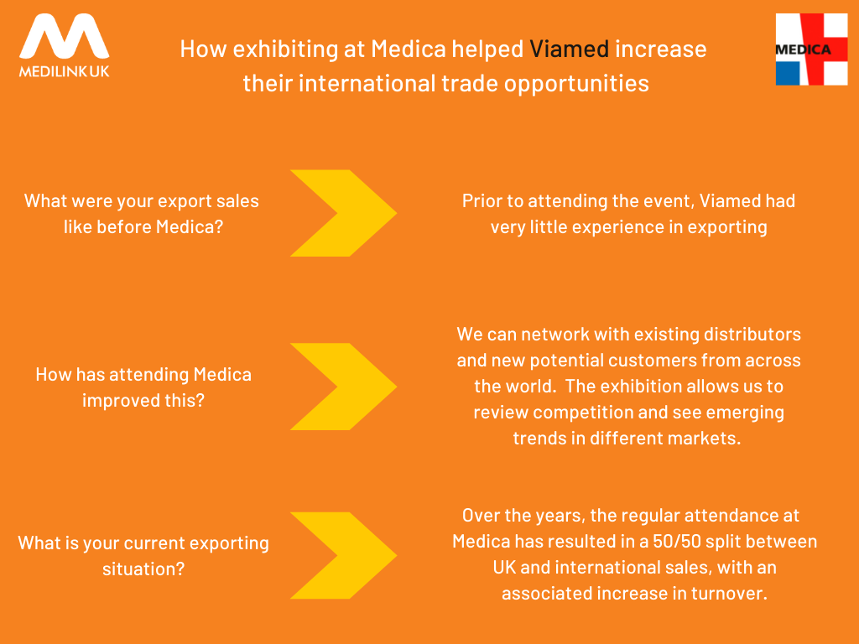

Eager to embark on your exporting journey and showcase your medical solutions to a global audience? Join Medilink UK and be part of a British pavilion at Medica 2021, taking place on 15th – 18th November in Düsseldorf, Germany.

To discuss your requirements and to book your place, contact our International Team on international@medilink.co.uk / 0114 232 9272.

To find out more about Viamed, please visit https://www.viamed.co.uk/.

