VM3COP20.84 Wildix Telephone System Quick Start Guide
Full User Guide can be found at:
https://confluence.wildix.com/display/DOC/Android+Collaboration+Mobile+App+-+User+Guide
URL: https://viamed.wildixin.com/confirmation/
or click the logo to the right of your name on Intrastats top banner.
Login
This will be your extension number, and then password – originally set up as Summer=1234.
Please update the password to your own. To do this go to Settings and click the pencil icon to the right of “Password” and follow the instructions.
Google Chrome Extension
So that you see all notifications, please make sure you have the Wildix Collaboration extension installed, this will allow the calls to show on your screen when not in the Wildix interface. The Chrome extension will either come up as a pop up in your browser or click the following link:
URL: https://chrome.google.com/webstore/detail/wildix-collaboration/lobgohpoobpijgfegnlhdnppegdbomkn
Make sure notifications have been given permission to “allow”.

Web Interface
Select required telephone use:
Any: Calls ring on all open applications.
Web: Working from Home with computer
Workforce: In the office, with desk phone
Mobile (may appear as a different name depending on device): Mobile Application anywhere

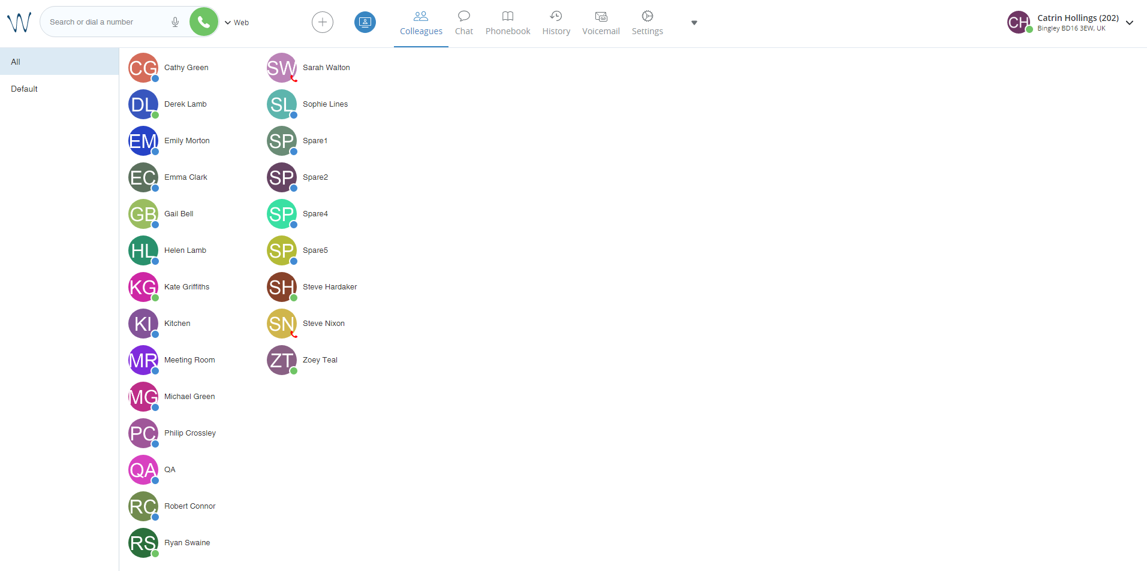
This is you, see page 2 for further information.

Click here to show all Viamed extensions and their status

Statuses
The following icons show what each type of status the extension/person is in:
 |  |  |  | 
Active | Away | Do Not Disturb | On Call | Not logged into web interface

Changing your Status
To change your status click the arrow to the top right of your name in web interface.
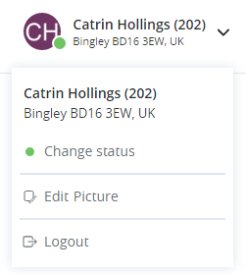
To change your status click here.

This will show the below pop up in the middle of the screen.
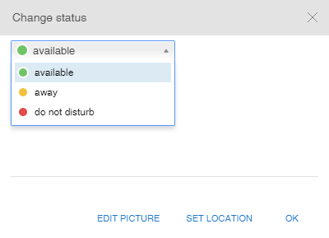
You can update your location here.

Update your status here, when set to away and do not disturb your phone will not ring and will provide a message to the caller.

Once all changed, as required, click ok and this will amend the top right of your screen.
Incoming Call
All lines are set to ring with different people after so many rings. When a call is ringing on your extension you will receive the following pop up to the right of the screen (usually by the clock).
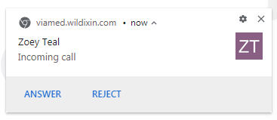
Click answer to take the call and reject to refuse.
Options when on the call
When you are on a call there will be a pop up on the Wildix screen as follows. This gives you options of what to do with the call.

Hide/display call dialog window

Record call

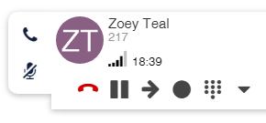
Dialpad

Transfer call

Put call on hold

Hang up call

Mute microphone

Putting calls on hold
To transfer the call to another staff member:
- Click the transfer button…
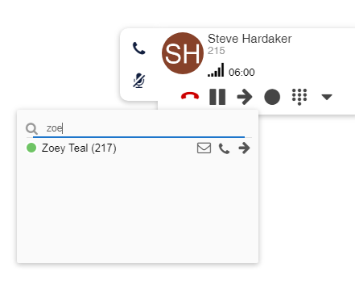
2. Type the name or extension you wish to transfer to
3. Click the transfer (arrow) button if you want to put the call straight through without announcing the call.
3. Click the phone icon if you wish to speak to this person before you transfer the call.
The call which is on hold will have a flashing hold sign: 
When speaking to the second call you will have a display like below.
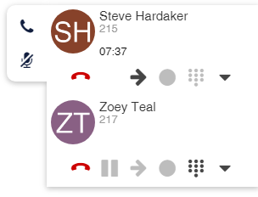
There are now four options:
- HOLD: Put both call on hold by pressing the hold button on the active call, so both are flashing.
- RESUME: Click the flashing hold button to resume the call and put the other call on hold.
- TRANSFER: Click the transfer (arrow) icon and it will transfer the calls to each other.
- DISCONNECT: Click the red hang up (phone) icon and the call will be disconnected.
If you were to hang up on either of the calls, the other call would remain on hold. You will need to press the hold button to resume.

