

Post Market Surveillance Review to 31st December 2020
4310064 Flowsensor SpiroTrue D, 3.2m
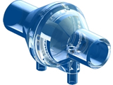
OEM pack of 20 sets

Bluepoint Medical ref.: 6030131001
First sold: 15th May 2017
Total sales to date: 125 packs
Total failures: No reported failures or issues
To 31st December 2020 there has not been any reported failures.

The design, functionality and reliability of the sensor is very good. We do include feedback forms within each pack of sensors for the OEM to be able to easily report possible issues and/or for confirming compatibility.



Reviewed by:

Steve Nixon
Director – Viamed Ltd.

Date: 5th February 2021

