
Post Market Surveillance Review to 31st December 2020
4310002 Flowsensor SpiroTrue A (PC). Box of 5

Bluepoint Medical ref.: 7030131001
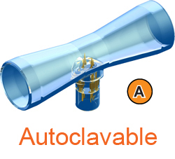
First sold: 24th May 2013
Total sales to date: 10,435 boxes,
91 different customers across 30 countries
Total failures: 10 boxes
Total returns: 10 boxes
Total customer failures: 0.096%
Royal Brompton Hospital SRS64245, received 1 box 19th March 2014
Inaccurate tidal volume readings. Sometimes on 500ml inspired volume, the A(PC) will read up to 590ml, other times just a little out, e.g. +10ml. It is not an issue with the ventilators, as the problems do not exist when they revert back to original Draeger flowsensors. Customer originally purchased Flowsensor SpiroTrue A, but switched to SpiroTrue A (PC) due to MHRA stance on single use designation.
Result: Customer stopped purchasing, their requirements is about 60 boxes per year. Will try and regain the sales, with either Flowsensor SpiroTrue A or Flowsensor SpiroTrue A (PC).

James Paget Hospital SRS64307, received 5 boxes 16th May 2014
Calibration issues when used with Evita 4. Customer originally purchase Flowsensor SpiroTrue A, but switched to SpiroTrue A (PC) due to MHRA stance on single use designation.
Result: Customer retained.
Royal Bournemouth SRS64386, received 4 boxes 15th July 2014
Calibration issues on Draeger Evita XL, this happened on six different ventilators. Some failed initial calibration, other failed shortly afterwards. Customer originally purchase Flowsensor SpiroTrue A, but switched to SpiroTrue A (PC) due to MHRA stance on single use designation.
Result: Customer stopped purchasing, their requirements is about 15 boxes per year. Will try and regain the sales, with either Flowsensor SpiroTrue A or Flowsensor SpiroTrue A (PC).
For the period from 16th July 2014 to 31st December 2020, there has not been any new reported failures or failures that refer to the claims listed above.

The design, functionality and reliability of the sensor is very good. We do include feedback forms within each box of sensors for end users to be able to easily report possible issues and/or for confirming compatibility. Unfortunately, we get very few feedback forms returned as the customers are happy with the sensors and have nothing to report.

Applications:
Manufacturer | Description
Asmuth GmbH Medinzintechnik | AS432+-AUTO | Flow Sensor
Asmuth GmbH Medinzintechnik | AS434 | Flow Sensor
Asmuth GmbH Medinzintechnik | SpiroTrue APC | Flow Sensor
Draeger | Apollo | Anaesthesia System
Draeger | AV1 | Anaesthesia System
Draeger | Cato | Anaesthesia System
Draeger | Cicero | Anaesthesia System
Draeger | Dura | Ventilator
Draeger | Eva | Ventilator
Draeger | Evita | Ventilator
Draeger | Evita 4 | Ventilator
Draeger | Evita XL | Ventilator
Draeger | Fabius GS | Anaesthesia System
Draeger | Julian | Anaesthesia System
Draeger | MK01900 (autoclavable version of Spirolog) | Flow Sensor
Draeger | PM 8030 | Monitor
Draeger | PM 8035 | Monitor
Draeger | PM 8050 | Monitor
Draeger | PM 8060 | Monitor
Draeger | Primus | Anaesthesia System
Draeger | Savina | Ventilator
Draeger | SpiroLife (autoclavable version of Spirolog) | Flow Sensor
Draeger | SpiroLife MK01900 | Flow Sensor
Draeger | Sulla | Anaesthesia System
Viamed | 7030131001 | Flow Sensor
Viamed | Flowsensor A (PC) | Flow Sensor
Viamed | SpiroTrue A (PC) | Flow Sensor
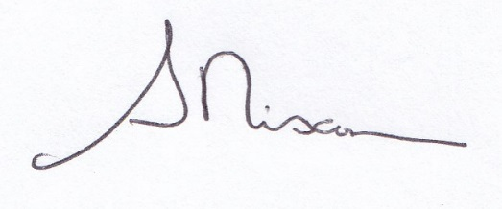

Reviewed by:

Steve Nixon
Director – Viamed Ltd.

Date: 5th February 2021

