
Post Market Surveillance Review to 31st December 2020
4310001 Flowsensor SpiroTrue A. Box of 5
Bluepoint Medical ref.: 1030132006
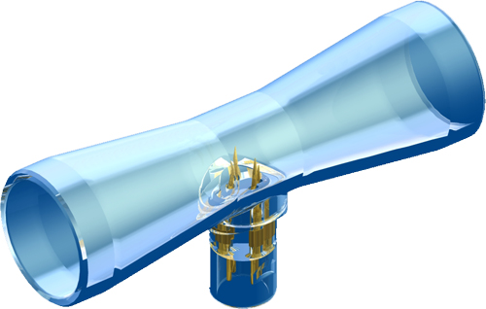
First sold: 12th January 2009
General sales suspended 18th December 2013 due to MHRA stance on single use designation. Reinstated when covered by Bluepoint Medical CE certification.
Total sales to date: 4,686 boxes, 111 different customers across 34 countries
Total failures: 6 boxes
Total returns: 6 boxes
Total customer failures: 0.128%
Liverpool Heart & Chest Hospital SRS63066, received 1 box 10th October 2011
Failed calibration. Also reported sensors generally have shorter life than Draeger OEM sensors.
Result: Customer lost, approximately 100 boxes per year. Resumed using Draeger OEM sensors, will try and regain the sales with Flowsensor SpiroTrue A.

Dorset County Hospital SRS63869, received 1 box 3rd June 2013
Failed calibration.
Result: Customer lost, approximately 12 boxes per year. Will try and regain the sales with Flowsensor SpiroTrue A.

Papworth Hospital SRS64002, received 4 boxes 11th September 2013
Failed calibration when used on Evita 4s.
Result: Customer lost, approximately 120 boxes per year. They have tried both SpiroTrue A and SpiroTrue A (PC). Will try and regain the sales with Flowsensor SpiroTrue A.

For the period from 12th September 2013 to 31st December 2020, there has not been any new reported failures or failures that refer to the claims listed above.

The design, functionality and reliability of the sensor is very good. We do include feedback forms within each box of sensors for end users to be able to easily report possible issues and/or for confirming compatibility. Unfortunately, we get very few feedback forms returned as the customers are happy with the sensors and have nothing to report.

Applications:
Manufacturer | Description
Acutronic | 1601+ | Flow Sensor
Acutronic | SpiroQuant A | Flow Sensor
Asmuth GmbH Medinzintechnik | AS432+ | Flow Sensor
Asmuth GmbH Medinzintechnik | AS8403735 | Flow Sensor
Asmuth GmbH Medinzintechnik | SpiroTrue A | Flow Sensor
Biometric Cables | 910246001 | Flow Sensor
Biometric Cables | FS1 | Flow Sensor
Bluepoint Medical | 1030132006 | Flow Sensor
Bluepoint Medical | 6871980 (NOTE Viamed does not have RFID) | Flow Sensor
Bluepoint Medical | PM 8030 | Monitor
Bluepoint Medical | SpiroTrue A | Flow Sensor
Draeger | Spirolog 84 03 735 | Flow Sensor
Draeger | 8403735 | Flow Sensor
Draeger | Anemone | Monitor
Draeger | Apollo | Anaesthesia System
Draeger | AV1 | Anaesthesia System
Draeger | Cato | Anaesthesia System
Draeger | Cicero | Anaesthesia System
Draeger | D-9118-2009 | Flow Sensor
Draeger | Dura | Ventilator
Draeger | Eva | Ventilator
Draeger | Evita | Ventilator
Draeger | Evita 4 | Ventilator
Draeger | Evita XL | Ventilator
Draeger | Fabius GS | Anaesthesia System
Draeger | Infinity ID (NOTE Viamed ver. does not have RFID) | Flow Sensor
Draeger | Infinity V500 (NOTE Viamed ver. does not have RFID) | Anaesthesia System
Draeger | Julian | Anaesthesia System
Draeger | MT-2086-2007 (NOTE Viamed ver. does not have RFID) | Flow Sensor
Draeger | PM 8030 | Monitor
Draeger | PM 8035 | Monitor
Draeger | PM 8050 | Monitor
Draeger | PM 8060 | Monitor
Draeger | Primus | Anaesthesia System
Draeger | Savina | Ventilator
Draeger | Spirolog | Flow Sensor
Draeger | Spirolog 8403735 | Flow Sensor
Draeger | Sulla | Anaesthesia System
Envitec | 1000470 | Flow Sensor
Envitec | SpiroQuant A+ | Flow Sensor
Integral Process | 0032 00 02 | Flow Sensor
Integral Process | 65025 | Flow Sensor
Integral Process | 8403735 | Flow Sensor
Intersurgical | 2777000 | Flow Sensor
Intersurgical | e-FlowSensor | Flow Sensor
Lub Dub Medical | OX-2529 | Flow Sensor
Medacx | M-45-00-0005 | Flow Sensor
Medacx | SpiroQuant A | Flow Sensor
Proact Medical | 1000470 | Flow Sensor
Proact Medical | SpiroQuant A+ | Flow Sensor
Viamed | 1030132006 | Flow Sensor
Viamed | Flowsensor A | Flow Sensor
Viamed | SpiroTrue A | Flow Sensor

Reviewed by: Steve Nixon
Director – Viamed Ltd.

Date: 5th February 2021

