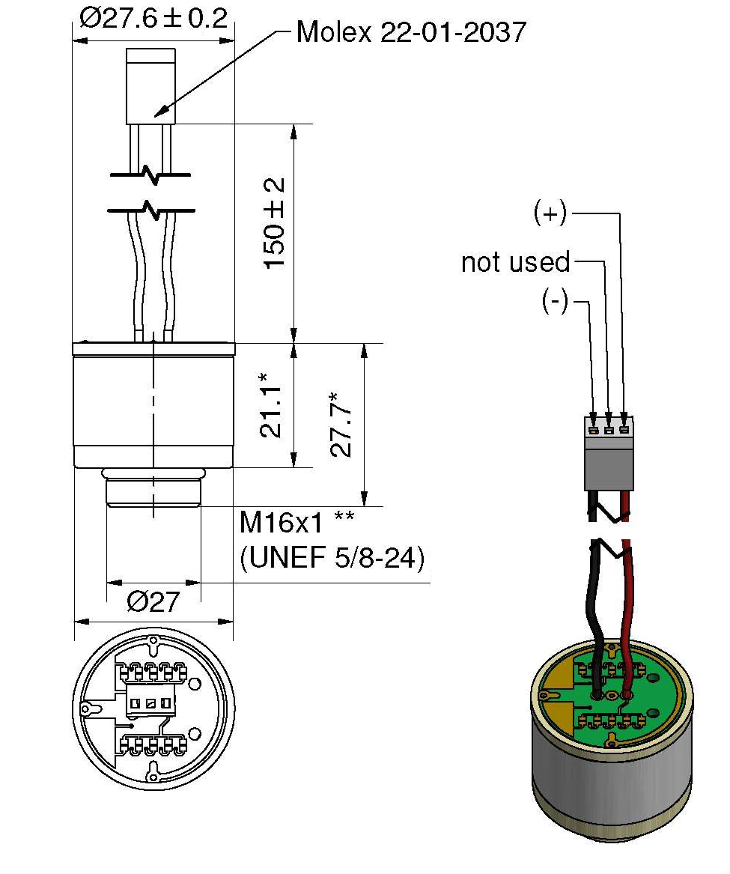
Dimensions in mm
General tolerances ISO 2768-c
* Sensor housing without PCB, tolerances ± 0.2

** Intermediate thread: Metric / Unified Extra Fine
Molex connector to be removed after QA testing

