North Yorkshire
Local Resilience Forum (LRF)

Community Risk Register
2021 - 2023

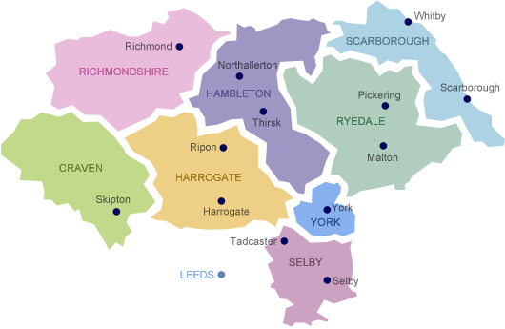

North Yorkshire Local Resilience Forum (NYLRF) is a partnership, made up of all the organisations needed to prepare for and respond to any major emergency in the North Yorkshire area.

The area is covered by North Yorkshire County Council, the administrative area comprises seven districts: Craven, Hambleton, Richmondshire, Ryedale, Selby, and the boroughs of Harrogate and Scarborough; York is within the ceremonial county of North Yorkshire.

Within the county are the North York Moors and most of the Yorkshire Dales; two of eleven areas of countryside within England and Wales to be officially designated as national parks. Between the North York Moors in the east and the Pennine Hills in the west lie the Vales of Mowbray and York. The Tees Lowlands lie to the north of the North York Moors and the Vale of Pickering lies to the south. Its eastern border is the North Sea coast. The two major rivers in the county are the River Swale and the River Ure. The Swale and the Ure form the River Ouse which flows through York and into the Humber estuary. The river Tees forms part of the border between North Yorkshire and County Durham.

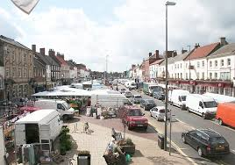
The market town of Northallerton.

The Community Risk Register
This document highlights risks that have the highest likelihood and/or potential to have significant impact to local communities resulting in wide scale disruption.

The purpose of the Community Risk Register is to:
- Inform you about the highest risks in the county and their consequences
- Detail steps that can be taken to become better prepared and more resilient in your home, business and community
- Provide you with links to organisations and websites to find out more information.
While certain risks are described it does not mean that they will definitely occur in the region. It means there is a possibility of them happening and therefore all agencies within the local resilience forum have plans in place to respond to such incidents.

The Community Risk Register is the result of professional judgement from a range of contributors, historical evidence, scientific input and expert analysis in evaluating the key risks facing North Yorkshire.

What is in this risk register:
- Emergency Management Steps.
- North Yorkshire’s Top Risks.
  - Pandemic Influenza
  - Flooding (Coastal, Fluvial and Surface water)
  - Adverse / Severe Weather
  - Marine Pollution
  - Disruption or Failure Electrical Network
  - Food Supply Contamination
  - Air Quality
  - Land Movement
  - Cyber Security

- What you can do to be prepared in your home.

- How your local community can be prepared.

- How your business can be prepared.
Is this not all just common sense?
The document is intended to bring together in a readable format a lot of information that some people may be partly aware of and other people may have much less understanding of the problems that could arise. Airline pilots do not work from a checklist because they do not know how to fly – they work from a checklist, so nothing gets missed!

Emergency Management Steps

Mitigation

How are agencies across North Yorkshire working to ensure the effects of an emergency can be reduced?
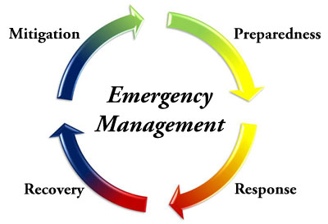
- Understanding risks, their cause and the impact they would have locally.
- Partnership working to reduce the likelihood of the risk happening and lessen the impacts if the risk occurs.

Preparation – Being ready to respond to an incident

- Understanding the impact and consequence of each risk.
- Developing emergency plans and procedures for response to the risks.
- Training staff and testing procedures.
- Matching our capabilities to the needs of each emergency.
- Developing longer-term recovery plans.
- Raising awareness of each organisation’s roles and responsibilities.
- Learning lessons from previous incidents.
- Establishing links for help and assistance from other counties for lengthy or widespread incidents.

Response – Reacting in the event of an incident

- Initial emergency activities (such as public safety, evacuation and shelter, limiting the spread of the incident, search and rescue).
- Initial damage assessment.
- Multi-agency coordination.
- Warning and informing the public.

Recovery – Actions following an incident

- Initial and long-term recovery efforts.
- Re-housing of displaced persons.
- Humanitarian Assistance.
- Regeneration.
- Welfare Arrangements.
Top Risks
Influenza - type Disease (Pandemic)
A pandemic occurs when a new strain of an influenza virus emerges and spreads around the world, most people do not have immunity.

An influenza type pandemic remains the highest assessed natural hazard which would have a significant impact on our communities.

Consequences:

- Health and local authority social care services may become overloaded.
- Normal life is likely to face wide disruption, particularly vulnerable people who may have to self-isolate and limited interaction with family and friends.
- Disruption to businesses and organisations through staff shortages, supply chain interruptions and mandatory shut down of non-essential businesses.
- Impacts on the national and local economy.
- Social events cancelled.

Who can be affected?

Each pandemic is different and the nature of the virus and its impacts cannot be known in advance. A pandemic is likely to occur in one or more waves, possibly weeks or months apart. Each wave may last around 15 weeks and up to half the UK population may be infected.

What are we doing in North Yorkshire?

We work together to plan for:
- Public awareness through our communications/media team.
- Management of the demand on the NHS and social care.
- Making sure individual organisations have their own business continuity plans in place to cope in times of staff shortage.
- Distribution of anti-viral medication to the public.
- Vaccination with the newly developed pandemic vaccine once available.
- Making plans to deal with the potential number of deaths.

What can you do?
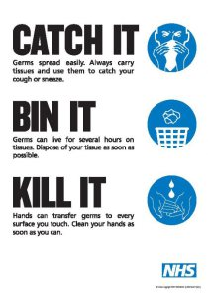
- Maintain a healthy lifestyle by washing your hands frequently with soapy water or sanitising hand gel to reduce the spread of the virus and regularly clean surfaces with disinfectant.
- Look out for and observe advice and NHS guidance, particularly about reducing the spread of illness.
- Identify a flu friend – who can collect your medication, food and other supplies allowing you to stay at home when ill.
- Keep small personal stocks of ‘over the counter’ cold and flu medication to help relieve your symptoms.
- Know the arrangements of your child’s school.

Measures may include:
- Staying at home when ill provided there is no need to go to hospital or visit a doctor. You may wish to contact NHS 111 for advice.
- Covering the nose and mouth with a tissue when coughing or sneezing and disposing of dirty tissues promptly and carefully.
- You may be asked to wear face coverings when in public places.
- Washing hands frequently with soap and warm water to reduce the spread of the virus from the hands to the face, or to other people, particularly after blowing the nose or disposing of tissues or coming in from outside.
- Regularly cleaning frequently touched hard surfaces, such as kitchen
worktops and door handles.

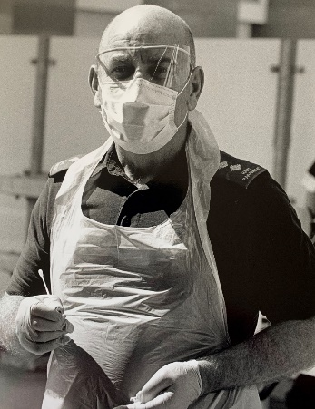
Where can you get further information?

Visit: https://www.gov.uk/guidance/pandemic-flu

Flooding
This is the most common and widespread natural disaster in the UK; we need to prepare in advance to minimise the impact that flooding could have.
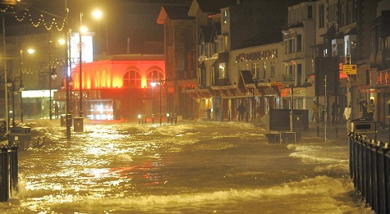
Flooding can occur from the sea, rivers and
from continuous and /or abnormal rainfall
levels. The highest flooding risk is surface
water flooding (where drainage systems are
unable to cope with the volume of rainfall).
Consequences
Issues associated with flooding are widespread and can include:
- Risk to life.
- Damage and disruption to homes, personal property, businesses, infrastructure.
- Pollution of local environments.
- Disruption to utilities and evacuation.
- Short, medium and long-term homelessness.
- Long term health and psychological impacts.

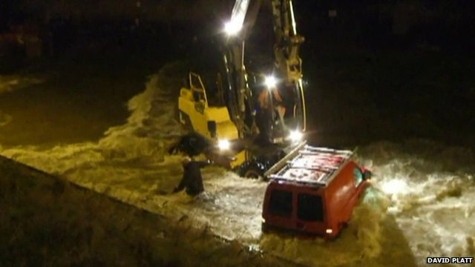

Who can be affected?

Those at risk from river and coastal flooding are relatively easy to identify. Surface water flooding has the potential to occur anywhere but is more common in built up areas.

What are we doing in North Yorkshire?
- Investigating the causes of significant flooding across the county.
- Working with local flood groups eg Tadcaster, Malton, Scarborough
- Working with emergency services, local authorities utilities and other agencies to develop flood response plans and procedures
- Communicating with housing developers to incorporate flood protection into new developments
- Regular maintenance and clearing programme of gullies and culverts, especially in the event of storm warnings.
- Development of ways and means of alerting the public as early as possible when there is a significant flood risk.
What can you do? Have a plan, Have a kit, Stay informed
- Register for alerts and receive “flood warnings direct” – a free service operated by the Environment Agency – by ringing 0345 988 1188.
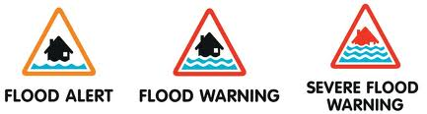
- Know what different flood warnings mean.
- Report instances of flooding to the local council.
- Where possible, move valuable/irreplaceable items to upper floors during times of flood risk.
- Plan where you will go if you have to evacuate and how you will get there.
- Who can look after your pets and have your medication to hand (see section “What can you do to be better prepared in your home”).
- Identify neighbours who may need assistance or can provide assistance to you, in case of evacuation.
- Buy flood barriers eg sandbags/aqua sacs, boards now – there will not be time in the event of an emergency.
- Know where and how to safely turn off utilities.
- Put together an emergency grab bag in case of evacuation or being stranded in your home.
- Do not drive, cycle or walk through flood water.

Where can you get further information?

Environment Agency
http://www.environment-agency.gov.uk/homeandleisure/floods/

Severe Weather

The UK experiences a wide variety of weather systems.

The impacts are varied from heavy rain, snow and ice to shortage of rain and drought along with a wide range of temperatures which can lead to:

- Ill health
- Property damage
- Disruption to utilities-power cuts,
phone lines down, water shortages
- Travel disruption
- School closures-childcare issues
- Increased number of admissions to
hospitals and GPs-slips, trips, falls, heat
exhaustion

These may produce a knock-on effect to individuals, businesses and the ability for organisations to deliver essential community functions.

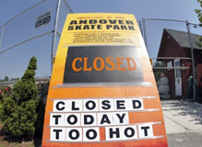
Consequences
As well as the obvious travel disruption, a significant aspect
of adverse weather is its ability to damage pylons and above
ground utility structures. Staff are unable to get into local
schools which means that education is disrupted often with
significant damage to property to deal with.

In the event of a weather warning, ask - is it necessary to make the journey? Could a telephone call do instead? Can I work from home? The elderly and vulnerable are at an increased risk in heat waves or cold snaps.

What are we doing in North Yorkshire?

- Production of multi-agency plans to manage the effects of severe weather events including any impact on utility networks.
- Work closely with the MET Office who provides advice and severe weather warnings which can be received in many ways, such as television, internet, radio or social media.
- Winter planning undertaken by many agencies such as gritting routes.
- The NHS provides winter flu jabs and plans for expected surges.
- The health service gears up every autumn for the additional pressure which will be placed on their resources over the winter and particularly works with the local authorities to target elderly and vulnerable people.
- Additional support via health and social services is identified for elderly and vulnerable people.
- Utilities companies plan their own responses to maintain power, gas and water supply
- All emergency service organisations have their own Business Continuity Plans to make sure they are still able to function.

What can you do?

Ensure you are prepared for winter. Make sure you can access the latest weather forecasts. Depending on the level of warning:
- Follow instructions and advice given by
authorities.
- Listen to broadcasts on local and
national radio / tv stations; check
council website.
- Avoid non-essential journeys.
- If you must make a journey, plan ahead –
carry emergency food/clothing/blanket
/water or flask of hot drink.
- Check on elderly or vulnerable relatives and friends.
- If you are aware of property damage that may get worse in strong winds - get it fixed now.
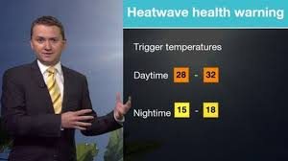
- Likewise, it is important to recognise that during the summer any prolonged exposure to strong sunlight presents its own health hazards. Make sure that you and your family make sensible use of sunscreen at such times and keep hydrated for your own safety.

Where can you get further information?

Met Office
http://www.metoffice.gov.uk/public/weather/warnings/?regionName=uk
Marine Pollution
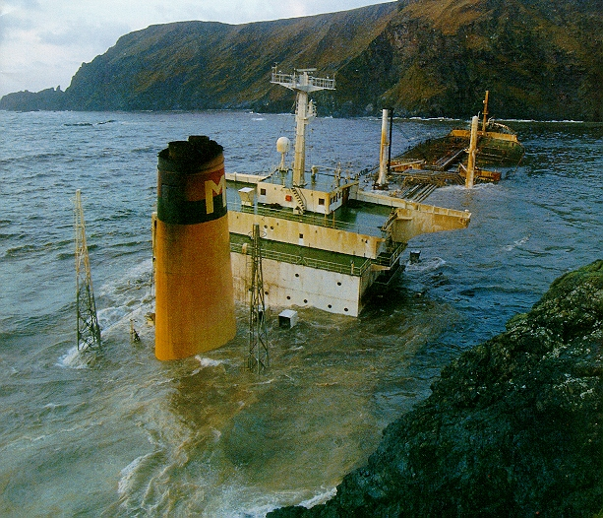
North Yorkshire has a significant coastline although there are no major ports, there is a risk by large vessels accessing the large ports either side at Teesport and the Humber. Those most likely to be affected by pollution are beach users and those working on or near to the sea. Tourism may be significantly affected depending where and how the incident occurs.

Consequences
- Significant damage to the environment including fishing stocks and other marine life.
- Potential health risk to local residents and tourists.
- Closure of the ports.
What are we doing in North Yorkshire?
- We work closely with key partners including the Maritime and Coastguard Agency, wildlife agencies and port operators to produce a marine pollution plan.
- Testing the plan and procedures.
- Staff is trained in marine pollution control.
- The Environment Agency and Marine Coastguard Agency (MCA) undertake investigations into sources of pollution and where possible prosecute.
What can you do?
In the event of an incident abide by any restrictions, for example on fishing or using beaches. Report any incidents of pollution to the MCA or the Environment Agency.

Where can you get further information?

www.dft.gov.uk/mca

Disruption or Failure to Regional Electricity Network
There have been occurrences of wide area power cuts affecting large areas in the UK but such incidents are usually restored within 24 hours.

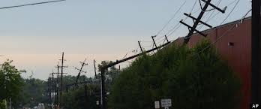
The failure of the electricity network can affect a wide range of essential services with disruption to water supplies, transport services telecommunications, health care provision, the internet and schools.
A national blackout has never happened, but in recent years severe weather and storms have caused significant damage to the electricity distribution overhead line network, resulting in the long duration loss of power to many communities.
Consequences
- People may lose power to their homes instantaneously and without warning. This would also cause cascading impacts on local water supplies, gas and telecommunications.
- Disruption to business.
- If blackouts are prolonged there may be disruption to health care and emergency services.
- Failure of street lighting and security systems.
- Congestion due to traffic light failures.

What are we doing in North Yorkshire?

- The UK electricity system is well managed, robust and resilient and is operated to minimise the effect of any failure.
- There are comprehensive plans in place for handling a complete national outage as well as outages in a number of local areas.
- Working with the local electricity company, emergency services, local authorities, other utility companies and agencies to minimise the impact.
- Identifying vulnerable people requiring special treatment in the event of a prolonged electric network failure.

What can you do?
PRIORITY SERVICE REGISTER
The priority services register is for customers who feel that they are particularly vulnerable and would benefit from receiving additional support during a power cut.
0800 169 2996

0800 169 2996

- Keep an emergency kit in your home containing items such as a wind-up torch/radio and supplies of tinned/dried food and drinking water.
- Where appropriate register as a vulnerable customer with relevant companies.
- Outages may come without warning, so consider how you can be prepared.
- Be on alert for bogus callers posing as utility company workers.

Where can you get further information?

Northern Powergrid has comprehensive advice and information regarding local power cuts: http://www.northernpowergrid.com/page/powercuts
Yorkshire Water also has comprehensive advice on their website or if you need assistance contact: https://www.yorkshirewater.com/priorityservices
Northern Gas Networks offer free help and advice: https://www.northerngasnetworks.co.uk/network-supply/priority-customers/

Food Supply Contamination
A major contamination incident involving a microbiological pathogen in the food chain causing illness, hospitalisation and possible fatalities in a moderate to large number of people over a period of a few days to weeks to identify the contaminant and months for the response.
There may be direct consumer health effects arising from this incident. It should be noted that events such as these can potentially also cause chronic health effects and demands on health care for many months or years following the incident.
Consequences
- Disruption to national choice of food (over 40%) for 3 days.
- An outrage would be amplified if the problem affected specific high risk products e.g. baby/toddler products.
Who can be affected?
Microbiological food incidents are identified and responded to on a frequent basis with an average of 300 incidents per year nationally and reported to the FSA. Incidents of substantial scale and/or public health impact do occur relatively frequently.
What are we doing in North Yorkshire?
- In the majority of cases the Local Authority would expect to receive a Rapid Alert System for Food and Feed (RASFF) alert for any human food contaminations.
- There is a NYCC Food Incident Product Recall Plan to deal with any large scale traceability exercises, product recall and investigations into criminal offences as required.
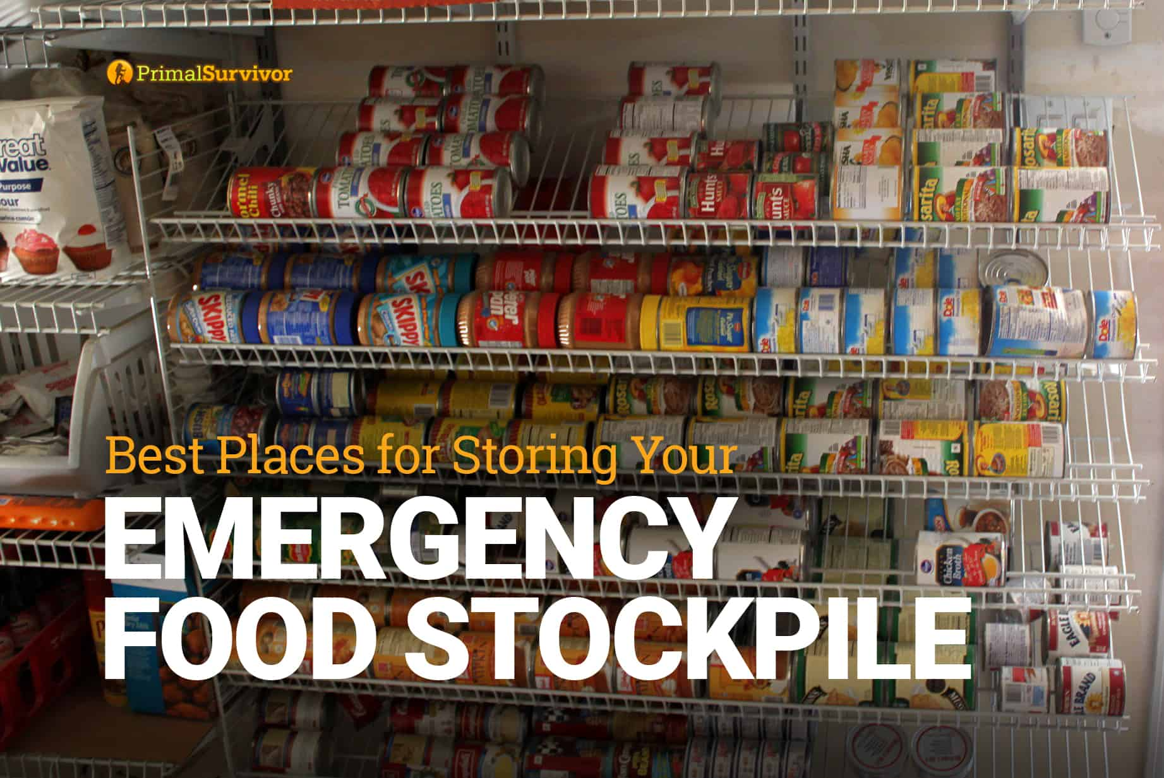
- NYCC Trading Standards & Planning Services have specific officers that are trained in human food work. Additional officers with minimal additional specific training can be diverted from other duties to deal with a major incident.
What can you do?
- Resist the temptation to buy or stockpile goods.
- Store/cook food safely.
Poor Air Quality
Air pollution can affect human health and the environment. Sustained periods of elevated pollution levels, referred to as air quality episodes, can lead to significant health risks.

The pollutants which have the most significant short term impacts on human health are ground - level Ozone and particulate matter. The duration of an air quality episode is heavily influenced by meteorological conditions. High pressure conditions are associated with weak wind speeds and poor atmospheric mixing.

Consequences

- Increase in deaths (especially elderly and other sensitive cohorts) resulting from exacerbation of respiratory or cardio-vascular conditions.
- Increase in hospital referrals for respiratory and cardio vascular conditions (eg shortness of breath).
- Additional pressure on emergency services having to respond to increased referrals
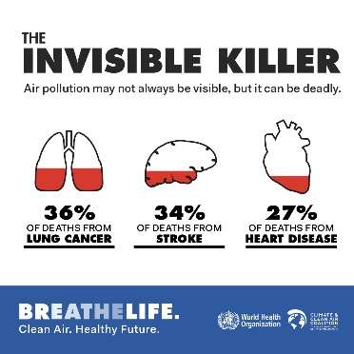
What are we doing in North Yorkshire?

- Monitor air pollutant levels.
- Alert the public if conditions deteriorate.
- Provide advice to those in affected areas

What can you do?
- Follow advice given
- Do not undertake strenuous exercise if suffering from breathing difficulties.
- Seek medical advice if unwell

Land Movement/Sink Holes
A natural event which may lead to significant land slippage resulting in building collapse and significant disruption to the local infrastructure.
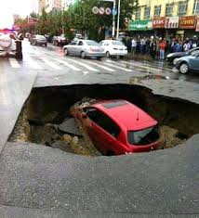
The possibility of an event could include anything from sinkholes, landslides, rock falls, subsidence and abandoned mineshafts leading to:
- Economic losses from reduction in tourism - local
impact to businesses due to road closures or
restrictions or diversions.
- Fatalities due to building collapse.
- Social disruption due to extended travel time and
costs; impact on property prices.
What are we doing in North Yorkshire?
The likelihood of an occurrence resulting from land slippage or earth quake within the North Yorkshire area is relatively low however, if it should occur the responding agencies have generic response plans which would be activated.
It is difficult to predict when and where land movement will happen. However, additional guidance from the Met Office in the event of a severe weather warning on saturated ground may assist with warnings to the public.
What can you do?

If you live in areas that are susceptible to land movement, consider a home emergency plan and report any concerns you may have to the local authority or the emergency services.

Cyber Security
Cyber space has become central to our economy and our society. Increasing our reliance on cyber space brings new opportunities but also new threats.

The scale of our dependence means that our prosperity, our key infrastructure, our places of work and our homes can all be affected. Vulnerabilities can take time to identify, leaving vast numbers of systems open to exploitation to be used in attacking other systems and networks remotely.

Worldwide interconnectivity and digitalisation is transforming how individuals, businesses and local authorities live and operate with a wide scale shift of services and capabilities online.

Consequences
- Impacts of cyber-attacks can cause fatalities and casualties should the NHS be specifically targeted.
- Financial loss is the most commonly seen impact resulting from cyber-attacks, both the direct theft of funds online, but also the recovery costs post attack.
- Loss / compromise of personal or corporate information
- Damage to business, the economy and reputation
- Loss of / interruption to supply of essential goods and services and communications network.

What are we doing in North Yorkshire?
- Assess the local consequences of malicious threats in line with UK Government guidance
- Develop and exercise multi-agency plans to ensure an effective response to and manage the consequences of malicious attacks
- Communicating advice to the public and businesses, and support government awareness campaigns
Encourage all LRF organisations to review and demonstrate that where possible they have responsible cyber resilience strategies
What can you do to increase your cyber security?
- Install internet security on your laptop/tablet/PC, there’s a wide range of paid for and free programmes available
- Consider the websites you use; some are more likely to be targeted by criminals
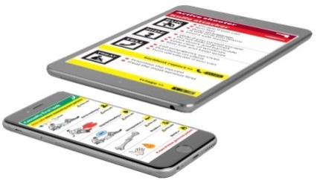
- Don’t reuse the same password for your social
media accounts, email addresses and other
online accounts. Also consider using fake
answers for memorable questions
- Review your social media privacy settings to
see what other internet users can see about you

As a business there’s a lot that can be done to protect against cyber-attacks. Cyber Essentials is a new government-backed and industry supported scheme to guide businesses in protecting themselves against cyber threats.

Free to download, Cyber Essentials shows businesses how to address the threats and get better protected against the most common cyber threats. www.cyberstreetwise.com/cyperessentials

Recovery
The range of impacts caused by malicious cyber activity can be wide ranging and recovery can be a long and expensive process. The capability of attackers is uncertain, and the time taken to recover from a cyber-attack is entirely dependent on the scale and the effectiveness of any recovery plans.

Further information
- National Cyber Security Centre
- Top tips for staying secure online


WHAT CAN YOU DO TO BE PREPARED IN YOUR HOME?

Some emergencies require evacuation; some require staying in and sheltering - are you ready? In most major emergencies, the simple advice is to go inside, stay there and tune into local radio for updates or check the web sites of the various agencies or follow social media.

We use local radio to broadcast emergency warnings and information. It is one of the most accessible means of communication as it can be received in homes, businesses and cars.

Fire & Rescue Service, Met Office, Environment Agency and Health agencies work together with BBC Radio (and other media outlets) to make sure they give out accurate and up-to date information to keep people fully informed on what to do during any emergency.

Knowing what to do during an emergency is an important part of being prepared and may make all the difference when seconds count.

HOW CAN YOUR COMMUNITY BE MORE PREPARED?

Wide-scale emergencies can, and do, happen. In the last five years the UK has seen events such as heavy snow, flooding, chemical incidents, drought, riots, terrorist attacks, utility failures and fuel shortages.

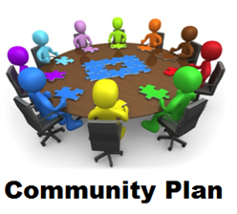
What is a community emergency plan?
A community emergency plan provides advice and guidance to a local community (this may be the parish council, neighbourhood watch area or even a single street) both in advance of and during any significant emergency.

Why have a community emergency plan?
The purpose of community resilience is to encourage people to plan and be prepared to put in place a self-help response within a community which is affected by an emergency. Experience has shown that, sometimes due to the scale and nature of an emergency, the normal response provided by the emergency services and the local authorities can be delayed. On these occasions anything which the local community can do to support each other will help them deal with the emergency more effectively.

Where can you get further information?
If you have any concerns or require any further information, please email emergency@northyorks.gov.uk

If you need help getting started with your Household or Community Emergency Plan email emergency@northyorks.gov.uk
Returning home after an emergency
Listen to advice from emergency services or local authorities about specific actions you should follow when told it is safe to return home.

BUSINESS CONTINUITY MANAGEMENT

5 Steps to Effective Business Continuity

1. Understand your business
What parts of the business are critical and what priority would you allocate to restoring functions if they fail?
2. Risk assessment
What risks does your business face (internal and external)? Consider these risks within your business risk assessment.
3. Consider the resource needs of each of your business functions: People, Premises, Equipment, Information, Communications, External suppliers /contractors
4. Document information in a user-friendly format about your businesses’ critical functions and the resources required, including alternatives / backups for each to assist you during and after an emergency.
5. Train and test your staff in activating the continuity plan and the roles and procedures within it.

https://www.gov.uk/resilience-in-society-infrastructure-communities-and-businesses
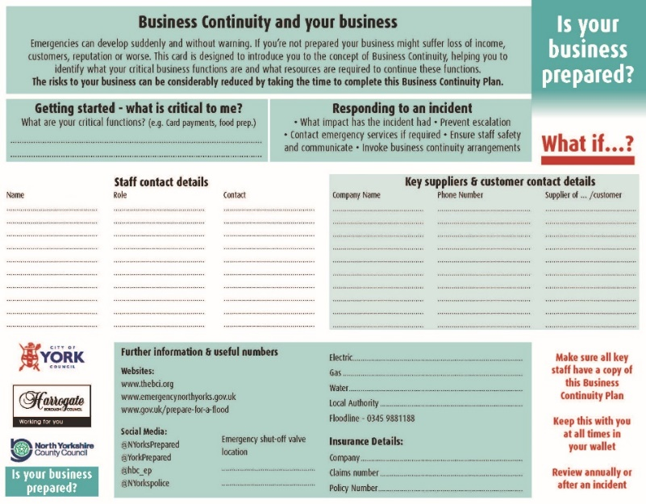

To receive a copy of this template, email: emergency@northyorks.gov.uk

