VM3COP38.20 AX/MX300 Calibration Test

- Connect the Microcal to the AX/MX300 analyser using the test lead, as shown. | 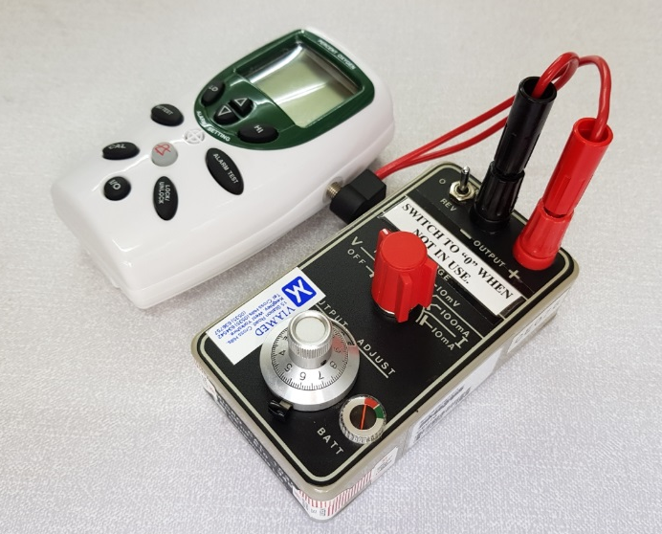
- Set the Microcal to 100 mV scale and the polarity switch to NORM. | 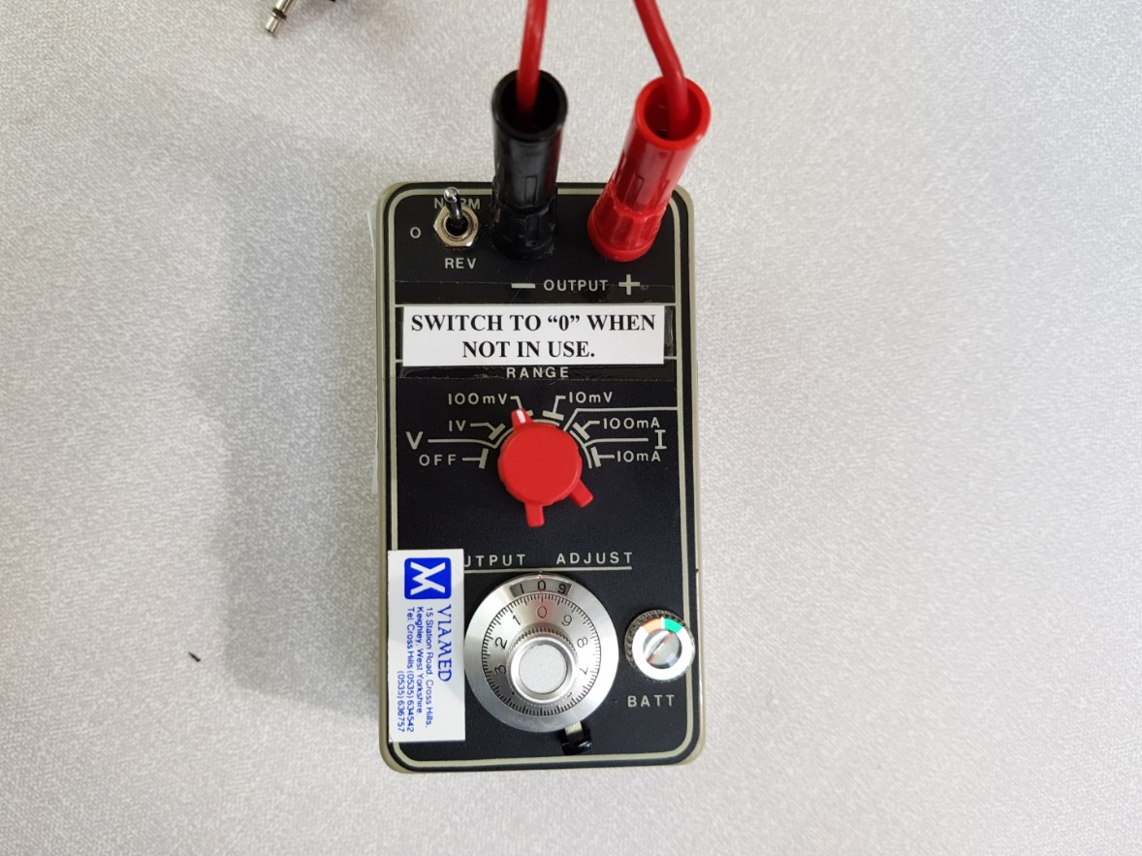
- Set the output adjustment dial to 50.0 mV.  - Power up the AX/MX300 analyser.  - Using the CAL button on the AX/MX300, calibrate the AX/MX300 analyser. During the calibration procedure the analyser will count down from 9 to 0. | 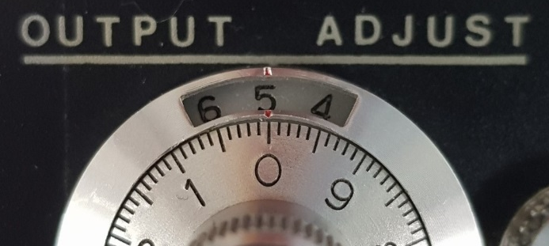
- At the end of the calibration procedure the analyser should display 100.0. If the AX/MX300 analyser fails to calibrate, then check the connections and repeat the test.  The Microcal is simulating the output of an Oxygen sensor reading a 100% Oxygen concentration. By decreasing the output of the Microcal to set values, the accuracy of the AX/MX300 analyser can be determined across a range of simulated Oxygen concentrations. | 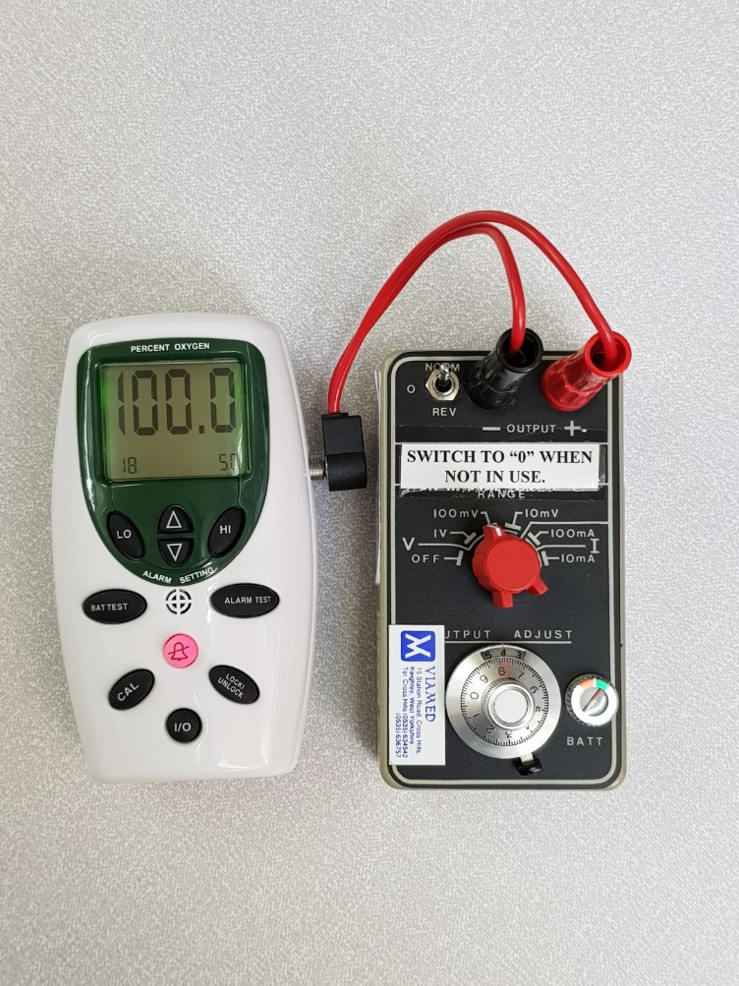
- In turn, dial in the input voltages from the table below. Record the values on the certificate (VM3COP38.21).  - Using the Calibration certificate generator, located in the stock section of Intrastats, generate a certificate number and record on the certificate.  - Record the part number and serial number on the certificate.  - Record the tester’s name and the date on the certificate.  - Print a copy on Viamed letter headed paper and sign where indicated.  - Produce a PDF copy and upload to Intrastats. | 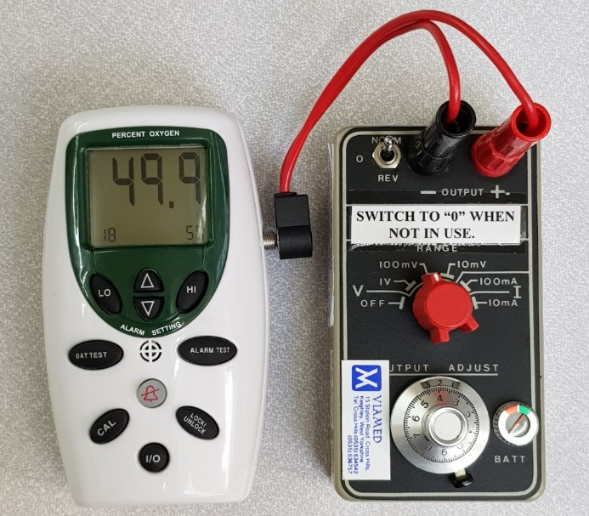
Microcal output | AX/MX300 expected reading (≤2% relative)
50.0 mV | 100% (98.0% - 102.0%)
45.0 mV | 90% (88.2% - 91.8%)
40.0 mV | 80% (78.4% - 81.6%)
35.0 mV | 70% (68.6% - 71.4%)
30.0 mV | 60% (58.8% - 61.2%)
25.0 mV | 50% (49.0% - 51.0%)
20.0 mV | 40% (39.2% - 40.8%)
15.0 mV | 30% (29.4% - 30.6%)
10.5 mV | 20.9% (20.5% - 21.3%)
9.0 mV | 18% (17.6% - 18.4%)

