North Yorkshire
Local Resilience Forum (LRF)

Community Risk Register

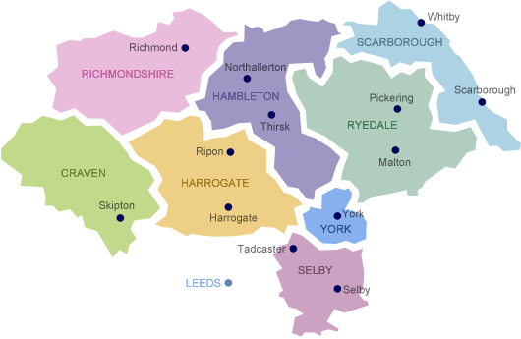

INTRODUCTION:
NORTH YORKSHIRE

Who are we?

North Yorkshire Local Resilience Forum (NYLRF) is a partnership, made up of all the organisations needed to prepare for and respond to any major emergency in the North Yorkshire area.

The North Yorkshire Community Risk Register (CRR) provides information on the emergencies that could happen in the North Yorkshire, together with an assessment of how likely they are to happen and the impacts they will have if they do. This includes the impacts to people, their homes, the environment and local businesses. These risks are regularly reviewed.

The area is under the control of the county council, or shire, and is divided into a number of local government districts: Craven, Hambleton, Harrogate, Richmondshire, Ryedale, Scarborough, Selby and the City of York.
Within the county are the North York Moors and most of the Yorkshire Dales; two of eleven areas of countryside within England and Wales to be officially designated as national parks. Between the North York Moors in the east and the Pennine Hills in the west lie the Vales of Mowbray and York. The Tees Lowlands lie to the north of the North York Moors and the Vale of Pickering lies to the south. Its eastern border is the North Sea coast. The two major rivers in the county are the River Swale and the River Ure. The Swale and the Ure form the River Ouse which flows through York and into the Humber estuary. The river Tees forms part of the border between North Yorkshire and County Durham.
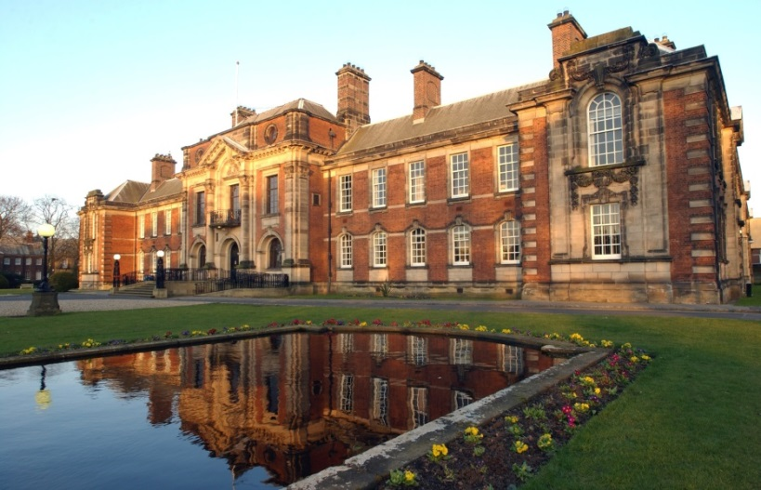
Northallerton County
Town Market Town
Northallerton is the county town of North Yorkshire and is the seat of The North Yorkshire County Council and Hambleton District council.
This document is designed to inform people about the risks that could occur where they live, so they can think about what they can do to be better prepared in their homes, communities and businesses.
Looking at all of the risks together can also help emergency services, local authorities and other organisations plan their joint response. The CRR aims to help these agencies make decisions on emergency planning work, and will help them develop better relationships.
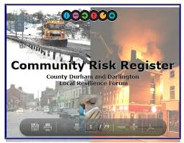
The Community Risk Register
The Community Risk Register (CRR) provides information on emergencies that could occur within North Yorkshire. It provides, an assessment of how likely they may happen and the impacts should they do so.

It identifies:
- Emergency Management Steps.
- North Yorkshire’s Top Risks.

  - Pandemic Influenza.
  - Flooding.
  - Severe Weather
  - Industrial Incident
  - Marine Pollution.Disruption or Failure Electrical Network.
  - Industrial Action.
  - Animal Health.
  - Hazardous Transport
  - Cyber Security
  - Run, Hide, Tell

- What you can do to be prepared in your home.
- How your local community can be prepared.
- How your business can be prepared.

Emergency Management Steps

Mitigation

How are agencies across North Yorkshire working to ensure the effects of an emergency can be reduced?
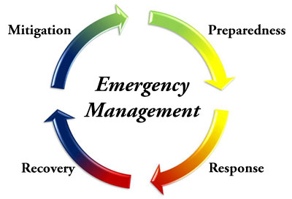
- Understanding risks, their cause and the impact they would have locally.
- Partnership working to reduce the likelihood of the risk happening and lessen the impacts if the risk occurs.

Preparation – Being ready to respond to an incident

- Understanding the impact and consequence of each risk.
- Developing emergency plans and procedures for response to the risks.
- Training staff and testing procedures.
- Matching our capabilities to the needs of each emergency.
- Developing longer-term recovery plans.
- Raising awareness of each organisation’s roles and responsibilities.
- Learning lessons from previous incidents.
- Establishing links for help and assistance from other counties for lengthy or widespread incidents.

Response – Reacting in the event of an incident

- Initial emergency activities (such as public safety, evacuation and shelter, limiting the spread of the incident, search and rescue).
- Initial damage assessment.
- Multi-agency coordination.
- Warning and informing the public.

Recovery – Actions following an incident

- Initial and long-term recovery efforts.
- Re-housing of displaced persons.
- Humanitarian Assistance.
- Regeneration.
- Welfare Arrangements.
Top Risks
Influenza - type Disease (Pandemic)
A pandemic occurs when a new virus spreads easily from person to person.

A pandemic can occur at any time - the last being in 2009. Fortunately the virus caused only a mild flu illness in most people affected. A future pandemic virus may cause more severe illness.

If the virus causes severe illness:

- Health care and local authority social care systems may become overloaded.
- Normal life is likely to face wide disruption, particularly if staff shortages affect the supply of essential services, including production and transport of goods.
- Up to 750,000 additional deaths could occur in the UK by the end of a pandemic.

Who can be affected?

Each pandemic is different and the nature of the virus and its impacts cannot be known in advance. A pandemic is likely to occur in one or more waves, possibly weeks or months apart. Each wave may last around 15 weeks and up to half the UK population may be infected.

What are we doing in North Yorkshire?

We work together to plan for:
- Management of the demand on the NHS and social care.
- Distribution of anti-viral medication to the public.
- Vaccination with the newly developed pandemic vaccine once available.
- Public awareness.
- Making plans to deal with the potential number of deaths.
- Making sure individual organisations have their own business continuity plans in place to cope in times of staff shortage.
What can you do?
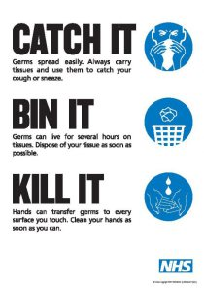
- Look out for and observe advice and NHS guidance, particularly about reducing the spread of illness.
- Identify a flu friend – who can collect your medication, food and other supplies allowing you to stay at home when ill.
- Keep small personal stocks of ‘over the counter’ cold and flu medication to help relieve your symptoms.
- Know the arrangements of your child’s school.

Measures may include:
- Staying at home when ill provided there is no need to go to hospital or visit a doctor. You may wish to contact NHS 111.
- Covering the nose and mouth with a tissue when coughing or sneezing.
- Disposing of dirty tissues promptly and carefully.
- Washing hands frequently with soap and warm water to reduce the spread of the virus from the hands to the face, or to other people, particularly after blowing the nose or disposing of tissues or coming in from outside.
- Regularly cleaning frequently touched hard surfaces, such as kitchen
worktops and door handles.


Where can you get further information?

Visit: http://www.nhs.uk/conditions/pandemic-flu/Pages/Introduction.aspx

NHS Direct 111

NHS Direct (Text Phone) 0845 6064647

Flooding
This is the most common and widespread natural disaster in the UK; we need to prepare in advance to minimise the impact that flooding could have.
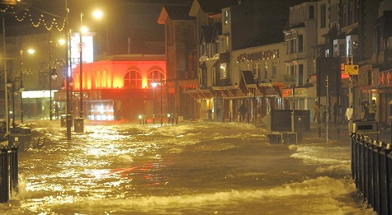
Flooding can occur from the sea, rivers and
from continuous and /or abnormal rainfall
levels. The highest flooding risk is surface
water flooding (where drainage systems are
unable to cope with the volume of rainfall).

Issues associated with flooding are widespread and can include:

- Risk to life.
- Damage and disruption to homes, personal property, businesses, infrastructure.
- Pollution of local environments.
- Disruption to utilities and evacuation.
- Short, medium and long-term homelessness.
- Long term health and psychological impacts.

Who can be affected?

Those at risk from river and coastal flooding are relatively easy to identify. Surface water flooding has the potential to occur anywhere but is more common in built up areas.

What are we doing in North Yorkshire?

- Investigating the causes of significant flooding across the county.
- Working with local flood groups eg Tadcaster, Malton
- Working with emergency services, local authorities and other agencies to develop flood response plans and procedures
- Communicating with housing developers to incorporate flood protection into new developments
- Working with emergency services, local authorities, utilities and other agencies to develop flood response plans and procedures.
- Regular maintenance and clearing programme of gullies and culverts, especially in the event of storm warnings.
What can you do? Have a plan, Have a kit, Stay informed

- Register for alerts and received “flood warnings direct” – a free service operated by the Environment Agency – by ringing 0345 988 1188.
- Know what different flood warnings mean (See further information below).
- Report instances of flooding to the local council.
- Where possible, move valuable/irreplaceable items to upper floors during times of flood risk.
- Plan where you will go if you have to evacuate and how you will get there.
- Who can look after your pets and have your medication to hand (see section “What can you do to be better prepared in your home”).
- Identify neighbours who may need assistance or can provide assistance to you, in case of evacuation.
- Buy sandbags/aqua sacs now – there will not be time in the event of an emergency.
- Know where and how to safely turn off utilities.
- Put together an emergency grab bag in case of evacuation or being stranded in your home.
- Do not drive, cycle or walk through flood water.

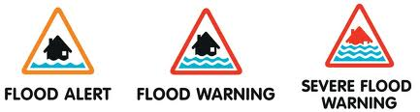

Where can you get further information?

Environment Agency
http://www.environment-agency.gov.uk/homeandleisure/floods/

Met Office
http://www.metoffice.gov.uk/weather/uk/advice/flooding.html

Severe Weather
The UK experiences a wide variety of weather systems.

The impacts are as varied as the types of weather and include:

- Ill health
- Property damage
- Disruption to utilities
- Travel disruption
- School closures
- Increased number of admissions to
hospitals and GPs.

These produce a knock-on effect to individuals, businesses and the ability for organisations to deliver essential community functions.

Who can be affected?

In the event of a weather warning, ask - is it necessary to make the journey? Could a telephone call do instead? Can I work from home? The elderly and vulnerable are at an increased risk in heat waves or cold snaps.

What are we doing in North Yorkshire?

- Production of multi-agency plans to manage the effects of severe weather events including any impact on utility networks.
- The MET Office provides advice and severe weather warnings which can be received in many ways, such as television, internet, radio or social media.
- Winter planning undertaken by many agencies such as gritting routes.
- The NHS provides winter flu jabs and plans for expected surges.
- Additional support via health and social services is identified for elderly and vulnerable people.
- Utilities companies plan their own responses to maintain power, gas and water supply
- All emergency service organisations have their own Business Continuity Plans to make sure they are still able to function.

What can you do?

Make sure you can access the latest weather forecasts. Depending on the level of warning:

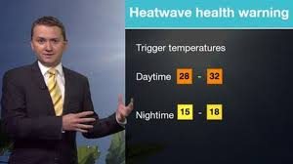
- Follow instructions and advice given by authorities.
- Avoid non-essential journeys.
- If you must make a journey, plan ahead and carry such items as emergency food/ clothing/ blanket/water and flask of hot drink.
- Check on elderly or vulnerable relatives and friends.
- If you are aware of property damage that may get worse in strong winds - get it fixed now.

Where can you get further information?

Met Office

http://www.metoffice.gov.uk/public/weather/warnings/?regionName=uk

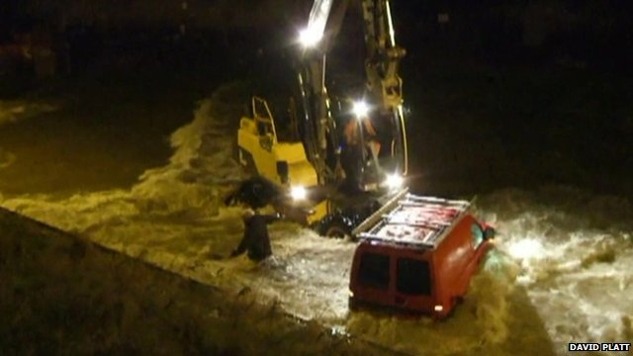

Industrial Site Incident
There are a number of industrial sites that in the event of an incident, could affect the public or environment.

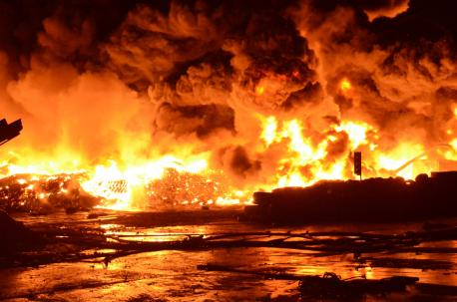
Impacts might include:

- Ill health or risk to life.
- Pollution of the environment.
- Damage to wildlife and the environment.
- Economic impact to the local economy including agriculture and tourism economy.

Who can be affected?

Those at most risk are people who live or work within close proximity to industrial sites.

What are we doing in North Yorkshire?

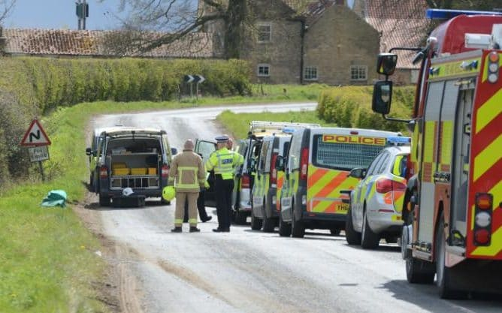
We work together to:
- Understand the risks.
- Reduce the risk through provision of advice and regulation.
- Develop multi-agency plans for sites and situations posing a risk to the environment.
- Test and exercise those plans.

What can you do?

Be aware of the actions to be taken in the event of an emergency
- Go in (seek shelter).
- Stay in (close doors and windows, switch off air conditioning).
- Tune in (to local media for further advice).

Where can you get further information?

Environment Agency
https://www.gov.uk/government/organisations/environment-agency
Marine Pollution
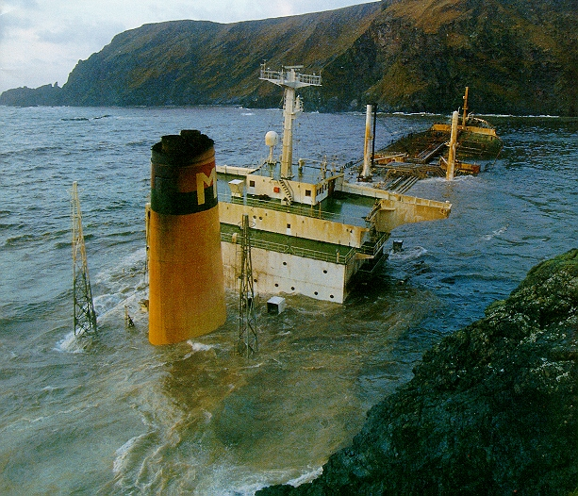
North Yorkshire has a significant coastline although there are no major ports, there is a risk by large vessels accessing the large ports either side at Teesport and the Humber. Those most likely to be affected by pollution are beach users and those working on or near to the sea. Tourism may be significantly affected depending where and how the incident occurs.

In the event of a marine pollution incident issues include:
- Significant damage to the environment including fishing stocks and other marine life.
- Potential health risk to local residents and tourists.
- Closure of the ports.
What are we doing in North Yorkshire?
- We work closely with key partners including the Maritime and Coastguard Agency, wildlife agencies and port operators to produce a marine pollution plan.
- Testing the plan and procedures.
- Staff is trained in marine pollution control.
- The Environment Agency and MCA undertake investigations into sources of pollution and where possible prosecute.
What can you do?
In the event of an incident abide by any restrictions, for example on fishing or using beaches. Report any incidents of pollution to the MCA or the Environment Agency.

Where can you get further information?

www.dft.gov.uk/mca

Disruption or Failure to Regional Electricity Network
There have been occurrences of wide area power cuts affecting large areas in the UK but such incidents are usually restored within 24 hours.

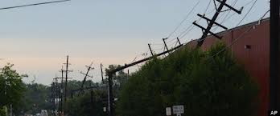
Because of our reliance on electricity, even localised losses of electricity can have a significant impact on those affected.

What are we doing in North Yorkshire?

- There has been no increase in the likelihood of a power cut affecting the whole of a region for 24 hours in recent years.
- The UK electricity system is well managed, robust and resilient and is operated to minimise the effect of any failure.
- There are comprehensive plans in place for handling a complete national outage as well as outages in a number of local areas.
- Working with the local electricity company, emergency services, local authorities, other utility companies and agencies to minimise the impact.
- Identifying vulnerable people requiring special treatment in the event of a prolonged electric network failure.

What can you do?

- Keep an emergency kit in your home containing items such as a wind-up torch/radio and supplies of tinned/dried food and drinking water.
- Where appropriate register as a vulnerable customer with relevant companies.
- Outages may come without warning, so consider how you can be prepared.
- Be on alert for bogus callers posing as utility company workers.

Where can you get further information?

Northern Powergrid has comprehensive advice and information regarding local power cuts on its website: http://www.northernpowergrid.com/page/powercuts
HM Government
https://www.gov.uk/government/publications/sector-resilience-plans

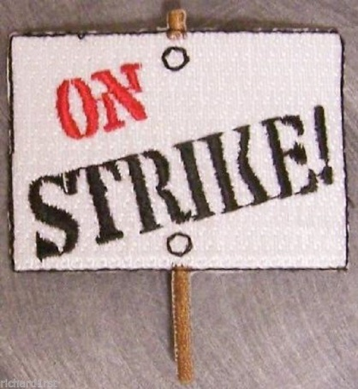
Industrial Action
Industrial action usually happens when trade union members are involved in a dispute with the government or their employer that fails to be resolved by negotiation.
Recent examples of industrial action included the fuel tanker driver dispute, civil servants, industrial contractors, health staff, fire fighters and teachers.
Who can be affected?
Disruption to services could affect any public sector organisation in the event of industrial action. Strike action by firefighters has been particularly highlighted by government and special arrangements are now in place.
What are we doing in North Yorkshire?
- Maintaining a register of proposed industrial action.
- Identifying what the wider impacts are likely to be on essential users.
- Producing specific plans to ensure essential services are maintained.
- Monitoring situations to ensure that parties are aware of any issues and arranging for remedial action where possible.
What can you do?
- Resist the temptation to buy or stockpile goods. On a number of occasions the public and media have made a minor shortage into a far bigger problem.
- Find out if you can work with friends/colleagues to minimise the impact eg car sharing or childcare in the event of industrial action.

Animal Health
Some animal diseases may be passed to humans. Others may only be passed from animal to animal.

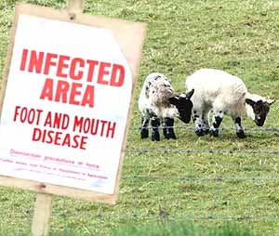
The 2001 Foot and Mouth outbreak resulted in over 10 million sheep and cattle being killed across the country.

The impacts of a similar outbreak would include:
- Potential large scale livestock deaths or animal welfare issues
- Risk to human health
- Psychological/social impacts on farming community.
- Potential financial impact on agricultural industry, associated businesses and
tourism

Who can be affected?

Previous incidents have devastated rural economies and communities. However, incidents can extend wider and impact upon tourism.

What are we doing in North Yorkshire?

- On-going work with DEFRA to make sure that lessons identified from previous incidents are incorporated into emergency plans.
- Looking ahead to identify and cut off potential disease risks.
- Maintaining quarantine procedures for animals coming into the UK from
abroad.

What can you do?

For those involved in farming:

- Register livestock with DEFRA.
- Make sure sick animals are checked and reported.
- Vaccinate livestock where possible.
- If an outbreak is declared, follow government advice to limit the spread of the disease and protect your livestock.

For the public:
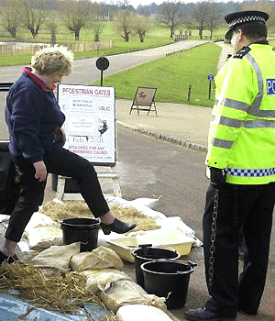
Abide by restrictions limiting the spread of the disease, such as closed footpaths in rural areas.

Where can you get further information?

HM Government
Animal Health and Veterinary Laboratories Agency - Defra

Hazardous Transport
There are a significant number road and rail tankers that carry chemicals everyday around the North Yorkshire area. Some of the products carried are hazardous and could lead to an incident.
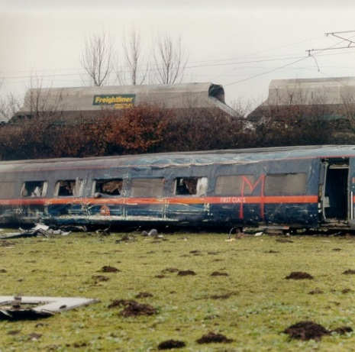
Issues include:
- Disruption to normal travel, people stranded for long periods
- Death or injury to people
- Environmental damage, depending on the chemical, to air, land or water
- Damage to local infrastructure (e.g. roads, rail)

Who can be affected?

Road and rail users and those close to key roads and rail lines.

What are we doing in North Yorkshire?

Local plans exist within the emergency services, Highways England and the Environment Agency to provide for a response - there is extensive National and European Legislation covering the transportation of dangerous loads.
What can you do?

Be aware of the actions to be taken in the event of an emergency.
Where can you get further information?
www.environment-agency.gov.uk/business/topics/waste/32180.aspx
Cyber Security
Cyber space has become central to our economy and our society. Increasing our reliance on cyber space brings new opportunities but also new threats.

The scale of our dependence means that our prosperity, our key infrastructure, our places of work and our homes can all be affected. Vulnerabilities can take time to identify, leaving vast numbers of systems open to exploitation to be used in attacking other systems and networks remotely.

Consequences of a cyber-attack may include:
- Loss / compromise of personal or corporate information
- Damage to business, the economy and reputation
- Loss of / interruption to supply of essential goods and services and communications network.

What can you do to increase your cyber security?

As a business there’s a lot that can be done to protect against cyber attacks. Cyber Essentials is a new government-backed and industry supported scheme to guide businesses in protecting themselves against cyber threats.

Free to download, Cyber Essentials shows businesses how to address the threats and get better protected against the most common cyber threats. www.cyberstreetwise.com/cyperessentials

Personal Security

It’s not just businesses that need to stay safe online. The internet has become an essential tool in everyday life and there are a few simple steps we can take to stay safe online:
- Install internet security on your laptop/tablet/PC.
- Consider the websites you use, some are more likely to be targeted by criminals.
- Don’t reuse the same password for your social media accounts, email addresses and other online accounts. Also consider using fake answers for memorable questions.
- Review your social media privacy settings to see what other internet users can see about you.

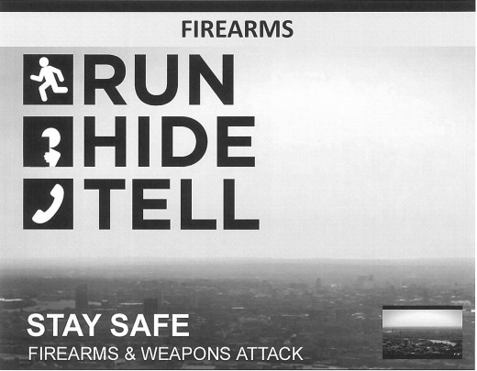
Run, Hide, Tell

The police and security service work constantly to foil malicious attacks in the UK. Attacks of this nature are very rare in the UK but we are not complacent about keeping you safe.

In the rare event of a firearms or weapons attack:

RUN – to a place of safety. This is a far better option than to surrender or negotiate. If there’s nowhere to go, then…

HIDE – it’s better to hide than to confront. Remember to turn your phone to silent and turn off vibrate. Barricade yourself in if you can.

TELL – the police by calling 999 when it is safe to do so.

The citizenAID App

Simply download the free, no adds citizenAID App from either Google Play, Apple App or the Windows store.
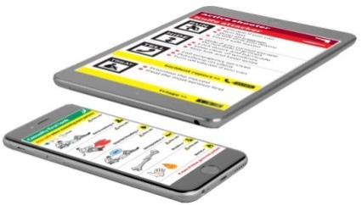
The citizenAID App will reduce the anxiety from difficult decision making in an unfamiliar situation. Follow the logical steps to do the right things in the right order. Stay safe and help us… to help you… to save lives.
The citizenAID app is free to the UK public and is designed initially for use in the UK. Access is left open internationally for the wider public good, but recognising there is detail that relates only to the UK (such as emergency service phone number). Additional country versions will be developed dependent on demand.” US Version is available, search “citizenAID US” in google & iTunes.

WHAT CAN YOU DO TO BE PREPARED IN YOUR HOME?

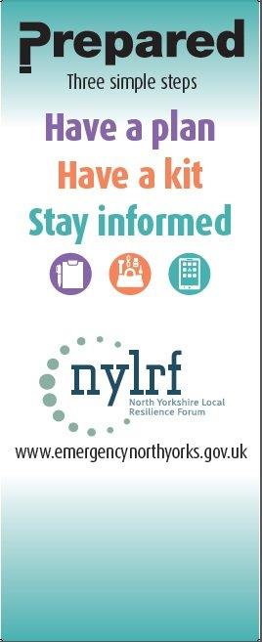
Some emergencies require evacuation; some require staying in and sheltering - are you ready? In most major emergencies, the simple advice is to go inside, stay there and tune into local radio for updates or check the web sites of the various agencies or follow social media.

We use local radio to broadcast emergency warnings and information. It is one of the most accessible means of communication as it can be received in homes, businesses and cars.

Fire Brigade, Met Office, Environment Agency and Health agencies work together with BBC Radio (and other media outlets) to make sure they give out accurate and up-to date information to keep people fully informed on what to do during any emergency.

Knowing what to do during an emergency is an important part of being prepared and may make all the difference when seconds count.

HOW CAN YOUR COMMUNITY BE MORE PREPARED?

Wide-scale emergencies can, and do, happen. In the last five years the UK has seen events such as heavy snow, flooding, chemical incidents, drought, riots, terrorist attacks, utility failures and fuel shortages.

What is a community emergency plan?
A community emergency plan provides advice and guidance to a local community (this may be the parish council, neighbourhood watch area or even a single street) both in advance of and during any significant emergency.

Why have a community emergency plan?
The purpose of community resilience is to encourage people to plan and be prepared to put in place a self-help response within a community which is affected by an emergency.

Experience has shown that, sometimes due to the scale and nature of an emergency, the normal response provided by the emergency services and the local authorities can be delayed. On these occasions anything which the local community can do to support each other will help them deal with the emergency more effectively.

BUSINESS CONTINUITY MANAGEMENT

5 Steps to Effective Business Continuity

1. Understand your business
What parts of the business are critical and what priority would you allocate to restoring functions if they fail?

2. Risk assessment
What risks does your business face (internal and external)? Consider these risks within your business risk assessment.

3. Consider the resource needs of each of your business functions: People, Premises, Equipment, Information, Communications, External suppliers /contractors

4. Document information in a user-friendly format about your businesses’ critical functions and the resources required, including alternatives / backups for each to assist you during and after an emergency.

5. Train and test your staff in activating the continuity plan and the roles and procedures within it.

Returning home after an emergency

Listen to advice from emergency services or local authorities about specific actions you should follow when it is safe to return home.

Where can you get further information?

If you need help getting started with your Household or Community Emergency Plan email emergency@northyorks.gov.uk

https://www.gov.uk/resilience-in-society-infrastructure-communities-and-businesses

