Important: Use only Fomblin grease during assembly of Tom Thumbs. Do not use or allow organic greases to enter the Tom Thumb. Ensure all parts are clean before assembly.

Check all products used in production or service are within their lifespan / use by date.

Equipment required. | 14mm open-ended spanner, pick, isopropyl alcohol, kitchen tissue, adjustable spanner, PTFE tape, 4mm allen key.

Parts list.
Qty. | Description. | Part No.
1 | Body block | 0330202
1 | Diamond copper washer | 0330212
1 | Pressure gauge | 0330193
2 | Thick O ring – 3/32 section | 0330213
6 | Thin O ring – 1/16 section | 0330214
2 | Flowmeter bolt | 0330205
1 | Flowmeter (15 lpm, oxygen) | 0320060
1 | Flowmeter (15 lpm, air) | 0330204
1 | Precision valve | 0330210
1 | Adjustable valve | 0330211
1 | 15mm outlet | 0330209
1 | Details / serial no. label | 0390008
1 | “Thumb Vent” label | 0390014
1 | Adjustable valve label | 0390010
1 | CE label | 0390011
--- | Fomblin grease | 0330220
1 | NeoPeeP Circuit | 3210011
1 | Reusable Silicone adaptor | 0120140
1 | Single Use Silicone Facemask | 3210071
1 | Spacer block | 0330191
1 | Rail Clamp | 0330190
4 | M4x10mm hex drive bolts | 0330216

Assembly.

- Clean the body block surface thoroughly with isopropyl alcohol. Clean threads of the body block to remove residual swarf. Fig.1.

- Affix Thumb Vent label onto the front face of the block. Fig.2.

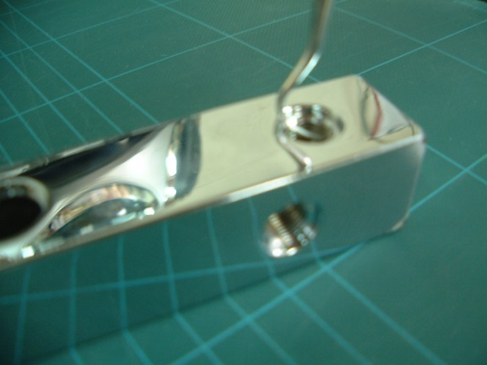 | 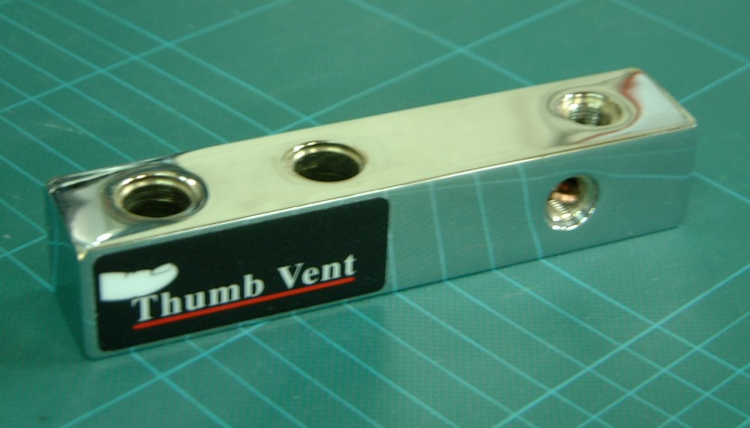
Fig.1 | Fig.2

- Insert diamond copper washer into the single threaded hole on the label side of body block. Fig.3.

- Screw in the pressure gauge in the single threaded hole on the label face of the body block; the gauge should appear straight in comparison to the block and not able to be removed without the aid of tools. Use 14mm open-ended spanner to tighten. Fig.4.

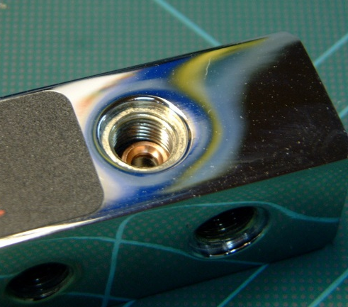 | 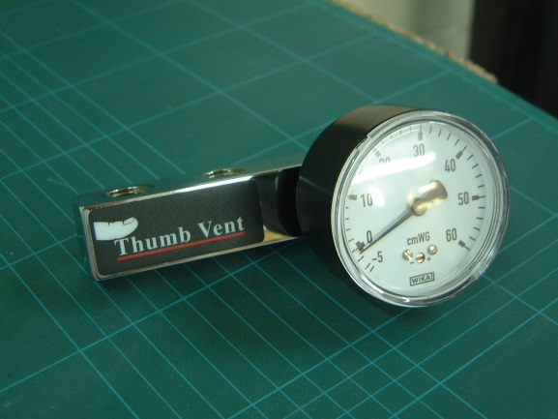
Fig.3 | Fig.4

- Push a thin O ring onto the flowmeter bolt. Fig.5.

- Push the flowmeter bolt / O ring from bottom to top into the right hand (non-threaded) hole. Fig.6.

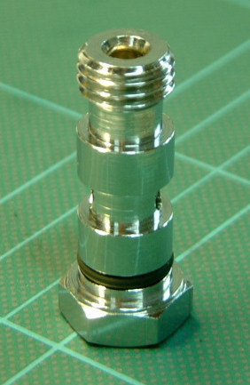 | 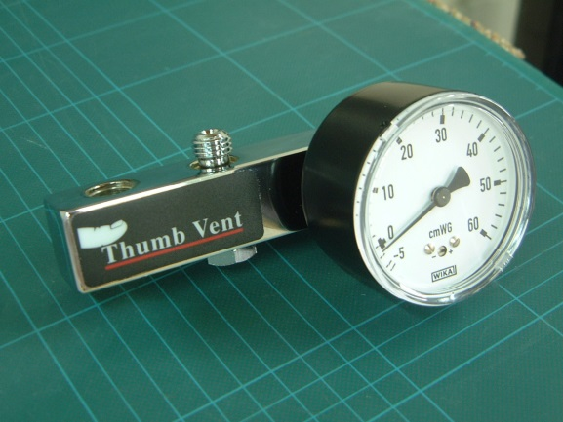
Fig.5 | Fig.6

- Push a thick O ring over the top thread of inserted flowmeter bolt. Fig.7.

- Remove the plastic fitting from the flowmeter and discard. Screw the air flowmeter onto the inserted flowmeter bolt ensuring the flowmeter is straight in comparison to the body block. Use the adjustable spanner to tighten. Fig.8.

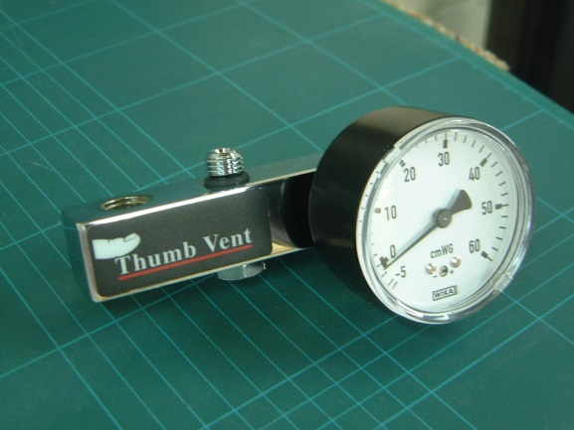 | 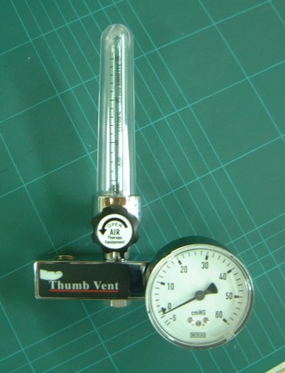
Fig.7 | Fig.8

- Push a thin O ring onto the flowmeter bolt. Fig.9.

- Push the flowmeter bolt / O ring from bottom to top into the left hand (non-threaded) hole. Fig.10.

 | 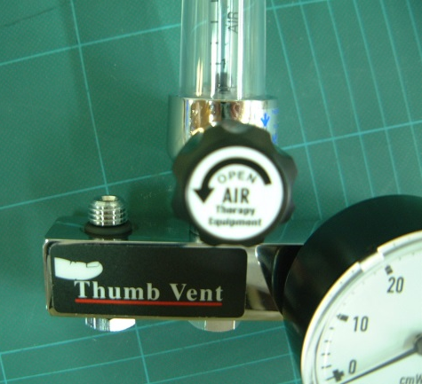
Fig.9 | Fig.10.

- Push a thick O ring over the top thread of inserted flowmeter bolt. Fig.11.

- Remove the plastic fitting from the flowmeter and discard. Screw the oxygen flowmeter onto the inserted flowmeter bolt ensuring the flowmeter is straight in comparison to the body block. Use the adjustable spanner to tighten. Fig.12.

 | 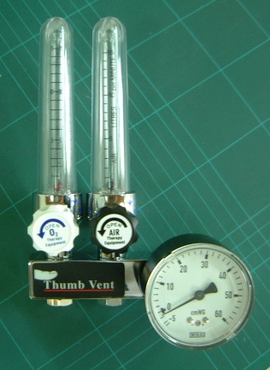
Fig.11 | Fig.12

- Place a thin O ring over the thread of the precision valve. Fig.13.

- Screw into the bottom-threaded hole. Use the adjustable spanner to tighten. Fig.14.

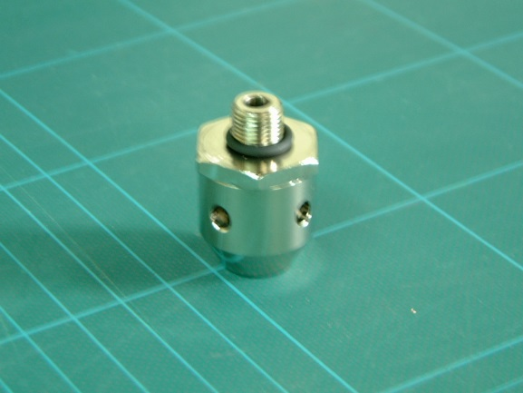 | 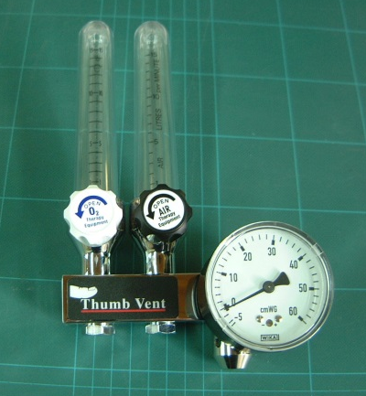
Fig.13 | Fig.14

- Place a thin O ring over the threaded end of the adjustable valve. Fig.15.

- Screw the adjustable valve into the threaded hole in the top face of the body block. Use the adjustable spanner to tighten. Fig.16.

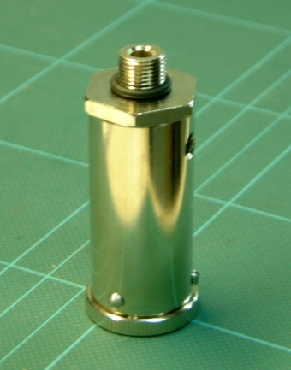 | 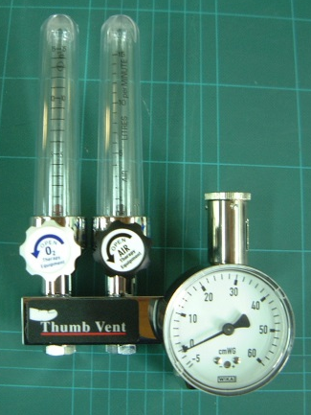
Fig.15 | Fig.16

- Place a thin O ring over the threaded end of the 15mm outlet. Fig.17.

- Screw the 15mm outlet into the threaded hole in the right face of the body block. Use the adjustable spanner to tighten. Fig.18.

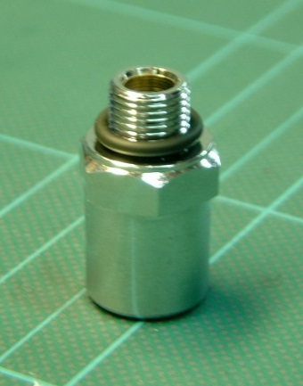 | 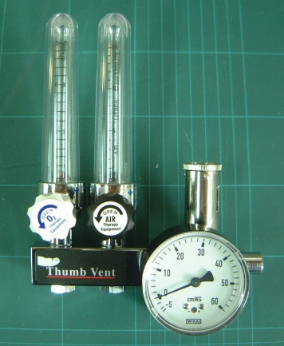
Fig.17 | Fig.18

- Affix Viamed details / serial no. label across the rear face of the body block.

- Attach the spacer block to the body block using 2x M4x10mm hex drive bolts. Fig 20a and 20b.

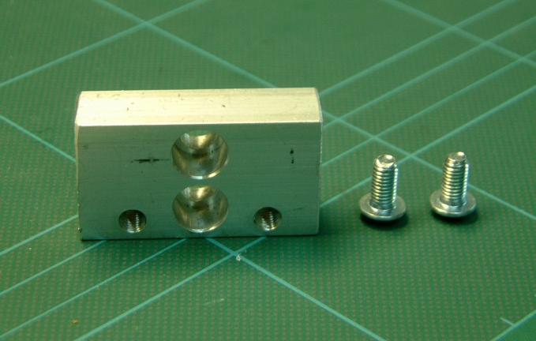 | 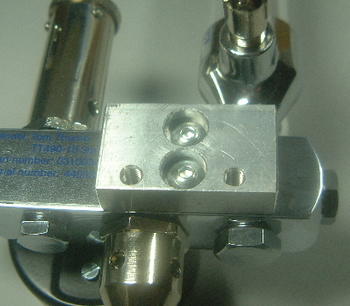
Fig.20a | Fig.20b

- Attach the rail clamp using 2x M4x10mm hex drive bolts. Fig 22a ,22b and 22c.

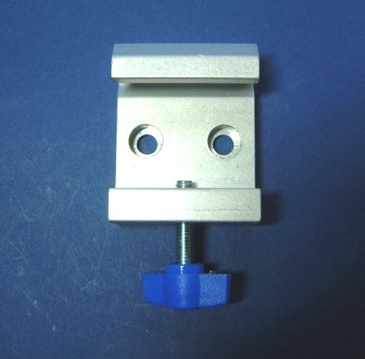 | 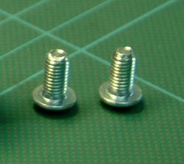 | 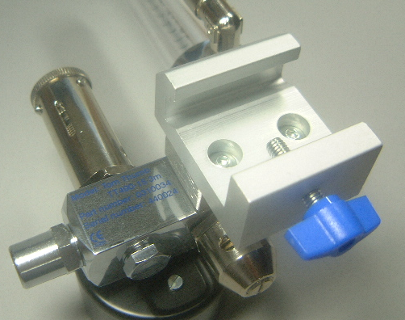
Fig.21a | Fig.21b | Fig.21c

Testing & Calibration: TT495.

- Check the TT495 for damage i.e. scratches to plastics, poor chroming, etc.

- Set the adjustable valve to minimum (fully counter clockwise) and flowmeters to minimum (fully clockwise).

- Connect the digital manometer (on 0-100.0 mbar range) with T piece adapter to the Tom Thumb outlet.

- Connect the air flowmeter to the oxygen supply at a pressure of 4 bar.

- Set the air flow meter to 10 Lpm.

- Check all mechanical connections between parts for leaks; use Snoop fluid and check for bubbling.

- Disconnect the air flowmeter from the oxygen supply.

- Connect the oxygen flowmeter to the oxygen supply at a pressure of 4 bar.

- Set the oxygen flow meter to 10 Lpm.

- Check all mechanical connections between parts for leaks; use Snoop fluid and check for bubbling.

- Check for minimum pressure out: Cover the T piece adapter port. Check the TT pressure gauge is less than 8.0 cmH₂O. Check that the digital manometer reading is less than 7.8 mbar and record on the Tom Thumb Calibration / Test & QA Sheet .

- Set up the adjustable valve: Set the adjustable valve control to maximum. Cover the holes in the precision valve and the T piece adapter port. Alter the adjustable valve collar until a reading of 43±1 cmH₂O is achieved on the TT pressure gauge. Ensure a reading of 42.2±1 mbar on the digital manometer and record on the Tom Thumb Calibration / Test & QA Sheet. Slightly unscrew the adjustable valve and apply Oxygen compatible threadlock to the exposed threads. Retighten the adjustable valve with the adjustable spanner.

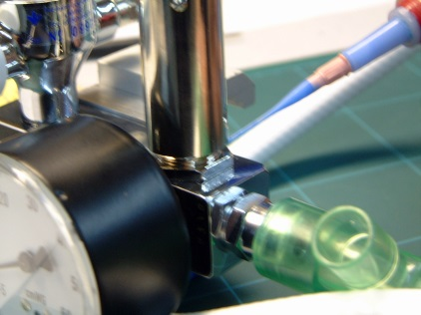

- Check for TT pressure gauge sticking: Release and cover the T piece adapter port a number of times, ensuring that TT pressure gauge returns to 43±1 cmH₂O. Uncover the precision valve holes.

- Set up the precision valve: Slightly unscrew the precision valve adjustable screw and apply Oxygen compatible threadlock to the exposed threads. Screw into the precision valve body until flush. Cover the holes in the adjustable valve and the T piece adapter port. Carefully adjust the precision valve screw in quarter turns to achieve a reading on the TT pressure gauge of 45±1 cmH₂O (Clockwise adjustment on precision valve screw to increase). Record the digital manometer reading on the Tom Thumb Calibration / Test & QA Sheet.

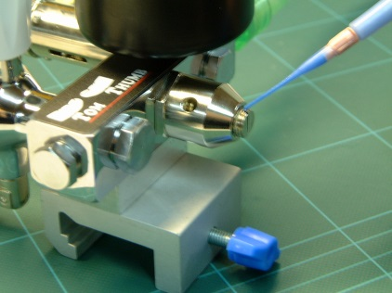

- TT pressure gauge accuracy check: Cover the T piece adapter port and increase the flow of gas to achieve a displayed reading of 30 cmH₂O on the TT pressure gauge. Ensure a reading of 29.4±0.5 mbar on the digital manometer and record on the Tom Thumb Calibration / Test & QA Sheet.

- Record both flowmeter serial numbers on the Tom Thumb Calibration / Test & QA Sheet .

- With the Flowmeter set at 10Lpm, gently shake the unit to check that both Flowmeter balls remain at the correct reading (not sticking), and then turn the Flowmeter and adjustable valve to minimum. Disconnect from oxygen supply and disconnect the digital manometer.

- Clean the Tom Thumb with isopropyl alcohol and remove the original labels from the flowmeter adjusters. Apply a Viamed label to the adjustable valve control and CE mark to the body block.

- Ensure stock sheets are generated and submitted together with the Tom Thumb Calibration / Test & QA Sheet for QA checking.

