Important: Use only Oxygen-compatible grease during assembly of Tom Thumbs. Do not use or allow organic greases to enter the Tom Thumb. Ensure all parts are clean before assembly.

Check all products used in production or service are within their lifespan / use by date.
Tools required. | 7/8 A/F spanner  5/8 A/F spanner  12mm spanner  3mm Allen key  5mm Allen key  Pick

Parts list
Qty | Description |  | Part No.
1 | Flowmeter (Oxygen) 0-15 lpm |  | 0320060
1 | Pressure gauge |  | 0330193
1 | Body block |  | 0330201
1 | Flowmeter bolt |  | 0330205
1 | 15mm outlet |  | 0330209
1 | Precision valve |  | 0330210
1 | Adjustable valve |  | 0330211
1 | Gauge seal (Diamond copper washer) |  | 0330212
1 | Thick O ring – 3/32 section |  | 0330213
6 | Thin O ring – 1/16 section |  | 0330214
1 | Right angle adaptor |  | 0330219
1 | Inlet restrictor |  | 0330235
2 | Blanking bolt |  | 0330296
1 | Spacer block |  | 0330191
1 | Rail clamp |  | 0330190
4 | M4x10mm hex drive bolts |  | 0330216
--- | PTFE tape |  | 11-0374
1 | Inlet hose | 1m | 0330217  or  0330218
1 | Inlet hose | 3m | 0330217  or  0330218
1 | Adjustable valve label |  | 0390010
1 | Tom Thumb front label |  | 0390015
1 | Address label |  | 0390016
1 | Serial no. label | 1m | 0390031 or 0390033
1 | Serial no. label | 3m | 0390031 or 0390033

- Clean the surface of the body block with isopropyl alcohol. Clean the threads of the body block, using the pick tool, to remove residual swarf. | 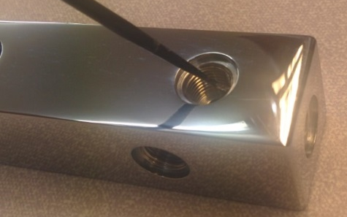
- Affix Tom Thumb label onto the front face of the block. | 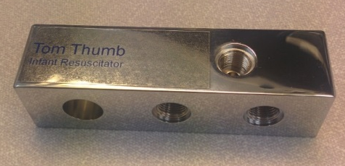
- Affix the part/serial number label to the rear face of the block. | 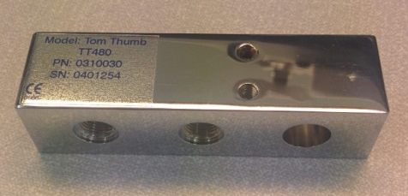
- Insert gauge seal (diamond copper washer) into the single threaded hole on the front face of body block. | 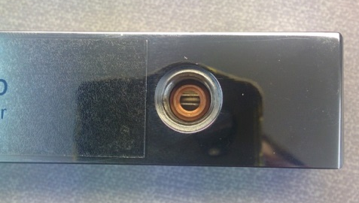
- Screw the pressure gauge in the single threaded hole on the front face of the body block. The gauge should appear straight in comparison to the block and not able to be removed without the aid of tools. Use 5/8 AF spanner to tighten. | 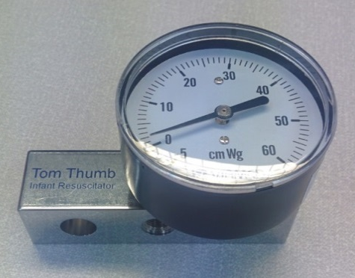
- Line the thread of the right angle adapter with two complete layers of PTFE tape. | 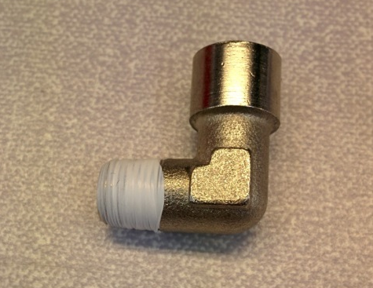
- Insert the flow restrictor into the right angle adaptor. | 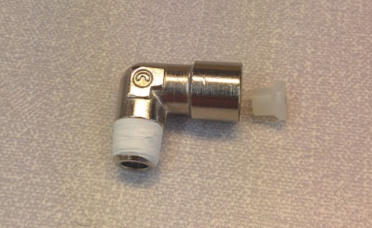
- Screw the right angle adapter into the rear of the flow meter and tighten using the 12mm spanner. Ensure that the adapter is vertical. | 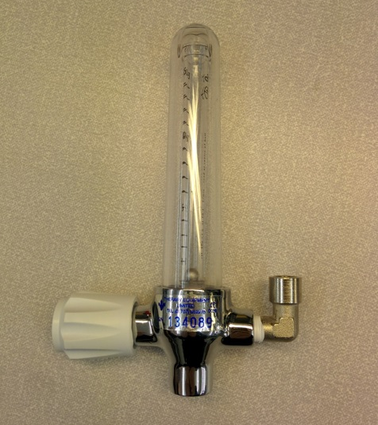
- Push a thin O ring onto the flowmeter bolt. | 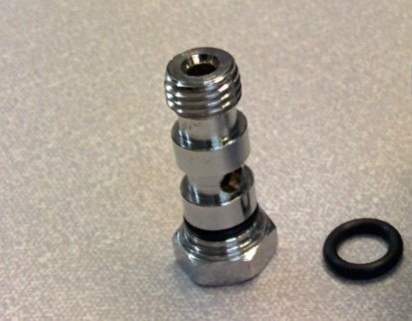
- Push a thick O ring over the top thread of inserted flowmeter bolt. | 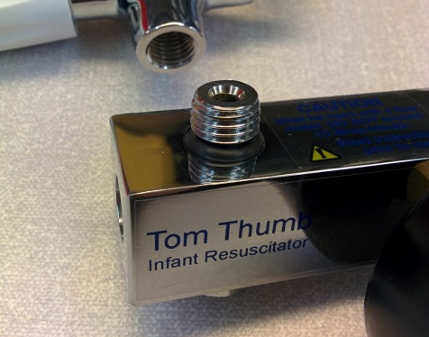
- Screw the flowmeter onto the inserted flowmeter bolt ensuring the flowmeter is straight in comparison to the body block. Use the 5/8 AF spanner to tighten. | 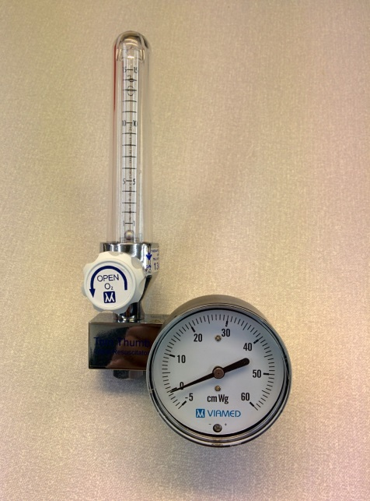
- Place a thin O ring over the thread of the precision valve. | 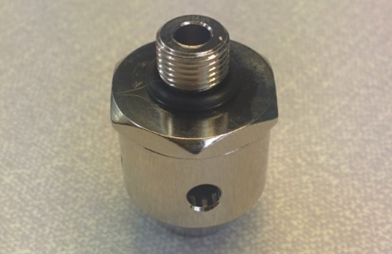
- Screw into the centre bottom threaded hole. Use 7/8 AF spanner to tighten. | 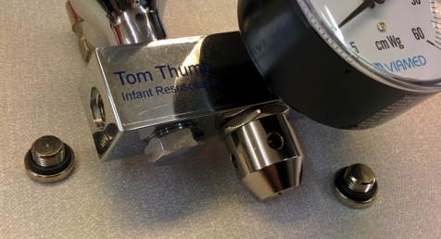
- Place a thin O ring over the thread of a blanking bolts. | 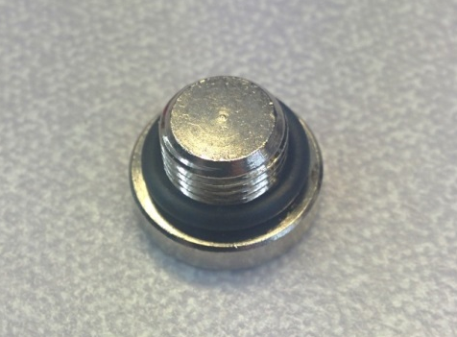
- Screw the blanking bolt into the left hand end hole of the body block. Use a 5mm Allen key to tighten. | 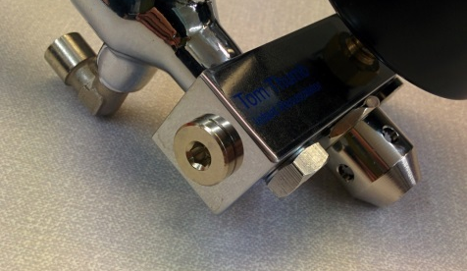
- Screw into the right hand threaded hole on the bottom face of the body block. Use a 5mm Allen key to tighten. | 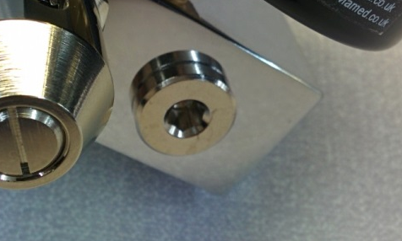
- Place a thin O ring over the thread of the adjustable valve. | 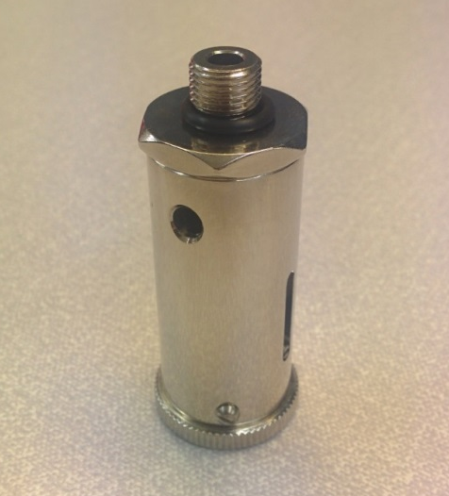
- Screw the adjustable valve into the remaining threaded hole in the top face of the body block. Use the 7/8 AF spanner to tighten. | 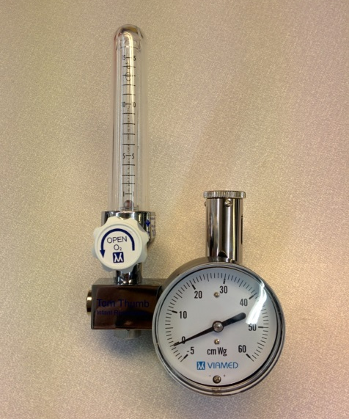
- Place a thin O ring over the threaded end of the 15mm outlet | 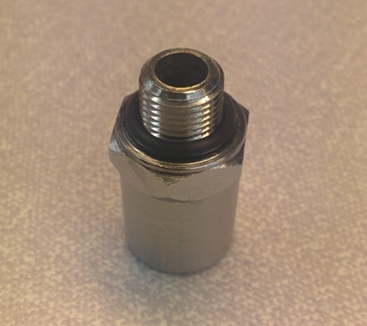
- Screw the 15mm outlet into the threaded hole in the right face of the body block. Use 5/8 AF spanner to tighten | 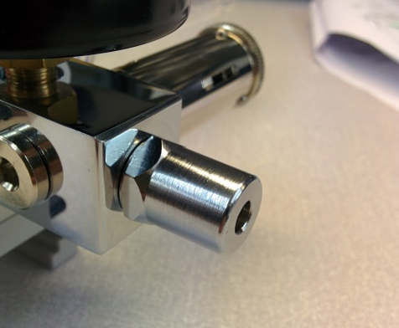
- Attach the spacer block to the body block using 2x M4x10mm hex drive bolts. Use a 3mm Allen key to tighten. | 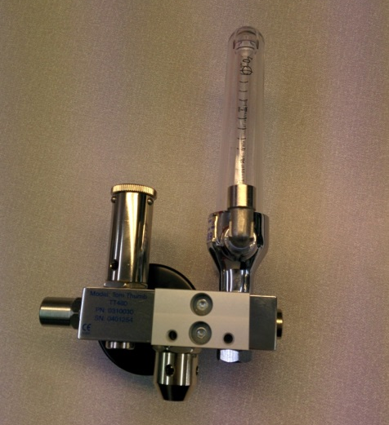
- Attach rail clamp to the spacer block using 2x M4x10mm hex drive bolts.  Use a 3mm Allen key to tighten. | 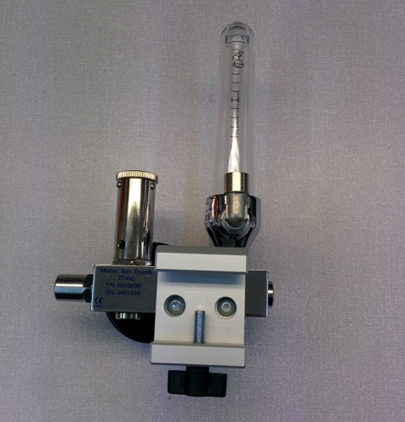
- Set the adjustable valve to minimum and attach the valve label. | 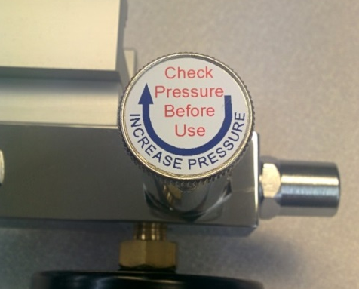
- Attach the address label to the underside of the pressure gauge. | 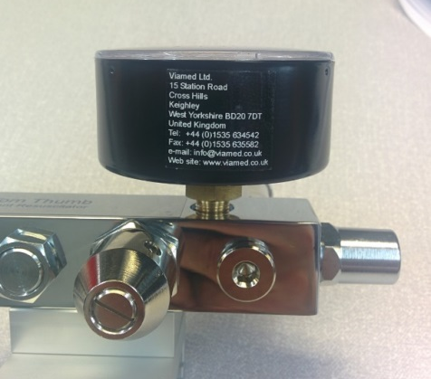
- The finished unit is now ready for testing and calibration. | 