Important: Use only Oxygen-compatible grease during assembly of Tom Thumbs. Do not use or allow organic greases to enter the Tom Thumb. Ensure all parts are clean before assembly.

Check all products used in production or service are within their lifespan / use by date.
Tools required. | 7/8 A/F spanner  5/8 A/F spanner  3mm Allen key  5mm Allen key  Pick

Parts list
Qty | Description | Part No.
1 | Pressure gauge | 0330193
1 | Body block | 0330201
1 | Flowmeter blocking bolt & nut | 0330206
1 | 10mm inlet | 0330208
1 | 15mm outlet | 0330209
1 | Precision valve | 0330210
1 | Adjustable valve | 0330211
1 | Gauge seal (Diamond copper washer) | 0330212
6 | Thin O ring – 1/16 section | 0330214
1 | Blanking bolt | 0330296
1 | Spacer block | 0330191
1 | Rail clamp | 0330190
4 | M4x10mm hex drive bolts | 0330216
1 | Adjustable valve label | 0390010
1 | Tom Thumb front label | 0390015
1 | Address label | 0390016
1 | Caution label | 0390018
1 | Serial no. label | 0390030

- Clean the surface of the body block with isopropyl alcohol. Clean the threads of the body block, using the pick tool, to remove residual swarf. | 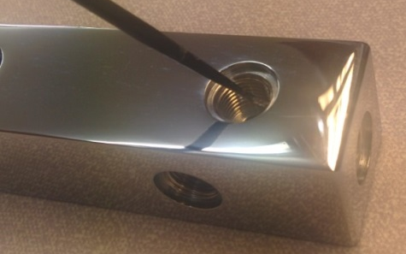
- Affix Tom Thumb label onto the front face of the block. | 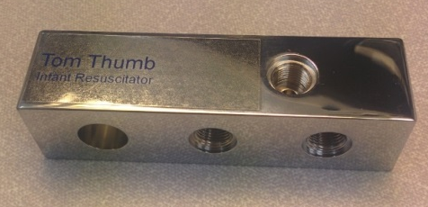
- Affix the part/serial number label to the rear face of the block. | 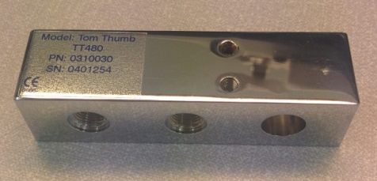
- Insert gauge seal (diamond copper washer) into the single threaded hole on the front face of body block. | 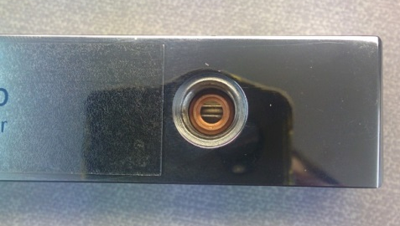
- Screw the pressure gauge in the single threaded hole on the front face of the body block. The gauge should appear straight in comparison to the block and not able to be removed without the aid of tools. Use 5/8 AF spanner to tighten. | 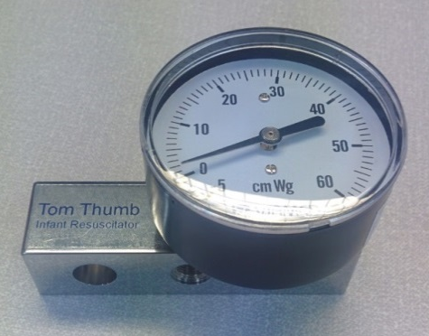
- Place 2 thin O rings onto the blocking bolt. | 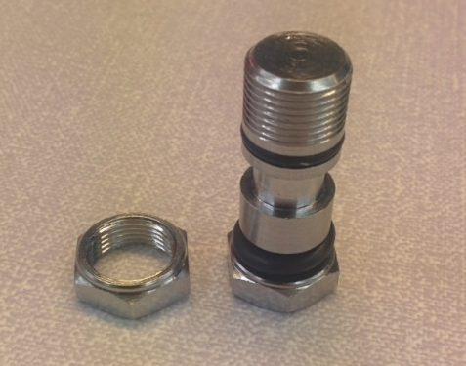
- Insert the blocking bolt with O rings into the hole at the top left side of the block. | 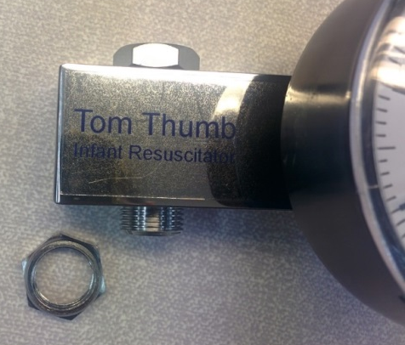
- Screw the flowmeter blocking bolt nut into position. Use 2x 5/8 spanner to tighten. | 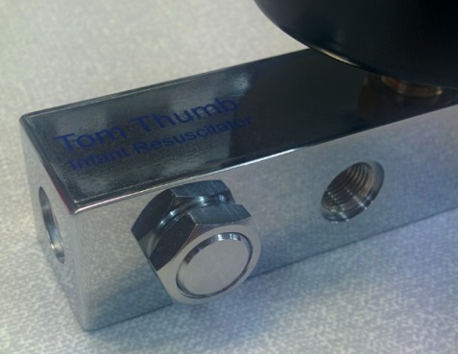
- Place a thin O ring over the thread of the adjustable valve. | 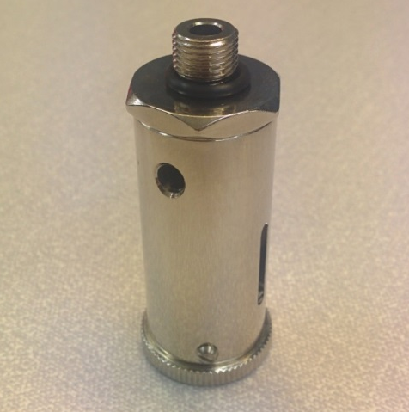
- Screw the adjustable valve into the remaining threaded hole in the top face of the body block. Use the 7/8 AF spanner to tighten. | 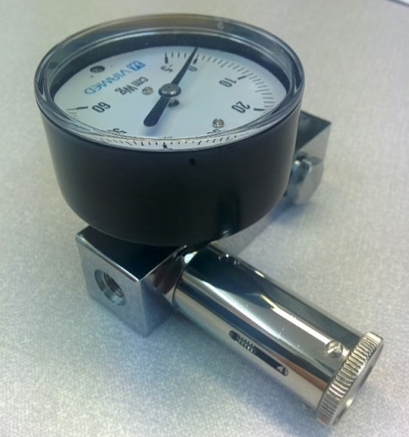
- Place a thin O ring over the thread of the precision valve. | 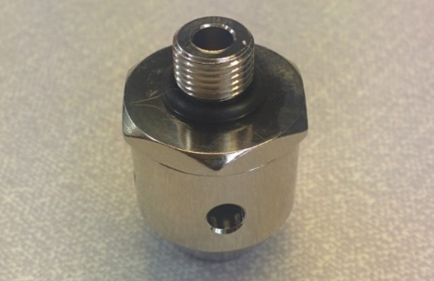
- Screw into the centre bottom threaded hole. Use 7/8 AF spanner to tighten. | 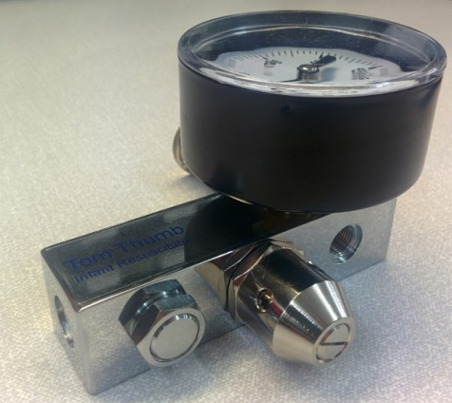
- Place a thin O ring onto the 10mm inlet. | 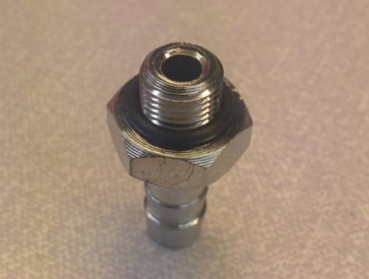
- Screw into the threaded hole on the left hand face. Use a 5/8 AF spanner to tighten. | 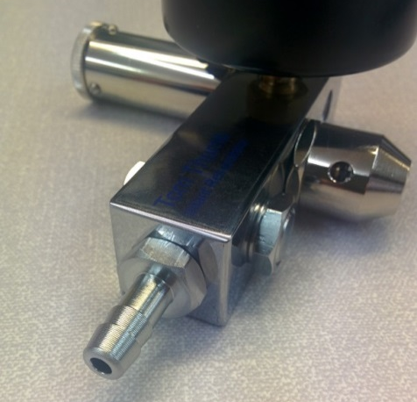
- Place a thin O ring over the thread of a blanking bolt. | 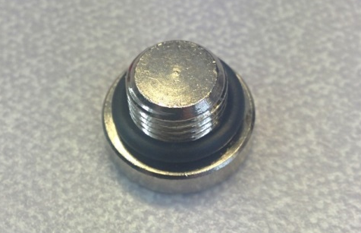
- Screw into the right hand threaded hole on the bottom face of the body block. Use a 5mm Allen key to tighten. | 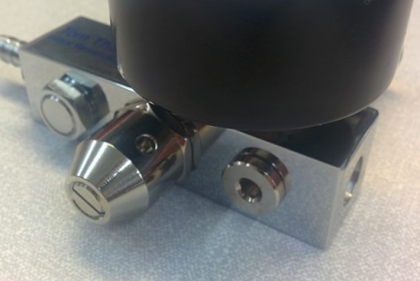
- Place a thin O ring over the threaded end of the 15mm outlet | 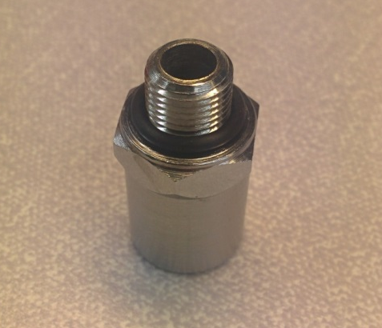
- Screw the 15mm outlet into the threaded hole in the right face of the body block. Use 5/8 AF spanner to tighten | 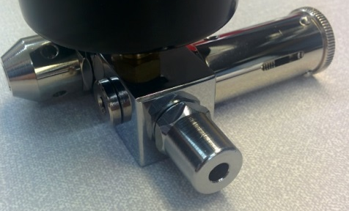
- Attach the spacer block to the body block using 2x M4x10mm hex drive bolts. Use a 3mm Allen key to tighten. | 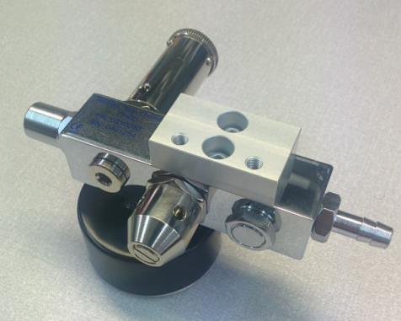
- Attach rail clamp to the spacer block using 2x M4x10mm hex drive bolts.  Use a 3mm Allen key to tighten. | 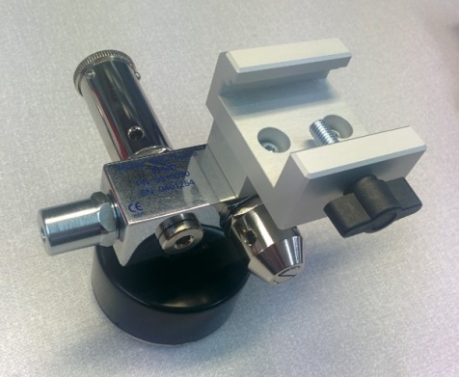
- Set the adjustable valve to minimum and attach the valve label. | 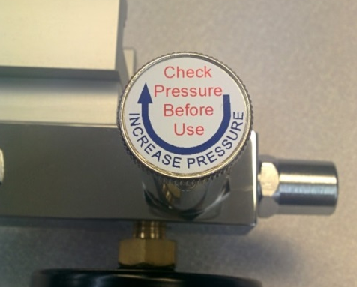
- Affix the caution label. | 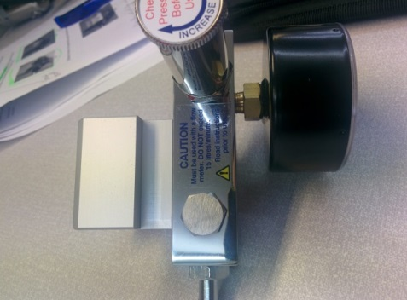
- Affix the address label to the underside of the pressure gauge. | 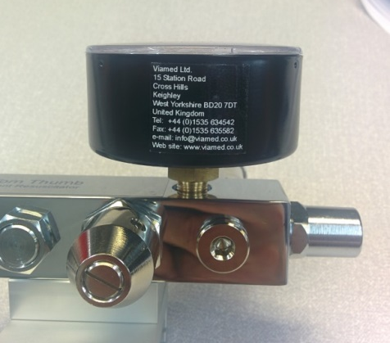
- The finished unit is now ready for testing and calibration. | 