«DEAR» «CONTACT»
«TITLE»
«DEPARTMENT»
«COMPANY»
«ADDRESS1»
«ADDRESS2»
«ADDRESS3»
«CITY» «STATE»
«ZIP»
May 2019
Dear «UPOSITION»,

Oxygen Monitoring Range including the OxiQuant S and Handi+ Oxygen Analysers
Viamed continually reviews its ranges and has recently added the OxiQuant S and Handi+ Oxygen Analysers to its offering.  These units can be used to verify oxygen concentrations in gas mixtures, delivered by: gas supply lines, oxygen concentrators, blenders etc; and the Handi+ is also certified for spot checking oxygen percentages during patient treatment.  The following table highlights the benefits of these great units. | 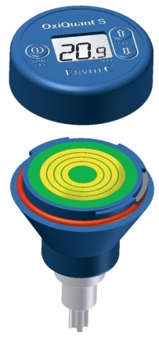 | 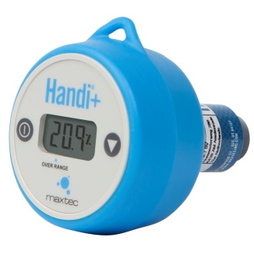
 | OxiQuant S | Handi+
Compact Size
Low Cost
Sensor  (replaceable sensor with integrated battery) |  | -
Disposable (integrated sensor and battery) | -
Manual Calibration (flexible) |  | -
Automatic Calibration | -
Auto Off | 3 minutes | 80 seconds
Quick Response Time
Warranty  - Device  - Sensor | 24 months  15 months | 24 months  -
T Adapter
Flow Diverter
22mm Oxygen Stem Connector
Oxygen Concentrator Adapter Cap
Accurate Readings – resolution to 0.1%
Used to determine oxygen concentrations in gas mixtures, delivered by oxygen concentrators, blenders…
Certified for spot checking oxygen percentages during patient treatment | -
CE Class | I  CE | II  CE0123

Oxygen Monitoring Catalogue…
The range also includes other oxygen analysers and monitors to measure oxygen levels in a number of different situations and applications, for example in ventilator circuits, oxygen hoods/tents, incubators, anaesthesia machines and CPAP circuits. These products can also be used to test medical equipment and gas supply systems to verify that the correct level of oxygen is being supplied.
For further information on this, please visit our website or for a copy of our latest UK Oxygen Monitoring Catalogue: www.viamed.co.uk/oxygenmonitoringcatalogue

The catalogue also includes the extended range of Medical Oxygen Sensors providing the widest range and the latest technology to offer the best value for money when using OEM and compatible oxygen sensors.

Should you require additional information on applications and compatibility, please visit our website – www.viamed.co.uk or go straight to our cross reference www.viamed.co.uk/xref. For any further information please contact a member of our sales team on:
01535 634542
(Between the hours of 09:00 and 17:30)
Yours sincerely



Catrin Hollings
Marketing

