Aryan Vazhavila Raju
QA Analyst
Sedana Medical Ltd.
Unit 2A The Village Centre
Two Mile House Naas
Co. Kildare
Ireland

Dear Aryan Vazhavila
Viamed Ltd. distributes and supplies the following product to Sedana Medical.

REF: 8090121313V
Part number: 4421517
Gas Sampling Line - H Type
Length: 2.5m
Connectors: LLM to LLM
Box of 25

The product is manufactured by bluepoint Medical and is CE certified, but to date not cleared for use in the USA.

We understand that Sedana Medical intends to utilize the Gas Sampling Line H as described above in two Sedaconda clinical trials, identified as SED003 and SED004.

Sedana Medical has proposed a label (see below) to be applied to each individual Gas Sampling Line H pouch packaging and also to the outer box packaging. The label identifies the devices as for investigational use only for purposes of the study.

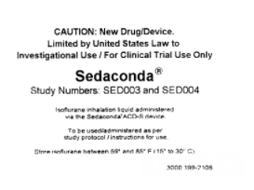

We hereby approve of the application of this label to the packaging of Gas Sampling Line - H Type (REF 809121313V, part number 4421517), subject to the following conditions:

None of the existing labelling is to obscured.

Liabilities for use and insurance related to use of the devices for the identified studies are the sole responsibility of the study sponsor.

For purposes of traceability, we request that Sedana Medical agree to confirm in writing upon request a list of device LOT numbers for which the label has been applied - a countersignature below will be sufficient to confirm.

For purposes of ongoing surveillance, Sedana Medical agrees to notify Viamed Ltd. of any adverse events which are specific to the performance of the Gas Sampling Lines.

Confirmation signature on behalf of Sedana Medical:

Name:

Position:

Date:

Yours sincerely

Bernd Linder
bluepoint MEDICAL GmbH & Co. KG

Date: 14th October 2021

