VM3COP??.?? Advisory Service Notice
Login to Intrastats as per VM3COP20.72.
Serviceable Items List
Go to Returns , then 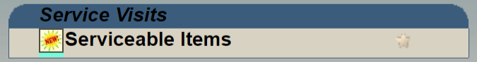.
This will bring up a list of services which are due within the next 3-4 weeks. The list contains invoices from new as well as from last time a product was serviced at Viamed.
Serviceable Items - Possible Chase ups for servicing screen
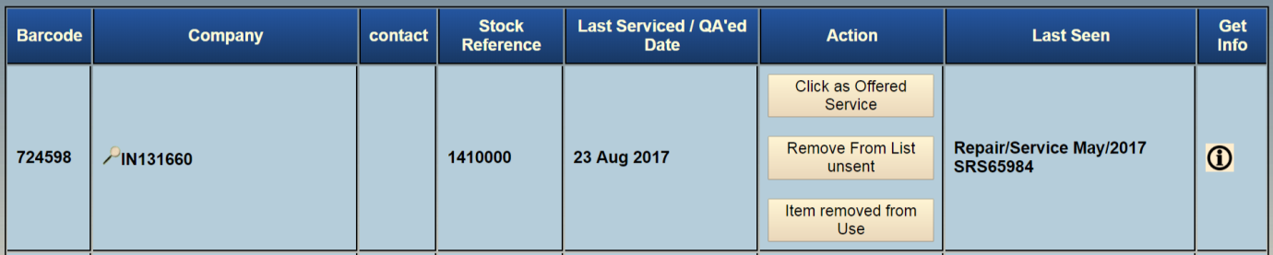
The contents of most of these columns are clickable to provide further information. For example clicking the barcode takes you to the history and QA of the barcode.
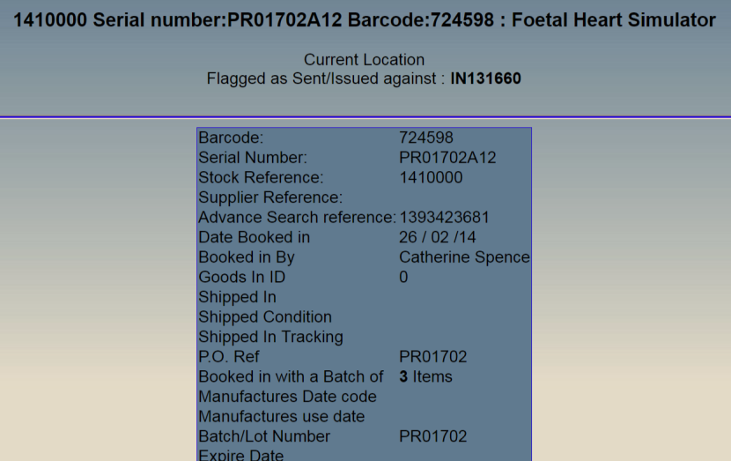
If the line shows an invoice number you can click the  and it will retrieve the company name, if available.
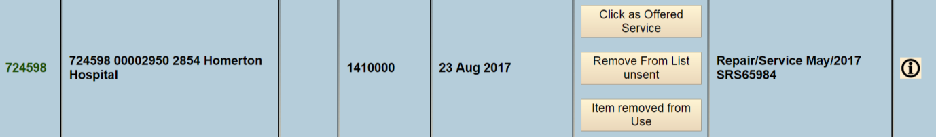
Note: Clicking the stock reference will filter the list to just show serviceable items for that part number.
Finding Sending out Advisory Servicing Requirements
Starting from the bottom of the list, find the first item to be serviced. There are two ways in which you can get the relevant information to send the letter.
- Click on the barcode, this will take you to the QA screen. From this screen you can click the invoice number.
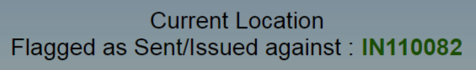
- Click on the IN/CRE number, this will open the invoice screen.
Please note: the delivery address may not be correct.
Within this screen you also have links to the PDF invoice, ORD checking etc.
Sending out Advisory Servicing Letters
Once you have found the relevant account details, find the contact required in Goldmine.
On the invoice screen it may provide a contact from whom the original order was received. Only use this contact if they are not based in the supplies/purchasing department.
Otherwise, letters are usually sent to the Department Manager of the EBME department, speak to marketing or UK sales if you are unsure.
- Login to GoldMine as per VM3COP20.72
- Locate the hospital and contact you have determined.
- Click 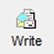, this will bring up the Document Management Center.
- Make sure the User is set to you. Locate the relevant Advisory Service Notice Letter
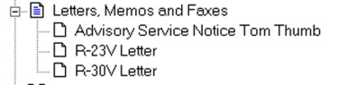
- Double click the letter you require, this will open the letter into your Word Processing application. Make sure all information has been transposed correctly, i.e. the address has been displayed correctly.

- From the invoice page in Intrastats, click the part number of the item to be serviced. This will show you the serial number of the product sent, use this information to fill in the details in the letter to the right of the address:
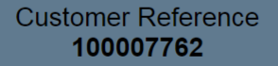
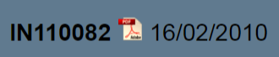
Purchase order number: *******
V1000 Serial number: *******
Invoice date: **/**/****

- Check all information is correct and print the letter to letterhead.
Please be aware that some letters are double sided so make sure you print to the colour printer with the doubled sided ability.

- Put the letter into a DL or C5 envelope and stamp the bottom right corner of the envelope with the red Advisory Service notice stamp.

- Place the letter in the post to be franked trays in the main warehouse.

- In Intrastats go back to the Serviceable Items page and click the “Offered Service button” on the relevant line. This will update the actions column, remove the buttons and put this:

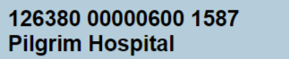

- Repeat until there are no active lines on the list.

