Steve:

The assembly steps of the cells are, at a high level:
- Assembly of digital O2 PCA with programmed microcontroller (you have this design and binary image)
- Note that the digital O2 MCU may also be programmed post-assembly, although this does add a step
- Assembly of digital O2 PCA with O2 cell, cell trimming should be as per your regular process
- Cell testing, analog connection as per your regular process
- Digital O2 data programming / testing

If you require, I can provide a programming fixture for the MCU.

I have also a programming fixture for the data programming. This fixture is designed to go in-line at the analog test station (analog pass-though) so that the analog cell test and digital data programming step can be done on the same fixture without moving the cell and little manual intervention. The programming fixture may be ganged up to 18 channels as shown:

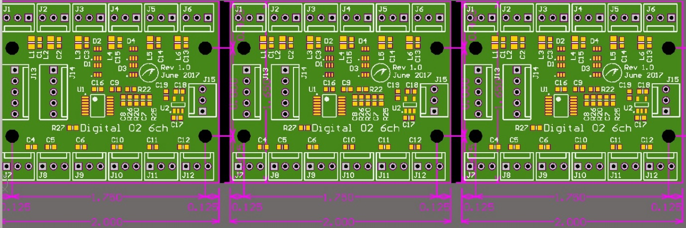

I also have a Windows application that can read a CSV data file and perform the programming operations through these boards. The programmed data is:
- Cell model name
- Manufacturer's ID
- Serial number
- Mfg date
- Expiry date
- Temperature calibration parameters
- PPO2 to mV calibration records for three analog test points, (PPO2, mV pairs)

I can provide these boards and application to you at no cost

