30th April 2018
User Manual queries and suggestions – Handheld Pulse Oximeter VM-2160

Manual used in conjunction with VM-2160 SMARTsat, installed with firmware:
version SCE V5.8 English

Page 2/28
Copyright 2010, should it be 2017?
HF: I thought the date does not change from first release of the document. Not correct?
Suggest change Distributor Contact information to Sales & Service contact information
HF: implemented

Page 5/28
Why have you stated insured/user ?
HF: was required in the German text to receive an official number from health insurance which allows easy billing of the device. But I removed it as it sounds strange in English…

Page 6/28
Should induced current be induced electrical current ?
HF: implemented

Page 7/28
Suggest changing:
Multifunction buttons used for
- Scrolling through menu items and
- Increasing/decreasing parameters.
to
Multifunction buttons used for:
- Scrolling through menu items.
- Increasing/decreasing parameter values.

HF: implemented

Page 8/28
- No mention of bar graph colour but covered later in the manual.
HF: added “The colour of the bar graph is an indicator for signal quality (refer to 2.3)”
- Suggest changing with strong to of good.
HF: implemented
- Suggest changing to Time-interval of trends
HF: implemented

Is the description for Display 3 to 5 valid?
Example shown of 15-minute trend display mode. Trend data is stored in parallel to on-going measurement.
Display 3 = 15-minute trend
Display 4 = 30-minute trend
Display 5 = 4-hour trend
HF: updated to be the same like for CapnoTrue
Display 3 to 5: Trend
(15 min, 1 h and 6 h Trend, parallel to ongoing measurement)

Page 10/28
Suggest changing always overlay alarms to always override alarms
HF: implemented
The high priority alarm appears to be with just a 1 second pause. Why have you stared two versions: 2 seconds pause and 3 second pause?
HF: indeed, it should be 1sec, thank you, great catch!!! Implemented correction
2 versions (1sec and 3sec) due to IEC_60601-1-8:
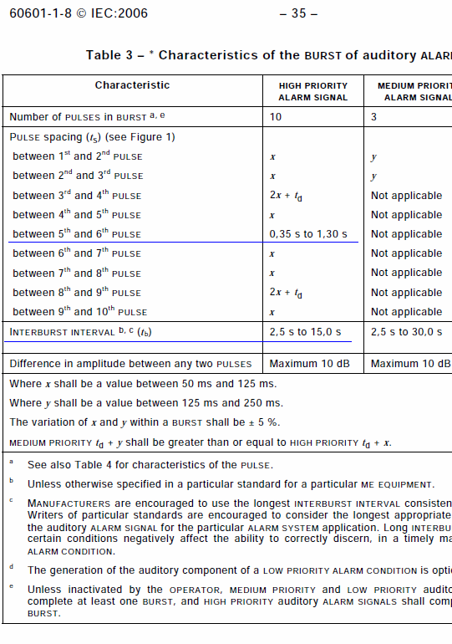

On the Low priority section suggest changing – Ambient light to – Excessive ambient light
HF: Not possible, too long to fit on display screen in monitor

Page 11/28
Suggest changing for a longer period of time to for a long period of time
HF: implemented

Page12/28
NOTE. In regard to the last warning, the single tone will not be heard if the loudspeaker has been switched off on the previous power down.

HF added description of start-up tone mute function in sections “2.1, 2.3, 3.3”.
Removed warning (not helpful, only confuses), instead added in section 3.4 “Ensure that the monitor is providing a reading and that the pulse tone can be switched on and off to verify proper operation.”

Page 13/28
NOTE. 3.5 Under what circumstances is the device considered not in use? If sensor removed from site or disconnected, the unit will not switch off.
HF: added “, provided no alarm condition is present”. Does this clarify enough?

Page 14/28
NOTE. Visual alarm - Only the critical value flashes yellow, the violated alarm limit turns yellow but does not flash!
HF: implemented correction

Page 15/28
4.1.3 should be Submenu: Setup not Submenu: Device setup
HF: implemented correction

Page 17/28
Suggest changing episodes like over-night to episodes such as over-night
HF: implemented correction

Page 18/28
4.2.2 Power-Save mode.
Do you know that if you keep your finger pressed, the screen flashes between two display formats. This does not look correct?
HF: implemented correction

Page 19/28
References EN ISO 9919:2005 rather than 80601-2-61 ?
HF: implemented correction

Page 20/28
Change The monitor generates uses and radiates to The monitor generates, uses and radiates
HF: implemented correction

Page 23/28
Pulse rate is specified as 2 Arms, shouldn’t this be a value of bpm i.e. 2 bpm?
So change from
20-300/Min. +/- 2 A_{rms}
To
20-300 bpm +/- 2 bpm
Do we need to state ‘no motion’?

HF: added (no motion).

According than 80601-2-61 need to also have Arms for pulse rate:

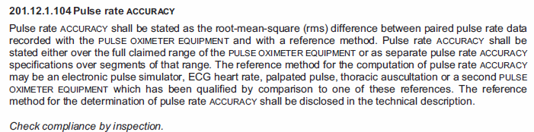

Page 24/25
IEC 60 601-1-8:2006 change to IEC 60601-1-8:2006
HF: implemented correction
No mention of the following, which there have been previous reference to:
IEC 60601-1-2:2014 (4th edition)
IEC 60601-1-11:2010
HF: we don’t have Test reports for these

Page 25/28
The pool consists of healthy, female and male with skin tones ranging from light to dark subjects that are 18 years of age or older.
Should be
The pool consists of healthy female and male subjects that are 18 years of age or older, with skin tones ranging from light to dark.
HF: implemented correction

At bottom of the page change (5 V DC )and to (5 V DC) and
HF: implemented correction

Page 26/28
Could we add our order numbers for each version?
0012165 – Central European
0012166 - Scandinavian
0012167 - Special European Character
HF: implemented
Why is Dutch in the Scandinavian package?
Historically due to a tender
Page 27/28
Please change REF 0014751 to 0014754
HF: implemented

Should we state that the wrap sensor is soft silicone. What about patient weight range, cable length (1.2M), cable material – silicone.
HF: implemented, however no weight indication as it depends on measurement site

Should we add the sensor wraps for the wrap sensor, 0014890?
HF: implemented. Do you sell them single, or in a box?

Can we add carrying case – soft pouch 0022178?
HF: implemented.
Should we add the cable lengths and cable material to the list of disposables?
Adult 0.45m cable, PVC
Paediatric 0.45m cable, PVC
Infant 0.90m cable, PVC
Neonatal 0.90m cable, PVC

HF: implemented.

