

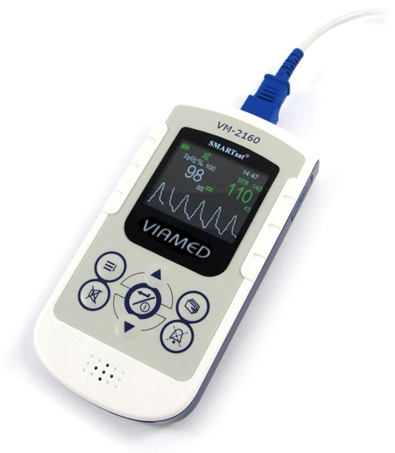

Handheld Pulse Oximeter VM-2160
User Manual
SMARTsat® Technology

VM-2160 (SMARTsat) User Manual

Version: EN 3.6
Released: 05/2018

The information in this document is subject to change without notice.

Copyright © 2010 bluepoint MEDICAL GmbH & Co. KG. All Rights Reserved.
This document contains proprietary information that is protected by copyright. All rights are reserved. No part of this document may be photocopied, reproduced or translated to another language without prior written consent of bluepoint MEDICAL GmbH & Co. KG.

Sales & Service contact information:

Viamed Ltd.
15 Station Road
Cross Hills
Keighley
West Yorkshire BD20 7DT
United Kingdom

Tel: +44 (0)1535 634542
Fax: +44 (0)1535 635582
E-mail: info@viamed.co.uk

www.viamed.co.uk

Declaration of Conformity

Manufactured by bluepoint MEDICAL GmbH & Co.KG, An der Trave 15, 23923 Selmsdorf, Deutschland, www.bluepoint-medical.com

 0482

This product meets the requirements of the 93/42/EEC guidelines for medical products.

Liability
bluepoint MEDICAL GmbH & Co. KG shall in no event be liable for any direct, indirect, special or consequential damages including without limitation damages for loss of business profits, loss of income, business interruption, loss of business information, loss of use or other related exposures, however caused, arising from the faulty or incorrect use of the product.
Bluepoint MEDICAL GmbH & Co. KG guarantees that the product delivered has been thoroughly tested to ensure that it meets its published specifications.

Warranty
bluepoint MEDICAL GmbH & Co. KG warrants the products manufactured or distributed by them to be free from faulty materials and workmanship for a period of 24 months from date of original shipment to first end user except for disposable products or products which have a stated guarantee longer or shorter than 24 months. bluepoint MEDICAL GmbH & Co. KG will perform warranty service at its factory.
The obligations for bluepoint MEDICAL GmbH & Co. KG under this guarantee shall be limited to repair, or at bluepoint MEDICAL GmbH & Co. KG 's discretion, replacement of necessary parts or assemblies and shall not include shipping costs or other incidental damages.
Claims for damages during shipment must be filed promptly with the transportation company. All correspondence concerning the products must specify both the name of the product and its serial number as written on the label on the product.
Use of the equipment for other than its intended use, or if it has been repaired by anyone except bluepoint MEDICAL GmbH & Co. KG or a bluepoint MEDICAL GmbH & Co. KG authorized service centre, or altered or modified or used without following the instructions in the user manual, will void this guarantee.

Trademarks
bluepoint MEDICAL GmbH & Co. KG owns the following registered trademarks:
SMARTsat®

Table of Contents
1 Intended Use - Warnings 5
2 Controls – Symbols – Display Modes 7
2.1 Controls and User Interfaces 7
2.2 Display Modes and Displayed Data 8
2.3 Symbols and Indicators 9
2.4 Audible Indicators 10
2.4.1 Pulse Tone (Beep) 10
2.4.2 Alarm Signals and Priorities 10
2.4.3 Battery Alarm 10
2.4.4 Audible Alarm Volume 10
2.4.5 Resetting of alarm signals 11
3 Preparation for Use 11
3.1 Battery Installation 12
3.2 Connecting the SpO₂ Sensor 12
3.3 Switching on the Device 12
3.4 Commencing Monitoring 13
3.5 Switching off the Device 13
4 Screen Contents – Menu Structure 13
4.1 Main Menu 13
4.1.1 Submenu: Alarm Settings 14
4.1.2 Submenu: Data Management 14
4.1.3 Submenu: Setup 15
4.1.4 Default Start Settings 17
4.2 Other 17
4.2.1 Volume Control Shortcut 17
4.2.2 Power-Save Mode 18
5 Troubleshooting guide 18
5.1 Adverse effects on SpO₂ measurement 18
5.2 Error Message – Cause - Corrective Action 18
5.3 Problem – Cause - Corrective Action 19
5.4 Problems with EMI (Electromagnetic Interference) 19
6 Maintenance – Cleaning – Testing 20
7 Symbol Definitions 22
8 Technical Specifications 23
9 Clinical study 25
10 VM-2160 PC-Software 25
11 Scope of delivery and order numbers 26

Intended Use - Warnings
The VM-2160 handheld pulse oximeter is intended for continuous or spot check monitoring of functional arterial oxygen saturation (SpO₂) and pulse rate of adult, paediatric and neonatal patients.

To be used by trained healthcare professionals only. For use in the home care environment the user may use the device after instruction by, or under supervision of, a trained healthcare professional.

Depending on the SpO₂ sensor connected, the VM-2160 may be used in hospital, hospital type facilities, transport, emergency care and mobile environments; as well as in the home care environment (see section 11 for more detail on sensors and field of application).
Warning:
Warnings are identified by the WARNING symbol shown above. Warnings alert the user to potential serious outcomes, such as death, injury, or adverse events to the patient or user.
Warning:
Do not make any clinical judgments based solely on the VM-2160. The monitor is intended only as an adjunct in patient assessment. It must be used in conjunction with clinical signs and symptoms. The interpretation of the measurement values should be done only by trained healthcare professionals.

Warning:
Explosion hazard, do not use VM-2160 in the presence of flammable anaesthetic mixtures with air, oxygen or nitrous oxide.

Warning:
Routinely monitor the patient to ensure that the VM-2160 is functioning and the sensor is correctly placed.

Warning:
Pulse oximetry measurements and pulse signals can be affected by certain environmental conditions, sensor application errors, and certain patient conditions. See the appropriate sections of this manual for specific safety information.

Warning:
Certain physiological conditions, medical procedures, and external agents may interfere with the monitor‘s ability to detect and display accurate measurements. (Chapter 5.1 provides information on possible interferences)

Warning:
For the measurement, the SpO₂ monitor uses red and infrared light with specific fixed wavelengths. Consider that these wavelengths might influence diagnostic parameters of other optical applications. The utilized wavelengths are listed in the instructions for use of the specific sensor.

Warning:
If you are uncertain about the accuracy of any measurement, check the patient’s vital signs by alternative means, then ensure that the VM-2160 is functioning correctly.

Warning:
The use of accessories, sensors, and cables other than those specified may result in increased electromagnetic emission and/or create invalid readings of the VM-2160.
Warning:
In high ambient light conditions it is required to shield the sensor application site with opaque material. Excessive ambient light may result in inaccurate measurements.

Warning:
Do not silence the audible alarm function or decrease the audible alarm volume if patient safety could be compromised.

Warning:
The VM-2160 is a prescription device to be operated only by trained personnel. The monitor is for attended monitoring only.

Warning:
No modification of VM-2160 and the accessories is allowed.

Warning:
As with all medical equipment, carefully route patient cabling to reduce the possibility of patient entanglement, strangulation, or injury to the patient

Warning:
The VM-2160 is not defibrillator proof. Remove the sensor from the patient throughout defibrillation or whilst an electrosurgical unit is in use, so as to avoid shock to the caregiver or patient.

Warning:
Disconnect the VM-2160 and sensor from the patient throughout computed tomography or magnetic resonance imaging (MRI) scanning. Induced electrical current could potentially cause burns.

Warning:
Pulse oximeter equipment measurements are statistically distributed. Only about two-thirds of measurements can be expected to fall within ± A_{rms} of the measured values by a CO-Oximeter. To verify the function of pulse oximeter probes a functional tester like Index II or equivalent can be used.
Warning:
A functional tester like Index II or equivalent can only be used to test the function of a sensor; it can’t be used to test the accuracy of an oximeter.

Warning:
Do not change the batteries or clean the device or sensors whilst in use or connected to a patient.

Controls – Symbols – Display Modes

Controls and User Interfaces
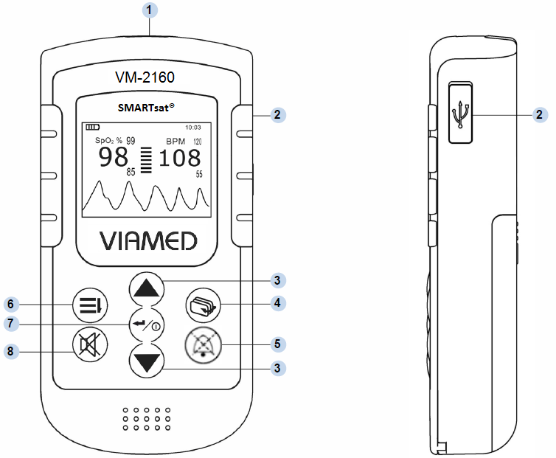
Front view
Side view

No. | Symbol | Features/Button | Function
1 |  | Sensor Port | Port for SpO₂ sensor
2 |  | USB | USB 2.0 interface
3 |  | Arrow Buttons  (up/down) | Multifunction buttons used for  - Scrolling through menu items.  - Increasing/decreasing parameter values.  - From monitoring display modes: can be used as shortcuts to volume/display power save mode
4 |  | Display Mode | Toggles between various display modes
5 |  | Alarm silenced | The audible alarm can be silenced for a maximum period of two minutes. Optical alarm remains activated.
6 |  | Menu | Menu selection
7 |  | ENTER button,  On/Off | Confirms selection  To turn on the device: press and hold power button briefly.  To turn off the device: press and hold power button for approx. 3 seconds.
8 |  | Pulse Tone | Turns pulse tone on/off.  Turn start tone on/off.

Display Modes and Displayed Data

Toggling Between Display Modes
The operator can toggle between various display modes by pressing button.

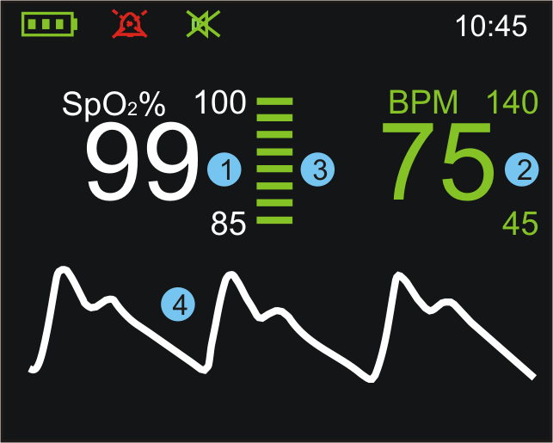  Display 1 | - The SpO₂ value shows the blood oxygen saturation level expressed as a percentage. The small numbers shown immediately above and below the measured value on the right side indicate the upper and lower alarm limits.  - Pulse rate in beats per minute. The small numbers immediately above and below the measured value on the right side indicate the upper and lower alarm limits.  - Bar graph for pulse amplitude. Indicates the dynamic pulse amplitude and rate. As the detected pulse becomes stronger, more bars light with each pulse. The reverse is true for weak pulses. The colour of the bar graph is an indicator for signal quality (refer to 2.3)  - Pulse waveform (plethysmogram). The reading is automatically adjusted to the pulse strength; therefore, a waveform of good amplitude should be visible at all times.  - Time-interval of trends  - Trend waveform for SpO₂ with continuous upper and lower alarm limits in yellow  - Trend waveform for pulse rate with continuous upper and lower alarm limits in yellow  - Pulse indicator  - Start and end times
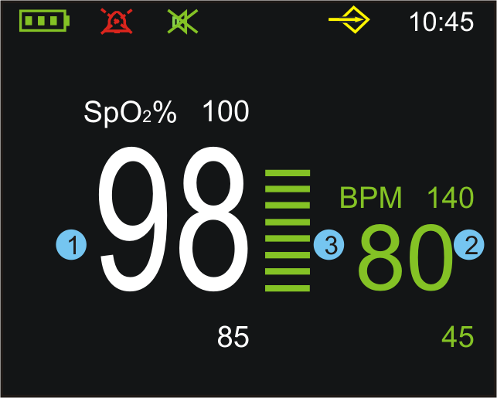
Display 2

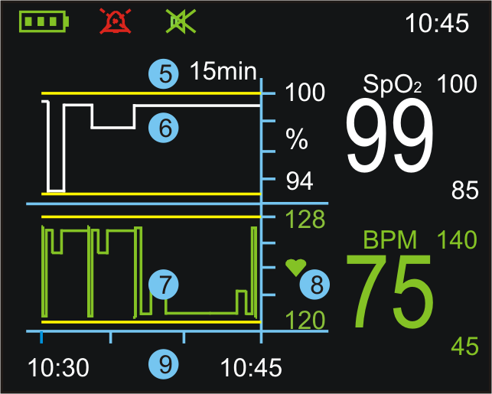
Display 3 to 5: Trend
(15 min, 1 h and 6 h Trend, parallel to ongoing measurement)

Symbols and Indicators

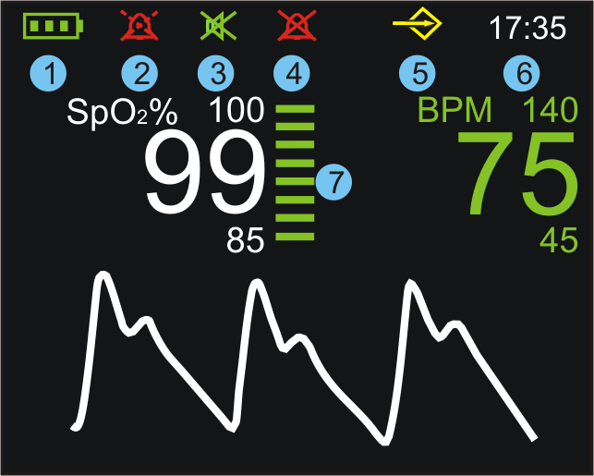

No. | Symbols/Indicators | Definition
1 |  | Battery level indicator. The three segments represent the battery charge level. The symbol flashes red when the battery capacity is low.
2 |  | Alarm silenced indicator. The audible alarm can be silenced for a maximum period of two minutes. Optical alarm remains activated.
3 |  | Pulse tone off. Start tone off at next switch on.
4 |  | Alarm silenced indicator (permanent). Optical alarm remains activated. This can only be activated in the SERVICE MENU.
5 |  | Memory symbol.  The device’s memory for measurement data is full. No new data can be stored. Old data can be erased or overwritten.
6 |  | Current time, displayed in 12h or 24h format.
7 |  | The colour of the bar graph is an indicator for signal quality.  - Green: good signal quality, very accurate measurement.  - Yellow: average signal quality, measurement may be inaccurate.  - Red: poor signal quality, unreliable measurement.

Audible Indicators

Pulse Tone (Beep)
During monitoring a pulse beep is audible for every detected pulse. The pitch of the pulse tone is dependent on the measured SpO₂ value. A higher pitch is indicative of higher oxygen saturation. The pulse tone volume can be adjusted under the menu item “Volume”. The pulse tone can be also silenced using the button. Pressing the button a second time will reactivate the pulse tone.

Alarm Signals and Priorities
The VM-2160 differentiates between alarms of high, medium and low priority. An alarm of higher priority will always override alarms of respective lower priority. Vice versa, an alarm of high priority cannot be silenced by a following alarm of lower priority.

Priority | Audio Signal Sequence (repeatedly) | Alarm Cause
High | BEEP_BEEP_BEEP___BEEP_BEEP  1 seconds pause  BEEP_BEEP_BEEP___ BEEP_BEEP  3 seconds pause | - Bad signal quality (no pulse signal found)  - SpO₂ below 60 %  - Battery low (last two minutes before switch off)
Medium | BEEP_BEEP_BEEP  5 seconds pause | - Violation of the SpO₂ or pulse alarm limits  - Battery low (see 2.4.3)
Low | BEEP_BEEP  16 seconds pause | - Probe off  - No sensor  - Ambient light  - Sensor fault  - Device defective  - Data memory full

Battery Alarm
When the device is switched on and a critically low battery level is detected, it will not start operating and a “Low battery” message will be displayed.

If the batteries reach a critically low level during monitoring, the battery indicator will start to flash yellow and an audible warning signal of medium priority will be generated. After one minute, the battery indicator turns red and an audible warning signal of high priority is generated. This warning signal will remain active for two minutes, at which point the device will automatically switch off.

Audible Alarm Volume
The alarm volume is not adjustable; however, it is possible to silence the alarm for a period of two minutes using the  button.

Resetting of alarm signals
Once triggered, an alarm will only be reset if the cause of the alarm has been resolved. Individual alarm limits can also be completely deactivated if necessary. Alarm signals can be confirmed and reset by pressing and holding the button .

If the initial condition for the warning is still present after resetting the warning signals, the warning will return immediately. In case of the alarm signals “Probe off!” and “No sensor!” the device switches to the on-position. Parameters which have been set by the user will be kept on alarm reset.

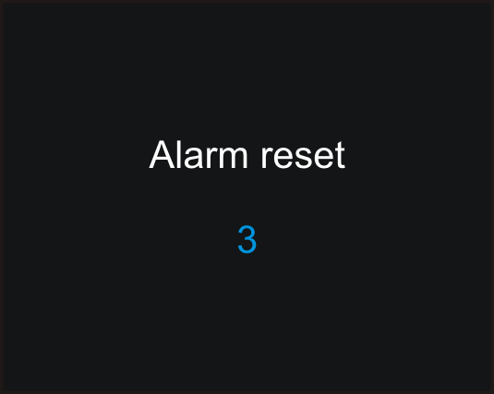 Press and hold button

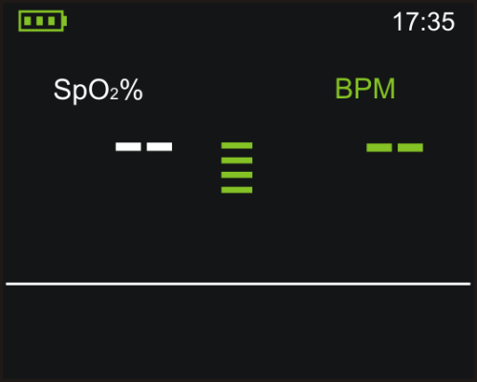 Display after reset

Preparation for Use

Caution:
The use of rechargeable instead of alkaline batteries may cause a shorter operating time of the device.

Caution:
Ensure that the speaker is clear of any obstruction and that the speaker holes are not covered. Failure to do so could result in an inaudible alarm tone.

Caution:
Remove the batteries if the device is to be stored, transported or not used for a long period of time.

Battery Installation

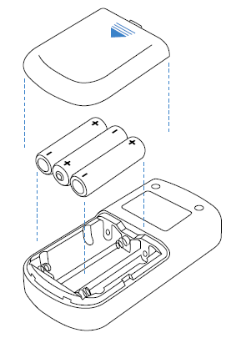
- Slide down the cover of the battery compartment on the rear panel of the device.
- Insert three batteries (1.5 Volt, AA), ensuring the correct orientation in accordance with the polarity markings.
- Slide the battery compartment cover back into initial position to close.

Warning:
Batteries may leak or explode if used or disposed of improperly. Please dispose of in accordance with your local ordinances and regulations.
Warning:
Explosion hazard, do not use AA rechargeable Lithium-ion batteries.
Use only Alkaline (1.5 Volt, Type AA LR6) or rechargeable NiMh AA (1.2 Volt, Type AA HR6, 1200 mAh)

Connecting the SpO₂ Sensor
Insert the sensor cable into the sensor port located on the top edge of the device, ensuring correct orientation of the sensor connector and the port.

Visual check
Before beginning operation, ensure that the device and sensor are not damaged.

Warning:
Do not use sensors or cables that appear to be damaged. Do not use a sensor when optical components are exposed. Do not use a device that appears damaged. Replace monitor immediately in cases of visible damages.

Warning:
Ensure that the speaker is clear of any obstruction and that the speaker holes are not covered. Failure to do so could result in an inaudible alarm tone.

Switching on the Device

Press and hold the on/off button briefly until an opening ‘welcome screen’ appears. The device performs a self-test. After the power on self-test is successfully completed the device is ready for monitoring. A start tone will sound after power on, provided the pulse tone has not been switched of before.

Commencing Monitoring
Once the sensor is connected and correctly positioned on the patient, monitoring begins automatically. Refer to the sensor ‘Instructions For Use’ to determine if an appropriate sensor is being used, and if it is applied correctly. Ensure that the monitor is providing a reading and that the pulse tone can be switched on and off to verify proper operation.
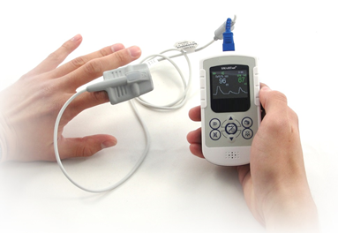

Switching off the Device
Press and hold the on/off button for approx. three seconds to switch off the device. The VM-2160 device will also power off automatically after two minutes when not in use, provided no alarm condition is present

Screen Contents – Menu Structure

Main Menu

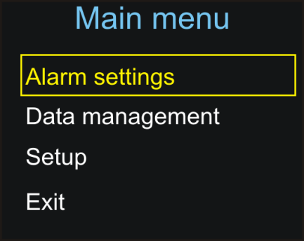 | All important and frequently used settings are accessible through the main menu, which can be opened by pressing the button .

Navigating the Menu
Use the buttons to scroll through menu items. The currently selected menu item is highlighted by a coloured frame. Press the button to confirm your selection.
Entering Data
In some submenus it is possible to adjust a certain parameter. In this case the parameter can be increased or decreased using the arrow buttons. The value will increase or decrease more quickly when the respective button is held down. Press the button to confirm the new value.
Exiting Menu and Returning to Display
Press the display button at any time, in any menu to return immediately to the monitoring display.
If no button has been pressed for more than 30 seconds, the device will automatically return to the monitoring screen.

Submenu: Alarm Settings

General Information
The alarm limits for SpO₂ and pulse can be set individually. The current alarm limits are shown as small numbers above and below the measured values on the right side. If a measured value either exceeds the upper limit or falls below the lower limit, visual and audible alarms will be triggered immediately.

Visual alarm
When an alarm has been triggered the critical value will turn yellow together with the violated alarm limit and the critical value flashes. An alarm will also be triggered if the sensor is removed from the application site, if the signal remains poor over a long period of time or if the sensor is disconnected from the device, provided that valid measurement data has been recorded beforehand.

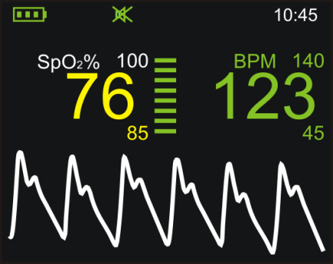 | Figure: Visual alarm which was triggered by a violation of the lower SpO₂ alarm limit.  Caution:  Do not set alarm limits to extreme values that can render the alarm system useless.

Adjust Settings
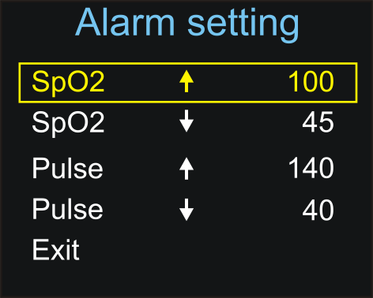 | Selection with buttons Selection/confirmation with button

Alarm Settings
Setting of the upper and lower alarm limits of the SpO₂ and pulse rate. “Off” deactivates the alarm limit. After restarting the device, the default alarm limits will be reset.

Submenu: Data Management

General Information
Recording Data
The VM-2160 device can store more than 560 hours of monitoring data. Each individual data set, regardless of its actual length, uses at least 15 minutes of memory space. A new data set is generated automatically each time the device is turned on. When the device is turned off, all of the measurements that were taken are automatically stored in the devices memory, together with the respective alarm limits, date and time. The device warns the user when the memory is almost full by displaying the  symbol. A maximum of 50 data sets can be stored in the memory. After this maximum has been reached the oldest data set is overwritten upon confirmation by the user. Stored data sets can be retrieved and erased under the menu item “Data management”. The data sets can be stored and processed with the user-friendly VM-2160 PC-Software.

Stored data will not be erased when the batteries are removed temporarily.

Data

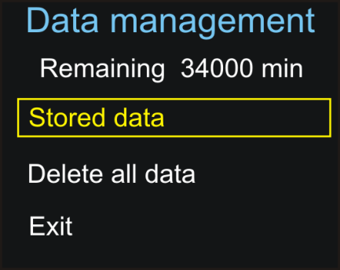 | Used Data Management menu to  - view remaining recording time in minutes  - access list of stored data sets  - delete all data in memory

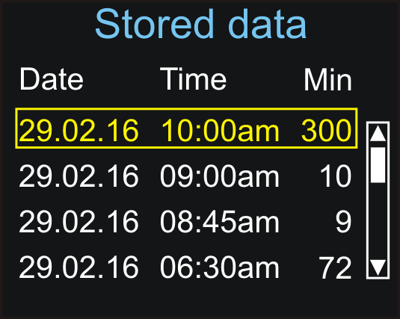 | Stored Data menu  List of all stored data sets. Retrieve selected data set by pressing the button.

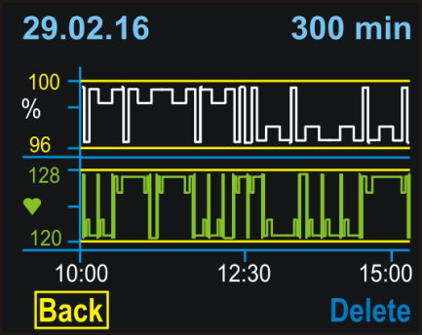 | Select “Back” to return to the list of stored data or “Delete” to erase the data set shown.

The stored measurements are displayed in graphic form together with the date, start time and duration of the recording. The SpO₂ reading is shown in white, and the pulse reading in green. The yellow lines represent the respective alarm limits.

Submenu: Setup

General Information

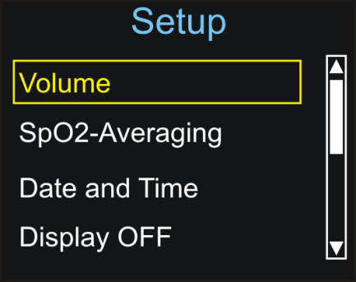 | 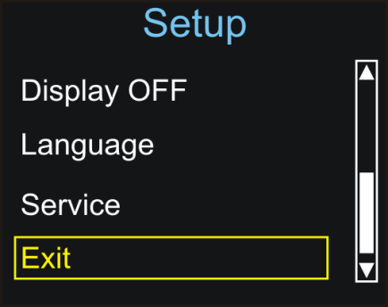 | This submenu offers access to various device settings; confirm selection by pressing the button.

Adjusting Settings
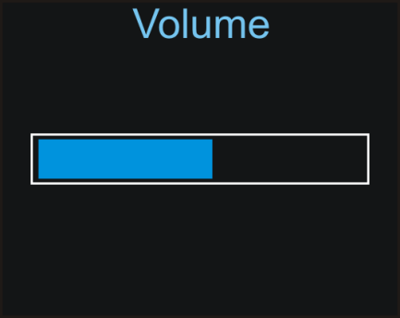 | Adjust the pulse tone volume using the buttons. Confirm new settings by pressing the button.

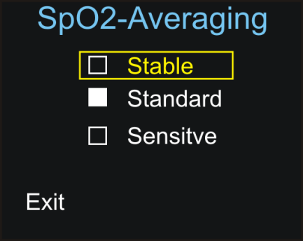 | Stable: When this setting is selected any strong and sudden variations in data will not immediately affect the reading (data incorporated over time); minor irregularities have little or no effect on the displayed reading.  Standard: Averaging parameters used for this setting are between those of the stable and sensitive settings.  Sensitive: The reading is more sensitive to irregularities but reacts very quickly to any changes in measured parameters.

Effects of the SpO₂ mean settings on the response time of the measurement:

Response Time Mode | Motion performance | Average response time
Stable | Highly motion resistant | 11 sec
Standard (default) | Motion resistant | 8 sec
Sensitive | Reduced motion resistance | 5 sec

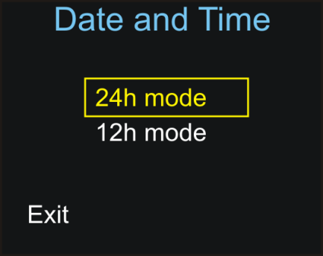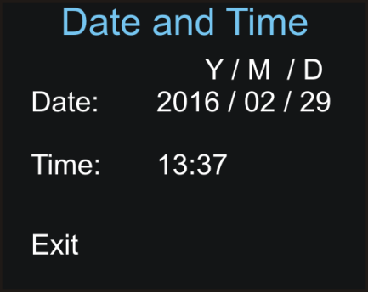

First, select between 12h mode and 24h mode; then set date and time. Settings for date and time are not erased when the batteries are temporarily removed.
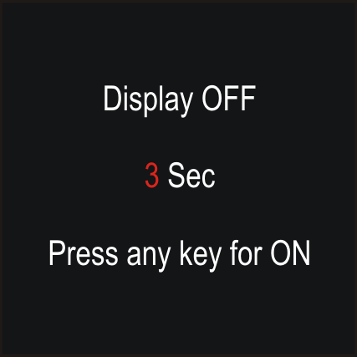 | Select display off to enter the Power Save Mode through the menu (refer to 4.2.2).

Note: Switching off the display during long measurement episodes such as over-night monitoring can prolong the battery life considerably!

 | Depending on the firmware, up to ten different language options are available here for selection. All messages and menus will be displayed in the selected language.

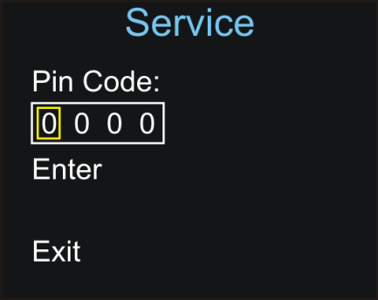 | Service:  The Service submenu is protected by a PIN code; only authorised service personnel can access this menu (only available in English).

Default Start Settings
Changed settings are in effect only as long as the monitor remains on. Once the monitor has been turned off, at the next start up, the default settings will be in effect. The start-up defaults can be changed in the PIN protected Service Menu. Only authorized service personnel have access.

The language and setting of pulse tone off are not reset during a restart of the device, the settings selected before will be stored.

Other

Volume Control Shortcut
If the button is pressed during any monitoring display mode the volume control screen will open. Adjust the volume using the buttons. Confirm new setting by pressing the button.

Power-Save Mode

The display can be turned off to save power and extend battery life. This can be accomplished by pressing the button once. A countdown will start, after which the display will be switched off. The device is now in economy power mode. The pressing of any button will reactivate the display. If an alarm is triggered, the display will be turned on automatically.

Troubleshooting guide

Adverse effects on SpO₂ measurement
Warning:
Physiological conditions, medical procedures, or external agents that may degrade pulse oximeter performance or affect the accuracy of the measurement include the following:

- Incorrect applications of the sensor
- Externally applied colouring agents such as nail polish or artificial nails
- Intravascular dyes
- Placement of the sensor on an extremity with blood flow restrictors (arterial catheters, blood pressure cuffs, infusing lines, etc.)
- Failure to shield the sensor site in high ambient light conditions
- Excessive patient activity
- Low perfusion
- Venous pulsations
- Anaemia or low haemoglobin concentrations
- Cardiac dysrhythmia like extrasystole or atrial / ventricular fibrillation
- Dysfunctional haemoglobin, e.g. caused by a carbon monoxide intoxication
- Electromagnetic interference
- Electrosurgical interference

Error Message – Cause - Corrective Action

“No sensor!” or “Sensor disconnected!”
The sensor is not connected properly to the device.
– Check sensor connection.

“Probe off!”
The sensor has been removed from the monitoring site.
– Check that the sensor is properly attached to the patient.

“Low battery!”, battery symbol flashing red
The batteries are almost completely discharged.
– Replace batteries immediately.

“Sensor fault!”
The connected sensor is either defective or not compatible with the device.
– Check sensor.

“Device defective!”
Fatal device error, e.g. resulting from improper handling, such as use with computer
tomography.
– Contact authorised service personnel or your local sales representative.

“Too much ambient light!”
High ambient light sources near the sensor, e.g. surgical lights.
– Shield sensor more effectively from external light.

“Bad signal quality”
Poor-quality pulse signal, for example as a result of low perfusion.
– Move the sensor to a different site on the patient or provide more effective monitoring conditions.

Problem – Cause - Corrective Action

Problem: There is no response to the Power button.
Cause – Corrective Action: Ensure that the Power button is fully depressed. The batteries may be missing, discharged, or oriented incorrectly. Install new batteries.

Problem: No pulse signal found or the pulse signal cannot be found anymore
Cause – Corrective Action:
a) Check the patient. Check the sensor instructions for use to determine if an appropriate sensor is being used and if it is applied correctly. Check sensor and extension cable connections. Test the sensor on another subject. Try another sensor or extension cable.
b) Perfusion may be too low for the monitor to track the pulse. Check the patient. Change the sensor site. Try another sensor. Test the monitor on a subject with good perfusion.
c) Interference due to patient activity may be preventing the monitor from tracking the pulse. Keep the patient still, if possible. Verify that the sensor is securely applied and replace it if necessary. Change the sensor site.
d) The sensor may be too tight, there may be interference due to ambient light, or the sensor may be on an extremity with a blood pressure cuff, arterial catheter, or intravascular line. Reposition sensor, as necessary.
e) Electromagnetic interference may be preventing the monitor from tracking the pulse. Remove the source of interference.

Problem: No pulse tone
Cause – Corrective Action: Continue to listen for the pulse beep tone as the monitor is used. If it does not sound with each pulse it indicates one of the following: Pulse beep volume is off. – Switch volume on. Speaker/audio has malfunctioned - Signal is corrupted. VM-2160 has stopped functioning. – Contact authorised service personnel or your local sales representative.

Problems with EMI (Electromagnetic Interference)
This device has been tested and found to comply with the limits for medical devices according to EN 60601-1-2:2007, EN 60601-1:2006, EN 60601-1-1:2001, ISO 80601-2-61:2011 and the Medical Device Directive 93/42/EEC. These limits are designed to provide reasonable protection against harmful interference in a typical medical installation.

Due to the proliferation of radio-frequency transmitting equipment and other sources of electrical noise in healthcare environments it is possible that high levels of such interference due to close proximity or strength of a source may result in disruption of performance of this device. Examples of noise sources in healthcare environments that could cause electromagnetic interference include:

- Electrosurgical units
- Cellular / Mobile phones
- Mobile two-way radios
- Electrical appliances
- High-definition televisions (HDTVs)

The pulse can be obscured by electromagnetic interference. During such interference measurements may seem inappropriate or the monitor may not seem to operate correctly.
Disruption may be evidenced by erratic readings, cessation of operation or other incorrect functioning. If this occurs, the operating environment should be surveyed to determine the source of disruption and the following actions taken to eliminate the source:

- Turn equipment in the vicinity off and on to isolate the offending equipment.
- Reposition or relocate the interfering equipment.
- Increase the distance between the interfering equipment and this equipment.

The monitor generates, uses and radiates radio frequency energy. Failure to follow these instructions may cause harmful interference with other devices in the vicinity.

Maintenance – Cleaning – Testing

Maintenance
The monitor requires no calibration. Repair or service of the device may only be performed by authorised service personnel with service qualification by the manufacturer. If service is necessary, contact the manufacturer or your local sales representative. The contact address and phone numbers are listed on the last page.

Caution: There are no user-serviceable parts inside the VM-2160. The cover should only be removed by authorised service personnel.

Caution: Follow local, state and national governing ordinances and recycling instructions regarding disposal or recycling of the device and device components, including batteries.

Cleaning
Use a soft cloth dampened with either a commercial, nonabrasive cleaner, or a solution of 70% alcohol in water. Lightly wipe the surface of the monitor.

Caution:
Clean contaminated and/or dirty equipment before returning, following the cleaning procedure described below.

Caution:
Clean the device separately from the sensors. For instructions on cleaning pulse oximeter sensors, refer to the respective sensor instructions for use.

Caution:
Do not use caustic or abrasive cleaning agents on the device or the sensors.

Caution:
Do not immerse the VM-2160 in any liquid. Do not spray, pour, or spill any liquid on the VM-2160, its accessories, connectors, switches, or openings in the enclosure as this may damage the monitor.

Note: Clean the VM-2160 once per week or more frequently if the handled by multiple users.

Disinfection
Use a soft cloth saturated with a solution of 10% chlorine bleach in tap water.

Caution:
The device may not be sterilized either with superheated steam or with hot air!

Caution:
Do not autoclave or immerse the device or sensors in liquid. Do not expose the device or components to excessive moisture or liquids.

Testing

Test of the alarm system
In order to trigger an alarm for test purposes during monitoring set the upper alarm limit of SpO₂ or pulse rate below the currently indicated measurement value. The device will react with a visual and an audible alarm.

Test of the measurement accuracy
The only reliable method of testing the measurement accuracy of a SpO₂ monitor is the clinical validation of the measurement data, indicated by the system monitor with sensor on the basis of a blood gas analysis. During extensive clinical studies, the monitor combined with the approved sensors evidenced the accuracy required.

Warning:
A functional tester cannot be used to assess the accuracy of a pulse oximeter monitor or sensor.

Symbol Definitions
 | Accompanied with “Warning: Supplementary text.” within this document. Warnings indicate potential harmful conditions that may lead to injury or death.
Accompanied with “Caution: Supplementary text.” within this document.
Cautions indicate conditions that may lead to damage to or malfunction of the device.
Note: | Denoted as “Note: Supplementary text.” within this document.  Notes inform the user to relevant facts and conditions in connection with the device.
 | Consult User Manual for detailed operating information.
 | Consult accompanying documents for important safety-related information.
 | Manufacturer
 | Type BF applied parts
 | Catalogue number / Part number
 | Serial number
 | Temperature limitation
 | Indicates that the transport package has to be kept out of heated areas.
 | Humidity
 | Fragile, handle with care
 | Do not dispose in the consumer waste. Electrical and electronic equipment shall be collected and recycled in accordance with (Directive 2002/96/EC).
CE 0000 | European Union approval (complies with 93/42/EEC Medical Device Directive).
IP32 | IP Code (International Protection Rating) according to IEC 60529.  IP3X: protection against tools, wires or similar objects with Ø > 2.5 mm, protection against solid foreign bodies with Ø > 2.5 mm.  IPX2: Protection against vertically falling water drops (up to a 15° angle) provided the device is in the intended position of use with the display facing the top while placed on the back.
 | Not made with natural rubber latex.
 | Not made with DEHP.

Technical Specifications

Measurement Range
SpO₂ | 0 – 100 %
Pulse Rate | 20 – 300 bpm (beats per minute)
Perfusion Index | 0.1 – 20 % (no motion)
Accuracy
SpO₂ | 60–100 % ± 2 A_{rms} (no motion)^{1, 4}  70–100 % ± 3 A_{rms} (motion)²  60–100 % ± 2 A_{rms} (low perfusion no motion,)³
Pulse Rate | 20–300bpm ± 2 A_{rms} (no motion)³
Range of Alarm limits
SpO₂ | 45–100 %
Pulse Rate | 20–300 bpm.
Average sound pressure level of the alarm signal at a distance of 1 m:
Low priority alarms | 58 dB(A)
Medium priority alarms | 59 dB(A)
High priority alarms | 60 dB(A)
Display (TFT colour display, 65000 colours, 128 x 160 pixels, 1.77”)
Data displayed | Oxygen saturation, pulse rate, plethysmogram, bar graph, short-term and longterm trends.
Indicators | Signal quality, pulse amplitude, battery status, alarm silenced, sensor detection, sensor disconnection.
Expected service life
VM-2160 | 5 years
Reusable SpO₂ sensors | 2 years
Reaction times First displayed value after application)
SpO₂ | Between 3 seconds and 7 seconds, depending on measurement conditions.
Pulse Rate | Between 5 seconds and 8 seconds, depending measurement conditions.
1) As inherent to their functional principle, pulse oximetry measurements underlie statistical spread; therefore only two thirds of the measurement data are within the specific range of +/- A_{RMS}
2) Tested with all motion patterns Fluke Index II Oximeter tester
3) Tested with Fluke ProSim 8 Oximeter tester
4) Applies to SC7500, refer to sensor specific results table 1

Trend Information
Long-term Trends | up to 560 hours
Short-term Trends | 15 min / 30 min / 240 min

Environmental Conditions
Operating conditions | -20 to +50 °C; 15 to 95% RH; 600 to 1300 hPa
Storage conditions | -30 to +70°C; 10 to 95% RH; 600 to 1500 hPa

Miscellaneous
Construction | Class IP32 degree of protection against foreign bodies and water provided the device is in the intended position of use with the display facing the top while placed on the back. For the classification of the sensor see instruction for use.
Electrical safety | Class of protection II / Type BF
Classification | Class IIb device, in accordance with MDD 93/42/EEC
Dimensions | (L x W x H): 11.8 x 6 x 2.5 cm
Weight | approx. 160 g (with batteries, without sensor)
Power Supply | 3 Alkaline batteries (1,5 Volt, Type AA LR6) Alternative: 3 rechargeable NiMh batteries, 1,2 Volt, Typ AA HR6, 1200 mAh
Battery Life | > 2 days of continuous operation, or approx. 5 days in power-save mode
Data Memory | More than 560 hours, maximum 50 datasets

Communication interface
USB 2.0 | ONLY connect devices via USB which provide safety extra low voltage 5V DC and double isolation according to IEC 60601-1 or IEC 60950-1.

Applied Standards
IEC 60601-1:2005 (3rd Ed); IEC 60601-1 (2nd Ed)
IEC 60601-1-2:2007 (3rd Ed)
EN ISO 80601-2-61:2011; EN ISO 9919:2009
ISO 14971:2007; IEC 60601-1-6:2010; IEC 60601-1-8:2006
ISO 10993-1:2009; ISO 10993-5:2009; ISO 10993-10:2010

Note: This product complies with ISO 10993-1, Biological Evaluation of Medical Devices
Part 1: Evaluation and Testing.
Note: This device is not made with natural rubber latex or DEHP.

Clinical study

SpO₂ Accuracy:
To validate the SpO₂ accuracy controlled hypoxia studies are conducted on a pool of consenting subject volunteers at an independent research laboratory. The pool consists of healthy female and male subjects that are 18 years of age and older, with skin tones ranging from light to dark. . In the range of 60 – 100% the measured SpO₂ value (arterial haemoglobin saturation) of the sensors is compared to SaO₂ value (arterial haemoglobin oxygen) in comparison to blood gas analyser samples.
The determination of accuracy is stated in terms of the root-mean-square (A_{rms}) difference between measured values (SpO₂) and reference values (SaO₂) for all subjects and relates to the ISO 80601-2-61 Medical electrical equipment – Part 2-61: Particular requirements for basic safety and essential performance of pulse oximeter equipment.

The table below presents the detailed measurement results of the study for each sensor respectively.
Table 1: SpO₂ accuracy validation results - VM-2160 (SMARTsat®)

 | A_{rms} by SaO₂-Ranges ²⁾
Sensor type | 60–100 % | 70–100 % | 90–100 % | 80–90 % | 70–80 % | 60–70 %
10-AP | 2,5 | 2,4 | 2,1 | 2,3 | 2,6 | 3,4
EP7500 | 2,4 | 2,3 | 1,4 | 1,6 | 3,2 | 3,3
SC7500 ¹⁾ | 1,7 | 1,6 | 1,5 | 1,8 | 1,7 | 2,4
SF7500 | 1,6 | 1,5 | 1,4 | 1,4 | 1,7 | 2,0
W7500 | 1,7 | 1,6 | 1,3 | 1,5 | 1,9 | 2,4

1) Accuracy statement applies to SC7500, SCM7500 and SCP7500
2) As inherent to their functional principle, pulse oximetry measurements underlie statistical spread; therefore only two thirds of the measurement data are within the specific range of +/- A_{RMS}

Warning:
A functional tester (like Index II or equivalent) may not be used to validate SpO₂ accuracy. A functional tester can be used to verify the function of pulse oximeter probes.

VM-2160 PC-Software
With the user-friendly VM-2160 PC-Software all saved data can be stored on a PC via the USB interface. This software offers a multitude of functions for more advanced analysis and archiving of the measured data.

System Requirements for using the PC Software:
- Windows XP SP2, Windows 2000 SP4, Windows Vista, Windows 7, Windows 8, Windows 8.1, Windows 10
- Microsoft.net Framework 4.0 or higher (latest version is installed on your PC while installing the VM-2160 PC-Software)
- CPU: Pentium 1 GHz or higher
- RAM: 512 MB RAM or more
- Super VGA (800 x 600) or higher-resolution video adapter and monitor
- One free USB 2.0 port USB which provide safety extra low voltage (5 V DC ) and double isolation according to IEC 60601-1 or IEC 60950-1
- Keyboard and mouse or compatible pointing device
- Available hard disk space: x86 – 600 MB, x64 – 1.5 GB
- To install the PC-software you must have Administrator rights
- Install the USB driver CP210xVCPInstaller delivered together with the PC Software
- Install the delivered VM-2160 PC Software
Caution:
Changing the PC Operating System, the USB Drivers or the Microsoft.net Framework version may result in malfunction of the VM-2160 PC-Software due to incompatibility.

Caution:
Bad connectivity of the USB cable or incompatibility with the PC Operating System, the USB Drivers or the Microsoft.net Framework can result in errors during download of data.
In such case an error message will be displayed by the PC software. Note that data will not be deleted on the device. Try the data download again on a PC with correct System Requirements.
For more information please read the enclosed software manual.

Scope of delivery and order numbers

Scope of delivery:
VM-2160 (SMARTsat) complete device:
1 x VM-2160 (SMARTsat), pulse oximeter
1 x Reusable SpO₂ sensor (selectable, see order numbers*)
1 x Lanyard
1 x Silicone protector
3 x AA batteries
1 x USB data cable
1 x User manual and PC software (CD-ROM)
1 x Quick start guide
1 x Hard Shell Carry Case

* Order numbers - VM-2160 (SMARTsat) complete device:
Please indicate language version and SpO₂ Sensor Style when ordering.

- Language Version¹⁾

REF | Type | Language Version | Lanugages
12020112001E | 0012165 | Central European | English, Afrikaans, Dutch, French, German, Hungarian, Italian, Polish, Portoguese, Spanish
12020112001N | 0012166 | Scandinavian | English, Danish, Dutch, Finish, Swedish
12020112001S | 0012167 | Special European Character | English, Greek, Russian, Turkish
¹⁾Refer to Viamed Ltd. for detailed information on the current languages available.

- SpO₂ Sensor Style
SC7500VM, SCM7500VM, SCP7500VM, W7500VM, EP7500VM, SF7500VM

Accessories and replacement parts for use in healthcare facilities, on transport and in the homecare environment:
Product | REF | Type
SC7500VM, Soft Silicone SpO₂ Sensor – Adult - Large (>20kg),  1.2m silicone cable | 6020132014 | 0014752
SCM7500VM, Soft Silicone SpO₂ Sensor - Medium (>20kg),  1.2m silicone cable | 6020132025 | 0014754
SCP7500VM, Soft Silicone SpO₂ Sensor – Paediatric (10 - 20kg),  1.2m silicone cable | 6020132305 | 0014753
SF7500VM, Finger Clip SpO₂ Sensor with ambient light shield,  1.2m PVC cable | 6020132012 | 0014651
W7500VM, Soft Silicone Wrap SpO₂ Sensor, 1.2m silicone cable | 6020132016 | 0014851
Wrap tapes for use with W7500VM, Disposable, box of 12 | 5020621001 | 0014890
EP7500VM, Ear Probe SpO₂ Sensor, 1.2m cable | 6020132264 | 0014850
Universal Mounting Kit, V-adapter with female pole-mount thread | 1020122059 | 0022171
Universal Pole-Mount Adapter: Adapter with vertical and horizontal adjustment | 1020122060 | 0121200
Carrying Case: Carrying bag for main unit and sensor, with shoulder strap | 6020122001 | 0022178
Silicone Protective Cover | 1020122056 | 0022160
Hard Shell Carrying Case | 8020122001 | 0022173
Wall mount | 0121180 | 0121180
Pole clamp, 14-25mm clamping width | 0121181 | 0121181
Pole clamp, 16-40mm clamping width | 0121182 | 0121182
Rail clamp | 0121184 | 0121184

Accessories and Replacement Parts for use only in healthcare facilities:
Product | REF | Type
10-AP-VM, Adult Plaster Disposable SpO₂ Sensor, 0.45m PVC cable, box with 24 pcs. | 6020131204 | 0015010
10-PP-VM, Paediatric Plaster Disposable SpO₂ Sensor, 0.45m PVC cable, box with 24 pcs. | 6020131207 | 0015011
10-IP-VM, Infant Plaster Disposable SpO₂ Sensor, 0.90m PVC cable, box with 24 pcs. | 6020131209 | 0015012
10-NP-VM, Neonatal Plaster Disposable SpO₂ Sensor, 0.90m PVC cable, box with 24 pcs. | 6020131211 | 0015013
XT6500VM, Extension Cable, 1.2m cable length, PVC cable | 1020132288 | 0014895
XT6501VM, Extension Cable, 2.4m cable length, PVC cable | 1020132296 | 0014896
USB Data Cable | 1020122057 | 0022174
CD-ROM VM-2160 SMARTsat PC-Software | 10020410002 | 0092791
Additional sensors and accessories are available upon request.

bluepoint MEDICAL GmbH & Co.KG
An der Trave 15
23923 Selmsdorf
Deutschland
VM-2160 (SMARTsat) User Manual, Version: EN 3.6
11/2017
Viamed Ltd.
15 Station Road
Cross Hills
Keighley
West Yorkshire BD20 7DT
United Kingdom

Tel: +44 (0)1535 634542
Fax: +44 (0)1535 635582
E-mail: info@viamed.co.uk

www.viamed.co.uk

Sales & Service contact information:

