Parts Used
Pt. Number  OEM number  Description | Qty | Description |  | Pt. Number  OEM number  Description | Qty | Description
7930102  7000383  Enclosure Top | 1 | 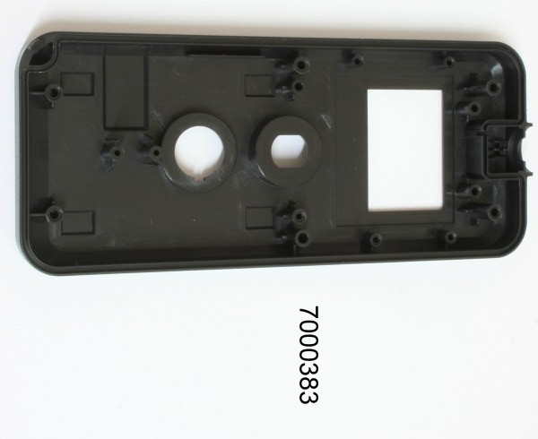 |  | 7930110  8000184  Label Front Housing | 1 | 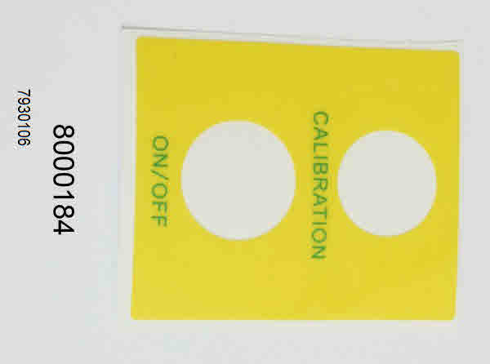
7930103  7000384  Enclosure bottom | 1 | 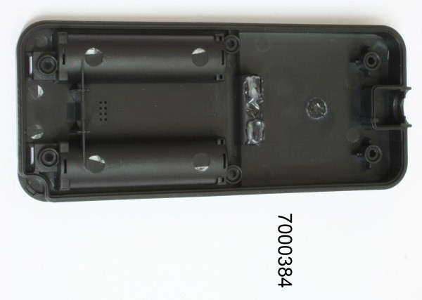 |  | 7930112  8000186  Label Battery Housing front | 1 | 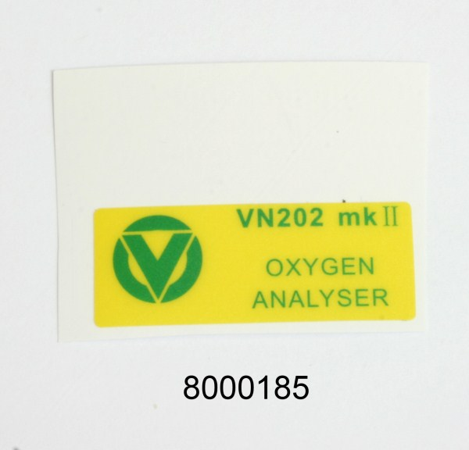
7930104  7000385  Enclosure battery cover | 1 | 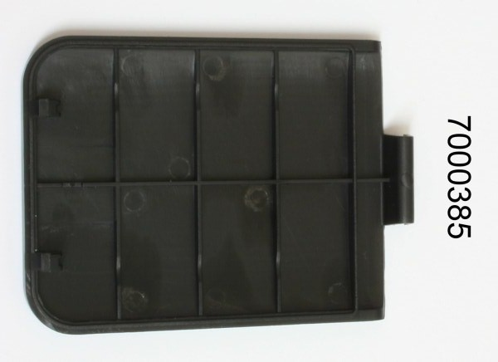 |  | 7930111  8000185  Label Back Housing | 1 | 
Serial number Label |  | 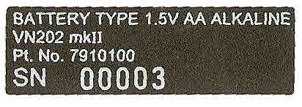 |  | 9730040  P16NP10KMA  Pot 10K Cal control | 1 | 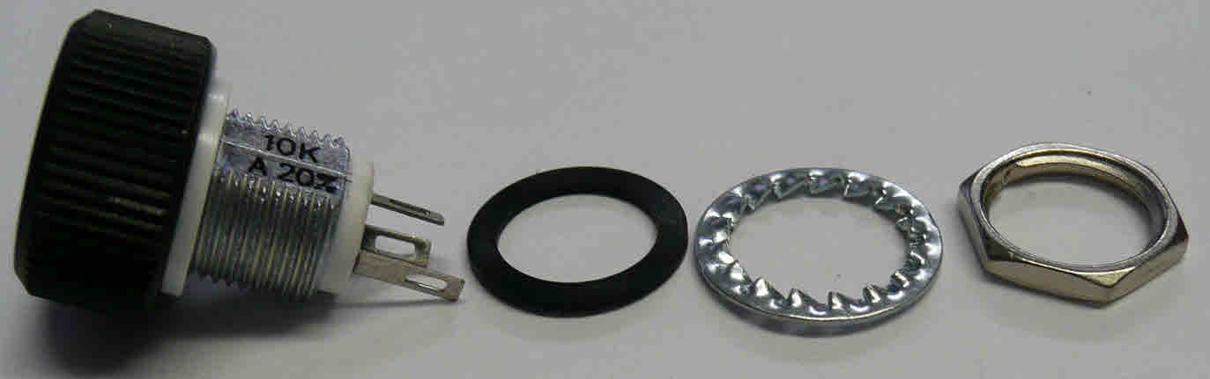
9000052-1  PCB loaded | 1 | 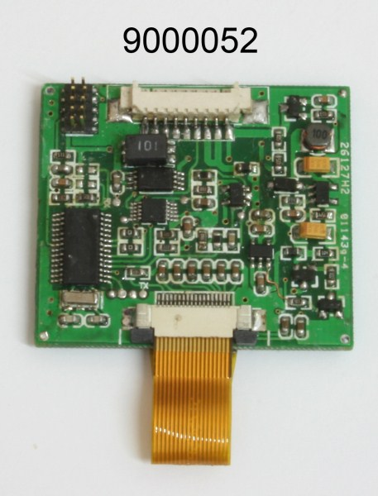 |  | 9730036  150-243  Yellow Push Switch, Round, | 1 | 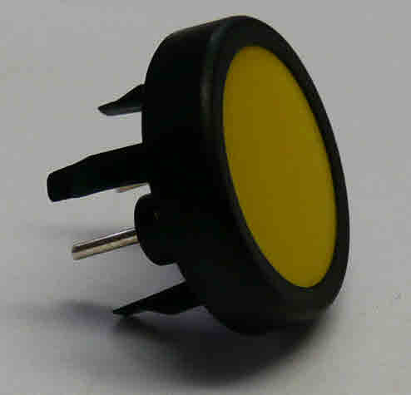
7930119  9000052  Graphics Display | 1 | 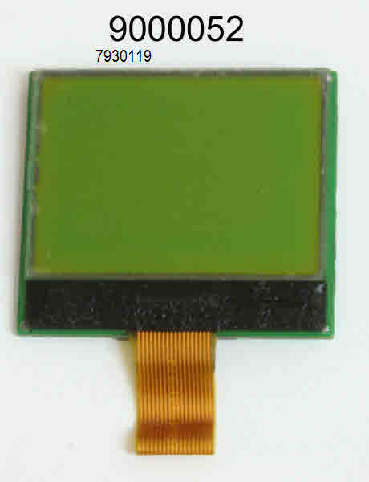 |  | 9730037  148-921  Switch waterproof kit | 1 | 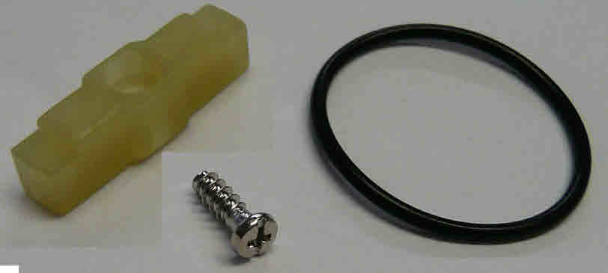
7930122  7000386  Holder Display | 1 | 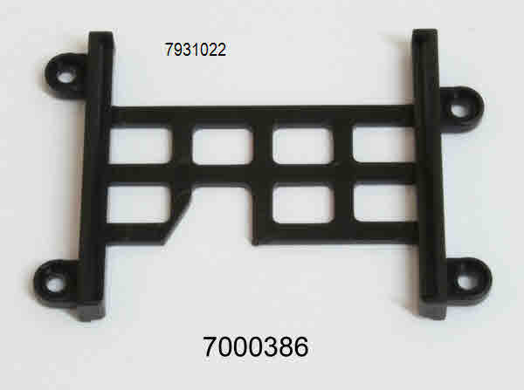 |  | 7930128  8000042  12 x12 rubber cushion | 1 | 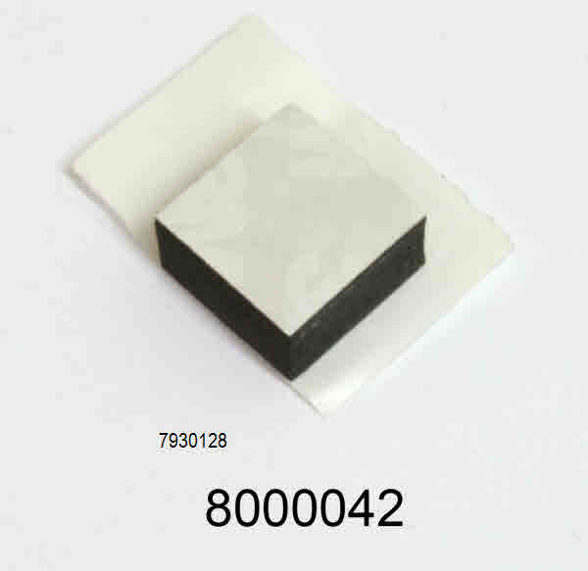
7930114  7000248  2.0 x h6.0 x3.5 screws PCB holder | 4 | 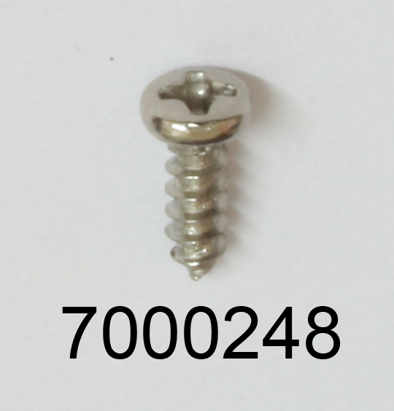 |  | 7930125  5000244  9 Pin wire | 1 | 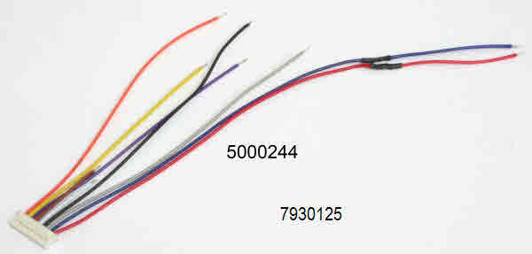
9080015  121-0467  Heat shrink Tubing  1 cm x 2mm | 3 | 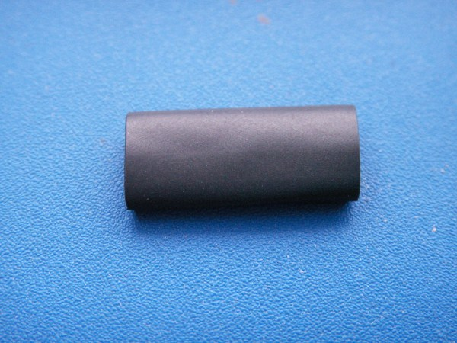 |  | 7930127  5000245  Electronic wire  Any colour | 1 | 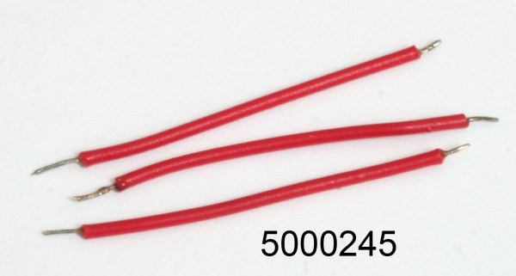
7930107  7000085  CO2 +v Battery term | 2 | 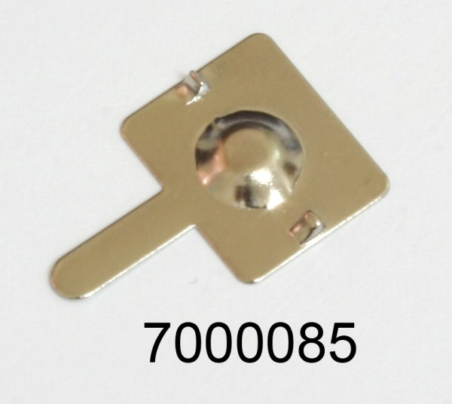 |  | 7930113  7000247  1.7 v h4.0 3.0 screws pcb | 2 | 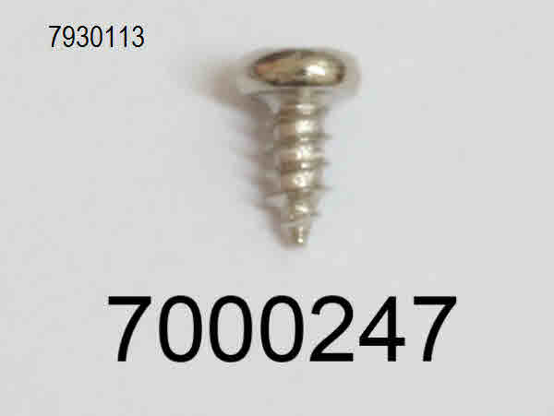
7930108  7000086  CO2 -v Battery term | 2 | 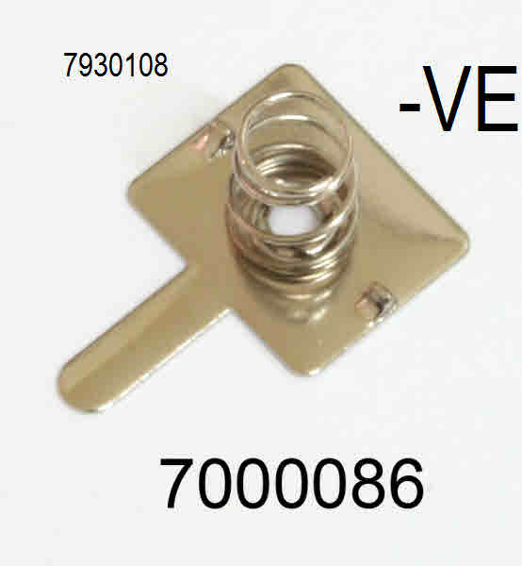 |  | 7930124  9000054  PCBA JTAG-B-V1.1 | 1 | 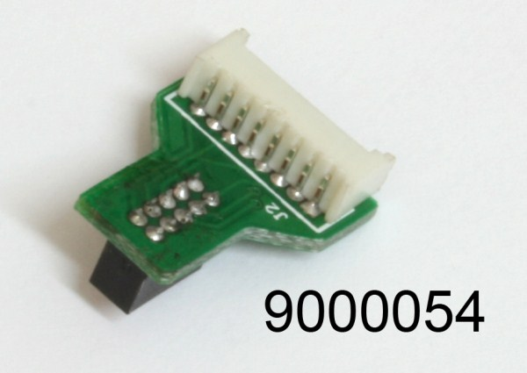
7930105  7000390  Seal ring Housing |  | 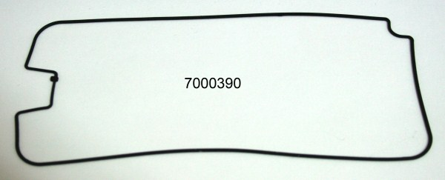 |  | 7930126  5000244  8 pin wire | 1 | 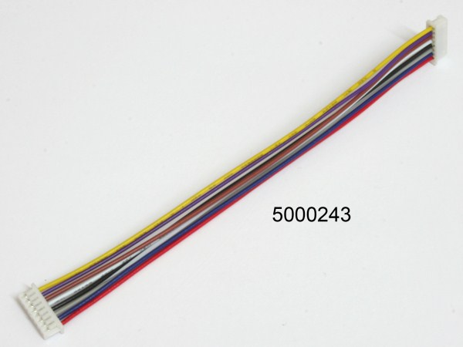
7930116  7000376  2.6 x h6.0 4.0 screws housing |  | 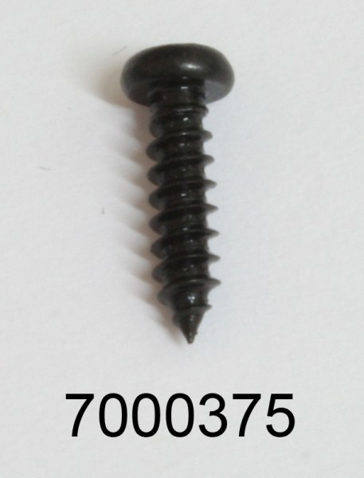 |  | 7000389  Display window |  | 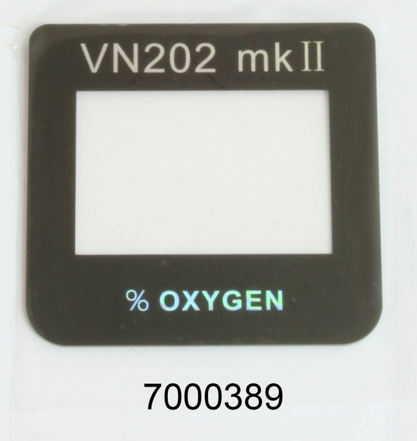
7930123  9000053  PCBA JTAG-A-V1.1 |  | 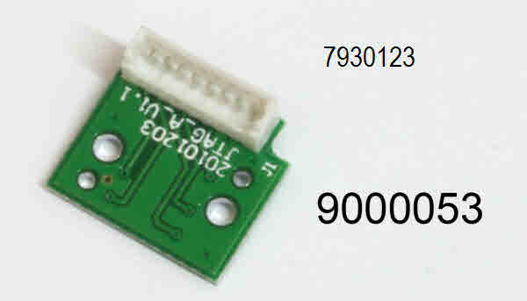 |  | 793115  7000375  2.6 x h10.0 4 screws housing | 4
 |  |  |  | Double sided taps | 1
- Unwrap the cases and separate them into their component parts,
- Add the Main label to the front panel
- Fit the yellow switch 9730036 for auto switch off or( Green for non auto switch off).
Ensure the waterproof kit 9730037 is fitted including the O ring
- Add the Calibration potentiometer 9730040
Ensure the long centre terminal is at the top.
The white spot should also be at the top half way between max and min settings.
- Graphics Display
If the graphics display and PCB are separate fix the graphics display to the back of the PCB with double-sided tape
Check OEM as pcb may need shorting links removed. See end of procedure
READ 6.0 > 15.0 before proceeding
- Remove the LCD protective film or enough to allow it to be removed through the front panel hole
- Fit the 9 pin cable 7930125 to the 9 pin socket.
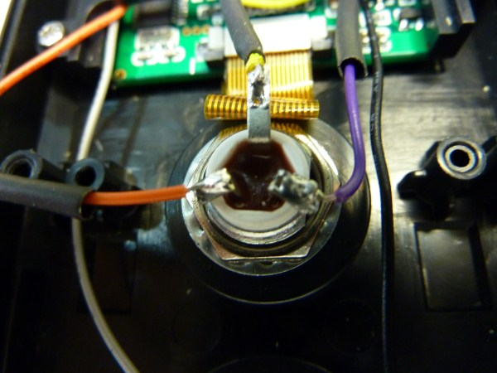
- Locate the PCB/LCD assembly in the recess as near to the
- Add the frame 7931022. It only locates one way.
- Place the small foam pad underneath the frame
- Fasten with 4 off 7930144 silver screws.
- NB Do not tighten as the LCD may need realigning.
Check once the wiring is completed and the batteries can be fitted.
- Blue and Red go down the side of the enclosure
- Grey & Purple go under the frame to the right
- The Yellow, Orange, & Black go under the frame to the left
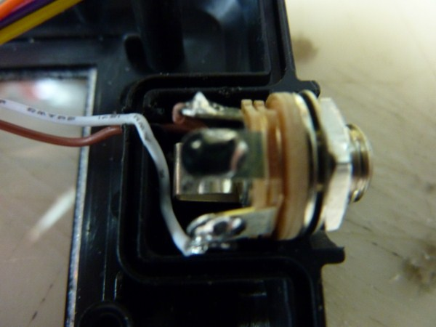
- Green and Brown go through the small channel in the Jack enclosure
- Wire Black & Grey to the switch
- Wire Orange Yellow Purple to the Calibration pot.
- Add heat shrink tubing 1cm x 2mm dia
- Wire the Jack socket. The short White & Brown go through the groove and into the Jack socket compartment.
- Brown (may be Green) pin 4 on socket White Pin 5 on socket
- Fit the Jack socket Type 42 into the small area and screw on the nut
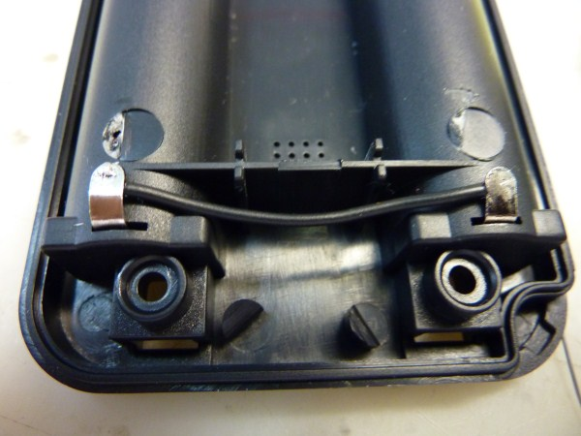
- Ensure the wires go through the access slit wires do not get trapped and are tucked down around the socket so that they do not foul the jack plug when it is inserted
- Connect the Red to +ve and the Blue to -ve on the battery terminals
- Connect a wire across the lower battery terminals
- Add non slump silcone to the access holes of battery cover
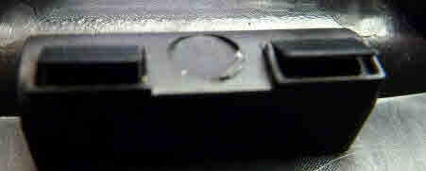
- CHECK
The seal is in the groove all around the enclosure
The Battery wires are not going to be trapped
The wires to the Jack are in their groove and covered by the seal.
The LCD is aligned
The potentiometer increases the reading when turned clockwise. A sensor or Oxycal is required for this test
- Fix the two parts of the enclosure together.
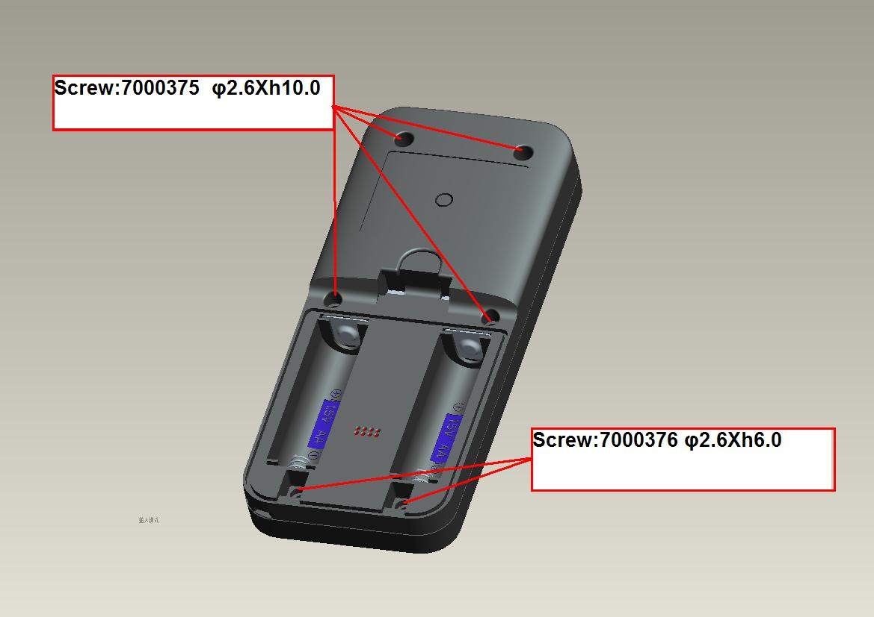
- 4 screws 793115 are used in the top half of the enclosure and 2 screws 7930116 in the bottom two holes.
- Fix the Rear Label
- Front small label
- Check Software
Software is different for different OEM
- Add serial number label
- Fit the battery cover
R11=10k R12= NC no auto off } NC means cut out the resistor
R11=NC R12=0R Auto off } Leave resistor in place it is zero ohms

R13=10K R14 = NC reverse display I.e. reads 0% when it is at 100% for non oxygen gases
R13= NC R14= 0R normal display


