Viamed Computer Issues VM3COP60.03

Possible Computer Problems Across ALL Clients

- No Internet, No Intrastats, No Opera / Goldmine.
- No Internet, Intrastats / Opera and Goldmine All work fine.
- No Intrastats , No Goldmine / Opera, Internet works Fine.
- No Intrastats , Goldmine / Opera and Internet Works Fines.
- Intrastats shows a Mysql Error on logging in on ALL Pc's
- No external access to Intrastats
- No external access to VNC
- Smart phone system stops working (The PC side), Phones work OK.
- Phones Stop Working

No Internet, No Intrastats, No Opera / Goldmine.

Probable Cause is either a Brief Power failure or a sustained power failure.

See : In Event of a Power Cut

No Internet, Intrastats / Opera and Goldmine All work fine.

Probable cause is the Modem.
In Goods in
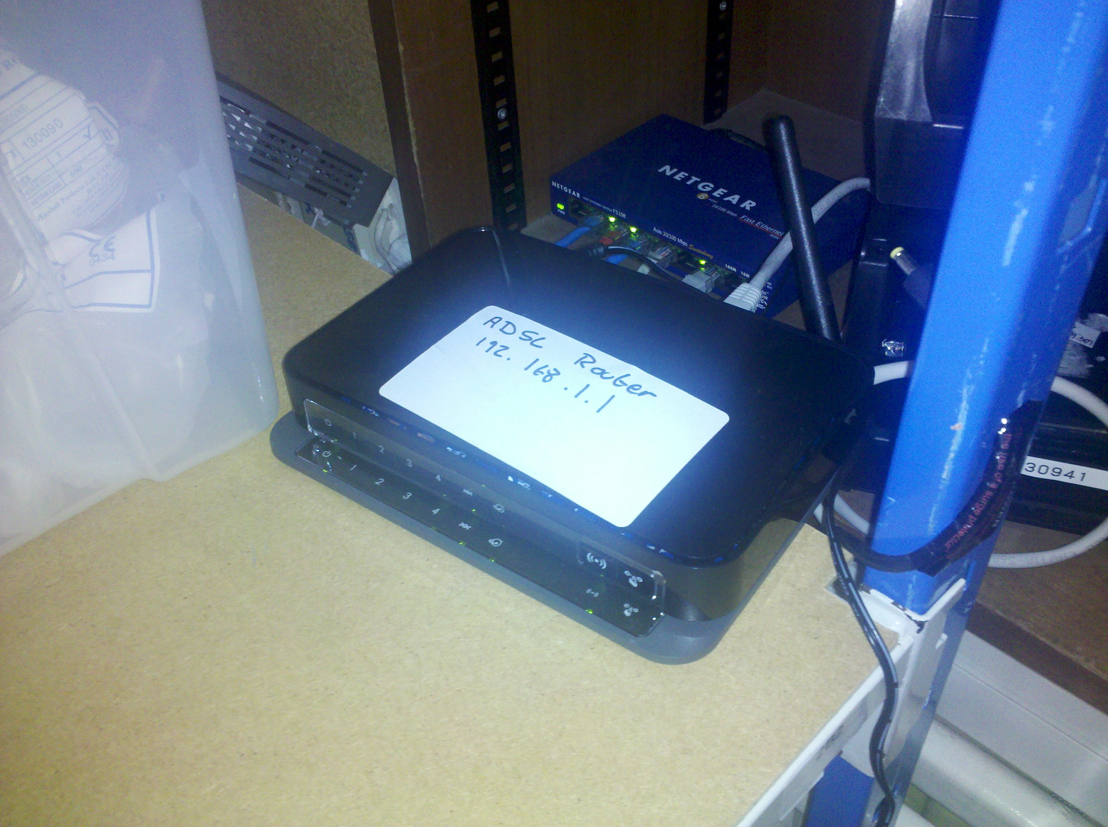
Unplug adsl router, count to ten plug back in.

If still fails check the fax machine (its on the same Phone line)

Contact Telesis for assistance – we are under contract with them.

No Intrastats , No Goldmine / Opera, Internet works Fine.

Check power failure instructions first.
Try to Putty to vmserver7
if you can get past the login screen,
type into the console sudo restart
type in the password 51685168

VMSERVER7 Will cleanly reboot and restart all the systems.

If you get a failed connection error, press and hold vmserver7 Power Button until pc goes off, count to 10 the press the power button,
Restart this way server can take 20-30 mins to fully start up.

No Intrastats , Goldmine / Opera and Internet Works Fines.
OR
Intrastats shows a Mysql Error on logging in on ALL Pc's

#SEE PUTTY to VMSERVER 7 / vmserver 6
Try to Putty to vmserver7
IF you can get past the login screen,
type into the console sudo reboot
type in the password 51685168

VMSERVER7 Will cleanly reboot and restart all the systems.

IF you get a failed connection error or black screen, press and hold vmserver7 Power Button until pc goes off, count to 10 the press the power button,
Restart this way server can take 20-30 mins to fully start up.

No external access to Intrastats
AND
No external access to VNC

Assuming the internet is available from inside VIAMED, the routers settings have been reset to factory defaults.
Cause: power failure / fluctuation

Router username: admin
password : password

Firewall Rules

VNC PORT 5802 and PORT 5902 Redirect to 192.168.1.4
HTTP PORT 80 Redirect to 192.168.1.2

http://kbserver.netgear.com/kb_web_files/n101145.asp

Suggest if this is the only fault, Live with it until Derek back in the Office.

External Intrastats works but VNC Fails

Reboot the VNC Machine
Small Black PC in Dereks office

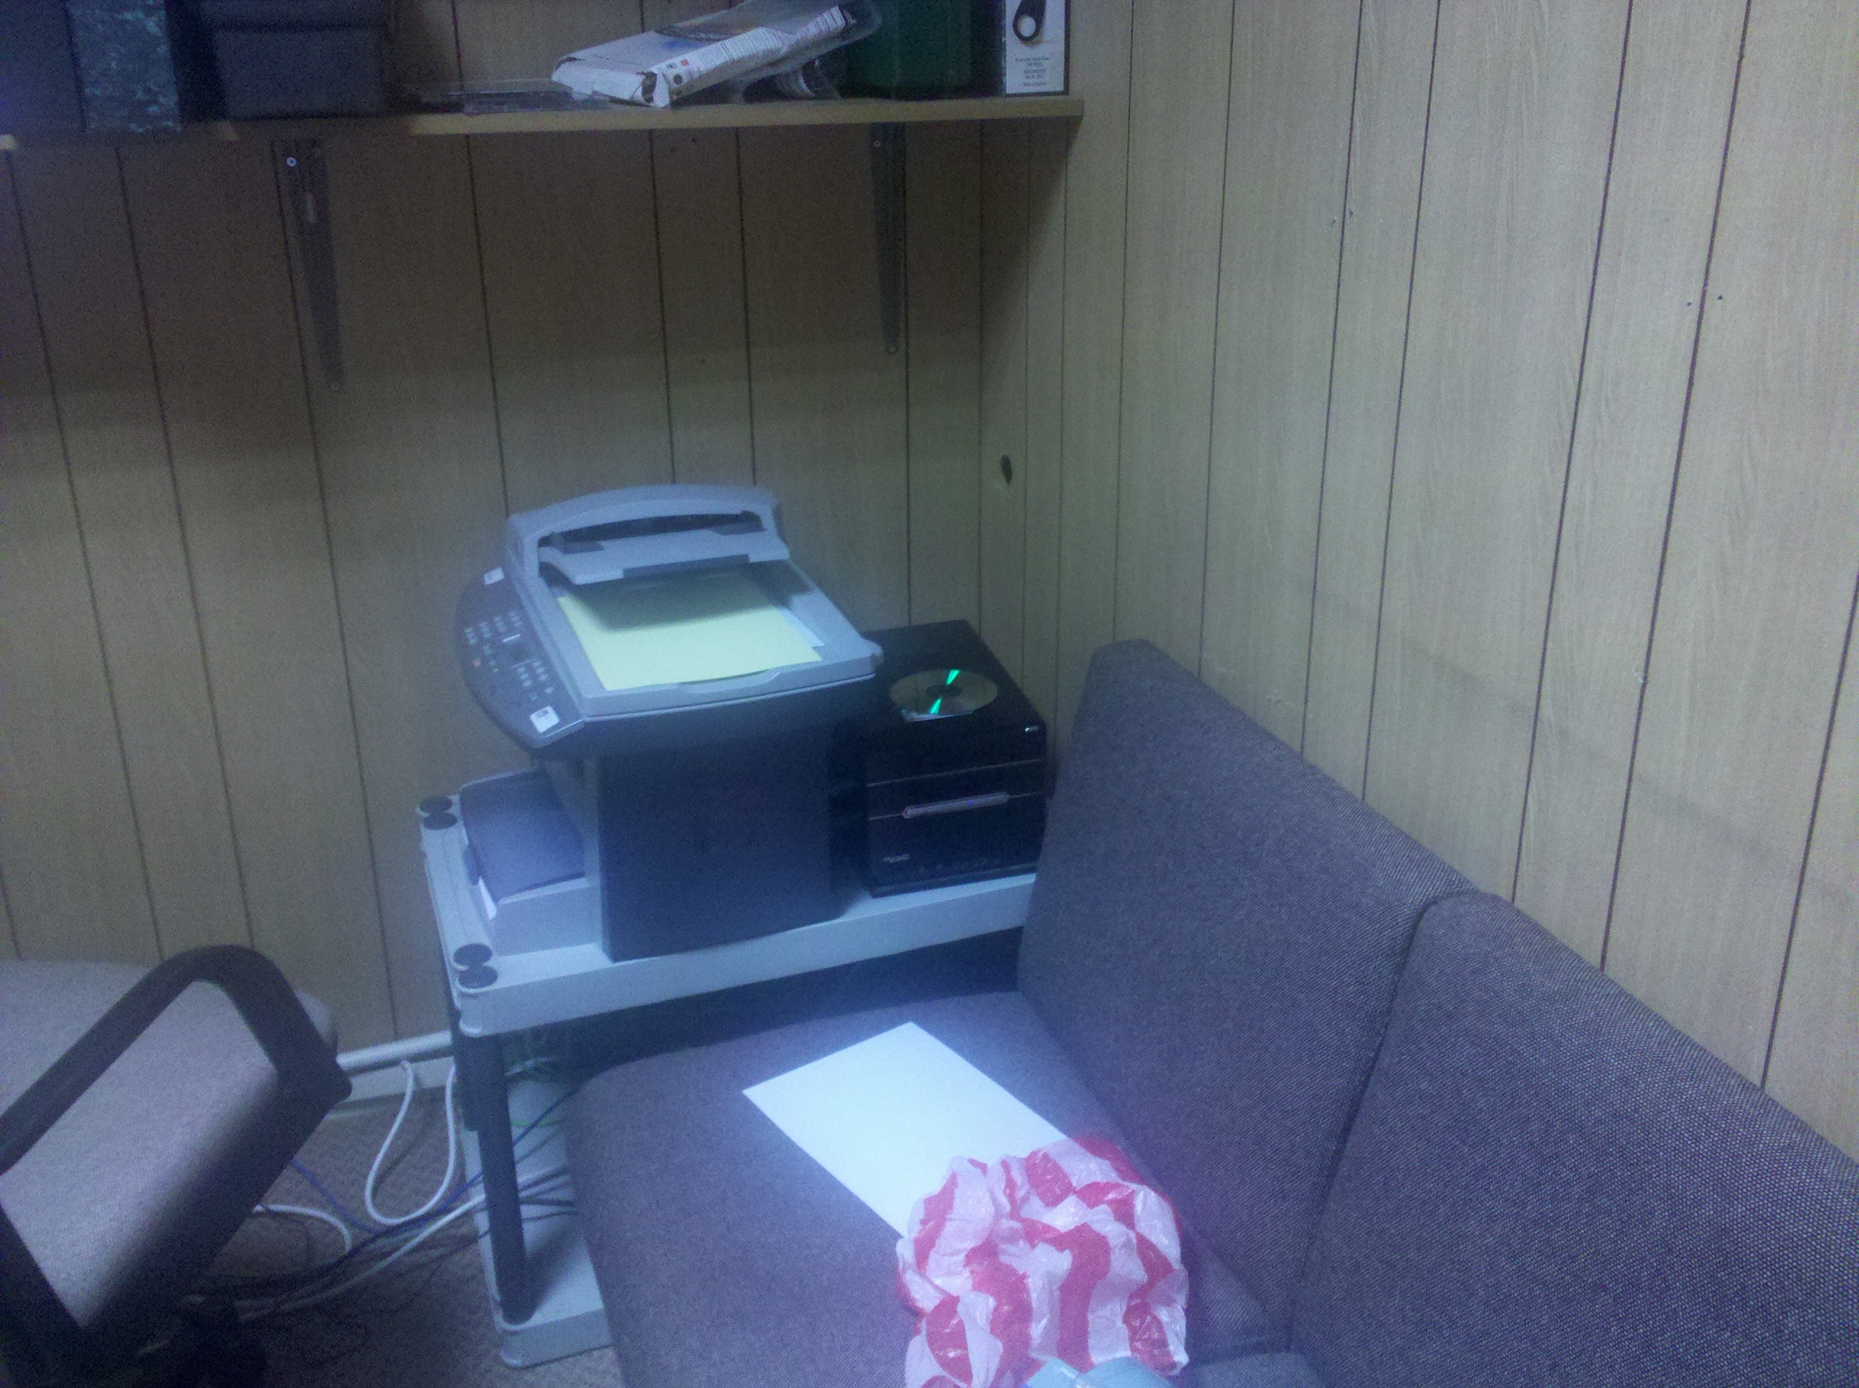

Smart phone system stops working (The PC side), Phones work OK.

Reboot the VNC/ Smart phone server Machine
Small Black PC in Dereks office

Phones Stop Working

IN the Cellar in the House,
Black box on the Wall check for Power -
Currently it runs through the Backup Battery – Check for Power,

IF battery failed, unplug system from battery and plug directly into the sockets,

Contact Telesis is problem persists

If black box has lights but phones not working, Contact Telesis
In Event of a Power Cut

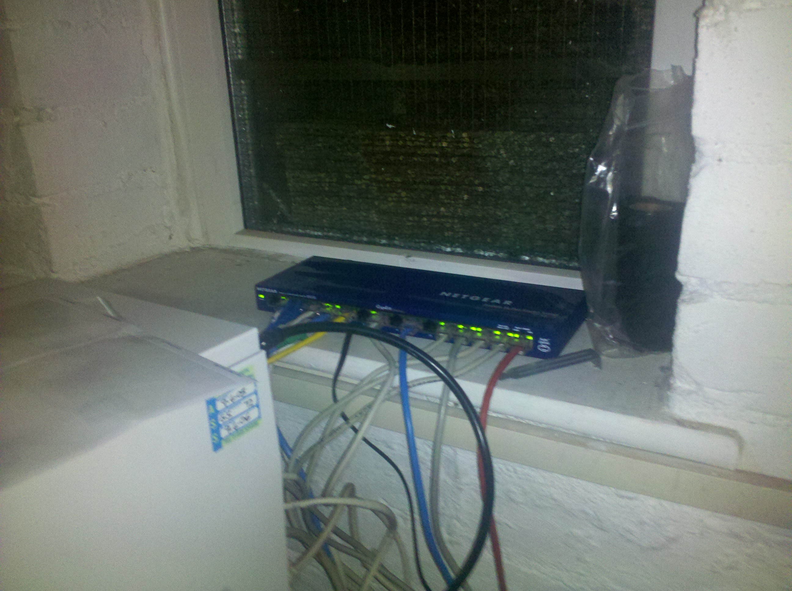
In the Warehouse Server Shelf, if the Routers lights are not on

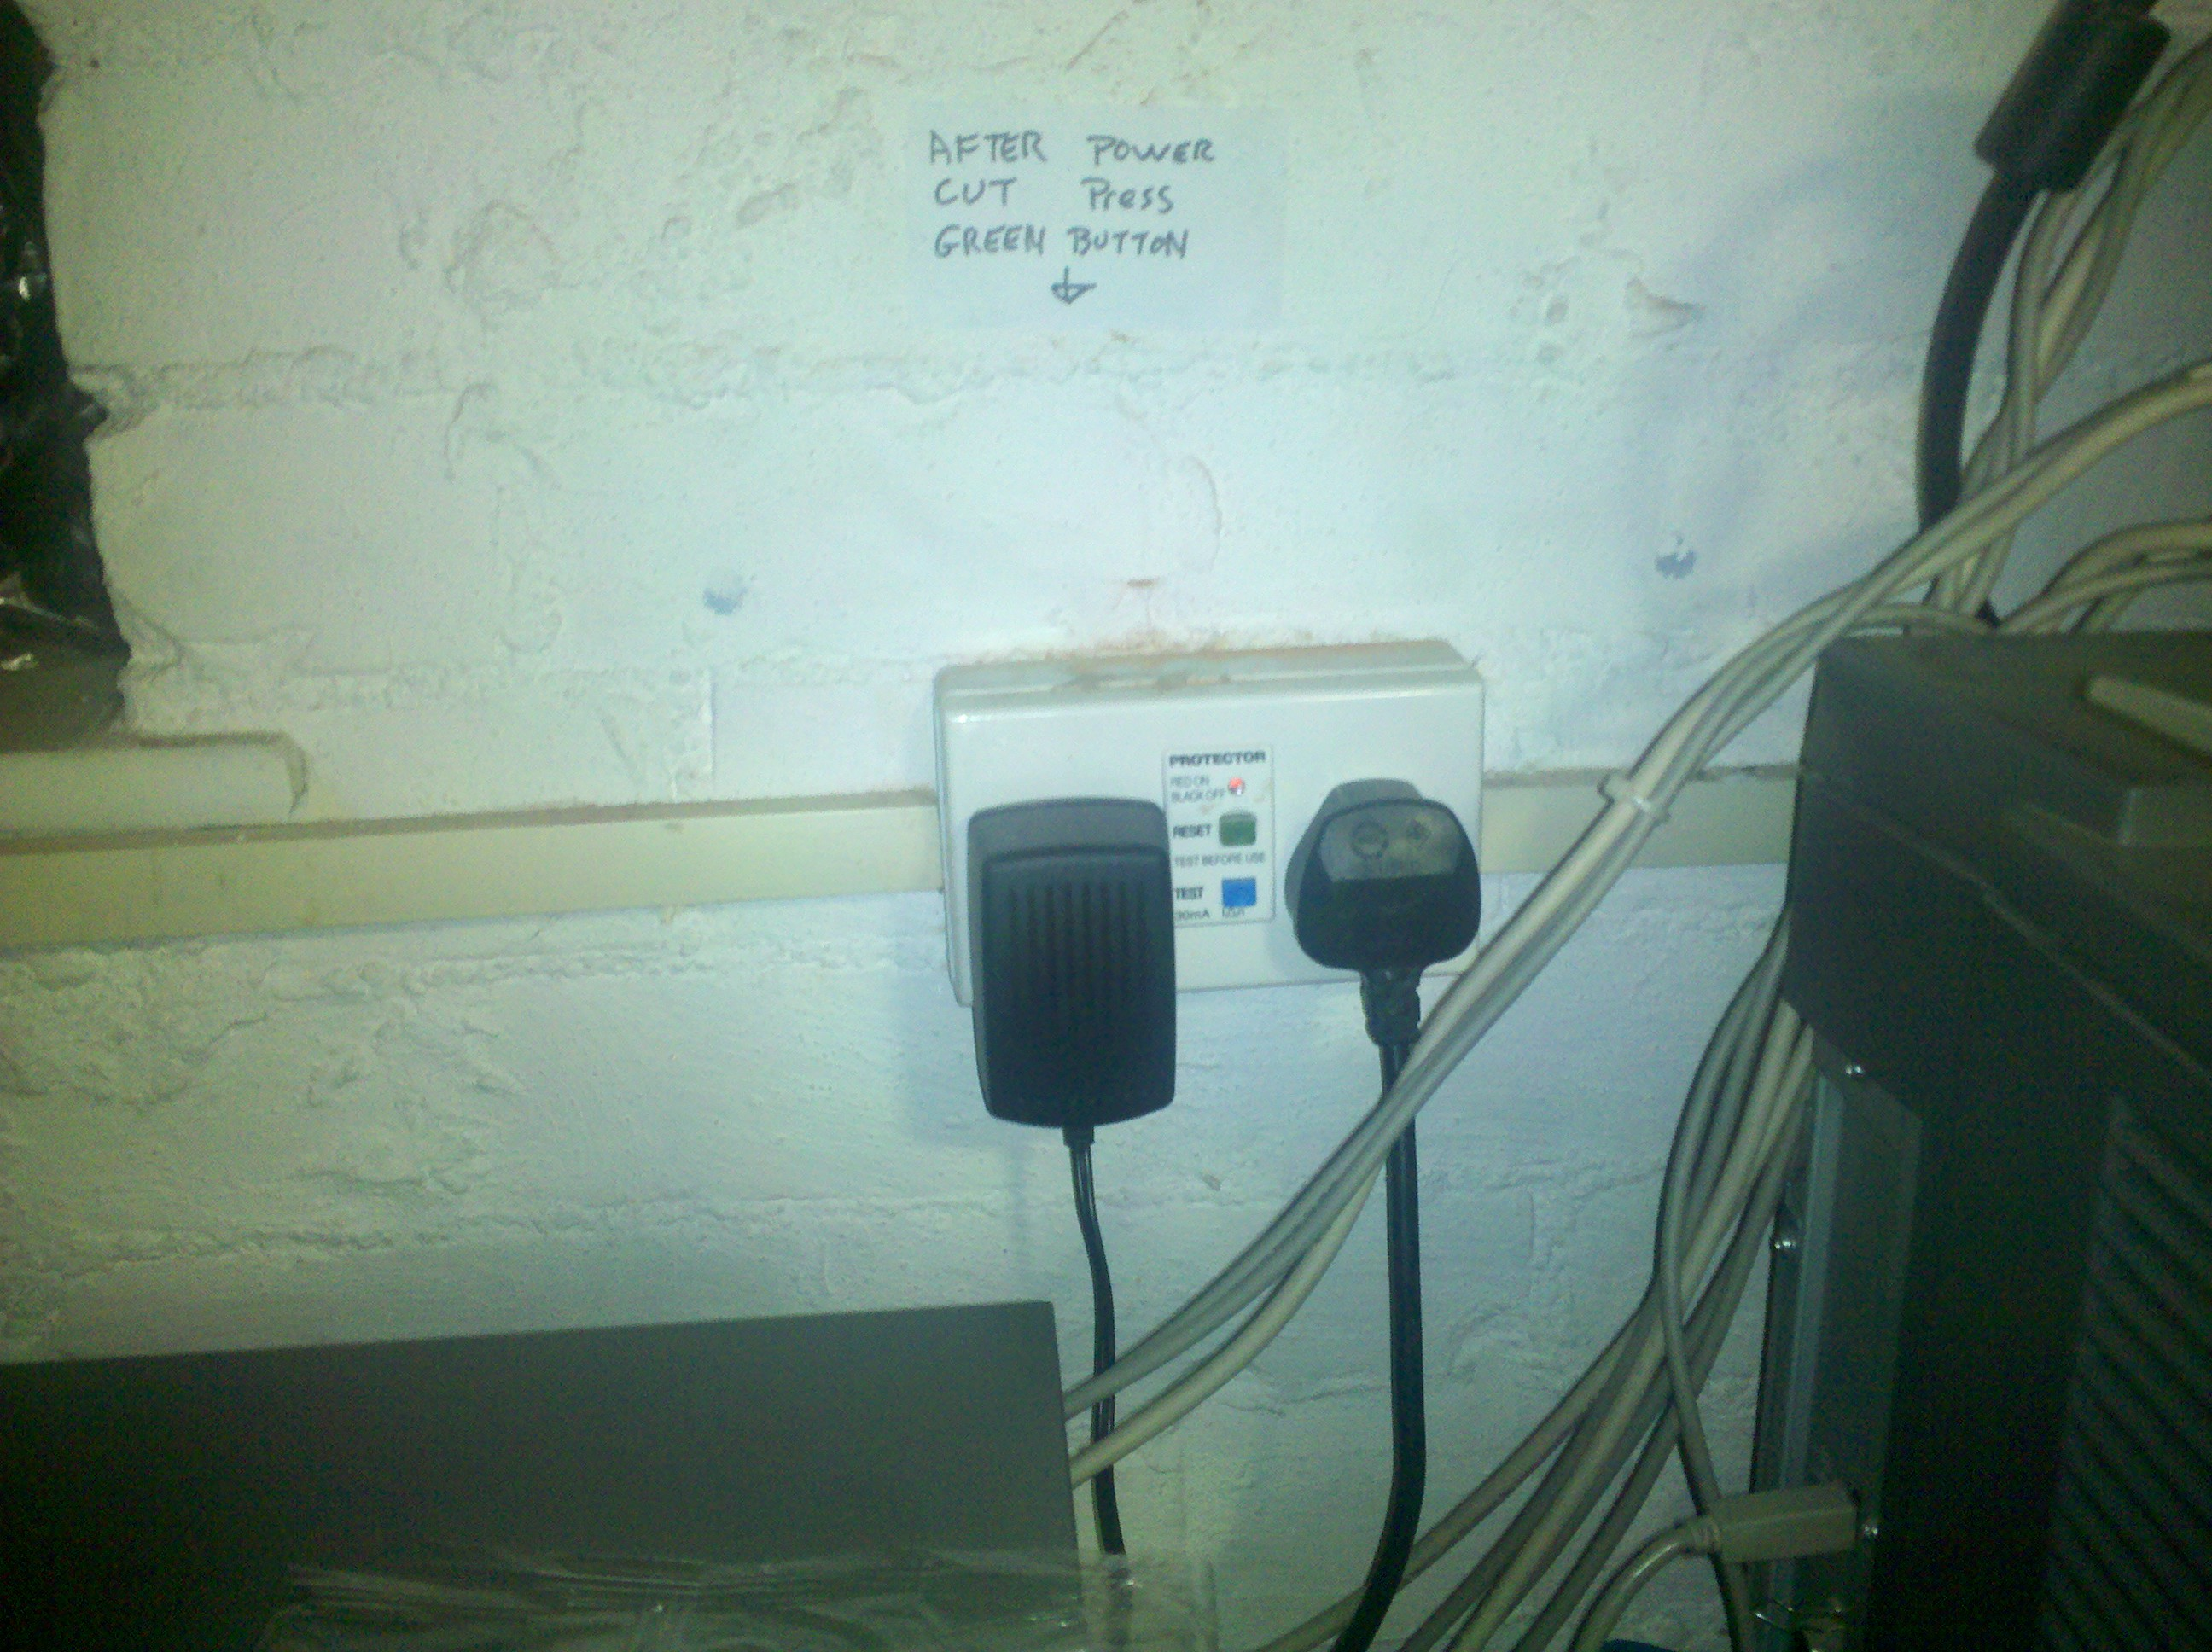

On the Back wall press the green Button,

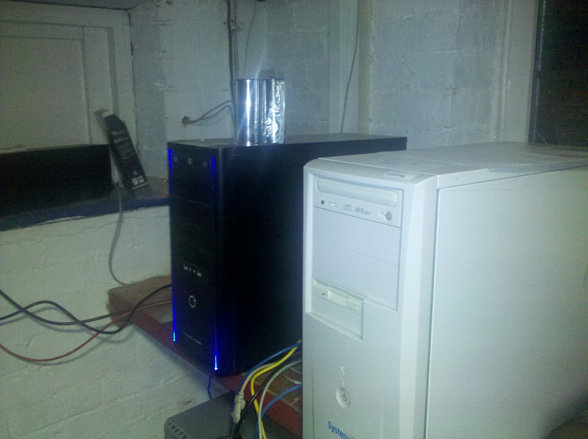
Check to see if VMSERVER7's Lights are on, Black Box Blue neon Lights
Check the Battery is on On shelf in background.
Press the power button (inside silver circle) to turn on VMSERVER7,

PUTTY to VMSERVER 7 / vmserver 6

Browse to

http://www.chiark.greenend.org.uk/~sgtatham/putty/download.html

download putty.exe

run putty
(note putty is also on Dereks desktop and Helens desktop)

To access MAIN server: host name : 192.168.1.2
Click Open
user-name derek
password 51685168

To access BACKUP server: host name : vmserver6
Click Open
user-name derek
password 51685168

ENABLE VMSERVER6 BACKUP SYSTEM

DO NOT TAKE THIS STEP LIGHTLY!!!!!!

In the unlikely event that Vmserver7 Fails.

UNPLUG VMSERVER7

ON EACH PC,
in the File Manager type in
\\VMSERVER6

You should see a List of network Folders:

Right Click on the Apps folder
Click Map Network Drive
In the drive Pull down Select Drive Q.

Repeat for

drivel → L , driveu → U , operauk → Y , operavan → V , operavst → X
usersopen → T , drivez → Z

ENABLE VMSERVER6 BACKUP SYSTEM 2

To enable Intrastats,

Putty into VMSERVER6 (try ip 192.168.1.152 if vmserver6 fails)

type:

cd /
cd home
cd network
cd viamed.scripts
sudo ./vmserver6hourly.sh
enter password 51685168
when finished,
all pcs can now log into intrastats via:

http://vmserver6/login.php

Thing To CHECK

OPERA's Last Invoice Numbers,

Intrastats, Check last items booked in
(Stock Book – Stock List Recent Additions)

Items for the current day may have to be REPICKED,

DO NOT ENABLE VMSERVER6 BACKUP SYSTEM UNLESS THERE IS NO OTHER OPTIONS

