Performing a Technical File risk assessment and clinical residual risk review.

Intrastats → Technical Files

Any VIAMED / VST products which require a review will be highlighted PMS DUE in red

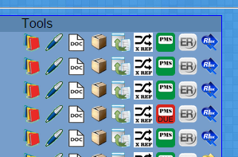

Click the Red Box.

The Following screen will produce all information regarding the product range
e.g. stock references, suppliers, returns information, documentation updates including instruction manuals, sales, Issues system,
It will also request Searches on the internet regarding clinical reports, fda / mhra reports on all similar devices on the markets

Each section will have 2 input boxes it with a further action request tick box,

The first section is for general comments on the section,
The second section is for if any of the information presented is if and new Risks have been identified. If a risk has been identified the further Action required check box MUST be ticked.

A PDF document will be produced which can be uploaded on top of the previous years report.

NO Resulting Issues
are created in the PMS the Clinical Evaluation can now be performed.

Resulting Issues

For each further action ticked a New Issue will be generated in the regular issue system.
For each Issue which is a New Risk a New entry in the Risk assesment file must be added.

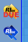
If the new risk is Specific to the range being reviewed Click the Risk check list button on the main page in line with the range

Then click

And Add the new question
Use Section code X.[x] where [x] is the next number along from the last X.xx number.
If the new risk may apply to more than the product range being reviewed as the risk as a core risk.
Intrastats → ISO → Risk Admin Core Questions.
Top Level Questions
Add a new Section Number.
Enter the actual risk into the box.

Each new risk requires being evaluated and responded to using the generated issue to keep information together.

Once all the risks has/have been evaluated the risk assessment questions can then be completed.

Click the Yellow Risk Due Icon

All New risks with incomplete answer are listed, E.G.
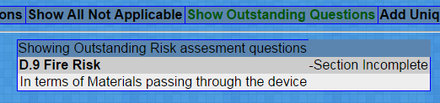
Click the Section head e.g. D.9 Fire risk

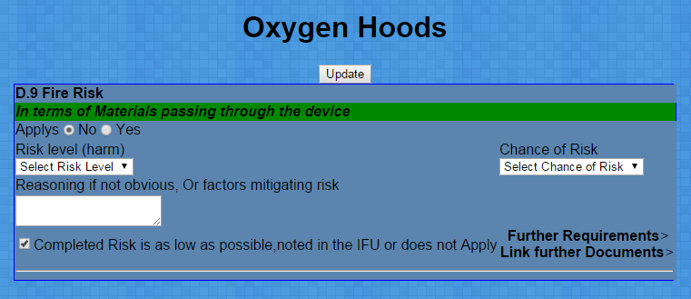
Select the level of risk (harm) and select the Chance of Risk,
Notes can be added in the box provided, reference any issue in the system that has looked at the risk.

Once all questions are completed,

Click the print report:

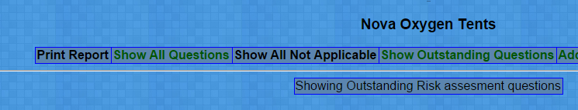

Right Click and save the report to disk,

In the correct technical file find the previous risk assessment report (section E 3). Upload the new report on top of the old one.

Set the Expiry date as 1 Year from today.

If the File is a Viamed Product Still being Manufactured :
A Clinical Re-Evaluation should now be performed
VM3COP27.12 Clinical Re-Evaluation
Find the previous years Clinical Re-Evaluation document in the technical file,
Click the Document requires amending – add to the notes the re-evaluation need doing submit the new issue.

