Procedure to assemble and test VN202’s

Requirements: VN202: Cable: socket cover: AA Batteries: test R-17VAN sensors usually qty 10): Serial number labels for instrument and package: UHU glue: plastic bags 24/15.5 centimetre : small screwdriver.

Can be assembled in batches of e.g. 10: 25: 50: 100

1. remove packaging of instrument and line up face down.
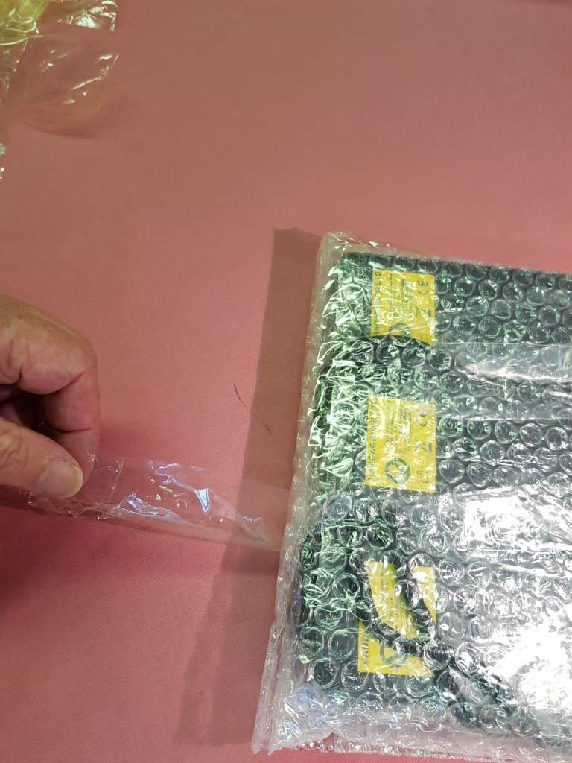
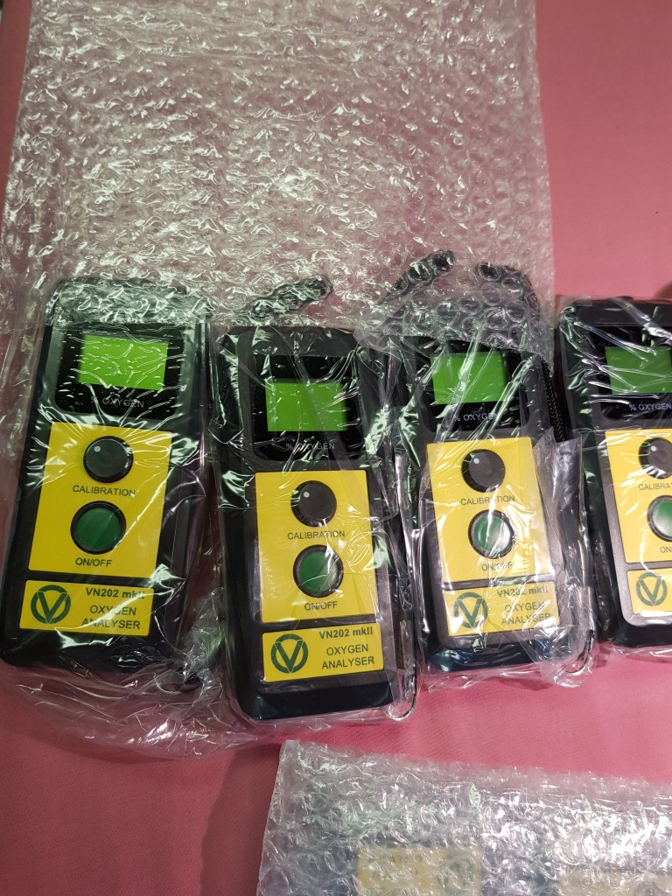
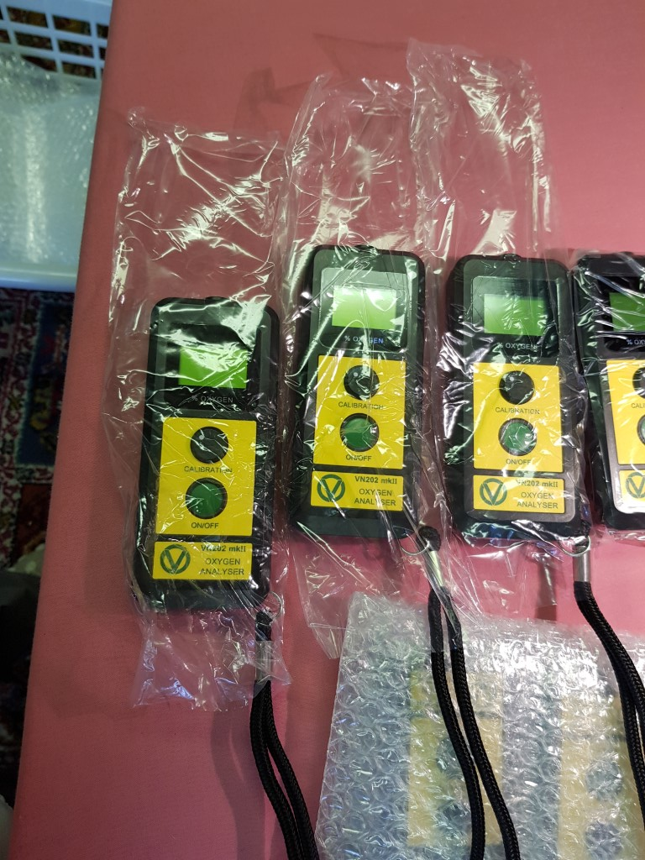

2. remove back plates using small screwdriver or similar

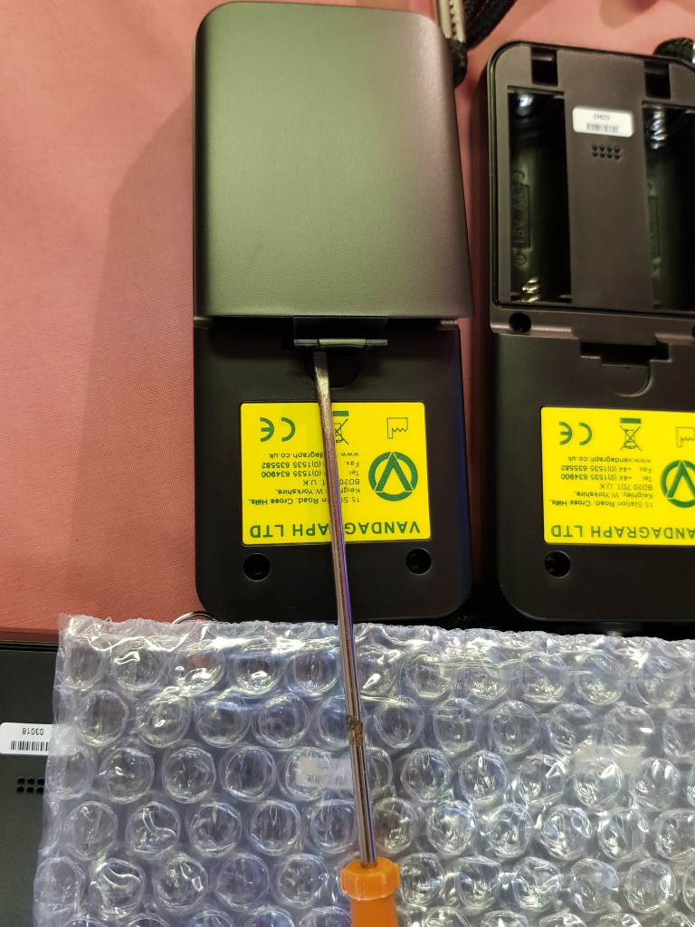

3.using spots of UHU insert socket covers. If the sockets are not central it may be necessary to loosen nut and centralise or loosen the screws on back of instrument if too tight.

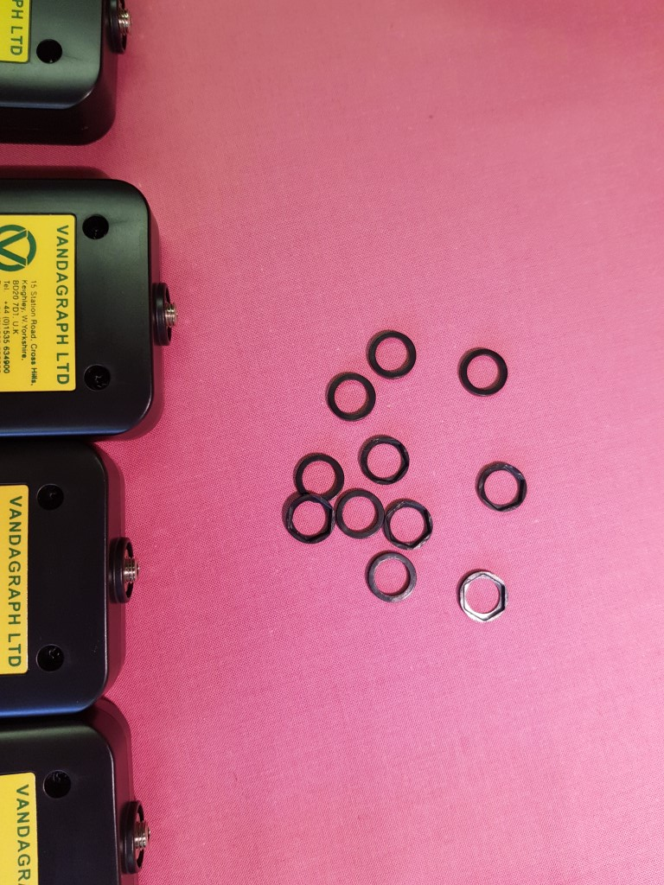
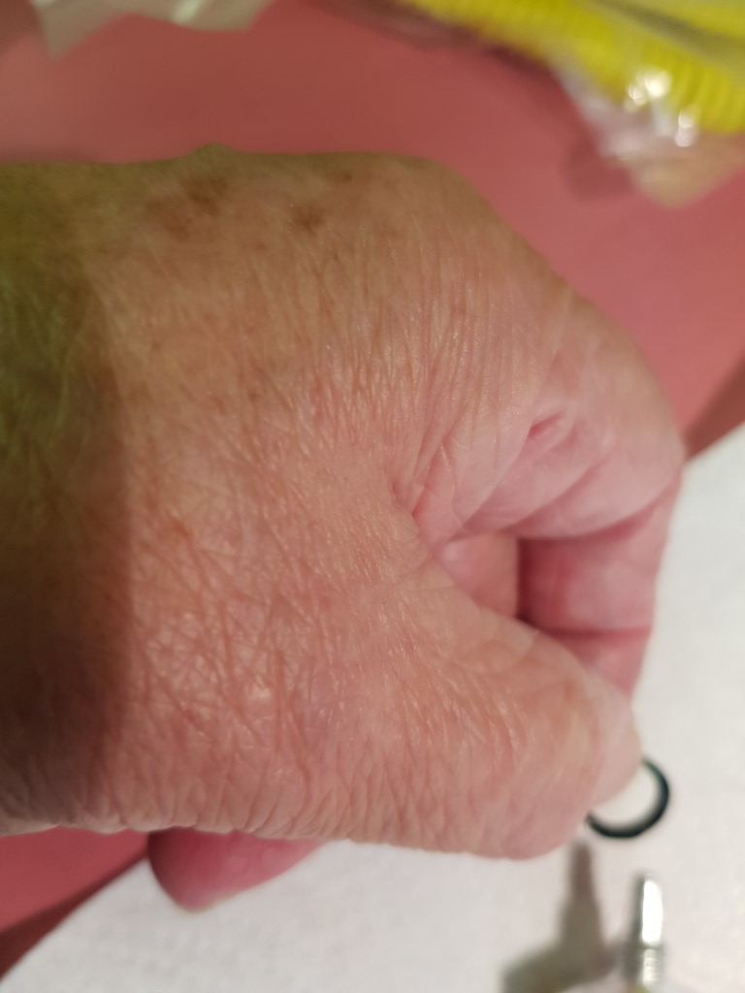
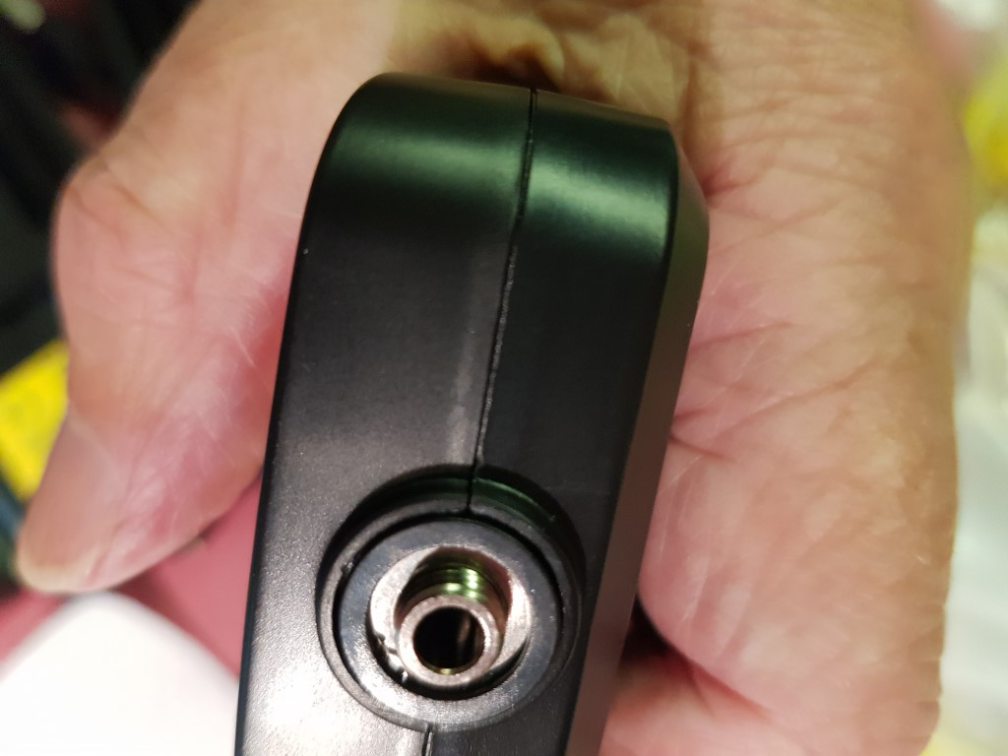

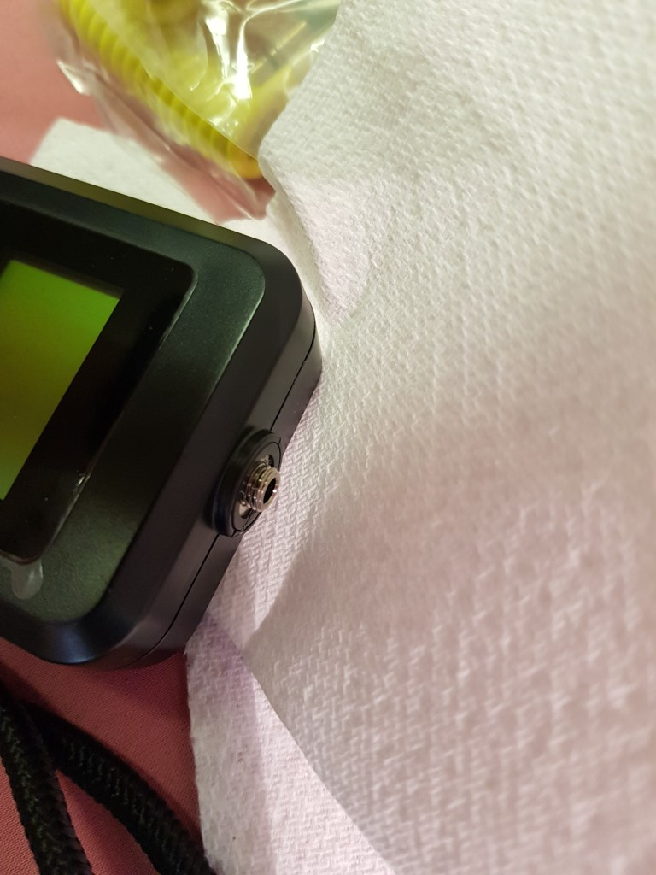

4*. insert batteries

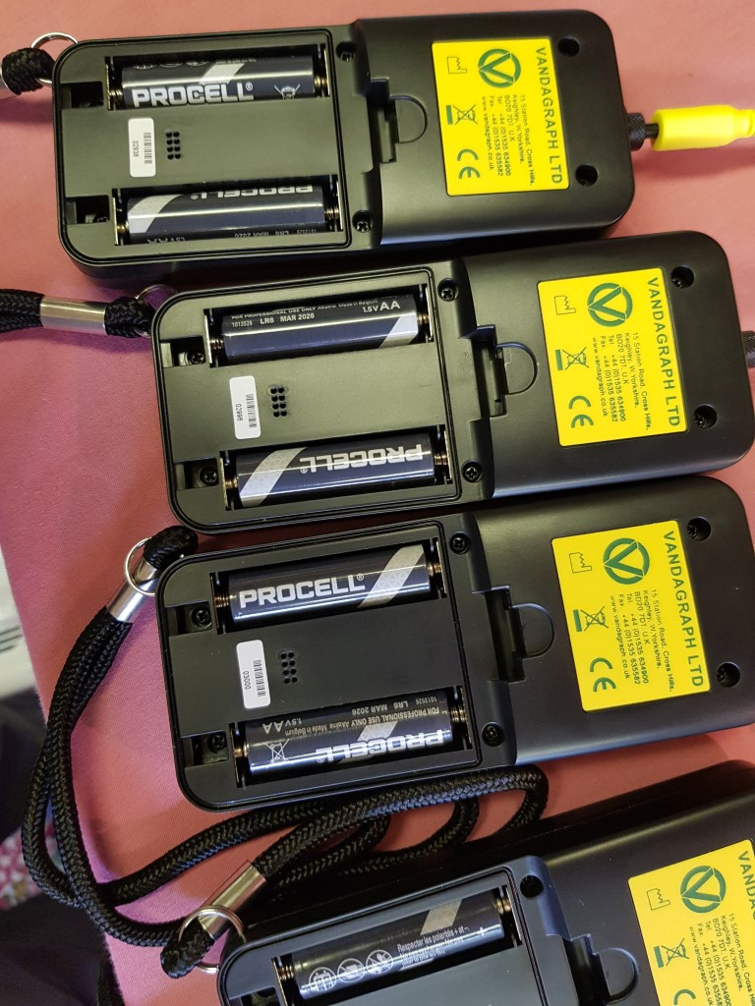

5. turn instrument face up

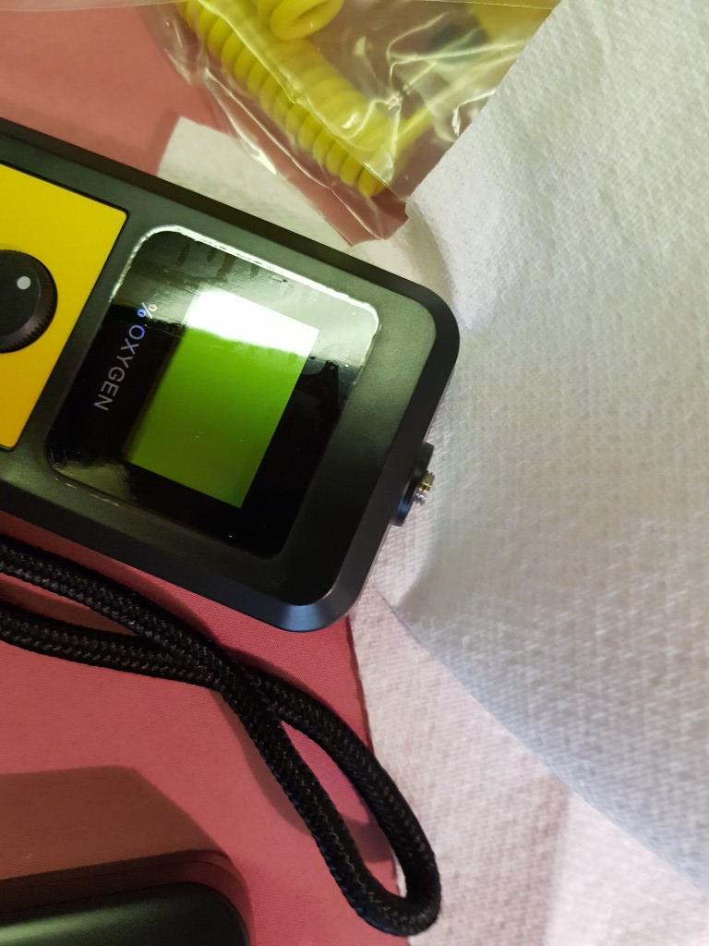
6* attach cable, finger tight, with S/N closest to the instrument.

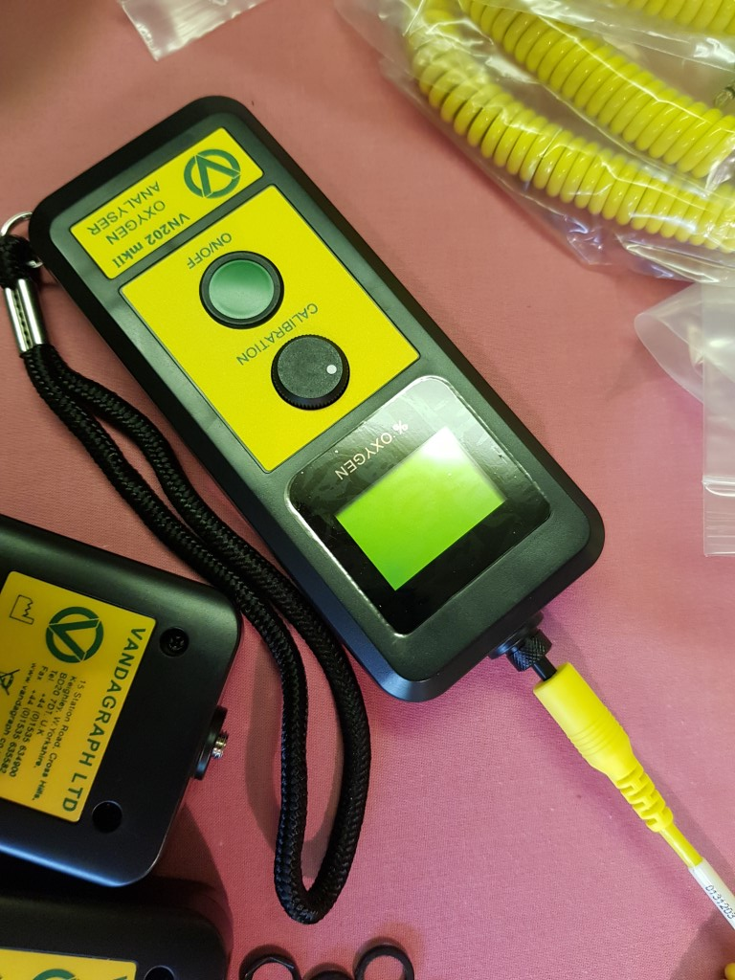

7. attach test sensor, with one turn to check no problem with cable connection and switch on. Display will show version of software then 0.0 (03 is acceptable) NB If cable has not previously been tested, stretch the cable and twist at each end to make sure the cable is not faulty. If faulty the reading will move or flash , usually to 0.0

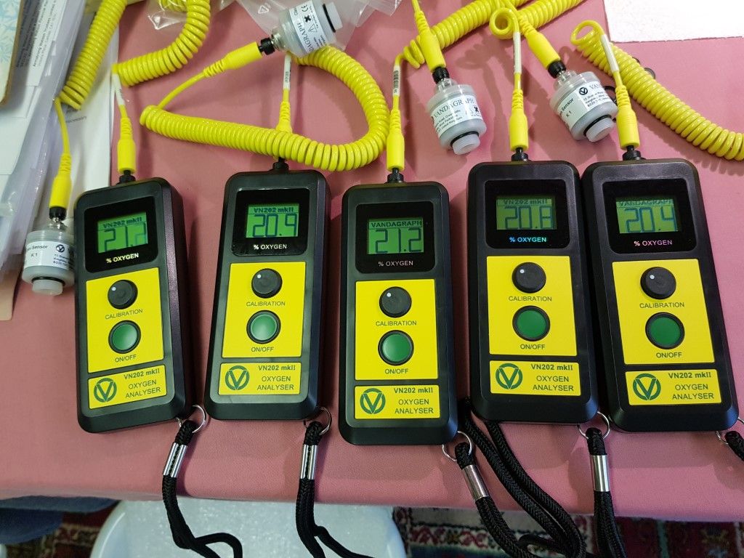

8. turn calibration knob to read about 20.9 (this checks there is no problem with the cal knob. Display should alternate between ”Vandagraph” and “VN202”

9. leave for about 7-10 minutes to check that the auto switch off version does switch off, and manual version does not
10. check reading is still the same
11.remove sensor
12. remove batteries

13. add black serial number label to centre block between battery compartments, then replace back case cover, making sure gasket is in place. Pack in plastic bag and add small label to the bag

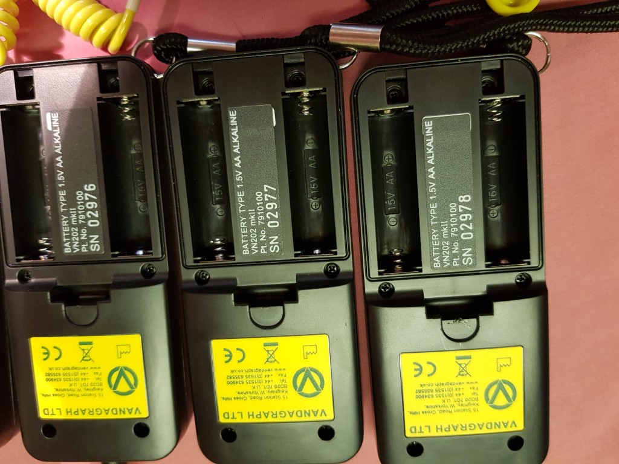
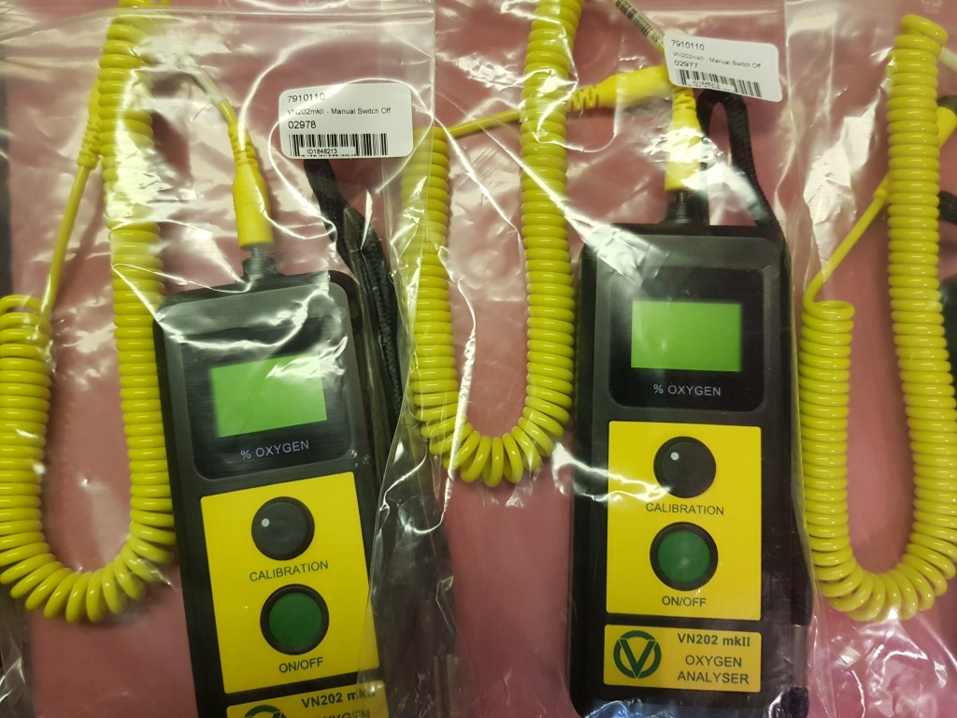
14. Pack anaylsers in carton with highest s/n on bottom.

* Cable may be attached before item 4

Pack in boxes with highest s/n at bottom.

Follow other instructions to assemble prior to sales.

Jean Lamb
15th Nov 21

Kingston USB

