Using Google to find Distributors

It was possible at one time to use different google search pages from specific countries to help locate distributors from that country, such as www.google.be for Belgium or www.google.de for Germany. However, this no longer seems to work as regardless of the google version you choose to use, Google will provide results based on your location.

There is a way to change the location that Google uses for searches:

- In Chrome, open a new incognito window. This can be done in the menu page of google:
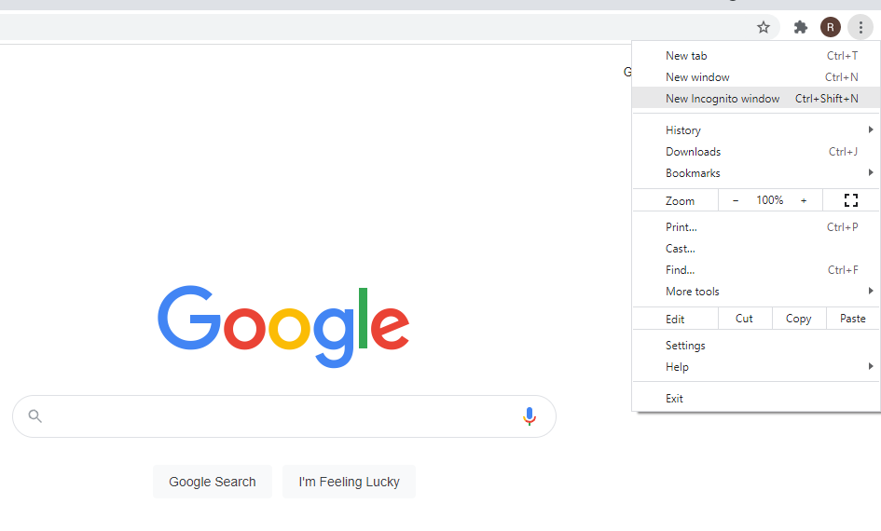
- Type into the address bar google.com and click enter, you will be presented with the standard google search box, but notice that your location is listed at the bottom of the page:
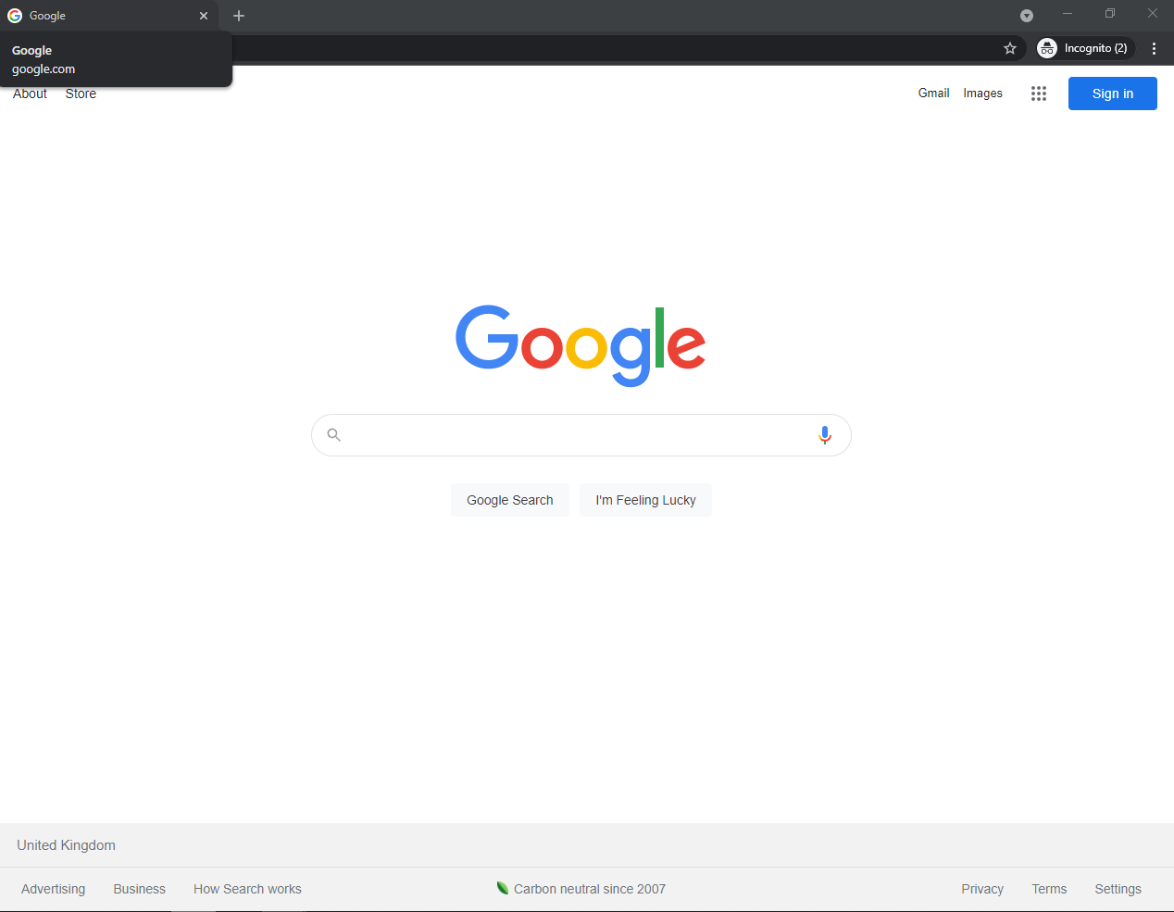
- Now click into the address bar and add the following: /?gl= and then add the two-letter code for the country you wish to search, such as es for Spain or de for Germany and then click enter. You will now see the location you have selected at the bottom of the screen:

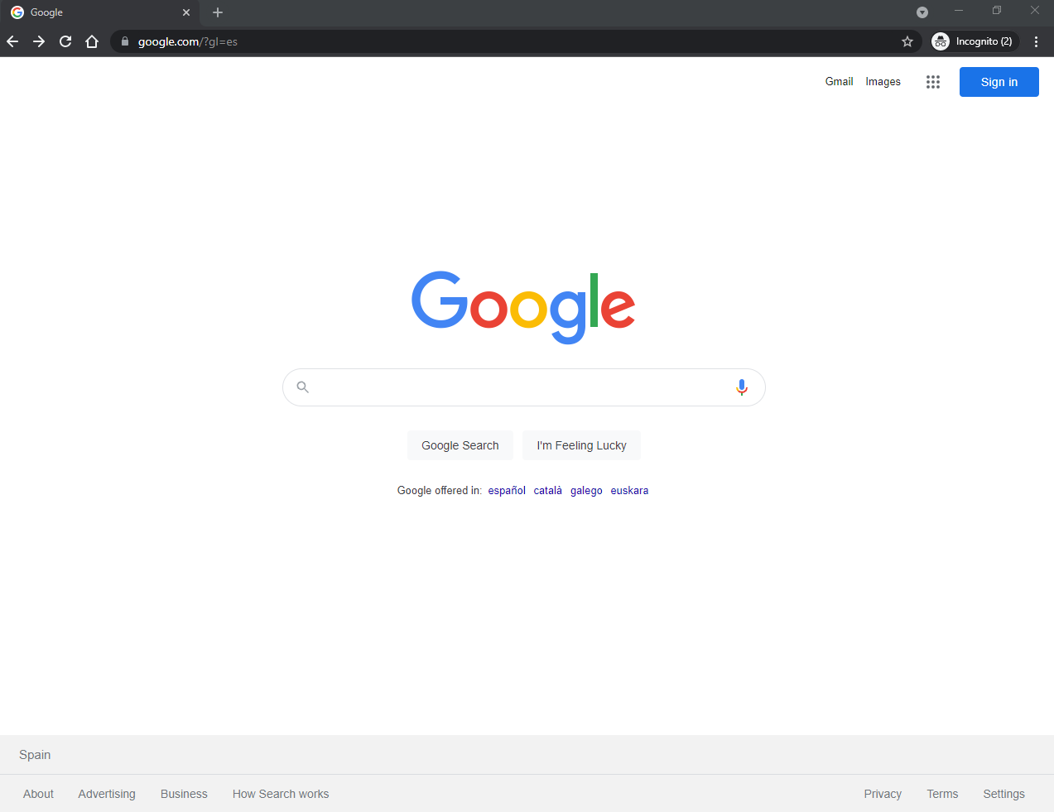

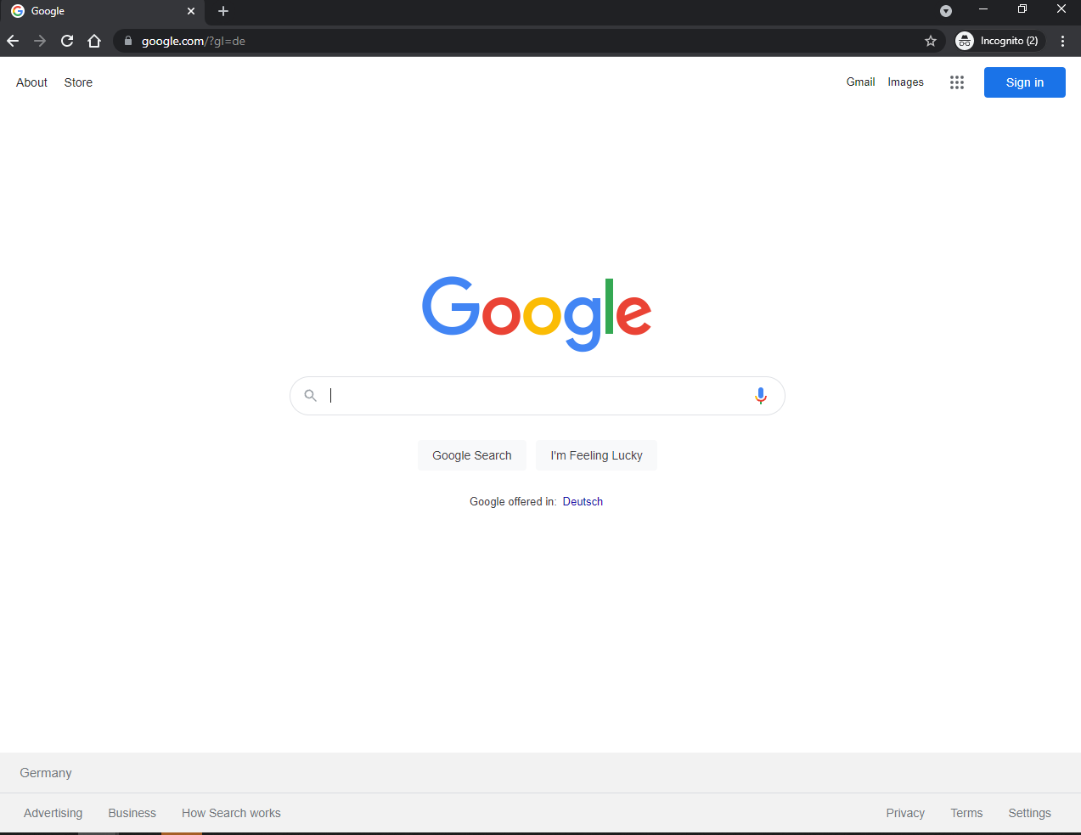

Using Google Translate

It is worth using the language appropriate to your search. It is easy to translate your search words using Google Translate. Open a tab in Chrome and search “Google Translate”. You can then select the languages and enter your search words.
Please see an example used to find potential automotive customers in Spain:



