Introduction.
It is envisaged to build a monitor that looks substantially like the existing VN202 and is used the same way,
However it would use the Tek-Ox electronics and incorporate several improvements to the VN202 Design.

The LCD Electronics and the battery compartment would be stacked so that the Electronics & battery compartment can be sealed.
All the electronics would be mounted on the front panel.
The rear panel could then be used to complete the case with access to the batteries from the rear
Or it could be left off so that the front can be fitted to a panel from the rear.
When used on a panel the sensor cable can be fed in from the rear so needs some form of fixing.
Improvements on the VN202
The cable would be terminated at both ends with Jack plugs. This will reduce the failure rate of cables and make cable change, when it is necessary, easy to implement.
The main problem with the current VN202 is the Calibration knob sticking proud of the front.
This should be recessed. In order to keep the colour scheme we need a yellow plate surrounding the Calibration knob and switch.
As this type of instrument requires two hands a facility for a photo screw thread is needed so that a lanyard can be used.
The batteries should be easily replaceable without a tool so the rest of the unit should be isolated and as waterproof as possible.

General Specification and illustrations
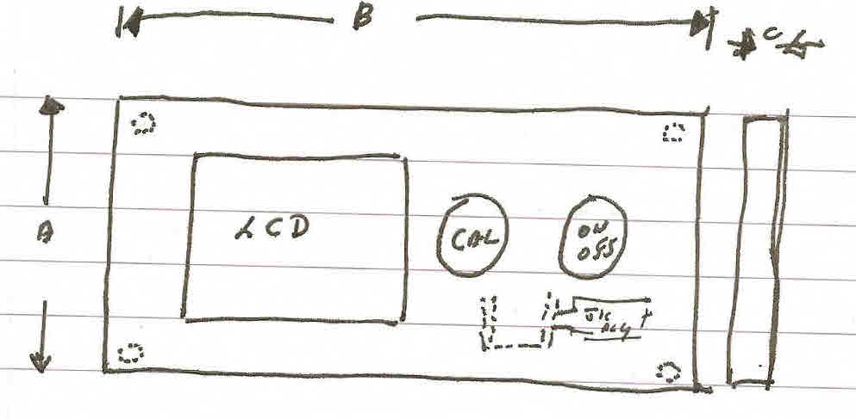
Front Panel
A = Size dictated by the length of AA Battery + the terminals used in the Tek-Ox; The LCD window size which is identical to the Tek-Ox

C = Depth T.B.A.

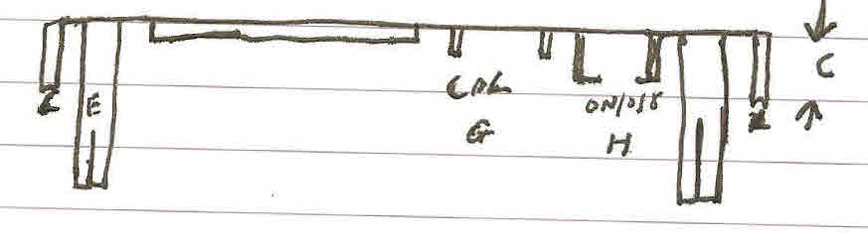
Side View Front

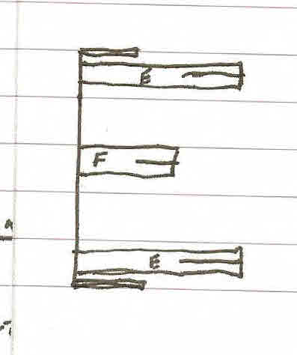

E = Mounting Pillars to a Panel or
for the rear case

F = Mounting Pillars for Battery holder
May need 4 x screws

Edge View

G= Recessed area for Calibration pot. Needs access for wires + mounting Kit
As used in Tek-Ox
H = On/Off Recessed to allow 2mm proud of front panel
J = Depth of LCD + Electronics + Battery
k = Length to match the front plate
L = O ring seal

NB Rear panel should preferably have a battery cover (M) that can be removed without a tool.

P = Battery plate

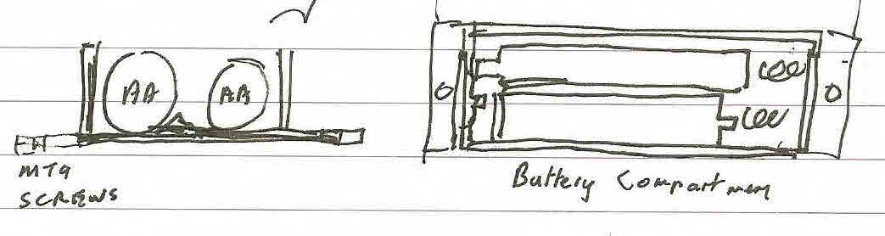

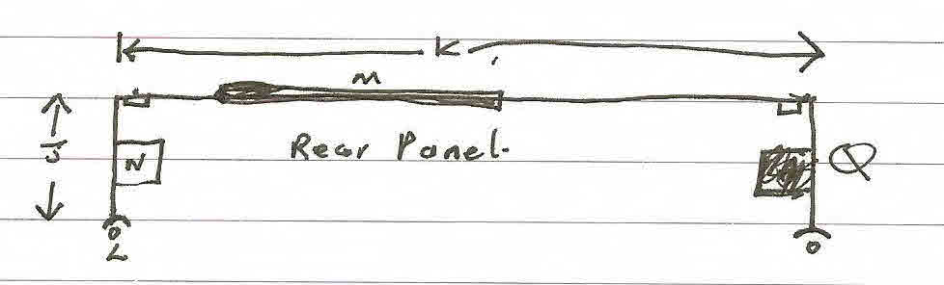
The battery compartment covers the LCD & Electronics

N = Jack socket compartment which is sealable

Q = Photo thread
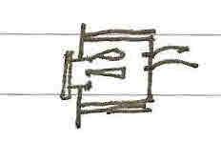
The battery box can contain a PSU instead of a battery.
Would only be used on a panel mounted version
The rear panel would also need two access points for 750 Jack so it can be fixed at either end

Somewhere between the CAL/ON/Off and the side of the box there needs to be a pillar to mount a “P” clip to hold the sensor cable or an area to hold and internal Jack socket. This allows the sensor to come into the unit from the panel

Future

It is envisaged that the instrument will evolve without great changes to the enclosure.

- Replacing the LCD with a colour graphics display
- Replacing the ON/OFF and calibration pots with an electronic system and membrane keypad
- Mains power supply or re-chargeable batteries.

