Search Issues for Non Conformance Reviewed

PART 1
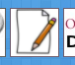
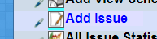

VST AND VIAMED AND VANDAGRAPH SEARCH for ‘NON C’

You should see a List of Non Conformance Headers appear:

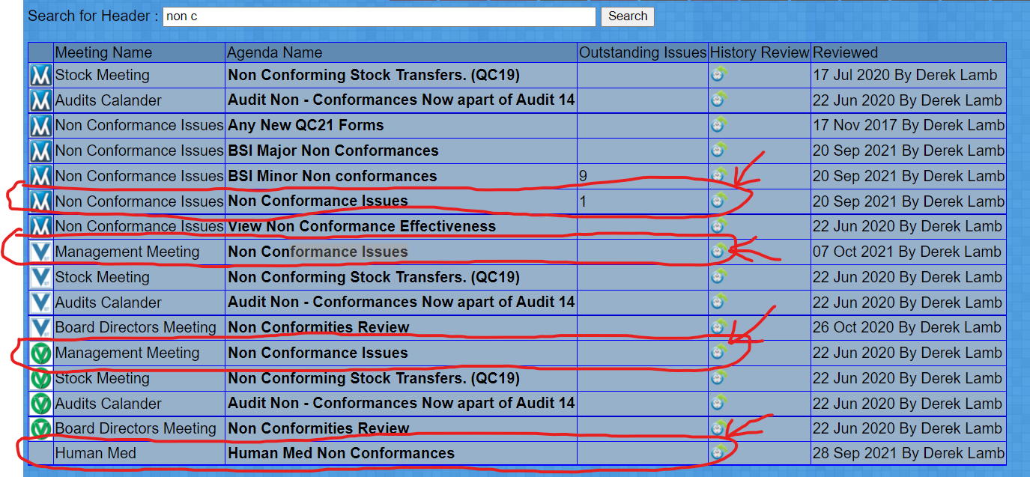

Click the History tab FOR the Highlighted rows

You will be Presented a list of Issues logged under the header.

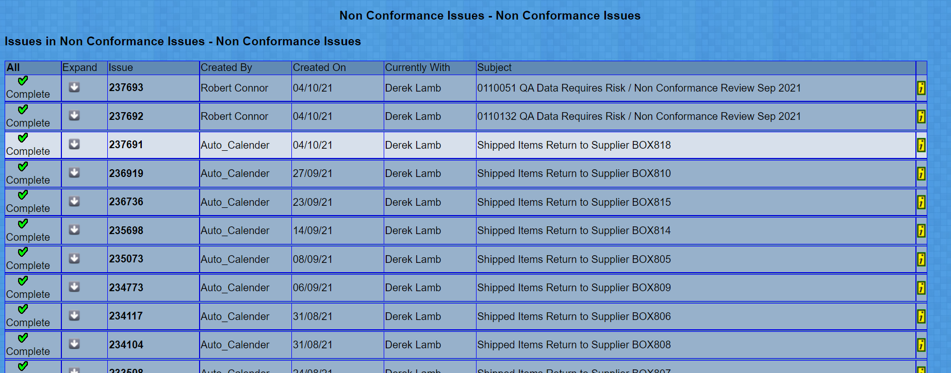

check each issue for the preivous month, for any non conformances that may need addressing.

PART 2
ISO – Non Conformance Reviews – Error Logs (Order Processing Non cons),

First Step Tidy up any new Resaons for Opening Orders.

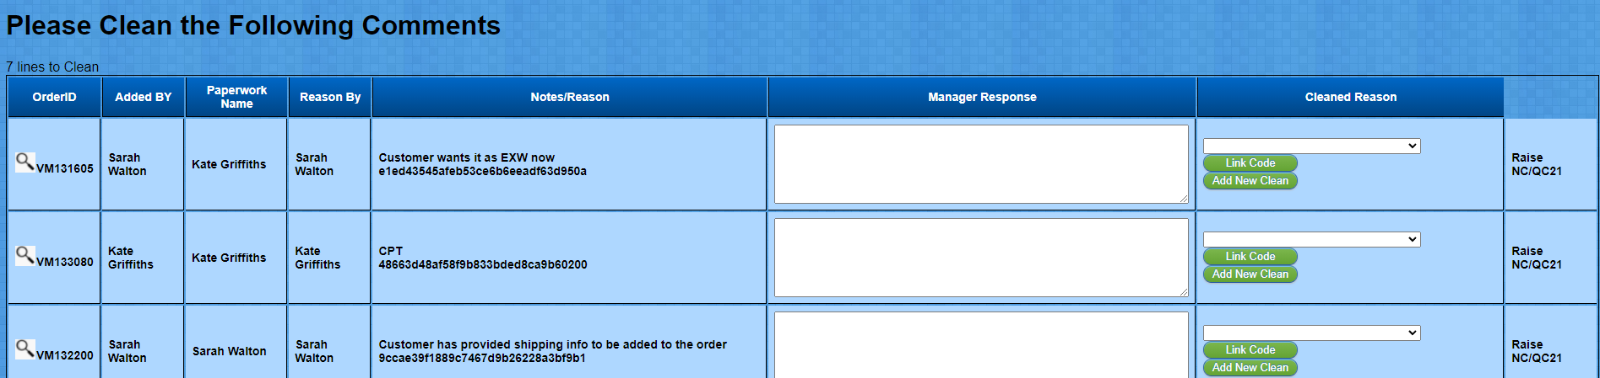
Select or create a new, Clean Reason for the opening of the order

once complete refresh the page.

You will see now a list of Reasons orders that have been opened for editing

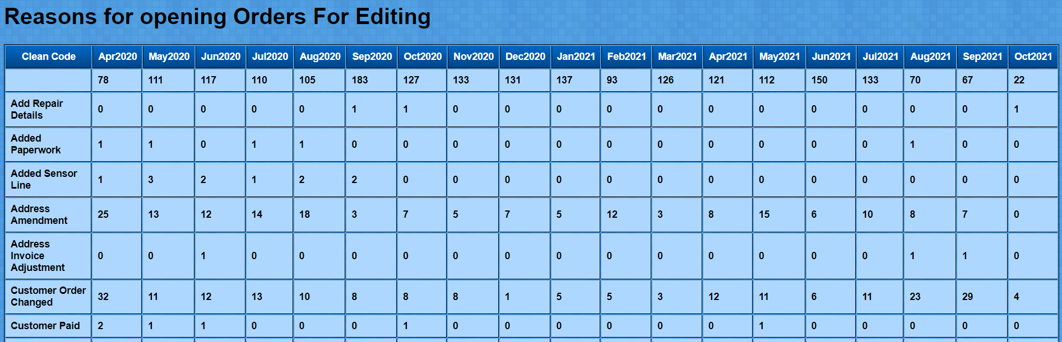

Look for areas with high errors, , Increasing Errors , or improved performance.
*Note currently normal process reason for open the orders are also shown in the list and are not considered Non Conformances.
Address Errors , Incorrect Items on Orders maybe classed as internal Non conformances.

PART 3

ISO Reviews

Non Conformance / Customer Complaints Review.

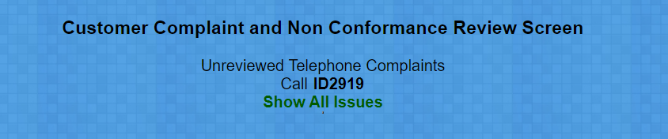

Click Show All Issues

Click Any Call ID’s listed other than ID2919.

Look for any other potential Non conformances.

