OPERATING & SERVICE INSTRUCTIONS FOR
AX300-I
Portable Oxygen Analyzer

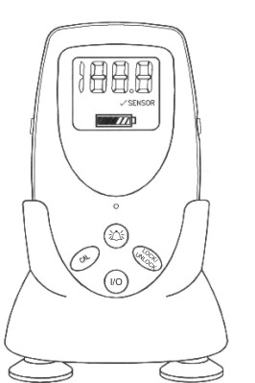

P/N M75708
xx/xx/xxxx
ECO # 07-0162
₀₀₈₆
TYPE B APPLIED PART:

Equipment provides a degree of protection against electric shock, particularly regarding—
• Allowable Leakage Current
• Reliability of the protective earth connection (if present).
Copyright © 2009 Teledyne Analytical Instruments.
All Rights Reserved
No part of this manual may be reproduced, transmitted, transcribed, stored in a retrieval system, or translated into any other language or computer language in whole or in part, in any form or by any means, whether it be electronic, mechanical, optical, manual, or otherwise, without prior written consent of Teledyne Analytical Instruments, 16830 Chestnut Street, City of Industry, CA 91749-1580, USA.

Warranty
Teledyne warrants that the goods are free from defects of material and of construction for a period of 2 years (or less, as the case may be, with consumables) from the date of shipment from Teledyne. The liability of Teledyne, if any, shall be limited solely to the replacement or repair of the goods, and shall not include shipping costs or other incidental damages as defined in Section 2-715 of the U.S. Uniform Commercial Code.
Teledyne cannot warrant any damage resulting from unauthorized repair, misuse, improper maintenance, negligence, or other events not caused by Teledyne or our goods.

CAUTION: Federal law restricts this device to sale by or on the order of a physician.

About This Manual
This Manual describes the installation, configuration, operation and maintenance instructions for Model AX300-I portable oxygen analyzer.
This Manual contains Cautions, Warnings, and Guidelines to ensure safe and efficient performance of the analyzer.
For convenience with operating and maintaining your analyzer, this manual includes Specifications, Troubleshooting and Maintenance Spare Parts sections.

How To Use This Manual
This manual is designed to walk you through the initial set-up of the AX300-I Portable Oxygen Analyzer. After you have used it to initially commission your analyzer, it becomes a quick reference guide to help you with specific questions or operating challenges.
Before operating the analyzer for the first time, you are advised to read the safety information on the next few pages and acquaint yourself with the information found in Chapters 1 and 2.

Safety Messages
Your safety and the safety of others are very important. Please carefully read the following safety messages.
Safety messages are indented to alert the user of potential hazards. Each safety message is associated with a safety alert symbol. These symbols are found in the manual and on the analyzer. The definition of these symbols is described below:
CAUTION: Refer to the instructions for details on the specific danger. These caution symbols warn of specific procedures, which if not followed could cause bodily injury, and/or damage the analyzer.

WARNING: This symbol is used to alert the operator of a condition that could cause bodily harm.
NOTE: Additional information and comments regarding a specific component or procedure are highlighted in the form of a note.
Caution: The analyzer should only be used for the purposes and in the manner described in this manual.
If you use the analyzer in a manner other than that for which it was intended, unpredictable behavior could result possibly accompanied with hazardous consequences.

Table of Contents

Safety Messages iv
List of Figures ix
List of Tables x
Introduction 1
1.1 Applicable Standards 2
1.2 Features 2
1.3 Options 3
1.4 Applications 3
1.5 Theory of Operation 4
1.5.1 Sensor 4
1.5.2 Signal Processing 4
Operation 5
2.1 Setup 5
2.1.1 Sensor Installation or Replacement 5
2.1.2 Mounting 7
2.1.2.1 V-Mount Adapter Installation 7
2.1.2.2 Universal Mounting Clamp Installation 8
2.1.3 Battery Installation 8
2.1.4 Calibration 10
2.1.5 Output 0-1 VDC or RS232 12
2.2 Use 15
2.2.1 Procedure 15
2.3 Factors Affecting Sampling Accuracy 16
2.3.1 Humidity 16
2.3.2 Temperature 17
2.3.3 Pressure 17
2.3.4 Discrepancy in Readings 18
2.3.5 Anesthetic Gases 18
2.3.5.1 Gases That Induce Reading Error 18
2.3.5.2 Care After Use in Nitrous Oxide 18
2.3.6 Cleaning 18
2.4 Dos and Don’ts 18
Service Manual 18
3.1 General Service Information 18
3.2 Overall Maintenance 18
3.3 Battery Maintenance 18
3.4 Sensor Maintenance 18
3.5 Calibration 18
3.6 Factors Affecting Sampling Accuracy 18
3.7 Troubleshooting 18
3.8 Watchdog 18
3.9 Other Problems with the Analyzer 18
3.10 Return Authorization for Service 18
Appendix 18
A.1 Specifications 18
A.2 Spare Parts List 18
A.3 Optional Accessories 18

List of Figures

Figure 1-1: AX300-I Front View 1
Figure 2-1: Installing the R17MED Sensor 6
Figure 2-2: Sensor Cable Connection to Analyzer 6
Figure 2-3: Mounting the Sensor in the Tee Adapter 7
Figure 2-4: V-Mount Adapter Installation 8
Figure 2-5: Brass Insert for Universal Mounting Clamp 8
Figure 2-6: Installing Batteries 9
Figure 2-7: Calibration Sequence 10
Figure 2-8: 0-1 VDC or RS 232 Digital Output Port 13

List of Tables
Table 2-1: Oxygen Reading Error in a Mixture of Anesthetic Gas 18
Table 3-1: Oxygen Reading Error in a Mixture of Anesthetic Gas Error! Bookmark not defined.
Table 3-2 Troubleshooting 18
Table 3-3 Error Codes 18

Introduction
The Teledyne Analytical Instruments AX300-I Oxygen Analyzer, hereinafter referred to as AX300-I or analyzer, is a portable analyzer designed to analyze oxygen concentration in medical gas mixtures. Oxygen analysis is linear across the single range of 0-100% using Teledyne’s class R17MED oxygen sensor.
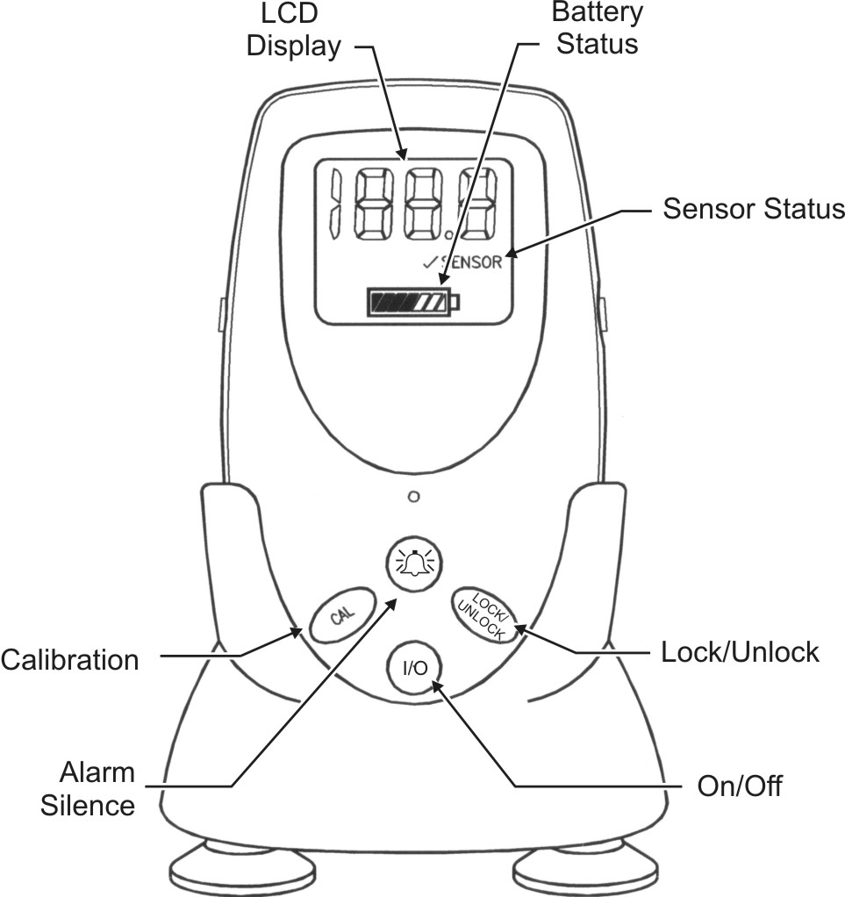
Figure 1-1: AX300-I Front View
The AX300-I’s liquid crystal display (LCD) consists of up to 3.5 characters plus a decimal point indicator capable of displaying up to 105%. An integral battery life indicator is displayed continuously on the AX300-I.
The analyzer is powered by three AA alkaline batteries and is designed to operate for 2000 hours on a single set of batteries in a Non-alarm State.
A sensor failure alarm is incorporated which warns the user if the sensor signal is lost or low. When this occurs, the √ SENSOR display flashes. The alarm buzzer can be silenced by pressing the ALARM SILENCE key () or pressing the unlock key. This alarm condition is also triggered when the oxygen concentration at the point of analysis falls below 18% (Reference: ISO 7767 standard).
Caution: During normal use, alarm conditions should not be overridden by pressing the unlock key. The cause for the alarm condition should first be resolved.

1.1 Features
The following features are standard on the AX300-I:
- Large easy to read 3½-digit LCD (see options)
- Automatic LCD back lighting upon key press
- Microprocessor controlled
- Sensor fail/disconnect alarm indicator (audible and visual)
- Non-adjustable concentration alarm below 18% O₂
- Alarm silence button
- 2000 operating hours from 3 AA alkaline batteries
- Battery status indicator
- Stand for upright tabletop deployment
- Optional hardware for pole clamping and V block support
- Rugged high impact ABS plastic construction
- Splash resistant case.
- Long life class R17MED sensor
- 0-1 VDC digital output (optional RS-232)
- FDA 510(k) market clearance and CSA/CE marking

1.2 Options
The following options are available for the AX 300-I analyzer:
- A-Option—2½-digit LCD instead of 3½-digit
- B-Option—RS 232 digital output instead of 0-1VDC
Note: Contact the factory for modifying your analyzer for 2½-digit LCD. For RS-232 reconfiguration, see Section 2.1.5.
- Universal Pole Mounting Clamp (P/N CP 2345)
- V-Mount Pole Clamp (P/N CP 2344)
- V-Mount Wall Adapter P/N B 647)
- 0-1 VDC Interface Cable (P/NB-75554)
- RS 232 Interface Cable (P/N B-75555)

1.3 Applications
The AX300-I analyzer is intended for spot checking the concentration of oxygen in gas mixtures used in applications such as Anesthesia gas delivery and Respiratory care, and is intended for adult, pediatric and neonatal populations.

1.4 Operation Summary
The AX300-I analyzer uses Teledyne Analytical Instruments’ Patented R17MED oxygen sensor. The sensor output is used to determine the oxygen gas concentration that is displayed on the LCD screen. The concentration alarm of AX300-I analyzer is non-defeatable and will alarm when the oxygen concentration falls below the threshold of 18%. This alarm is tied to sensor fail/disconnect alarm that will also warn the user of a possible sensor problem when the oxygen concentration is less than 18%. When a fault is detected, the √SENSOR indicator is displayed on the LCD, and the audible and visual alarms are activated.
The Class R17MED oxygen sensor is a disposable sensor. The sensor has a cathode (sensing electrode), an anode (counter electrode), and a compatible electrolyte, and is packaged in a small plastic sensor body. Oxygen entering the sensor reacts with the anode and a proportional current is collected at the cathode, which is then converted into a digital signal and displayed on the LCD screen on the analyzer.
Used with the R17MED sensor is a removable plastic diverter. This diverter is used to facilitate the transport of gas mixtures through the sensor. The diverter, packaged separately when shipped, is necessary when the tee adapter is used to sample gas flowing through a tube.
The diverter is not necessary and should not be used when the sensor is placed directly in a chamber, or when the sensor is used in confined volume analysis, such as incubators and inhalation tents.
CAUTION STATEMENTS:
The R17MED sensor contains a caustic electrolyte and lead. Do not try to open the sensor assembly. Check the sensor periodically for leaks. If the sensor is leaking, replace it. Do not try to repair it. Contact Teledyne for the material safety data sheet related to handling and disposal.

The R17MED sensor contains a caustic electrolyte, and in the event of a leak, the electrolyte may attack certain materials it is exposed to, such as aluminum. Use precaution in your choice of interface materials.

Remove and save the diverter when the sensor is used in confined volume applications.

The AX300-I oxygen analyzer, R17MED oxygen sensor and associated hardware are intended for use as secondary devices to verify the concentration of oxygen in gas mixtures. Do not use these devices as primary life-support or primary monitoring devices.

The information obtained from the AX300-I should never be used to adjust a life-support system. It should only be used as an indication that the life support system or device in the breathing system that AX300-I is being used with may require service and/or calibration.

Operating Instructions
Notes:
Upon receipt, INSPECT THE ENTIRE UNIT FOR ANY DAMAGE. Check the unit and all included accessories for broken or loose parts. If damaged, DO NOT USE. Notify the shipper, your distributor or Teledyne Analytical Instruments.
This equipment is internally powered using 3 AA batteries.
The LOCK/UNLOCK key helps prevent accidental change to the calibration set point. At least two keys must be pressed in order to modify the critical calibration set point value.
If the keys are unlocked and no keys are pressed, the analyzer will revert to the locked mode within nine seconds.
The ALARM SILENCE () key continues to operate normally when the lock feature is activated.

2.1 Setup
To use your AX300-I analyzer, first install the batteries, then install the oxygen sensor and then, calibrate the analyzer using the steps outlined in section 2.1.4.

2.1.1 Sensor Installation or Replacement
Note: The R17MED oxygen sensor must be installed before the oxygen analyzer can be operated
- Remove the new sensor from its protective bag. Inspect the sensor for damage or electrolyte leakage.
WARNING: The sensor electrolyte is caustic. DO NOT USE A DAMAGED OR LEAKING SENSOR. Do not let THE ELECTROLYTE come in contact with skin. If it does, flush affected area with water. Do not attempt to open or repair the sensor.

WARNING: The sensor also contains lead. Leaking or exhausted sensors should be handled and disposed of in accordance with local regulations. Contact Teledyne for the Material Safety Data Sheet
WARNING: The AX300-I oxygen analyzer, R17MED oxygen sensor, and associated hardware are non-sterile devices. Autoclaving or other chemical cleaning may damage the analyzer and the sensor.
- Plug one end of the coiled cable into the receptacle on the back of the R17MED sensor and secure it in place with the capture nut located at the base of the connector. See Figure 2-1.

Figure 2-1: Installing the R17MED Sensor
- Plug the other end of the cable into the receptacle located on the side of the unit and secure it using the capture nut. See Figure 2-2.

Figure 2-2: Sensor Cable Connection to Analyzer
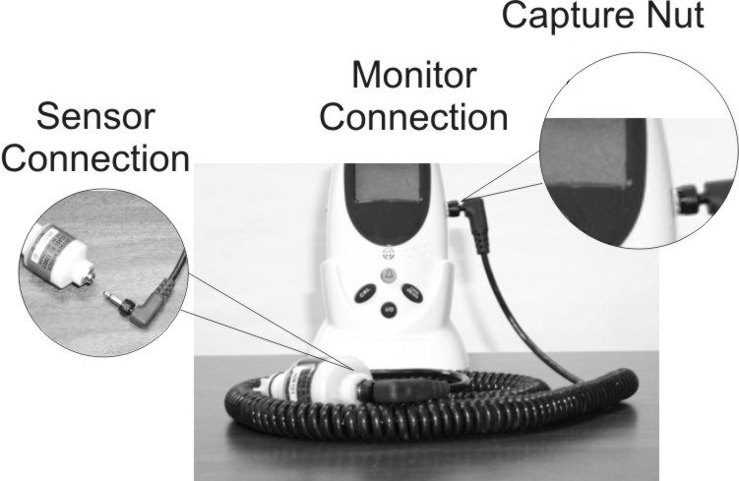
Note: Cable shown is for illustration purposes only. Supplied cable may not have a right-angle bend.
Note: Do not use the plastic flow diverter with the R17MED sensor when the sensor is used for diffusion sampling (such as with oxygen tents, incubators, etc.). When the sensor is used with a Tee Adapter, such as in a breathing system, the diverter must be used as shown in Figure 2-3.
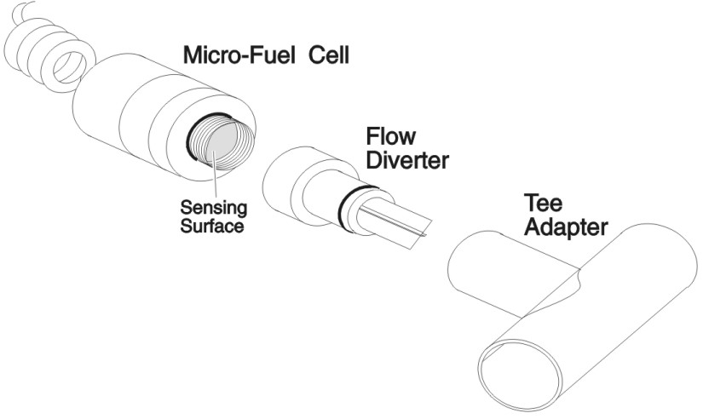
Figure 2-3: Mounting the Sensor in the Tee Adapter

2.1.2 Mounting
The AX300-I can be mounted in several ways depending on the optional equipment ordered at the time of purchase. See Section 1.3.

2.1.2.1 V-Mount Adapter Installation
The V-Mount Adapter consists of a matching plastic plate with integral V-grooves that attach to the rear of the analyzer.
To install V-Mount Adapter, remove the battery compartment door by prying up the hinged latch at the bottom of the cover, then slide the adapter plate into grooves provided in rear case. Replace the battery compartment door and secure door latch. See Figure 2-4.
Note: The door latch is a tight fit onto the battery cover. Use a coin to gently pry up the latch.
Figure 2-4: V-Mount Adapter Installation

2.1.2.2 Universal Mounting Clamp Installation
The optional Universal Mounting Clamp comes with a 1/4-20 screw for securing the clamp to the rear of the analyzer. A threaded brass insert is installed on the back of the analyzer for this purpose. See Figure 2-5.
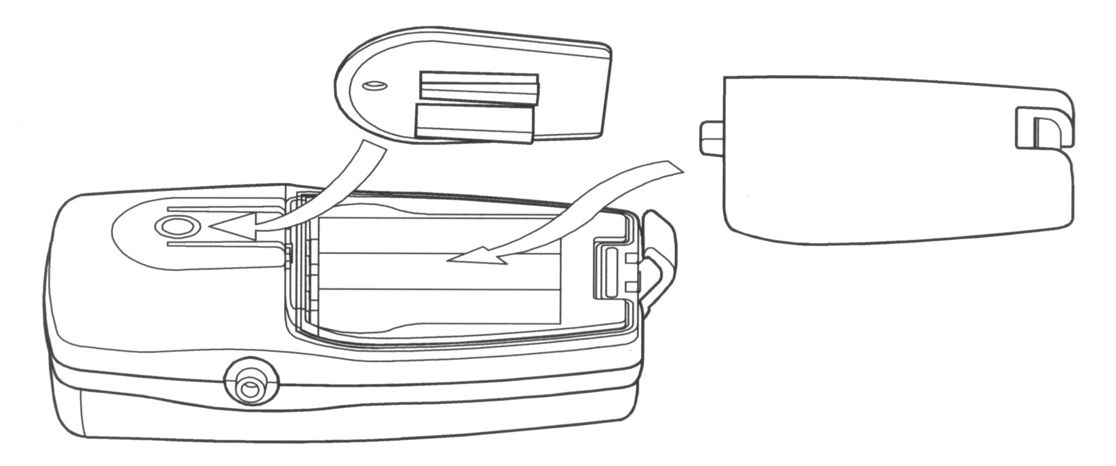
Figure 2-5: Brass Insert for Universal Mounting Clamp
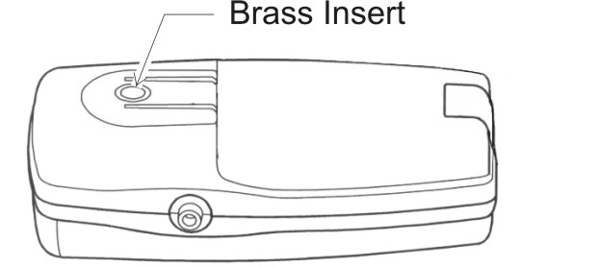

2.1.3 Battery Installation
Note: Three “AA” alkaline batteries must be installed in the unit before the analyzer will operate. The unit must be recalibrated whenever new batteries are installed.
To install the batteries:
- Turn the unit off (if it is on).
- Hold the analyzer face down in the palm of your hand. Use a coin to pry up the latch that secures the battery compartment door. Remove the battery compartment door.
CAUTION: Improper installation of the batteries may result in damage to the unit and batteries.

Note: Use alkaline batteries only. Other battery types will produce erroneous battery test readings.
- Install 3 “AA” alkaline batteries into the holder as shown in Figure 2-6. Each battery has its own slot. To insure proper polarity, place the bottom (flat) or negative end of the battery in the end of the holder marked “–”. Place the top (button) or positive end of the battery in the end of the holder marked “+”. Do this for each battery.
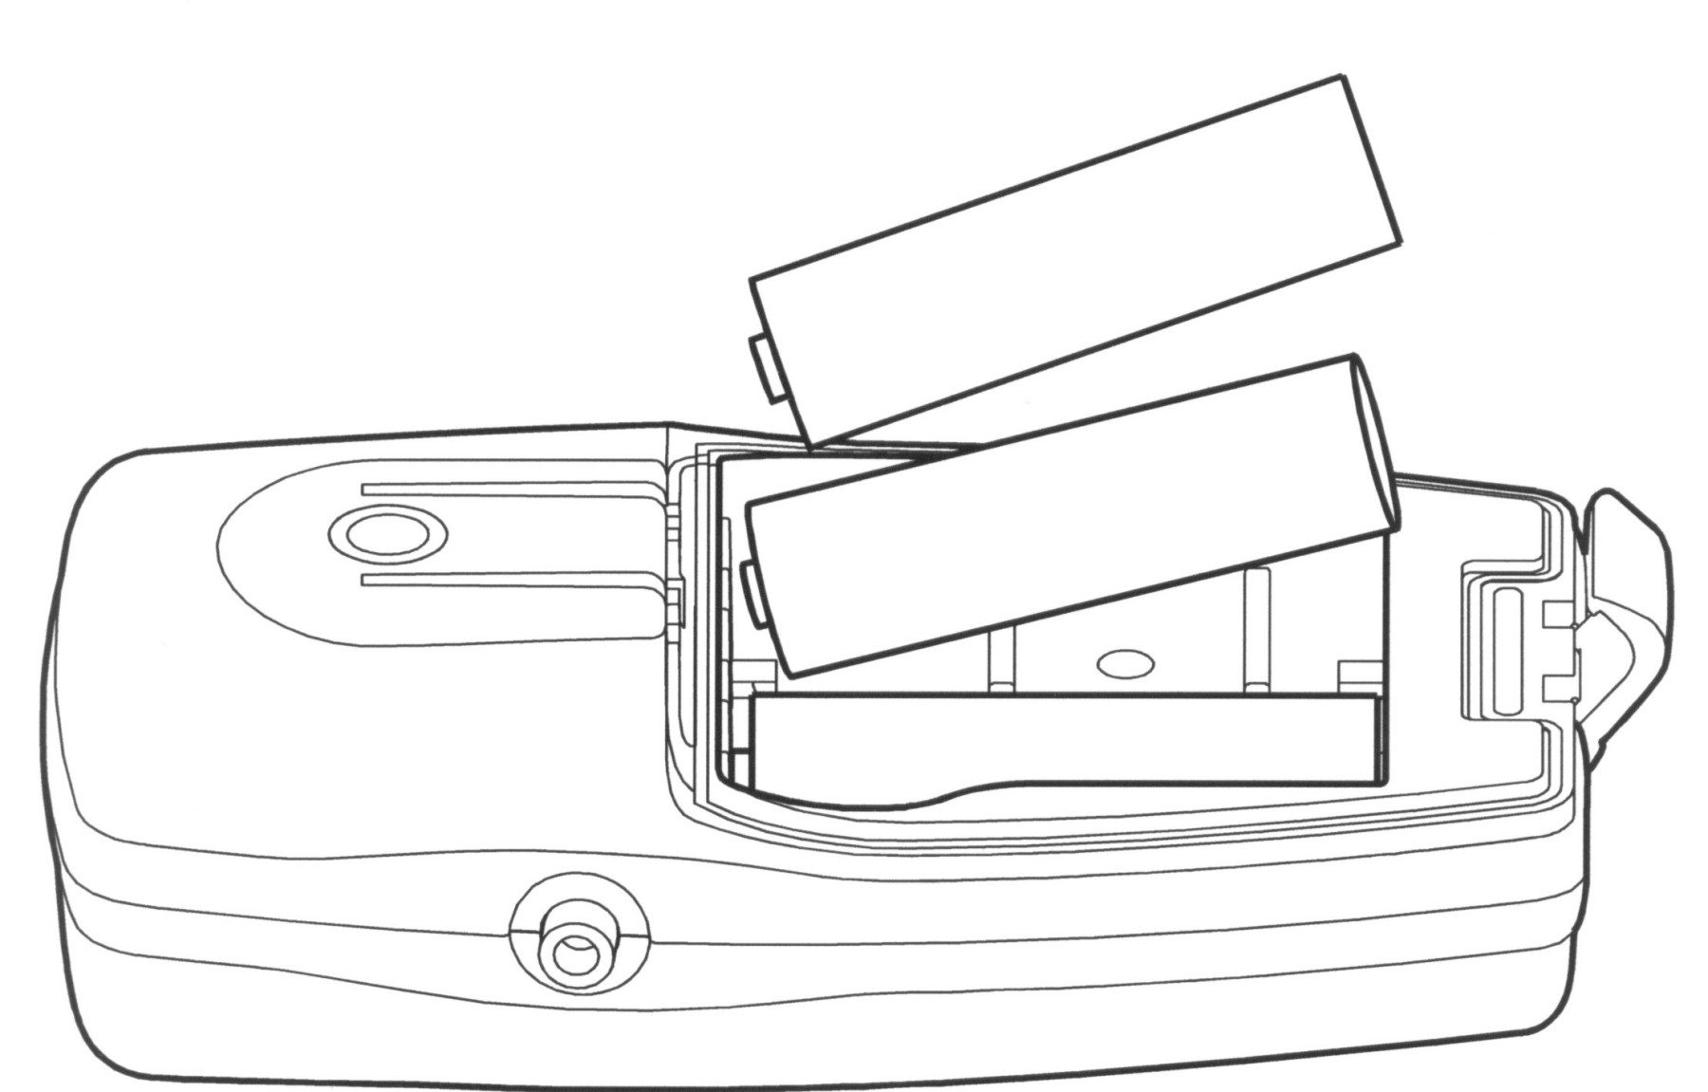
Figure 2-6: Installing Batteries
- Re-install the battery compartment door. When the unit is first turned on, the screen will momentarily display all LCD segments. During this period, diagnostic tests are being conducted to ensure that the circuits are functioning correctly. The unit will activate the audible and visual alarms for about 1 second. The LCD will flash continuously indicating the unit is in the unlocked position ready for calibration.
Note: When batteries are first installed or power is lost for any reason, the analyzer defaults to the calibration mode. All keys except the CAL and ON/OFF (I/O) keys will be inoperable until a successful calibration is achieved.
- Note the battery display located below the oxygen readout display. It continuously shows a bar graph of the remaining life to the batteries. Using new batteries will illuminate all 5 segments from the left to the right end of the bar. The bar graph indicator is continuously on when the analyzer is powered on.

2.1.4 Calibration
The AX300-I should be calibrated before each use and every 8 hours to maintain accuracy.
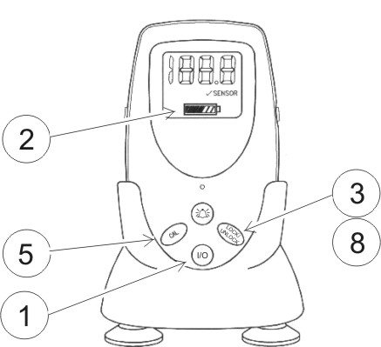When batteries are removed for any reason or when new batteries are installed, the oxygen analyzer defaults to the calibration mode with the LCD display flashing 00.0. Only the CAL and ON/OFF (I/O) keys are functional at this point.

Note: For first time and for routine maintenance calibrations, make sure that the sensor and sensor cable are installed correctly before attempting to calibrate the analyzer

Figure 2-7: Calibration Sequence
To calibrate the analyzer (See Figure 2-7):
- Turn the unit on by pressing the ON/OFF (I/O) key.
- Check the battery status via the bar graph.
- If the LCD is not flashing, press the LOCK/UNLOCK key to unlock the keys. LCD will flash indicating that changes can be made to the settings. If the batteries have just been installed the LCD will flash 00.0
- As with most oxygen analyzers, the highest level of accuracy is achieved when calibration is conducted using 100% oxygen. After installing the flow diverter as noted in Section 2.1.1, insert the sensor into the plastic tee and connect to a supply of pure dry oxygen flowing at 1-2 liters per minute.
Note: An accessory calibration assembly (P/N C53790) is available from Teledyne for use with the R17MED sensor
- Wait about 20 seconds to ensure that the sample line is completely purged with the calibration gas. Press the CAL key. The LCD will count down from 9 to 0. The analyzer electronics will measure the sensor output during this countdown to determine the gas concentration and selects the calibration range of either 100% or 20.9%. When the calibration is complete, the LCD will display the gas value.
Note: At the end of the calibration countdown, the analyzer will display a solid number, indicating acceptance of the calibration value. No further user action is required. If the LOCK/UNLOCK key is still pressed, the display will start blinking, allowing the recalibration. If this LOCK/UNLOCK key-press is in error, either press the key once more or allow the software to revert to the locked mode automatically, which will occur within nine seconds of not pressing any functional keys. Once the analyzer reaches the locked mode, press the LOCK/UNLOCK key and press the CAL key to repeat calibration.
Note: The AX300-I can only be calibrated using certified medical grade 100% oxygen or ambient level air (20.9% Oxygen). Improper calibration or use of other gas concentrations will either activate the √ SENSOR indicator or render the analyzer to assume that the gas delivered for calibration was 100% Oxygen. This latter behavior of the analyzer, which is common across many other peer group analyzers, would introduce significant error in analysis. Hence, use only certified medical grade 100% Oxygen gas or ambient level air (20.9% Oxygen) to calibrate your analyzer.
- Remove the sensor from the oxygen supply and confirm the LCD reads less than 22% in room air. It is not necessary for it to read exactly 20.9%.
- It is important to perform the calibration carefully and thoroughly, using calibration gases that are free from contaminates. The accuracy of the analyzer is only as good as the accuracy of calibration gases used and the accuracy of the procedure used to calibrate the analyzer.
Note: A single point air calibration is not recommended unless the sensor can be exposed to a known source of fresh outdoor air. Hospital room air may often be enriched with excess oxygen, which will introduce errors into the calibration. Air calibration should only be used for analyzing oxygen levels between 21% and 40% and should never be used where a high degree of accuracy is needed.
Note: Never calibrate the unit in humidified gas, as water vapor makes the oxygen concentration appear lower than it really is. See Section 2.3.1: Humidity.
- The analyzer is now ready for use.

2.1.5 Output 0-1 VDC or RS232
The AX300-I Portable Oxygen Analyzer comes with optional 0-1 VDC and RS232 signal outputs for use with compatible external recording, indicating or computing equipment.
An optional 0-1 VDC Interface Cable (P/N B-75554) is available from Teledyne for accessing the voltage output.
To connect the analyzer to an analog recording/indicating device:
- Insert one end of the interface cable into the output port on the side of the analyzer. See Figure 2-8.
- Insert the other end into the analog recorder/indicator device equipped to handle a 0-1 VDC signal.
When properly calibrated, the output signal generated by the analyzer is linear and proportional to the oxygen concentration.
If you requested Option-B (RS 232 digital output) at the time of purchase, a digital RS 232 signal is output from the output port shown in Figure 2-8. Use the optional RS 232 Interface Cable (P/N B-75555) available from Teledyne for connection to a standard RS 232 port on a computer or other suitably equipped digital device.

Caution: AX300-I ANALYZER should only be connected to an EN60601-1/IEC60606-1 approved device.

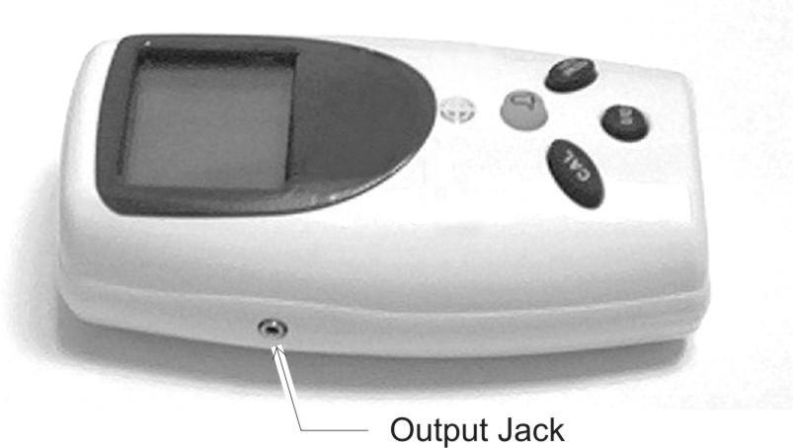
Figure 2-8: 0-1 VDC or RS 232 Digital Output Port
RS232 signal output has been tested with window Hyperterminal. The setup changes with different windows versions. If other software other than windows hyperterminal is used, consult with factory.

Windows 95 version
Baud: 2400
Data: 7
Parity: ODD
Stop bit: 1
Flow control: NONE

Windows 98, Windows 2000 and Window XP version:
Baud: 2400
Data: 8
Parity: ODD
Stop bit: 1
Flow control: NONE
If your analyzer is set for analog (0-1 VDC) output, you can reconfigure it to use the digital output by changing a jumper on the internal PC board.
To activate the digital output:
- Remove the batteries and remove the five screws that hold the case together.
- Remove the rear case section leaving the PCB in the front half of the case.
- Remove jumper at position JP3 and reinstall it at position JP7.
- Replace the rear cover and secure in place with five screws. Install the batteries and recalibrate per Section 2.1.3.

To reconfigure the analyzer from a digital (RS 232) output to analog (0-1 VDC) output, use the same procedure except in step 3 remove the jumper from JP7 and replace it at JP3.

Caution: EXERCISE EXTREME CARE WHILE MODIFYING YOUR MEDICAL DEVICE. TELEDYNE WILL NOT BE RESPONSIBLE FOR ANALYZER MALFUNCTION DUE TO MODIFICATIONS NOT DONE BY THE FACTORY. WE STRONGLY RECOMMEND SENDING THE ANALYZER TO TELEDYNE FOR ANY DESIRED RECONFIGURATION.

2.2 Operating Instructions

2.2.1 Procedure
Note: Prior to every use, always test the batteries, check the sensor for any leaks or damage, and check the analyzer calibration.

The AX300-I analyzer can be used to measure a gas mixture for oxygen in two basic modes:
- In the inhalation side of breathing system upstream of any antibacterial filters, humidifiers and other such medicating devices.
- In confined volumes such as in incubators or tents.
When analyzing for oxygen in breathing systems, the flow diverter must be used. The diverter should be screwed onto the threaded front end of the R17MED sensor. A tee adapter (plastic, P/N A268, or metal, P/N A283) should be placed into the breathing loop, and the above sensor assembly plugged into the tee adapter. See Figure 2-3.

CAUTION: Check the breathing system for leaks. Be certain that the system downstream of the sensor does not produce any BACKPRESSURE or restriction to flow. errors in readings will result if this is not followed.
tHE OXYGEN SENSOR IS A NON-STERILE DEVICE AND SHOULD BE USED IN CONJUCTION WITH AN ANTIBACTERIAL FILTER. aLWAYS INSTALL THE SENSOR ON THE INSPIRED LINE AHEAD OF FILTERS, HUMIDIFIERS AND MEDICATING DEVICES. NEVER INSTALL THE SENSOR IN A LOCATION THAT WILL EXPOSE THE SENSOR TO PATIENTS’ EXHaLED BREATH OR SECRETIONS UNLESS YOU INTENd TO DISPOSE OF THE SENSOR AND FLOW ADAPTER AFTER USE.

When analyzing for oxygen in confined volumes such as incubators, hoods, etc., the flow diverter must be removed from the R17MED sensor so that it does not interfere with the rapid exchange of gases to and from the sensing surface of the sensor.

CAUTION: Failure to remove the diverter in these application areas will result in a marked REDUCTION of the response time of the sensor.
The R17MED sensor can be placed or hung inside incubators, tents, etc. When it is necessary to thread the cable through a small hole in order to gain access to the inside of a chamber, the cable should be disconnected at the sensor, threaded through the hole, and reconnected inside the chamber.

2.3 Factors Affecting Sampling Accuracy

2.3.1 Humidity
Humidity does not directly affect the accuracy of the sensor's measurement. However, when a nebulizer or other device is used to increase moisture levels in gas mixtures, the moisture actually dilutes the mixture. This dilution effect decreases the oxygen concentration. Your portable oxygen analyzer accurately measures the decreased oxygen concentration.
As with all diffusion based oxygen sensors, excessive condensation on the sensing surface of the R17MED will block the diffusion of oxygen to the sensor, rendering it inoperative. We recommend installing the sensor on the dry side of the breathing system at all times.

2.3.2 Temperature
The R17MED oxygen sensor compensates for ambient temperature changes in the range of 0–40°C (32–104°F). Since the thermistor that compensates for these changes is located in the rear of the sensor assembly, it is important that gas mixtures, flowing over the front of the sensor, be at room temperature, which is assumed to the temperature around the rear of the sensor. Reading errors may occur if gases at higher temperature from devices such as heated humidifier are used to measure oxygen with R17MED oxygen sensor.
A small thermal tracking error may be encountered in applications where the entire sensor assembly is placed in the gas mixture to be analyzed (such as in the incubators). Holding the sensor in your hand for more than a few minutes can also affect the temperature tracking which appears as a slow drift on the LCD. No adjustments should be made during this period since this error will be eliminated when both the thermistor and sensing electrode have had sufficient time to come to thermal equilibrium. This can take up to 2 hours.

2.3.3 Pressure
Virtually all gas sensors and analyzers measure the partial pressure of the gas that they sample. The only time that these analyzers can accurately read percentages is when the total pressure does not vary over time between calibrations and use. For this reason it is important to calibrate the AX300-I oxygen analyzer (with R17MED oxygen sensor) at regular intervals. It is recommended that the unit be calibrated prior to each use or every 8 hours. It is recommended that the analyzer be calibrated at the same pressure as the gas it will be used to analyze. If the gas being analyzed flows through some length of tubing, use similar tubing/apparatus and same pressure/flow rates when calibrating the analyzer.
When a ventilator is a part of the breathing system, the alternating “breathing” pressure cycles generated by the ventilator will be sensed as pressure pulses by the sensor, and over time, such pulses manifest as pressure increases in the fast-reacting sensors such as R17MED. This perceived pressure increase results in correspondingly higher oxygen reading. While the concentration of oxygen is not changing, it is the total pressure that is increasing producing a corresponding increase in the partial pressure of oxygen.

2.3.4 Discrepancy in Readings
When a discrepancy in oxygen readings is detected, the oxygen analyzer’s readings should be verified by checking the AX300-I battery condition and calibration using 100% oxygen. If the analyzer can be calibrated, the unit can be assumed to be in good working order. If, after reinstalling the unit, the discrepancy in oxygen readings persists, the problem is most likely elsewhere in the breathing system. Resolve the cause(s) for the discrepancy before using the analyzer. The troubleshooting section of this manual may provide additional assistance in locating the problem.

2.3.5 Anesthetic Gases

2.3.5.1 Gases That MAY INDUCE Reading Error
When using the R17MED sensor in the presence of anesthetic gases, the oxygen reading may fall (see Table below). The magnitude of this error will depend upon the level of oxygen and the duration of exposure.
The anesthetic agents listed in the following table (Halothane, Enflurane, Isoflurane, Sevoflurane, and Desflurane) were vaporized into a stream of 30% oxygen / 70% nitrous oxide, and the resulting drops in oxygen level after an exposure of approximately two hours were noted.
Exposures in excess of two hours may produce slightly greater errors. The errors listed are typical for all oxygen sensors such as the R17MED. Exposing the sensor to air or gases that do not contain anesthetic agents for a period of time equal to or greater than the exposure interval will eliminate the reading error in most cases.

Table 2-1: Oxygen Reading Error in a Mixture of Anesthetic Gas
Gas or Vapor Level
(Balance: Mixture of 30% O₂ / 70% N₂O, except where noted)
Gas or Vapor | Test Level | Oxygen Reading  Error
Helium | 50%, balance O₂ | 0%
Nitrous Oxide | 80%, balance O₂ | 0%
Carbon Dioxide | 10%, balance O₂ | 0%
Halothane | 4% | < 1.5% O₂ *
Enflurane | 5% | < 1.5% O₂ *
Isoflurane | 5% | < 1.5% O₂ *
Sevoflurane | 5% | < 1.5% O₂ *
Desflurane | 15% | < 1.5% O₂ *

* Errors are approximate and may vary based on exposure times and concentrations.
These performances meet or exceed the requirements of ISO 7767: 1997 (E).
CAUTION: The AX300-I should not be used in the presence of flammable anesthetics such as diethyl ether or cyclopropane.

CAUTION: The AX300-I, oxygen sensor and associated hardware are non-sterile devices. Do not autoclave the analyzer or sensor, as this will damage the equipment.

2.3.5.2 Care After Use in Nitrous Oxide
CAUTION: The R17MED sensor should not be left in nitrous oxide mixtures any longer than NECESSARY.

After exposure to nitrous oxide mixtures, the sensor should be left in 100% oxygen overnight (e.g., left in a breathing system that has been flushed with pure oxygen). If this is not practical, when using the tee, remove the plastic flow diverter and leave the sensor in room air. If the oxygen reading continues to drop after each use in nitrous oxide, the sensor should be removed from service. If the sensor can no longer be calibrated or if there is any sign of electrolyte leakage, the sensor should be disposed of in accordance with local regulations and the Material Safety Data Sheet (MSDS) available through Teledyne.

2.3.6 Cleaning
The AX300-I and R17MED sensor are non-sterile devices.
The oxygen analyzer, oxygen sensor, and sensor interconnection cable may be cleaned by wiping the surfaces with isopropyl alcohol or a mild cleaning solution.
When cleaning, do not allow liquids or moisture to enter the analyzer or sensor internal cavities. Do not expose the electrical connections to the cleaning solution. Do not immerse the analyzer, oxygen sensor or sensor interconnection cable in water or any other liquid.
Do not expose the analyzer, oxygen sensor and interconnection cable to steam, ethylene oxide, or radiation sterilization.
After cleaning, ensure that all surfaces are dry and the analyzer is properly calibrated before using the analyzer.

2.4 Dos and Don’ts
– DO –
- Read and understand the manual before using the analyzer
- Calibrate every 8 hours or before every use.
- Visually inspect the sensor for leakage before each use.
- Calibrate using 100% oxygen and check in air.
- Test batteries regularly and replace when battery indicator shows low battery (no bars)
- Keep the analyzer, sensor and connections dry, or on the dry side of the breathing system.
- Recalibrate after replacing the batteries.
- Recalibrate after replacing the sensor.
- Use only alkaline batteries.
- Ensure that the R17MED sensor is properly connected to the analyzer.
- Always use the plastic flow diverter when using the tee adapter.
- Remove and save the plastic flow diverter when using the sensor in non-flowing applications
- Use only isopropyl alcohol or mild detergent, if cleaning is required,
– DON’T –
- Use this analyzer if you suspect any malfunction.
- Use the analyzer in the presence of flammable gases.
- Use anything but alkaline batteries.
- Autoclave or freeze the sensor or analyzer.
- Open or try to repair a leaking or broken sensor.
- Immerse the unit or sensor in any liquid.
- Pass hot or cold gas mixtures over the sensor.
- Expose the unit to devices that produce high levels of radio, short wave, microwave, x-ray, or high frequency interference.
- Use cleaning agents or liquids in the cable receptacles or around the battery compartment.
- Place the unit in a water vapor-saturated environment.
- Expose the LCD to excessive sunlight.
- Expose the unit to a condensing water environment such as a mist tent.

Service Instructions

3.1 General Service Information
Without access to special probes and test equipment, troubleshooting and repair of the board or its components are not feasible. A factory replacement of the entire PC board is recommended if necessary.
With the exception of replacing the sensor or batteries, there are no user-serviceable components inside the unit. If a problem arises that cannot be corrected by recalibration, changing the batteries or replacing the sensor as described in this manual, the unit must be sent back to the factory for repair or replacement. See Section 3.10 for instructions on obtaining a Return Merchandise Authorization (RMA) number before sending a unit back to Teledyne for repair.

3.2 Overall Maintenance
The AX300-I analyzer requires very little maintenance, other than calibration, checking the batteries and sensor. Occasional cleaning of the plastic surface can be done with isopropyl alcohol. There are no user-serviceable components within the analyzer.

3.3 Battery Maintenance
DO: Test batteries regularly. (Replace immediately when all battery strength indicator bars are missing).
DO: Always use alkaline batteries.
DO: Recalibrate after replacing batteries.
The AX300-I analyzer has a battery strength indicator that continuously displays the approximate amount of useful life remaining on the set of installed batteries. Excessive alarm activation will drain the batteries faster. The minimum detectable change in battery voltage corresponds to an increment of about 50 hours, meaning that the battery voltage reading may not change for several hours at a time.
If the analyzer is not used for a period of 30 days or more, the batteries should be removed from the analyzer.

3.4 Sensor Maintenance
DO check the sensor for damage or leaks before use.
DON’T immerse the R17MED sensor in liquid.
DON’T autoclave the R17MED sensor.
DON’T open or try to repair the sensor.
Before every use, the sensor, cable and connections should be checked. Check the sensor for leaks and condensation. Check the cable for splitting or cracked insulation. Make sure the connections are tight and dry.
In the event that the sensor has been damaged, consult the Material Safety Data Sheet in the Appendix for handling guidelines.

3.5 Calibration
Incorrect readings can often be traced to improper calibration. The AX300-I should be calibrated before each use and every 8 hours to maintain accuracy. It must be calibrated whenever new sensor or batteries are installed. Calibration using methods other than described in section 2.1.4 will lead to improper operation.
Whenever new batteries are installed or removed for any reason, the oxygen analyzer defaults to the calibration mode with the LCD display flashing 00.0. Only the CAL and ON/OFF (I/O) keys are functional at this point.

3.6 Factors Affecting Sampling Accuracy
Refer to Section 2.3 of this manual.

3.7 Troubleshooting
The AX300-I oxygen analyzer provides a variety of built-in safety features that prevent its use when a fault is detected. When a unit displays the message √ SENSOR and sounds the audible and visual alarm continuously, it is an indication of a faulty connection between the sensor and the unit or an expired or faulty sensor. It also indicates when oxygen concentrations are below 18%.
For assistance with troubleshooting, see Table 3-2.

Table 3-2 Troubleshooting
Symptom | Why | What To Do
New sensor responds slow or drifts. | If the sensor is new and was just removed from its sealed bag it may need to run for several hours. | - Wait 1–2 hours and recalibrate.
Sensor will not read below 22 % after calibration in 100% O2. | Calibration in 100% was invalid or the room air enriched with excess oxygen. | - Recalibrate using dry gas  B) Make sure that at least 6" (30 cm.) of tubing is attached to the exhaust side of the tee adapter to prevent back filling. O2 flow rate should not exceed 5 l/min.  C) Oxygen concentration at the sensor is significantly higher than 21%. Take the analyzer to a well-ventilated area and check the reading again.  D) Try calibrating with a known good sensor, and if this fails, contact customer support.
The sensor does not react to changes in oxygen concentration, or the readings are unstable and drifting. | Water may have condensed on the sensing surface.  Electrical interference is disrupting the electronics | A) Remove the sensor from tee adapter and unscrew the plastic flow diverter. Using absorbent tissue or cotton swab, gently wipe off sensing surface inside threaded portion of sensor assembly. Do not damage the sensing surface, and do not leave any tissue/swab residue on the sensing membrane.  B) Relocate unit away from sources of electrical noise such as cauterizing equipment and two-way radios.
The display is flashing  √ SENSOR | The unit has detected a fault in the signal from the sensor.  Sensor has expired.  The sensor has been exposed to a gas containing less than 18% oxygen. | - Check sensor cable connections to ensure they are completely inserted into the mating connector and the capture nut is firmly in place.  - Expose the sensor in 100% O2 and check calibration.  - The sensor output has fallen to a level where it is no longer usable. Replace sensor.
The oxygen reading fluctuates or appears to be incorrect. | The sample pressure may be changing. | A) During calibration, make sure there is no restriction on exhaust side of sensor. If the reading changes with flow, the sensor is pressurized or there may be a leak in the system.  B) If a high degree of accuracy is desired, or the concentration of O2 being analyzed is in excess of 40%, calibration with 100% is recommended.  C) If humidified gas is used to ventilate the patient, water vapor actually dilutes the gas. See Section 2.3. .  D) If a blender is used, check its calibration.
The unit has stopped working and the LCD is displaying alphanumeric characters. | The AX300-I unit is equipped with an electronic "watch dog," which analyzes the circuitry within the unit for potential faults and renders the unit inoperable until the condition is corrected. (See Watch dog section)  Several conditions can activate the "watch dog." Dropping the unit, poor battery connections, and radio frequency interference are the most common causes. See the watch dog section for additional information | - Disconnect the batteries and inspect the contacts for corrosion. Reconnect the batteries. If the unit functions properly, calibrate the unit and reset the alarm values.  - Try a new set of batteries.  C) Increase the distance between the unit and any source of radio frequency interference. The sensor cable is a prime source of pickup as it can act like an antenna. Relocate the sensor cable and if possible change its coiled length to “de-tune” its antenna effect. Placing the cable in a different position may also help.
No display. | A) Batteries expired.  B) Bad battery connection. | A) Check/replace batteries.  B) Check battery connections.  C) Calibrate.

Note: In the event that none of these procedures produces desired results, remove the batteries and return the unit to Teledyne for repair.

3.8 Watchdog
The AX300-I is equipped with a watchdog circuit that continuously analyzes the electronics for proper operation. If the watchdog detects a failure, one of the codes in Table 3.3 will appear on the LCD.
The error codes can appear on the LCD when batteries are first installed, during normal operation or if the unit is subjected to shock. In some cases, an additional digit is used in the error code to supply additional information. For example, the error code 6 and 7 are followed by another digit listed as (N) in Table 3.3. The error code 65 would indicate that a key is stuck and this key is the Silence key.
In addition to supplying visual error codes, the audio device will beep a number of times to indicate the general error in case the display is not functional.
Note: To reset the watchdog error code, remove one battery for 5 seconds and replace. If the error persists, contact your local representative or Teledyne for assistance.
Table 3.3 Error Codes
Error Code | Audio Beeps | Error
Indeterminate | 2 | The watchdog timer has timed out indicating a serious software error
30 | 3 | Analog output is different from the expected value. May indicate a shorted or over-loaded analog output or a failure of the analog to digital converter or digital to analog converter circuit.
50 | 5 | The ADC circuit failed during POST.
6 (5) | 6  (There is no indication of which key is stuck) | A stuck key has been detected. The second digit example (5) on the display shows which key is stuck:  1 - Batt  2 - Cal  5 - Silence  8 - Key Lock
7(2) | 7  (There is no indication of the type of DAC failure) | A failure has occurred during the automatic calibration of the digital to analog converter (DAC) circuit. The second digit example (2) shows the type of digital to analog failure.  0 - Measurement  1 - High Test  2 - Low Test  3 - Offset Cal  4 - Gain Cal

3.9 Other Problems with the Analyzer
Most other problems arise from either mechanical damage to the analyzer or electronic component failure.
Repair or troubleshooting the PCB or individual components on the board is not feasible. Under most circumstances, a replacement of the entire PC Board is recommended. If the repair diagnosis indicates problem with the PCB, the analyzer must be returned to the factory for PCB replacement.

3.10 Return Authorization for Service
For any service beyond sensor and battery replacement, the analyzer must be returned to the factory. A return merchandise authorization (RMA) number must be obtained from Teledyne Analytical Instruments prior to returning the analyzer for service. You can request a RMA number via email by contacting us at:
tetci_customerservice@teledyne.com
You can also contact us at the address below.
Customer Service Department
TELEDYNE Analytical Instruments
16830 Chestnut Street
City of Industry, CA 91749-1580 USA
Phone (626) 934-1500, Fax (626) 961-2538
Or via the web at: www.teledyne-ai.com

Appendix

A.1 Specifications
Range: 0-100% oxygen
Accuracy: +2% of full scale (at constant temperature and pressure)
Response Time: 90% in less than 6 seconds at 25 °C
Battery Life: Approximately 2000 hours of continuous use in non-alarm condition
System Power: 3 AA alkaline batteries.
Sensor Type: Class R17MED
Alarm: Non-adjustable √ SENSOR alarm
activates upon sensor problem or O₂ concentration falls below 18%
Expected Life: 36 months in air at 25°C, Atmospheric Pressure and 50% Relative Humidity. (~7.5 months under similar conditions when continuously exposed to 100% oxygen)
Dimensions: 2.5" W × 1.25" D × 4.5" H (66 mm x 33-mm × 111.5 mm)
Sensor Cable: Retracted: 2 ft / Extended: 10 ft.
Storage Temp. 10-30°C (continuous), 5-50°C (Intermittent)
Operating Temp: 0-40°C

A.2 Spare Parts List
QTY PART NO DESCRIPTION
1 C43690-R17MED Micro-Fuel Cell R17MED with flow diverter P/N A50057
3 B99 “AA” size alkaline battery
1 C74721 Cable assembly
1 A268 Tee adapter (22 mm)

A.3 Optional Accessories
1 A50057 R17MED flow diverter
1 CP2345 Universal Pole Mounting Clamp
1 CP2344 “V” mount Pole Clamp
1 B647 “V” mount Wall Adapter
1 A51589 Sensor adapter cap, female (22 mm)
1 A51588 Sensor adapter cap, male (22 mm)
1 C53790 Calibration assembly
1 A284 Universal adapter set for pediatric circuits (15mm)
1 A274 Tee adapter, autoclavable
1 A283 Tee adapter, metal
1 B75554 0-1 VDC Interface Cable
1 B75555 RS 232 Interface Cable

Schematics are available on request.
____________________
A minimum charge is applicable to spare parts orders.

Note: Orders for replacement parts should include the part number (if available) and the model and serial number of the analyzer for which the parts are intended.

Orders should be sent to:
TELEDYNE Analytical Instruments
16830 Chestnut Street
City of Industry, CA 91749-1580
Phone (626) 934-1500, Fax (626) 961-2538
Web: www.teledyne-ai.com
Or your local representative.

