Power Supply
Batteies
IC1
LTC 3459
DC converter
IC2
Tc1072
Regulator
VDD
VSS
GND
VBatt

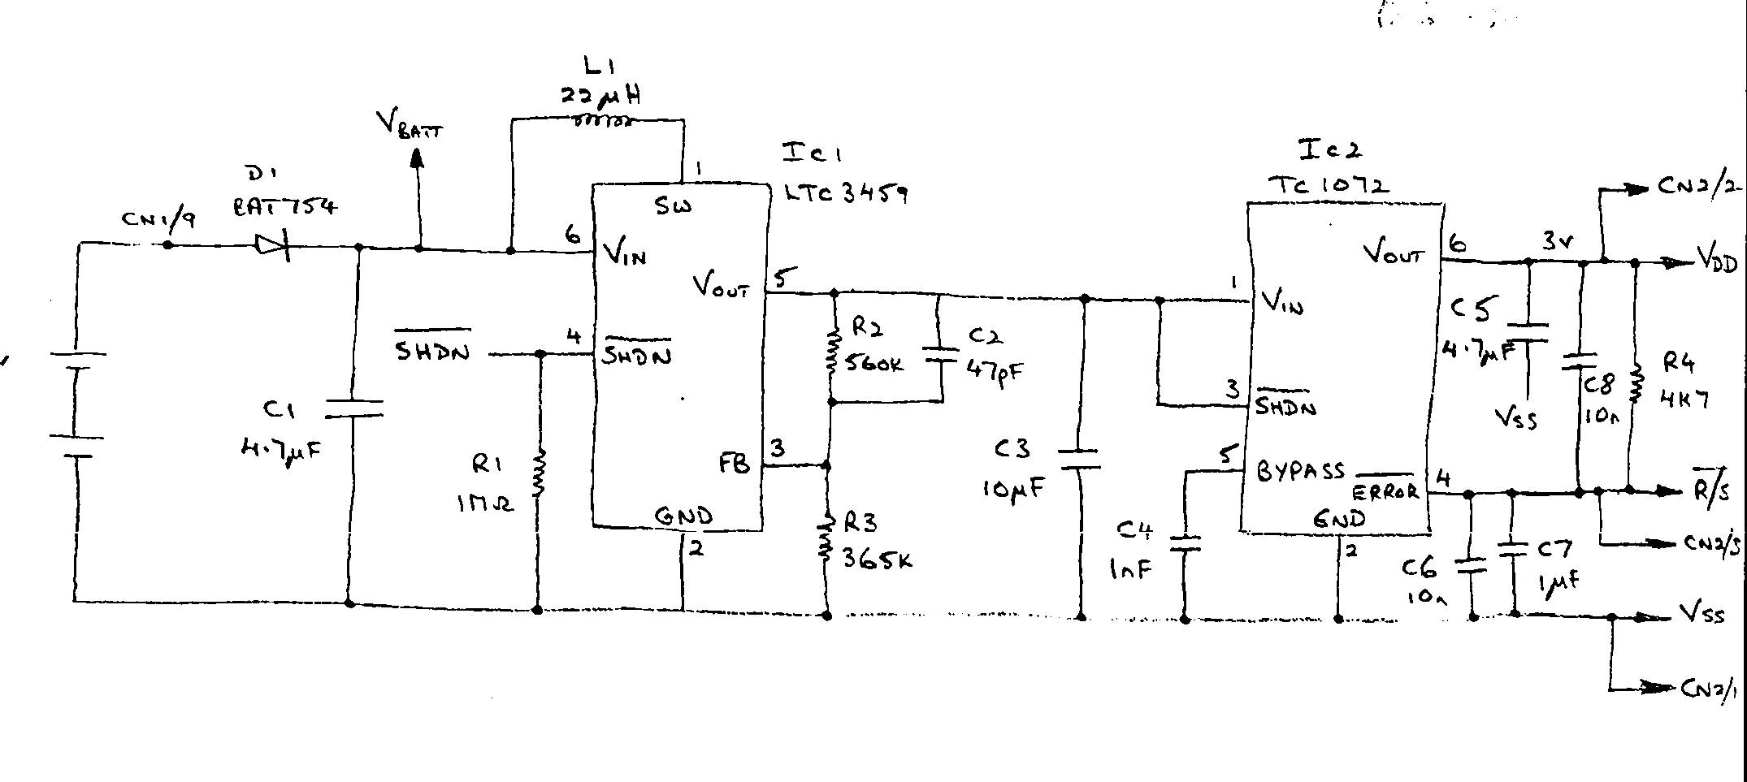

The unit is powered by 2xAA 1.5v Batteries.
Diode D1 ensures that the batteries can only be installed the correct way. Incorrect installation will prevent power entering the circuit.

C1 is a smoothing capacitor that slows the turn on.
IC1 LTC3459 is DC converter producing a 3.0 v output. This is stabilised to an input battery voltage down to 1.6v.

IC2 TC1072 is a very low current Voltage regulator producing 3.0v capable of handling large current requirements.

Analogue Switch

Sensor
Analogue switch
Op Amp
Ref
VDD
VSS
I/p
SEL

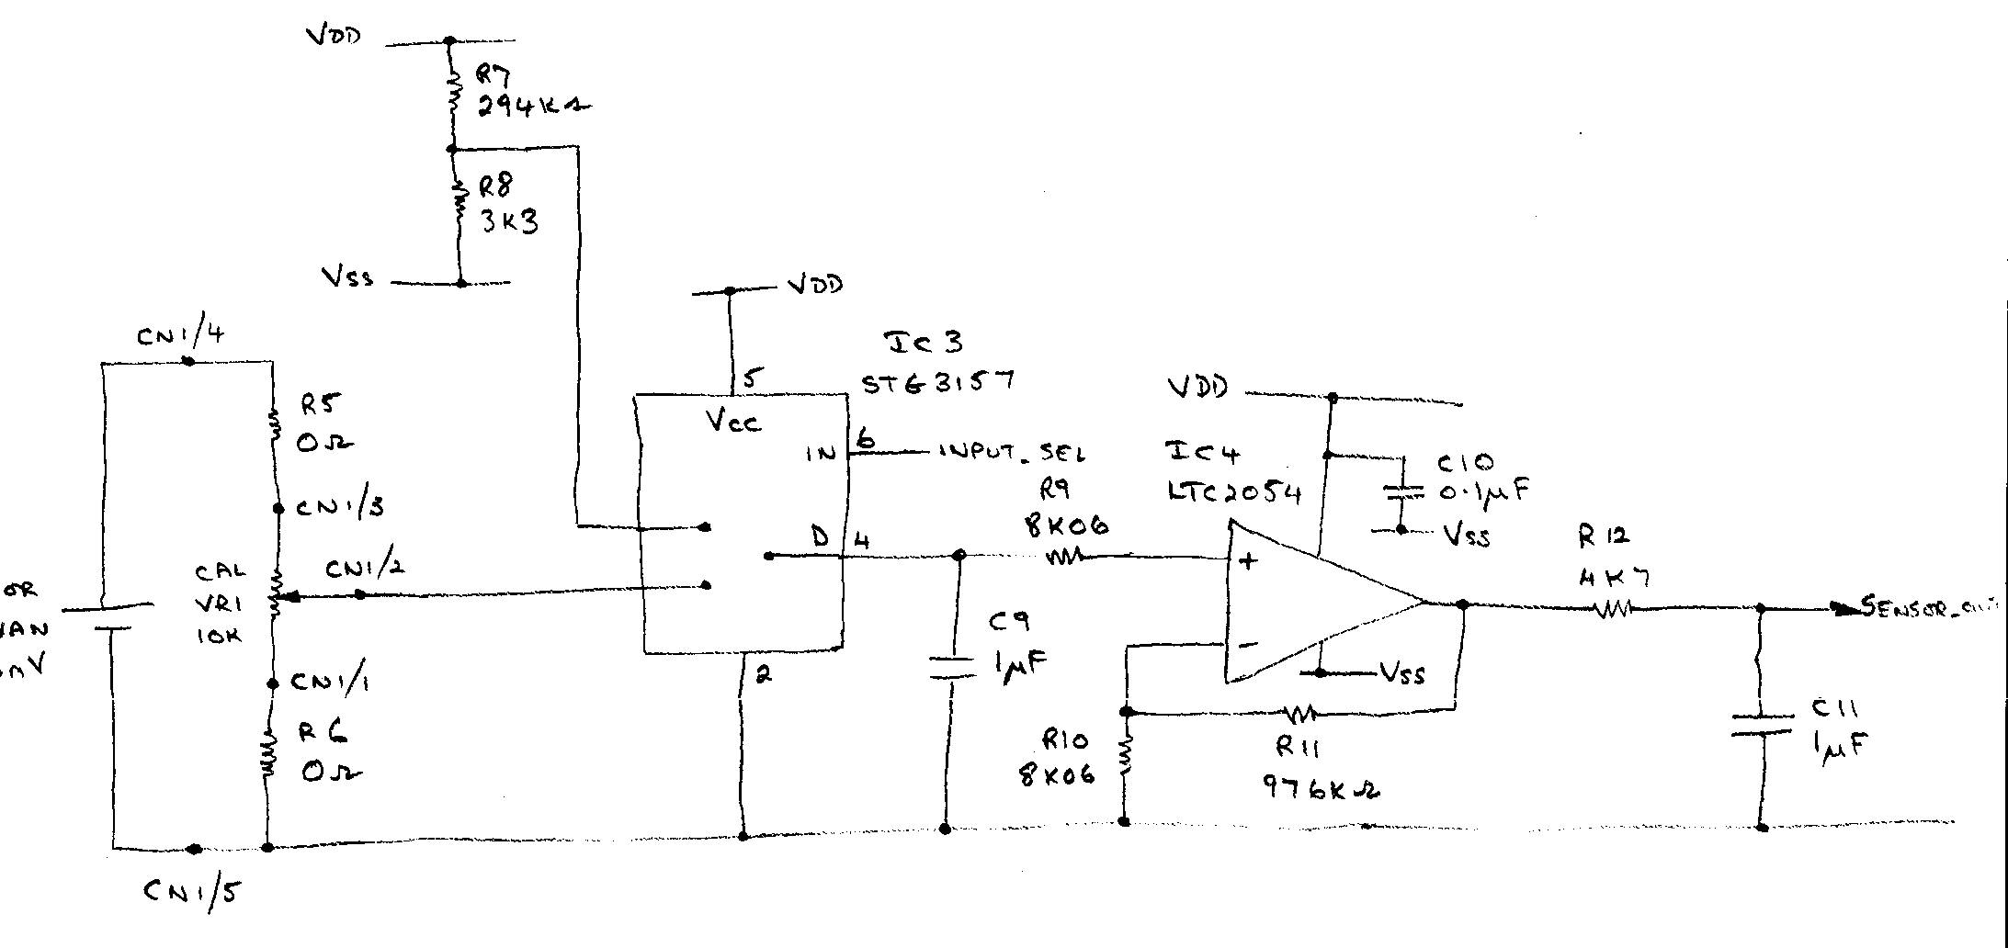

The analogue switch switches the input from a reference voltage supplied by R7/ R8 ( 33,3mV) to the sensor if the instrument is functioning correctly. The input select IN Pin 6 is supplied by the processor IC6 ( ST7FLITE 15)

Flash memory & Data EEPROM



