VM3COP27.45 Repair Code Failure.

Monitoring of repairs and new faults.

Process starts with rolling Issue task ID750 ‘Product Failures New Codes Review’

Linked to Process 7849 Review Product Failures New Codes.

Task Text
“Review Intrastats Page:
Returns-> Repair codes Clean up
If New Faults have entered the system,
Review the Stock Repairs and apply a clean code and tag Fault / user or No Fault.
Complete all Stock References until the list is empty “

a Link in the Issue

Takes you to:
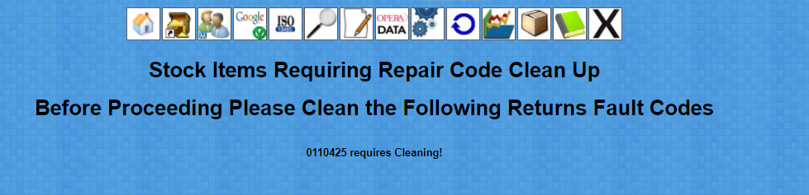

And products that require review will be listed. As in the above example
0110425 requires cleaning.

Clicking the link takes you to the product returns overview page

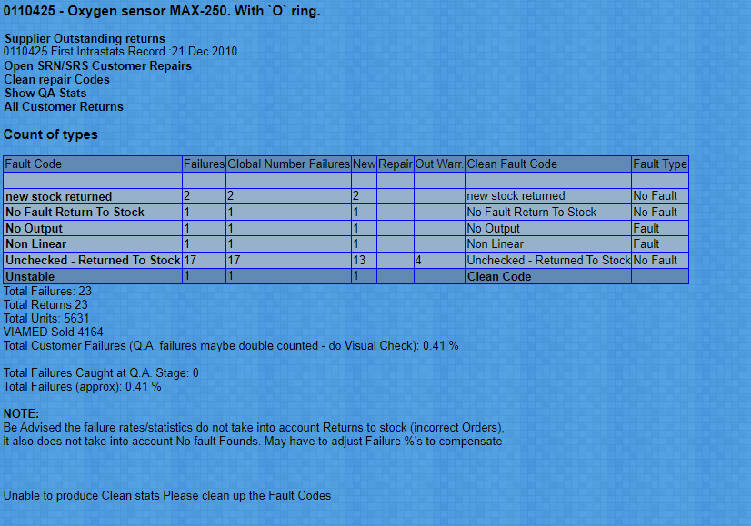

From here the fault code ‘Unstable’ requires Cleaning, and initially does not have a fault type set.

To review the report page on the Item Click the fault code ‘Unstable’

Click the SRNnumber to view the actual worksheet relating to this item.
It should open a NEW tab browser so you can review the details without losing the repair codes page.

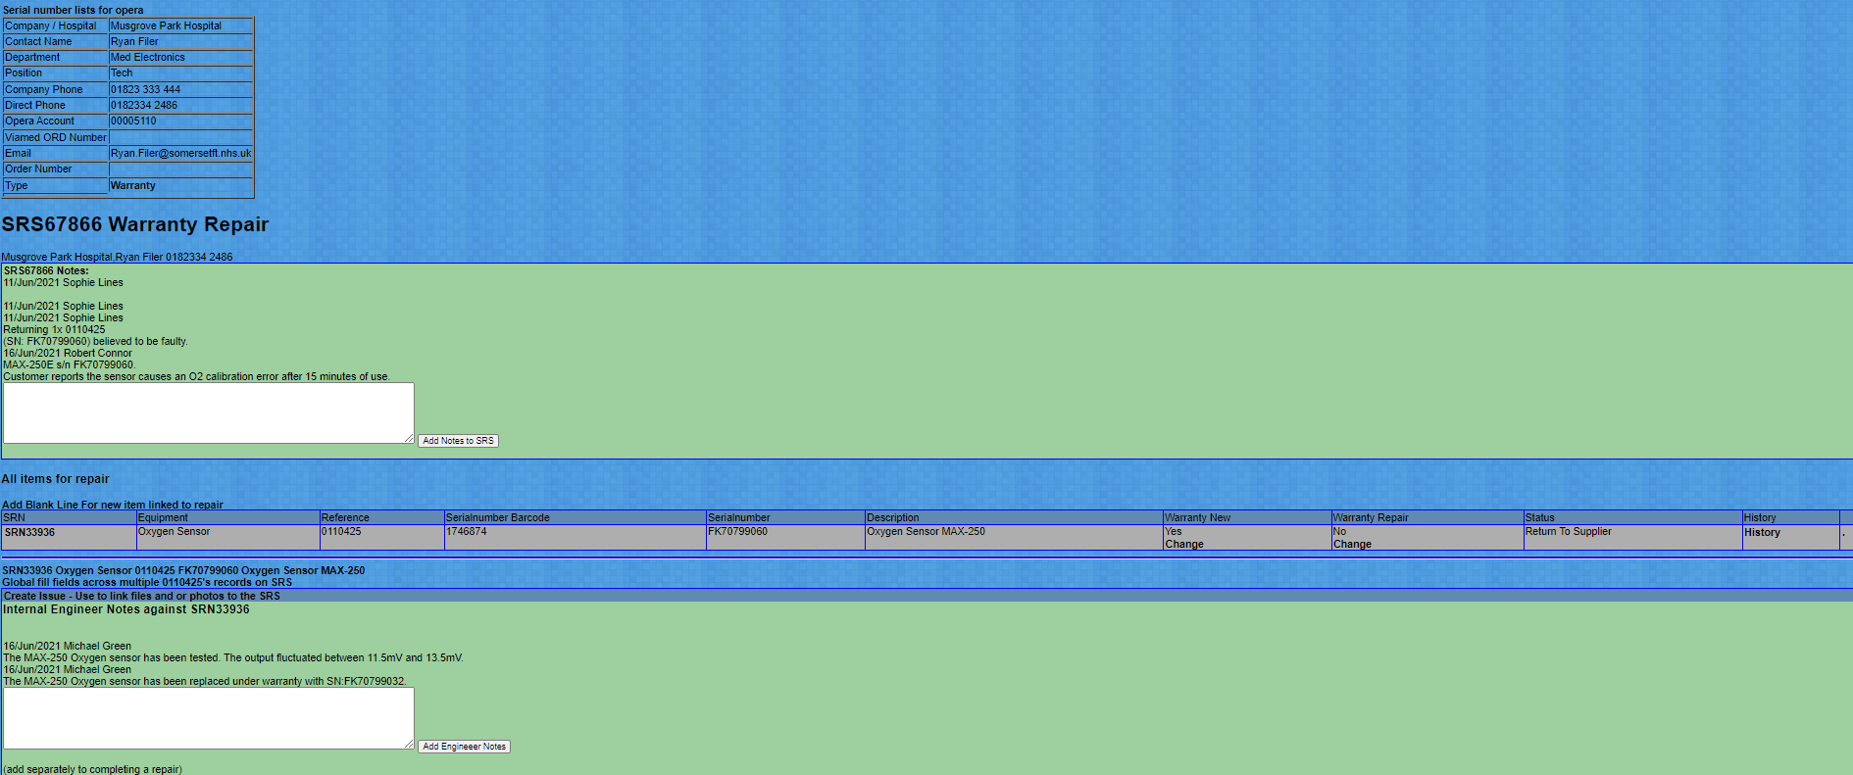
All external and internal notes and actions on the item should be displayed.

Use this page to determine if the failure is user failure , product failure a real fault or no fault.

Return to the fault code page and click ‘unstable’

A form will appear
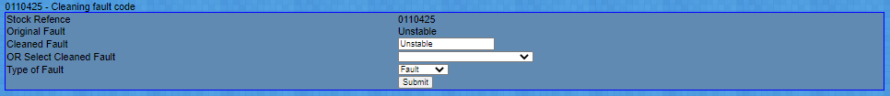

if the fault is the same as a pre existing fault but the engineer has worded it differently the code can be ‘cleaned’ to help with statistics,
then Type of fault can be selected, between Fault / No Fault / User Error.

Once filled in – providing there are no more codes to clean for this product you will be returned to the repair overview screen and can now see the statistics of all the returns

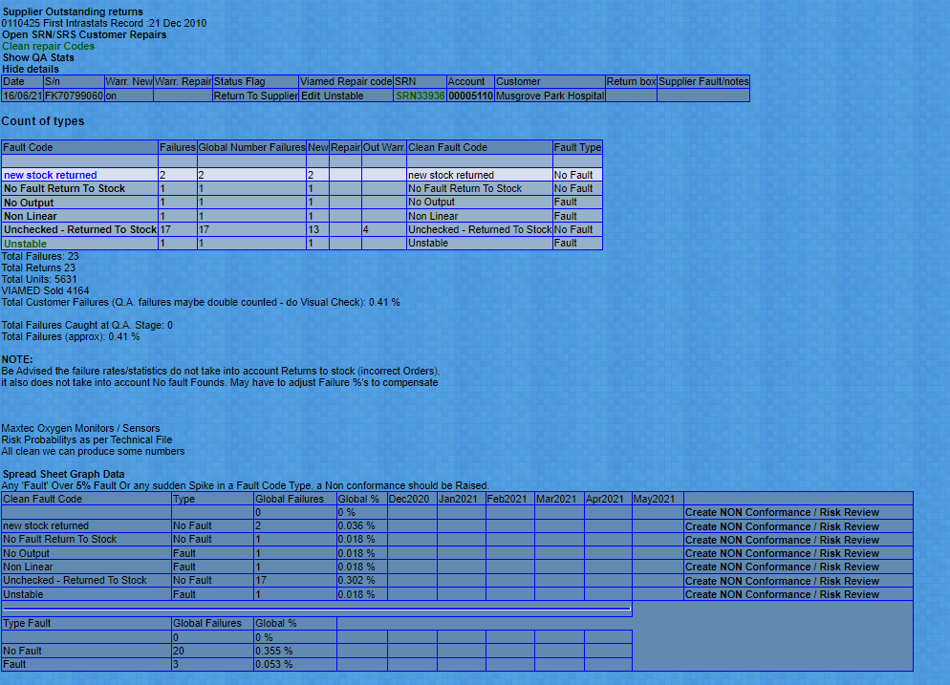

Can now make decision if any corrective action, or non conformance needs raising,

and fill in the starting point issue with the item you have cleaned, and statreif a corrective action plan (capa) needs doing.

Continue with all the products until you get

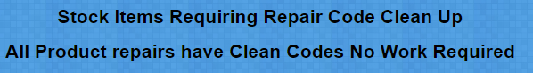

Then the task is complete.

