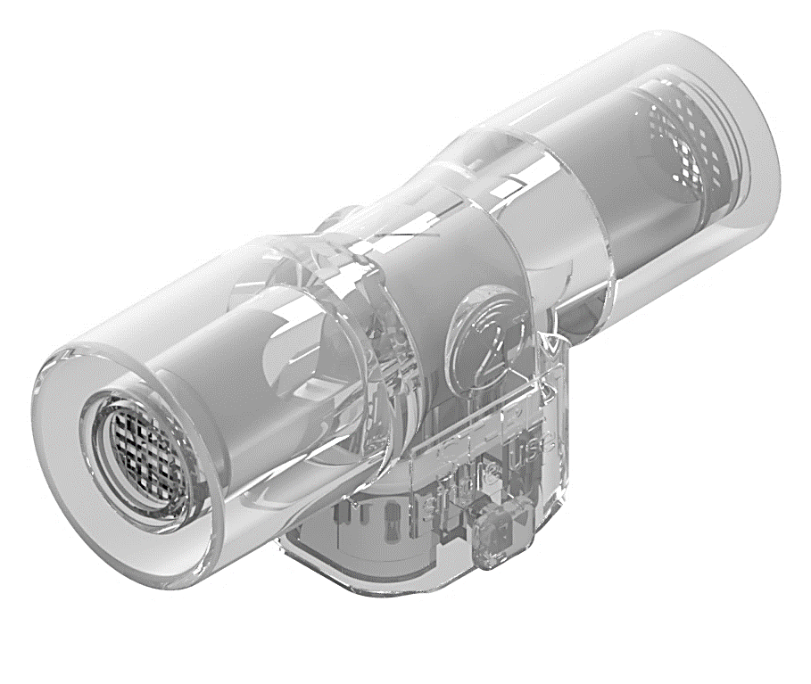
ST-BL

Disposable neonatal flow sensor

de | Gebrauchsanweisung | en | Instructions for use
fr | Mode d’emploi | es | Instrucctiones de uso
it | Istruzioni per l'uso | nl | Gebruiksaanwijzing
pl | Instrukcja użycia | ru | Инструкция по применению
zn | 使用說明 | ja | 使用説明書

Table of Contents
en ST-BL Instructions for use 3
de ST-BL Gebrauchsanweisung 9
ST-BL Marking and symbols explanation 10

en ST-BL Instructions for use
  - Intended use and medical purpose of ST-BLR
Intended use:
ST-BL is a disposable neonatal hot wire anemometric flow sensor, for measuring gas flow in Dräger’s neonatal ventilators. ST-BL flow sensor is compatible to:
- Dräger neonatal flow sensor ISO 15, REF 8411130

Intended medical indications:
Disposable neonatal flow sensor for measuring respiratory gas flow in neonatal ventilators.
Intended user profile:
Healthcare professional, trained for the application
Intended patient groups:
premature and newborn babies and infants

Clinical environment:
Professional healthcare facility

Contraindications:
Not intended to be used with flammable anaesthetic mixtures.
Not intended to be reused, autoclaved or sterilized.

  - General warnings and safety notices
Safety symbols used in this document:
Indicates potential harmful conditions that may lead to serious injury.
Important information on a topic or procedure, or conditions that may lead to damage or malfunctions of the device.

General warnings:
Do not use this medical product if it appears or is suspected to be damaged. Damage to the product may result in degraded performance.
Do not use this product if its packaging has been open before. Risk of infection, cross contamination!
No modification of this medical product is allowed.
ST-BL neonatal flow sensor is for single patient use only. Reusing the flow sensor may affect patient safety due to the possible contamination of the sensor.
ST-BL flow sensor cannot be autoclaved of sterilized.
Strictly follow the instructions for use. Handling of the device requires full understanding and strict observation of the operating instructions of basic device (ventilator) and these instructions for use.
The flow sensor must be calibrated within basic device (ventilator) and system check must be performed prior to patient use.
Due to fire risk - do not introduce any medicaments or other substances based on combustible solvents, such as alcohol, into the patient system.
Do not use explosive anaesthetic agents (e.g. ether or cyclopropane.

General safety notices:
The medical device is intended only for the application described herein.
Serious incident that has occurred in relation to this medical device should be reported to the manufacturer and the competent authority of the Member State in which the user and/or patient is established.
To report patient safety related events, send an email to the following manufacturer’s address:
prrc@bluepoint-medical.com with at least following information:
- order number and product name
- batch number of the product
- date of the serious incident
- description of the serious incident affecting the patient or any injuries
- your contact data (institution, address, contact person/representation, title and telephone number)

  - ST-BL Sensor overview
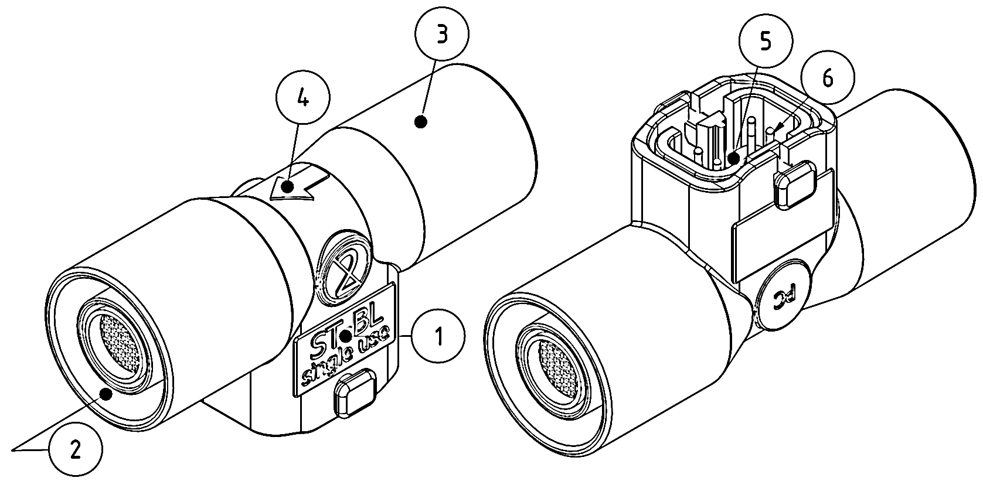

- Product name
- 15F sensor connector (to the patient)
- 15M sensor connector (to the Y-piece/ventilator)
- Sensor installing position (inspiratory flow direction)
- Sensor plug
- Sensor pins

The sensor insert by ST-BL neonatal flow sensor cannot be removed or replaced.

  - Installing, calibrating and operating of the flow sensor
This medical product must be connected/installed to the basic device (ventilator) according to the instructions for use of basic device. Risk for faulty operation!
Ensure correct positioning and secure connection of this product to the basic device (electrically, mechanically, flow direction). Risk for leakages and faulty operation!
The flow sensor and Y-piece must be angled approximately 45° downwards to prevent collecting of condensing water into flow sensor. Risk for faulty operation!
The flow sensor cable plug of the basic device has to be securely connected to the flow sensor plug. The sensor cable must be positioned along the breathing hoses laid free and not causing any mechanically stress to flow sensor plug during operation. Risk for leakages and faulty operation!
The flow sensor must be calibrated within basic device (ventilator) prior to patient use.
The flow sensor calibration must be performed in accordance with instructions for use of basic device (ventilator).
A preoperational device system check must be performed according to the instructions for use of basic device (ventilator) prior to patient use. If a malfunction is detected, do not operate the device! Patient hazard!
Due to fire risk – do not use this product with medicaments or other substances based on combustible solvents.
Before medication nebulization, disconnect the flow sensor completely from the basic device. Follow the instructions for use of basic device for operating with deactivated flow monitoring and use an independent monitoring. The patient may otherwise be jeopardized.

  - Disposal
The flow sensor must be disposed of as infectious waste.
  - Technical information
Measuring principle: | Hot wire anemometry
Measuring range: | 0 to 30 L/min, depending on ventilator(evaluation electronics)
Accuracy: | DIN EN ISO 80601-2-12,  Typically ±10% of measured value under calibration conditions depending on ventilator(evaluation electronics)
Sensor connectors: | 15F/15M acc. DIN EN ISO 5356-1
Recommended operating conditions:
Temperature: | 10°C to 40°C
Relative humidity: | 5% to 95%, non-condensing
Atmospheric pressure: | 700hPa to 1060hPa
Recommended storage and transport conditions:
Temperature: | -20°C to 50°C
Relative humidity: | 5% to 95%, non-condensing
Atmospheric pressure: | 700hPa to 1060hPa

  - Ordering information
Product name | UDI number | Order number
ST-BL disposable neonatal flow sensor, (5pcs per Box) | 24251679601726 | 9030132002

de ST-BL Gebrauchsanweisung

ST-BL Marking and symbols explanation
de: Katalognummer
en: Catalogue number
de: Chargennummer
en: Batch code
de: einmalige Produktkennung
en: Unique Device Identification
de: Medizinprodukt
en: Medical device
de: Stückzahl
en: Number of units
de: Herstellungsdatum
en: Date of manufacture
de: Ablaufdatum
en: Expiry date
de: Hersteller
en: Manufacturer
de: CE-Kennzeichnung. Kennnummer der benannten Stelle
en: CE-European Conformity authorization mark.
de: Gebrauchsanweisung beachten
en: Consult instructions for use
de: Die Warnhinweise in der Gebrauchsanweisung beachten!
en: Observe the warnings in the instructions for use
de: Nur für den einmaligen Gebrauch
en: Do not reuse
de: nicht steril
en: non-sterile
de: Bei geöffneter oder beschädigter Verpackung nicht mehr verwenden
en: Do not use if package is damaged and consult instructions for use.
de: Bei der Herstellung wurde kein DEHP verwendet
en: Does not contain Phthalates
de: Bei der Herstellung wurde kein Naturkautschuklatex verwendet.
en: Does not contain Latex
de: Von Hitze und Sonnenlicht fernhalten
en: keep away from heat and sunlight
de: Lagertemperaturbegrenzung
en: Storage temperature limitation
de: Feuchtigkeitsgrenzwerte
en: Humidity limitation
de: Grenzwerte des atmosphärischen Drucks
en: Atmospheric pressure limitation
de: Nicht mit dem Hausmüll entsorgen
en: Do not dispose of with domestic waste

ST-BL – Instructions for use
Multilingual version: en, de

Information within this document may be subject to changes. Amendments and alterations shall remain reserved without prior notices.
Copyright © bluepoint MEDICAL GmbH & Co. KG.
The content and works published in this document are protected by copyright.
All rights and liabilities are reserved. Without written consent of the bluepoint MEDICAL GmbH & Co. KG the information, work and intellectual property contained in this document must not under any circumstances be circulated, reproduced, duplicated, copied or translated in other languages.

 | bluepoint MEDICAL GmbH & Co.KG  An der Trave 15  23923 Selmsdorf, Germany  Phone: +49 (38823) 5488 – 0  Fax: +49 (38823) 5488 – 29  E.Mail: info@bluepoint-medical.com  Web: www.bluepoint-medical.com | 0482



