Updating MONDAY.com Suppliers orders from Intrastats.

Prior to uploading supplier Information check the Intrastats Page:

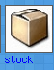

Wait while it calculates inprocess Goods in,

Any being flagged with the option to Complete, need the button Pressing to update the supplier pages the items have been received

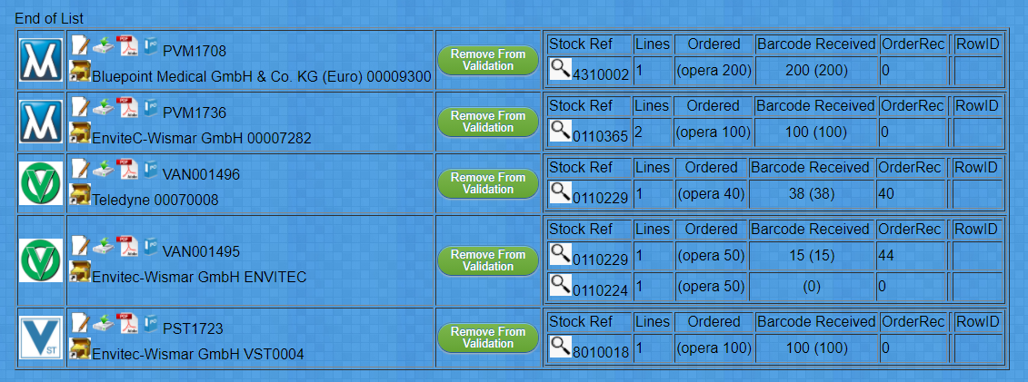
the remaining items, need reviewing against the supplier outstanding ages

At the bottom of the page :
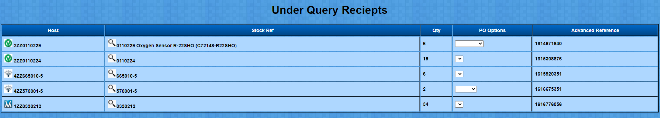
Anything in this List has been allocated trackin gbarcodes, but for some reason or other have NOT been booked in against a purchase order,
Once this page is Understood, you can move on top send data to MONDAY.com

Sending supplier data from Intrastats to Monday.

Intrastats Search for the Supplier:

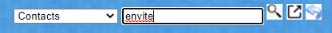
Results:
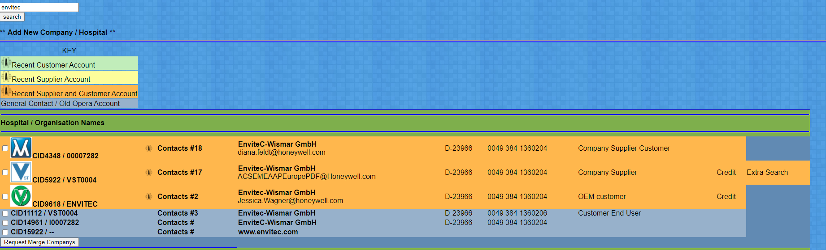
Pay attention to the HOST company logo,

Click into the Supplier / Host you wish to Export

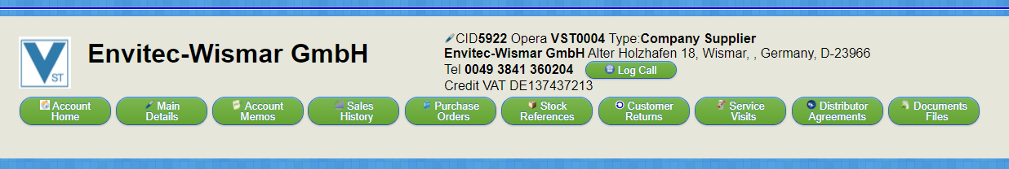
Click the Purchase Orders button,

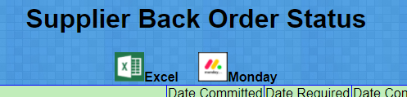
Click the Monday Icon

Your File will download
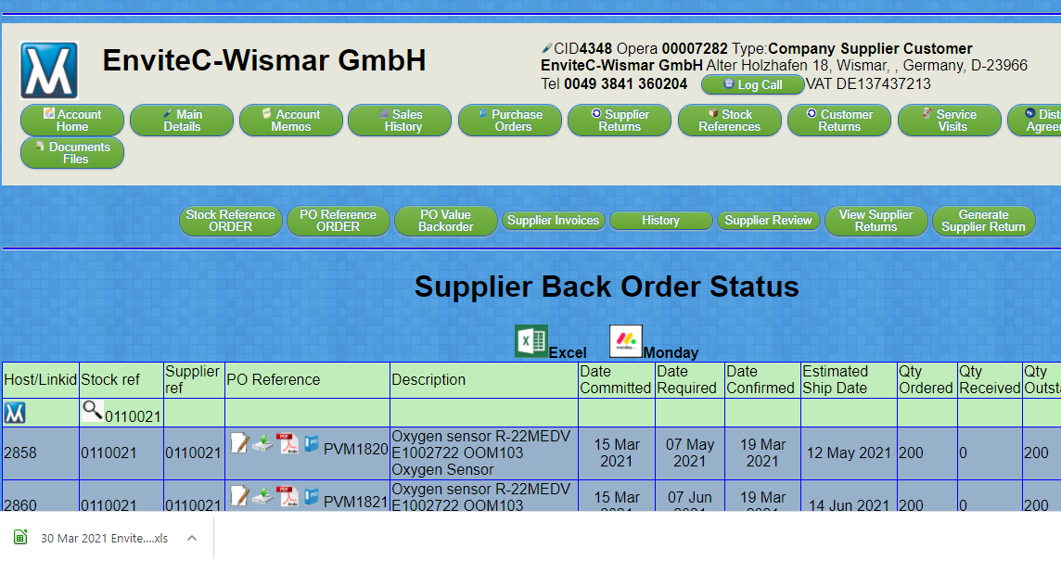
See Bottom Left of your broswer window.

Open Monday with the intrastats link top bar
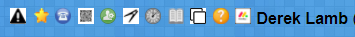

Login then click
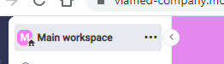
Find the Orders 'Board' for the Company your updating the supplier status of,
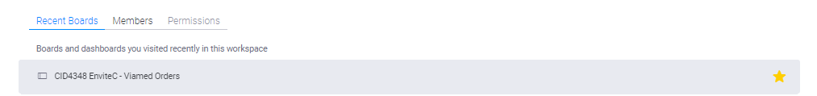
*Note the CID number should Match to the CID numberin intrastats

You should See something like:

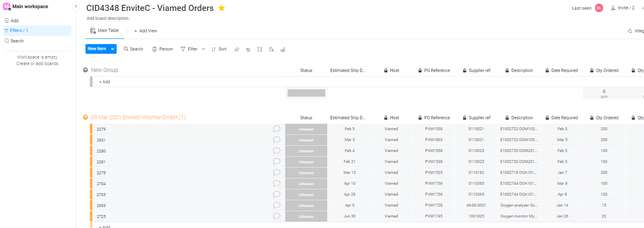
In the New Item Pull Down

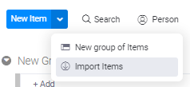
Select Import

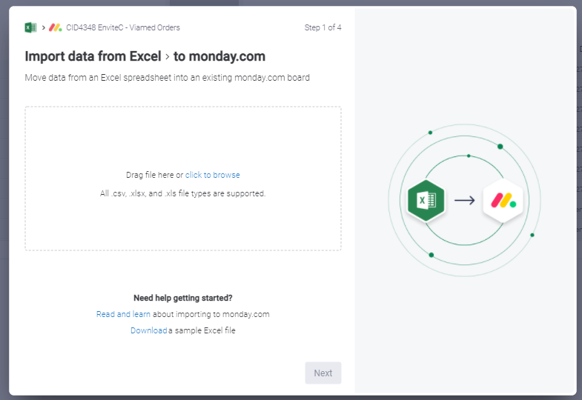
You should see the Above:

From the Intrastats Broswer window you can drag and drop the File you downloaded,
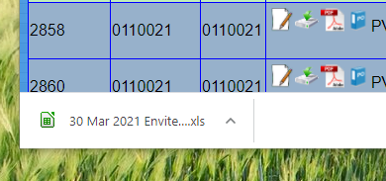
Or find the file in your downloads folder,

Either way Drag and Drop the file onto the Monday drag file location.

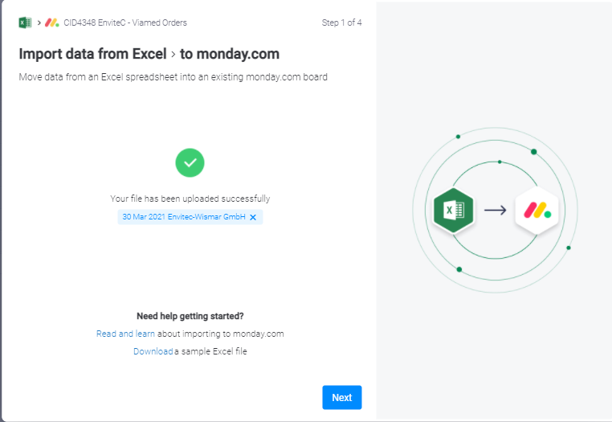
You should see a successful Upload:

Click Next

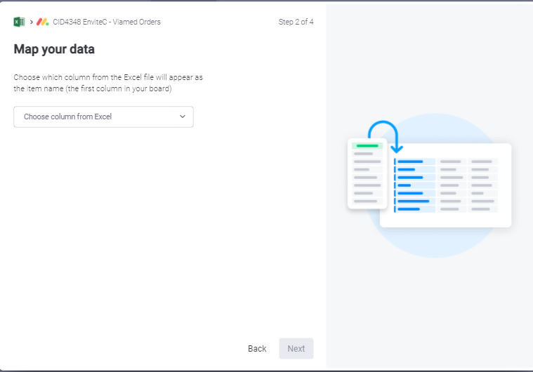

You will find have to tell monday the KEY LINK field, select LinkID Click Next

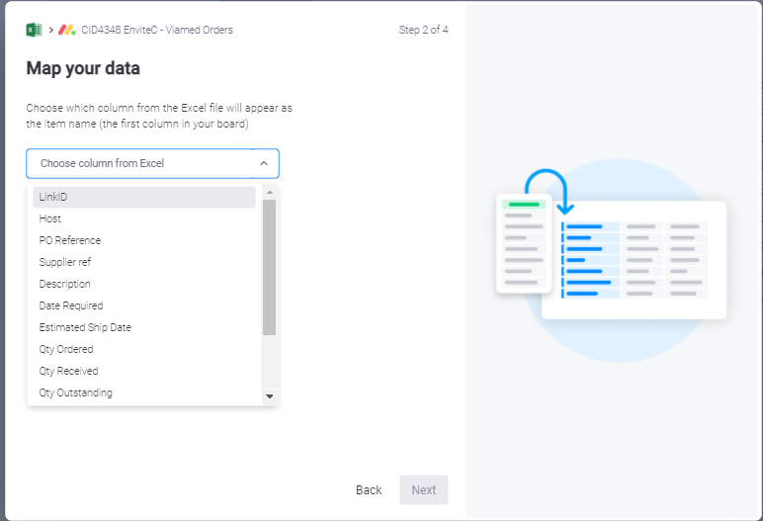

I believe Monday will update this bit somewhere as the fields are not automatically matched.

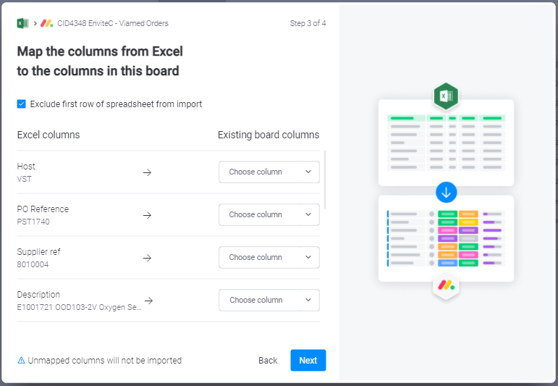

In the Choose column pull downs, select Like for like. Currently 10 fields to Match
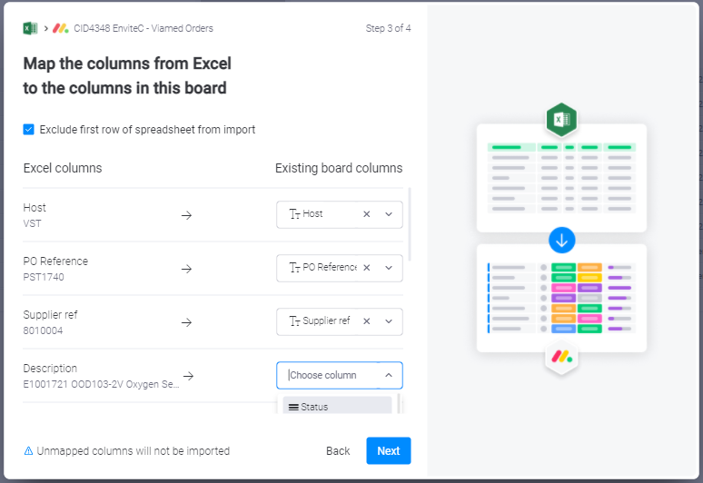

NOTE,
Monday has some funny display Issues on this screen,

Use the Middle mouse wheel to scroll down the list of fields or you might find the screen does not have space to list all the options.
See the Description field in the previous screen shot.
NOTE 2. Which bit of the window that scrolls is totally dependant on the mouse position.
To scroll down the answers ensure the mouse is hovering over the pull down menu options.

DONOTMAPx Fields are for potential future use. So do not pick a column.

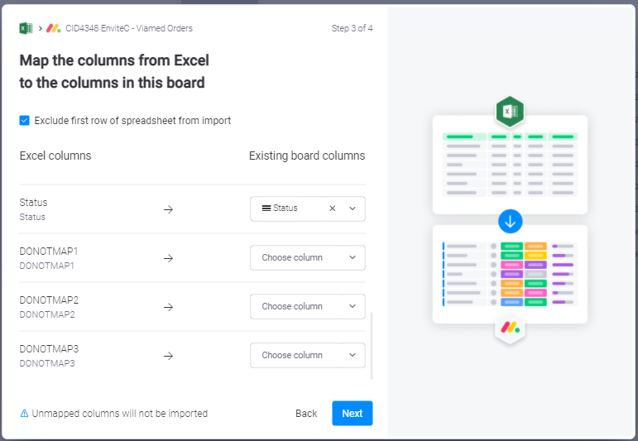
When finish Click Next

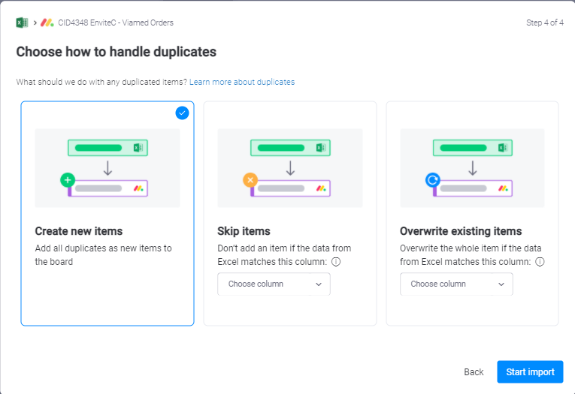
Click Create new items.

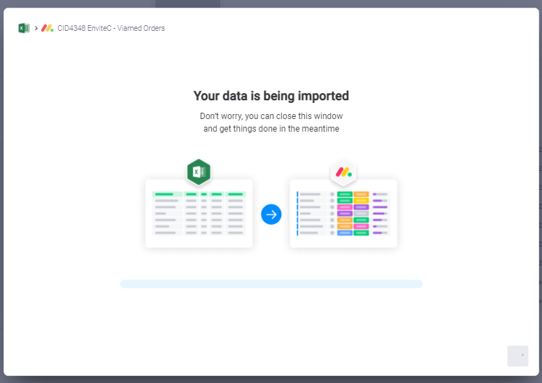
Wait...

Data should be imported
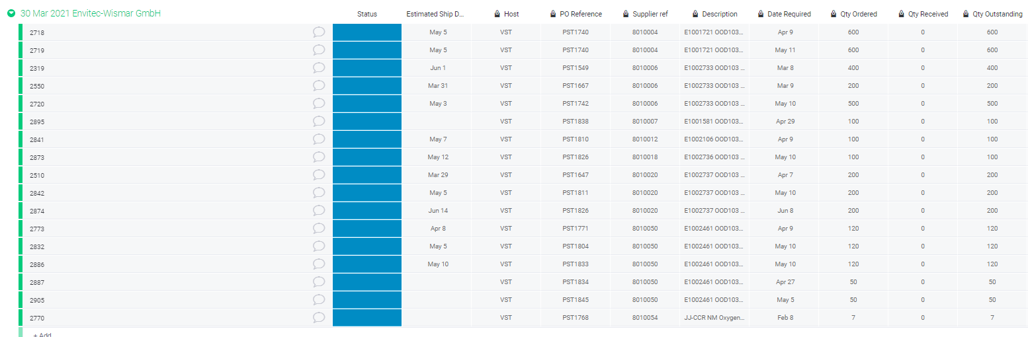

You can now Delete any OLD data in monday,

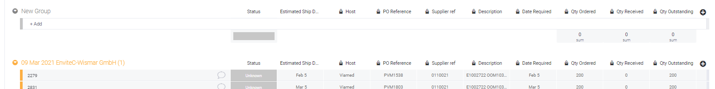
click the small blue down arrow, next to name of old report
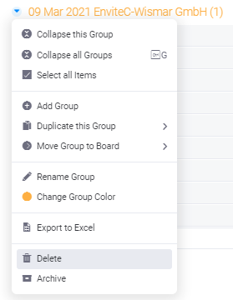
Data should now be in Monday,
All fields except Status and Estimated ship date are currently locked to external suppliers

