SpiroTrue H with 2,0m tube – REF4030131003
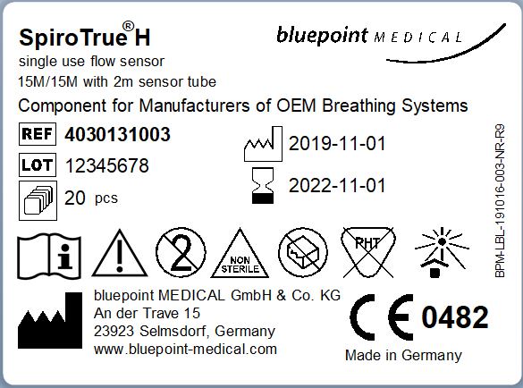

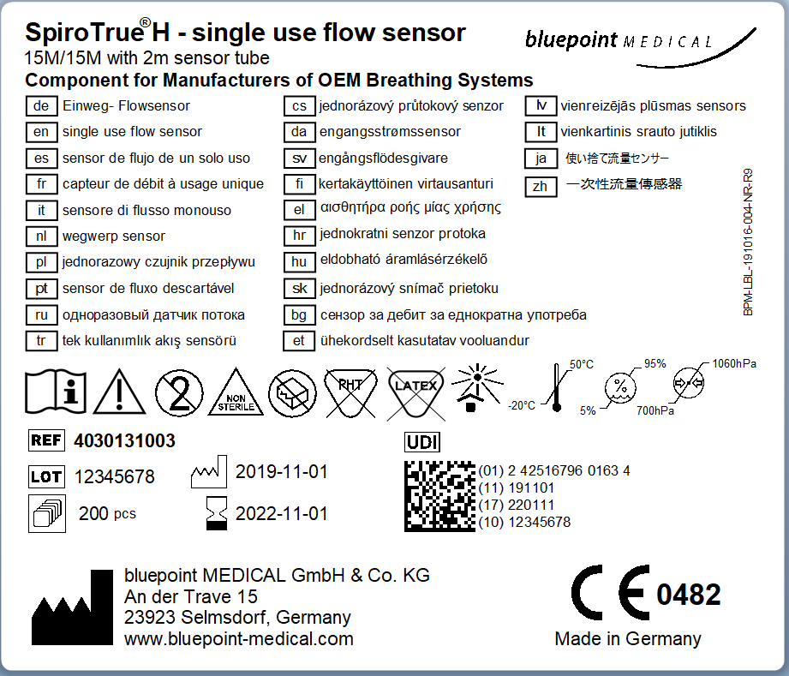
SpiroTrue D with 2,2m tube – REF 6030131002
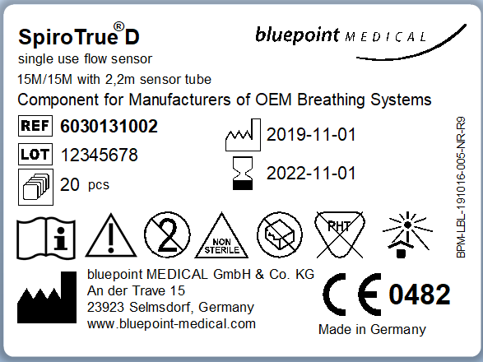

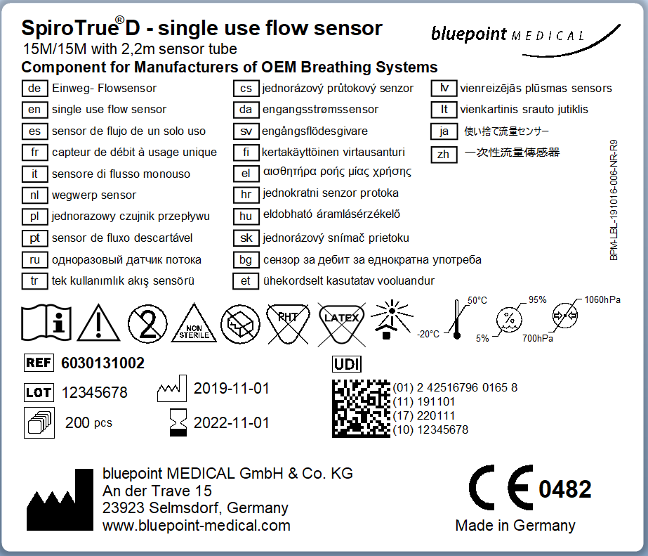
SpiroTrue D with 3,2m tube – REF6030131001
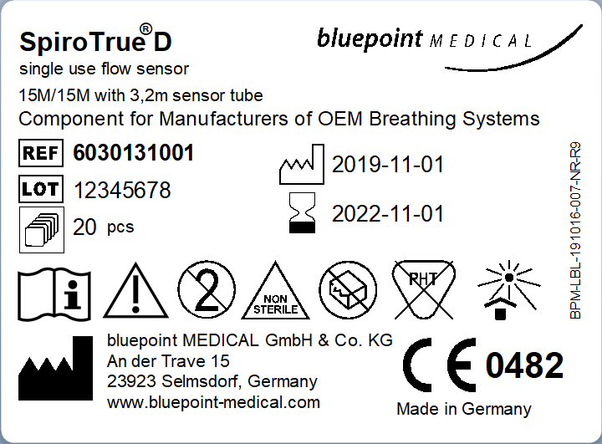

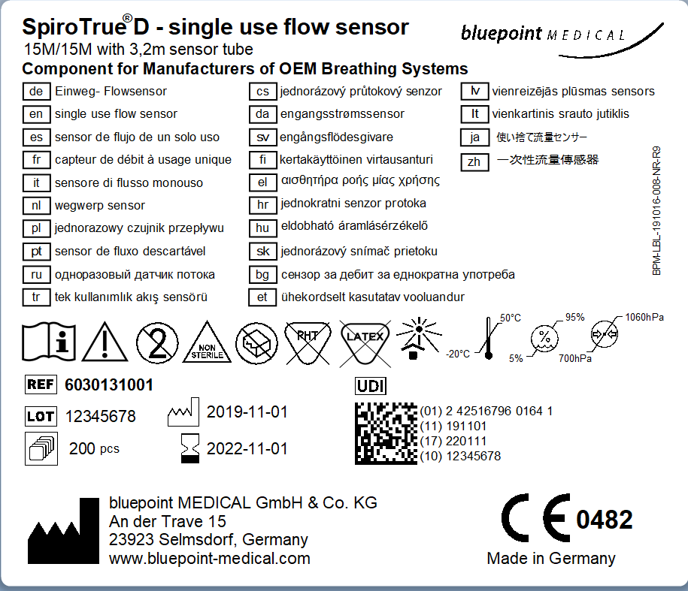
SpiroTrue H with 2m tube – Box of 6pcs (medical version) – REF1030132000
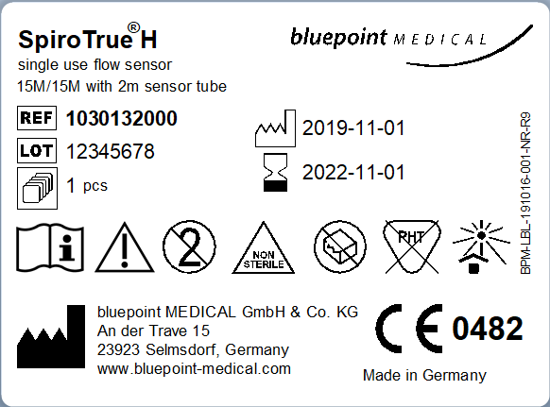

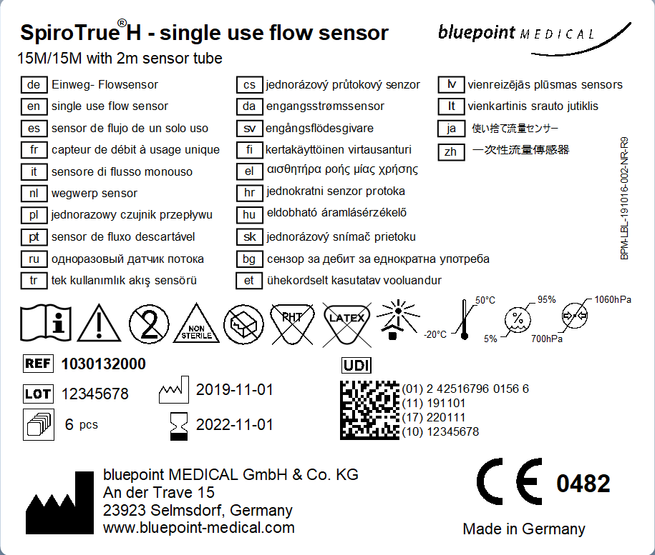

SpiroTrueH with 2m tube – Box of 6pcs (Medical version) manufactured for Viamed Ltd.-UK


