Handheld Pulse Oximeter
VM-2160
With SMARTsat® Technology

Service manual

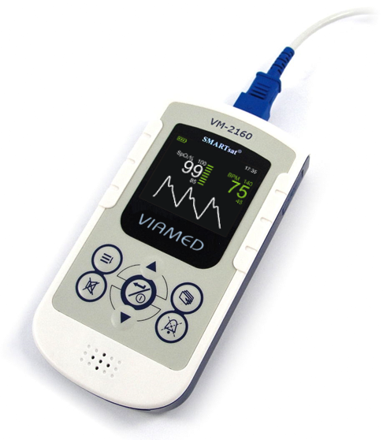

VM-2160 (SMARTsat®) - Service Manual
REV: 2
Released: 08/2018

The information in this document is subject to change without notice.

Copyright © 2018 bluepoint MEDICAL GmbH & Co. KG. All Rights Reserved.
This document contains proprietary information that is protected by copyright. All rights are reserved. No part of this document may be photocopied, reproduced or translated to another language without prior written consent of bluepoint MEDICAL GmbH & Co. KG.

Sales & Service contact information:

Viamed Ltd.
15 Station Road
Cross Hills
Keighley
West Yorkshire BD20 7DT
United Kingdom

Tel: +44 (0)1535 634542
Fax: +44 (0)1535 635582
E-mail: info@viamed.co.uk

www.viamed.co.uk

Table of Contents

1 Introduction 4
2 Service menu 4
2.1 Service PIN 4
2.2 Service menu structure 4
3 Maintenance 6
4 Service and repairs 6
4.1 General 6
4.1.1 Device disassembly 6
4.1.2 Device assembly 7
4.1.3 VM-2160 (SMARTsat®) components and HW compatibility 7
4.2 Replace Components 8
4.2.1 Main-PCB 8
4.2.2 USB-PCB 8
4.2.3 USB-PCB cable 9
4.2.4 Flat ribbon cable 9
4.2.5 SpO₂ Module 10
4.2.6 SpO₂ sensor socket 10
4.2.7 Keypad 11
4.2.8 Display window 12
4.2.9 Housing 13
5 Troubleshooting Guide 14
5.1 Failure modes 14
5.2 Error codes stored in the service menu log 15
6 Spare parts 16
7 Document History 17

Introduction
This service manual contains information for servicing the VM-2160 (SMARTsat®) handheld pulse oximeter. Only authorized service personnel may service this product.
The Handheld Pulse Oximeter VM-2160 (SMARTsat®) User Manual (the operator’s manual) is an integral part of the service procedures. Before servicing the monitor, read the operator’s manual carefully for a thorough understanding of how to operate the unit.
Only use the tools and test equipment as specified in this manual. Only use original spare parts available from your local distributor.
NOTE: This manual is for VM-2160 with SMARTsat® SpO₂ technology. A separate manual and price list with compatible spare parts is available for the VM-2160 monitor with the former ChipOx technology.
Warning:
Incorrect procedures may harm the patient, or damage the monitor.

Service menu
The Service menu is accessible to authorized personnel only. The PIN Code specified below shall not be given to any third parties. Changes of settings are only allowed with profound knowledge about each setting.
Warning:
Wrong settings may lead to misinterpretation and may affect patient safety!

Service PIN
The PIN Code for VM-2160 (SMARTsat®) can be accessed by menu item “Service”.
By entering the Service PIN CODE you confirm that you have read and understood the service manual and take full responsibility for the consequences that might result from the changed alarm functionality.
PIN CODE: 1 9 8 5

Service menu structure
Within the service menu point STARTUP SETTINGS selective default start-up parameters can be adjusted or the default start-up parameters can be reset to the factory defaults.
The service menu point SYSTEM INFORMATION is for factory internal use only; there are no adjustable parameters in this menu.
Warning:
Changing the default start-up settings of the device can seriously affect the functionality of the device and the alarms.
When entering the STARTUP SETTINGS menu, a warning appears “Changing system defaults can affect patient safety! Authorized personnel only!”. Confirm the warning window to change start-up settings only if you are authorized personnel.
Start-up setting:
Parameter | Possible settings | Factory default | Description
Volume | 0/ 1/ 2/ 3 | 1 | Set default loudness. 0 = off
Alarm SpO2 ↑ | 100 to Alarm SpO2 ↓+1/ Off | 100 | Set upper alarm limit SpO₂.  --- = off
Alarm SpO2 ↓ | 45 to Alarm SpO2 ↑-1/ Off | 85 | Set lower alarm limit SpO₂.  --- = off
Alarm Pulse ↑ | 300 to Alarm Pulse ↓+1/ Off | 140 | Set upper alarm limit pulse rate. --- = off
Alarm Pulse ↓ | 20 to Alarm Pulse ↑-1/ Off | 45 | Set lower alarm limit pulse rate. --- = off
High Alarms | On/Off | On | Turn alarms of high priority on/ off
Medium Alarms | On/Off | On | Turn alarms of medium priority on/ off
Low Alarms | On/Off | On | Turn alarms of low priority on/ off
SpO2 Averaging | Stable/Standard/Sensitive  (stb/std/sens) | Standard | SpO₂-Averaging (refer to the operator’s manual)
Memory full | On/Off | On | Enables display of „memory-full“ message each start-up, if the device memory is full
Auto-off | On/Off | On | Turns device off after 2 minutes, if no measuring takes place
Factory settings | No/Yes | No | Reset device to factory settings
Exit |  |  | Exits menu

System Information:
The service menu point SYSTEM INFORMATION is for factory internal use only; there are no adjustable parameters in this menu.
Parameter | Displayed status (read only) | Description
Device Information | SpO2 Module SN: xxx  SpO2 Module FW: xxx | Serial number and Firmware of the integrated SpO₂ SMARTsat module
Error Logs | Date, Time, Code | Upon occurrence each error is listed using a code. For a description on the error code see section 5.2.
Working Time | Total working time x h x min | Total working time gives an indication on the frequency of device use.
Exit |  | Return to the measurement screen

Maintenance
The handheld pulse oximeter VM-2160 / VM-2160 (SMARTsat®) requires no calibration, it is permanently factory calibrated.
NOTE: In accordance with ISO 80601-2-61:2017, pulse oximeter equipment is not designed to be calibrated after it leaves the factory.
The manufacturer (bluepoint medical GmbH & Co. KG) recommends that the VM-2160 / VM-2160 (SMARTsat®) Pulse Oximeter and Accessories undergo a functional test at least every 12 months as part of a planned preventive maintenance schedule. The functional test should include:
- Testing the audible and visual alarms
- Testing the audible tones
- Checking for damage on the device, cables and sensors
- Checking for any signs of wear and tear on the device, cables and sensors
- Make sure that all the keys are functional
- Check battery compartment for battery leakage and battery residue
- Make sure the display is clear and all the pixels are visible
- Functional test of all the parameters

Service and repairs

General
Opening of the housing (particularly removal of screw-securing) is only allowed by authorised personnel trained by the manufacturer.
Warning:
Perform a complete functional test (refer to section 3) after every manipulation inside the device (removal of screw-securing) before clinical use of the device to ensure proper operation.
Warning:
Remove batteries before each intervention to avoid damage to the circuits!

Device disassembly
Remove the screw-lock with a screw driver. Remove all 6 screws and carefully remove the bottom housing from the front housing by lifting the backside slightly and shift left with low force to not damage the USB connector. Remove the white flat ribbon cable from the USB-PCB.
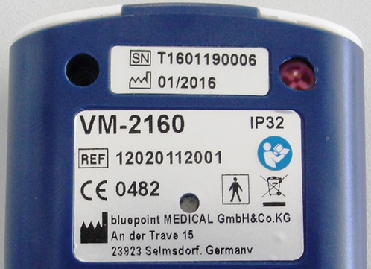  Screw-lock | 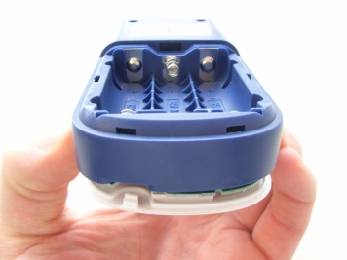 | 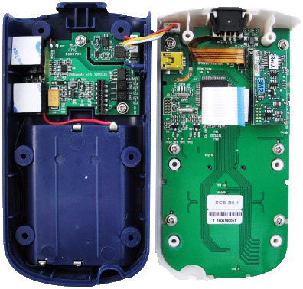  PCBA-screws
Remove screw-lock and housing screws | Lift bottom housing, push slightly left. | Remove 6 PCBA screws to remove Main-PCB

Device assembly
Prior to inserting the screws, pay attention that no cables (especially the USB-PCB cable) are pinched by the screw holes. Do not tighten the screws with electric screwdriver but only with hand tools to avoid over winding. After the device is set back up together and bolted, insert the screw-lock in the upper right hole. Push gently inside without damaging the housing.

VM-2160 (SMARTsat®) components and HW compatibility
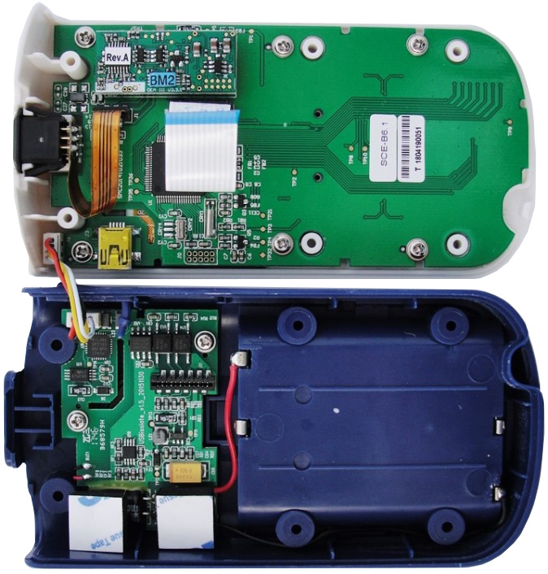
Main-PCB

Serial number

PCB-Screws

Battery contacts

Bottom housing
Front housing
SpO₂ – Module
Flat ribbon cable
SpO₂ sensor socket

USB-Connector
USB-Connection-cable

USB-PCB
Buffer capacity + Foam pad

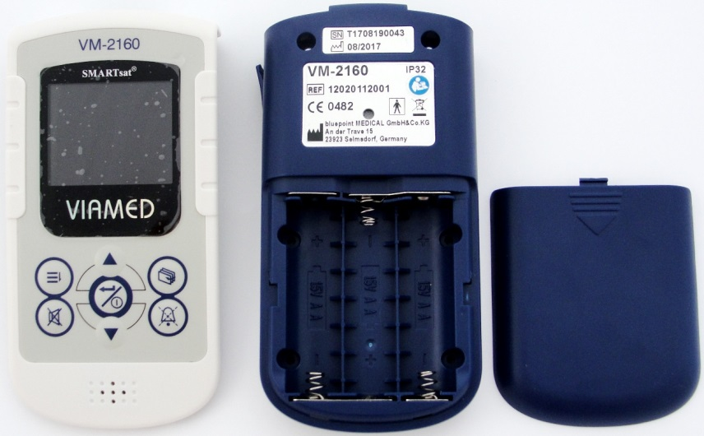
Front housing
Display window

Keypad
Location of screw-lock
Device label
Back housing

Battery compartment

Battery compartment cover

Table 1: VM-2160 (SMARTsat) Hardware Compatibility List
VM-2160 (SMARTsat) Main-PCB Version | SpO₂ module  (Mounted on Main-PCB) | Compatible USB-PCB Version
SMC20141021033(TFT)  (REF: 10020522001S) | SMARTsat® OEM III  (REF: 8110140011) | USI20141021014  (REF: 9020760001)
USBisolate_v1.5_20151130
(REF: 9020760001)

Replace Components

Main-PCB
Warning:
Before replacing the Main-PCB, check the HW compatibility of the Main-PCB and the USB-PCB in Table 1 (section 4.1.3). The use of Main-PCB with incompatible USB-PCB may lead to malfunction and may affect patient safety! Spare parts for the former VM-2160/ S monitor with the former ChipOx technology are not always compatible.
To replace the Main-PCB, open the housing as described in section 4.1.1. Disconnect all cables from the circuit board. Remove the SpO₂ module and all 6 board screws. The Main-PCB can now be replaced.
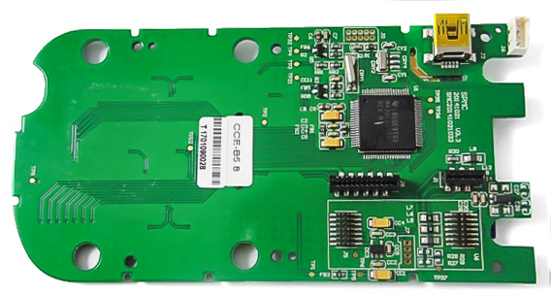 | 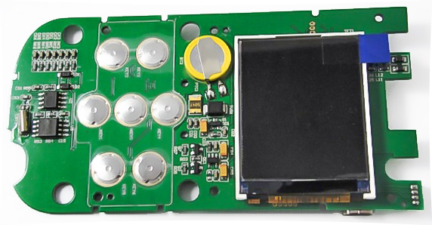  Clock Buffer battery (type CR1220)
Back of Main-PCB with connectors and serial number label | Front of Main-PCB with display and buttons
Before placing the new PCB, remove protective foil from the display. Remove dust at the display and display window with compressed air (clean and deionized, without oil). Place the new PCB into the upper housing and assure correct fitting.
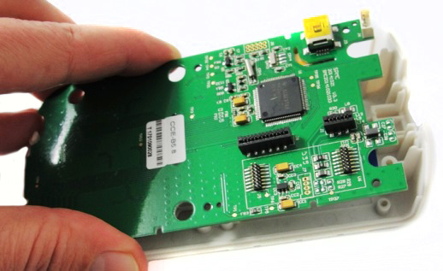
Mount the PCB back on the housing with 6 screws. Insert the SpO₂ module and connect all cables. Perform a function-test before fixing the housing parts with screws.

USB-PCB
Warning:
Before replacing the Main-PCB, check the HW compatibility of the Main-PCB and the USB-PCB in Table 1 (section 4.1.3). The use of Main-PCB with incompatible USB-PCB may lead to malfunction and may affect patient safety! Spare parts for the former VM-2160/ S monitor with the former ChipOx technology are not always compatible.
Remove the defective USB-PCB by opening the housing as described in section 4.1.1. Disconnect all cables and remove the battery leads from the bottom housing with a soldering iron. Remove the three USB-PCB screws, take out the PCB and remove the buzzer cables at the USB-PCB with a soldering iron.
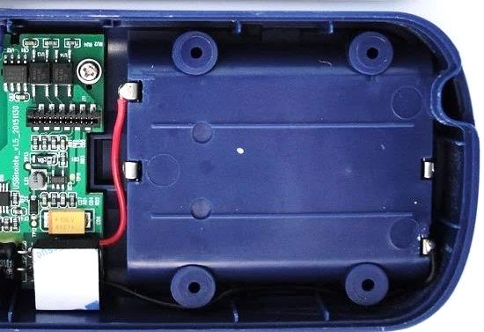 | 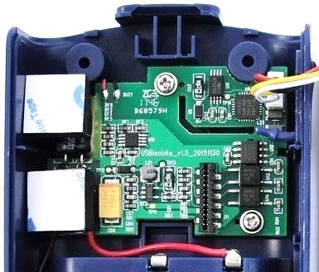
Soldering of battery leads | Soldering of buzzer leads
Take the new USB-PCB and solder the buzzer cables to the USB-PCB. Place the USB-PCB on the guiding pins at the bottom housing without pinching the buzzer cable. Screw the PCB to the bottom housing and solder the battery leads to the terminals at the back housing. Perform a function-test before fixing the housing parts with screws.

USB-PCB cable
To replace the USB-PCB cable, open the housing (section 4.1.1) and disconnect the cable from both plugs. Replace the cable with a new cable (REF: 2020522052). Both cable ends should be inserted in the plug (see image below).
Warning:
Pay attention that no cable is clamped inside the screw-holes while mounting the housing back together.

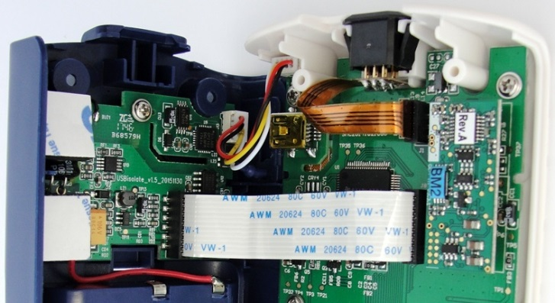 | 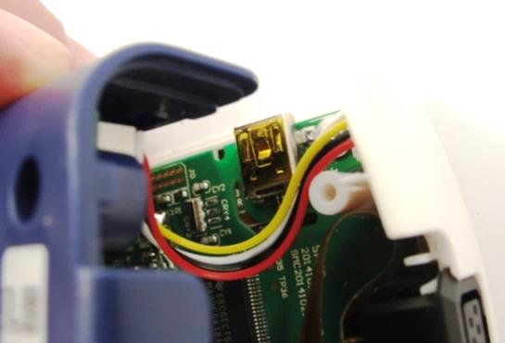
Correctly fitted cable | Position cable between USB connector and screw shaft to prevent clamping at screw hole.

Flat ribbon cable
Replace the Flat ribbon cable if it is mechanically damaged or if the power supply of the device shows malfunction.
Open the housing (section 4.1.1) and disconnect the cable from both plugs, replace the cable with a new cable (REF: 2020522054). Both cable ends should be inserted in the plug (see image below). Fold the cable to the direction of the USB plug while closing the device (not in direction of the SpO₂ module) to prevent clamping.
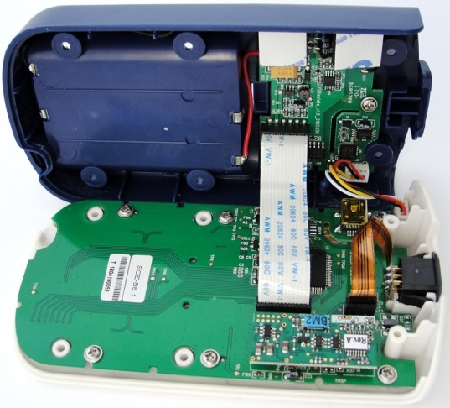
Fold cable into the direction of the USB plug to prevent clamping while closing the device

SpO₂ Module
If the module is defective or not connected correctly, the message “Device defective!” will be displayed. Open the housing (section 4.1.1) to verify correct fitting or replacement of the module.
First check correct fitting to avoid unnecessary replacements. The SpO₂ module must be connected to the Main-PCB in alignment with the white frame marking on the Main-PCB. All pins must be connected to the socket (no pin may be visible).
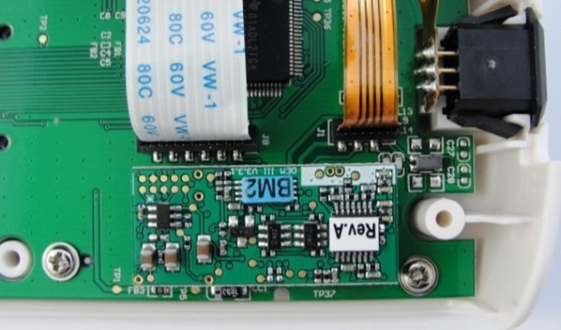 | 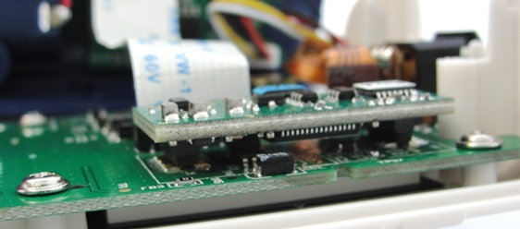
Module aligns over the white frame on the Main-PCB | Both plugs must mount completely on the sockets.
For repositioning remove the module and check the soldering of the socket at the module. Replace the module if the socket solder points are damaged/loose. In case of no damage at the socket, reposition the module correctly and perform a functional check. Replace the SpO₂ module if the error persists.
After replacing the module, test the SpO₂ measurement function. Replace the Main-PCB if the malfunction continues (chapter 4.2.1).

SpO₂ sensor socket
If the device is showing “Sensor fault”, or the measurement is interrupted from time to time, the SpO₂ sensor socket may be faulty.
If a sensor failure can be excluded, the SpO₂ sensor socket has to be replaced. To exclude a sensor failure, perform a measurement with a known working sensor. If the failure persists, replace the SpO₂ sensor socket.
Open the housing (section 4.1.1) and disconnect the flat ribbon cable. The device can be opened completely. Remove the SpO₂ sensor socket and replace it with a new one.

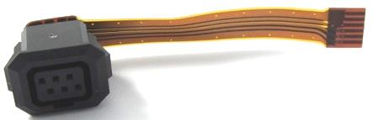
6 pin-Flex (REF: 9020522001)

NOTE: The dark square at the flex of the SpO₂ sensor socket must face the SpO₂ module, else the message “Sensor fault” will continue.
The nose at the SpO₂ sensor socket has to point to the display side after inserting it into the front housing.
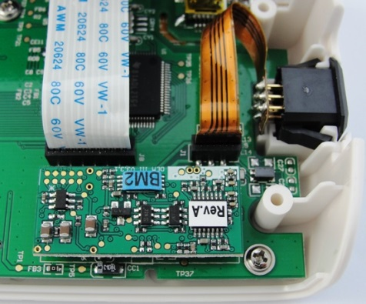  SpO₂ module | 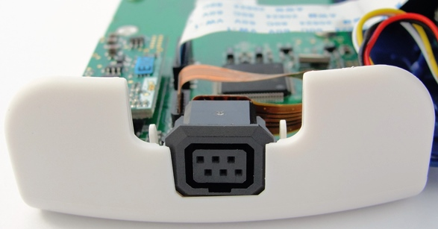
The dark square at the flex must face the SpO₂ SMARTsat® OEM III module. | The nose at the SpO₂ sensor socket has to point to the display side after inserting.
After replacing the SpO₂ sensor socket, test the SpO₂ measurement function by connecting a sensor to the finger. Wiggle the sensor connector in the plug and check that the plethysmogram is not influenced by the movement of the connector. The measurement has to be continuous with no error message.
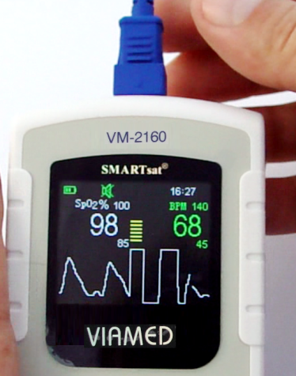 | 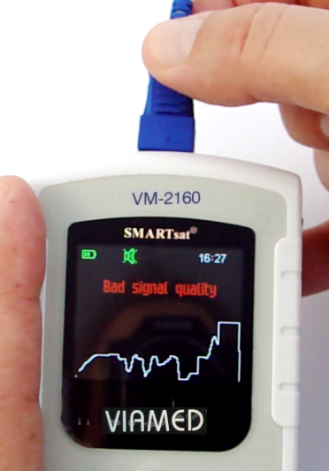
The plethysmogram may not be influenced by wiggling the plug. | No error messages may occur while wiggling the plug.

Keypad
Before replacing the keypad, pay attention to order the correct version (the former VM-2160/ S with ChipOx technology have different layouts).
Open the housing as described in section 4.1.1 and remove the Main-PCB. Be careful not to touch the inside of the display window. Place a scalpel or similar tool carefully under the lower left edge of the keypad. Lift the keypad and remove it carefully from the top housing (with finger or pliers).
Glue remains can be removed with fingers or suitable tool without scratching the front housing. Clean the surface of the housing with 70% isopropanol.
Remove the supporting foil from the new keypad and place it on the lower rim of the front housing. Stick it carefully around the display window and fix it by pressing with the finger.
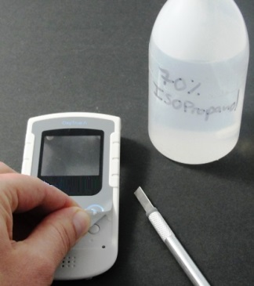 | 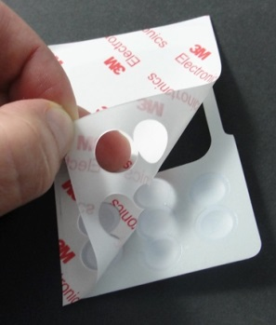 | 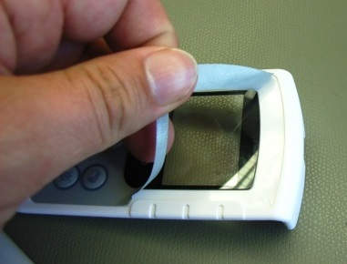
Attach tool and remove the keypad. | Remove the supporting foil | Fix the new keypad to the housing
Remove dust at the display and display window with compressed air (clean and deionized, without oil). Place the Main-PCB into the upper housing and assure correct fitting. Close the device according to section 4.1.2.
NOTE: It is possible to replace the keypad without opening the device.

Display window
Open the housing as described in section 4.1.1 and remove the Main-PCB.
Place a flat screw driver or similar tool between the display window and the housing to remove the display window. Remove dirt and glue remains from the housing using 70% isopropanol.
Remove the backside protecting foil from the new display window. Do not touch or damage the inner surface of the display. Fingerprints at the inner surface of the display window cannot be removed.
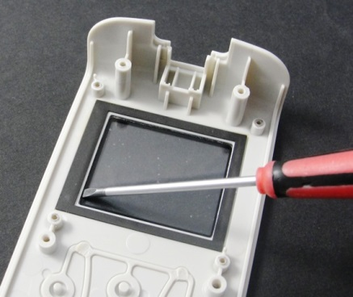 | 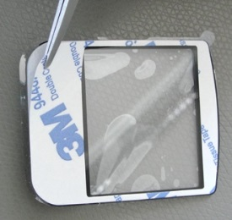 | 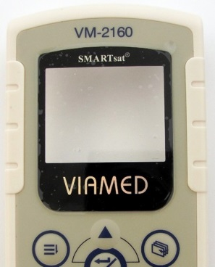
Remove the display window with a flat screw driver | Remove sheet. Don’t touch inside to prevent fingerprints | New display window
NOTE: The display should now be opaque. If not, remove the middle protection foil carefully without removing the outer silvery foil. Insert new window in an appropriate way. Remove dust at the display and display window with compressed air (clean and deionized, without oil). Place the Main-PCB into the upper housing and assure correct fitting. Close the device according to section 4.1.2.

Housing
Bottom housing
A spare serial number label with transparent protection sheet is required during replacement of the back housing. Order the label by contacting the Viamed Ltd. service department. State your device name and serial number.
NOTE: The former devices VM-2160 and S with ChipOx technology have differed label.

Replace the bottom housing by open the device and removing the USB-PCB (refer to section 4.2.2).
Place the label on the housing. Ensure that the buzzer hole is not covered by the label to avoid reduction of alarm sound volume. Close the housing according to section 4.1.2. Connect a new screw-lock.

Serial number Label with protective sheet
Screw-lock
Device Label
NOTE:
Ensure that the buzzer hole is not covered by the label to avoid reduction of alarm sound volume.

Front housing
Replace the front housing by open the device and removing the Main-PCB (refer to section 4.2.1).
If no window or keypad is fitted, place keypad and window according to section 4.2.7 and 4.2.8.
Close the housing according to section 4.1.2.

Troubleshooting Guide

Failure modes
ID | Failure mode | Possible causes | Corrective action | see Chapter
#1 | No display function (stripes, dark) | display defective, control of display defective | Replace Main-PCB | 4.2.1
#2 | Keys without function | Main-PCB or buttons on Main-PCB defective | Replace Main-PCB | 4.2.1
#3 | No USB connection | PC to USB cable defective, PCB-connector-cable faulty, USB-Connector on USB-PCB or Main-PCB defective | Replace cable(s) or Main-PCB | 4.2.3 / 4.2.1
#4 | Data download not possible despite recognized USB connection | Incompatibility of PC configuration, USB-PCB cable faulty, USB-Connector on USB-PCB or Main-PCB defective | Check PC configuration and USB drivers. Replace cable(s) or Main-PCB | 4.2.3 / 4.2.1
#5 | Keypad mechanically damaged | Wear of Keypad due to mechanical stress | Replace Keypad | 0
#6 | Clock is set to zero after batteries were changed | Buffer battery on Main-PCB flat or Main-PCB defective | Replace buffer battery on main PCB if voltage below 3.1V. Replace Main-PCB | 4.2.1
#7 | Display window defective (scratched, broken) | Wear of display window due to mechanical stress (fall damage) | Replace display window | 4.2.8
#8 | Device displays „Sensor fault“ | SpO₂ sensor defective or SpO₂ sensor socket faulty | Replace SpO₂ sensor or SpO₂ sensor socket | 4.2.6
#9 | Interrupted measurement | SpO₂ sensor defective or SpO₂ sensor socket faulty | Replace SpO₂ sensor or SpO₂ sensor socket | 4.2.6
#10 | Device displays „Device defective!“ | SpO₂ -Module faulty, wrong/defective positioned SpO₂ Module or Main-PCB defective | Correct/replace SpO₂ -Module or replace Main-PCB | 4.2.5 / 4.2.1
#11 | Strong fluctuation of measured values | - Patient has low perfusion / Motion artefacts  - Sensor faulty, SpO₂ Module or sensor socket defective | - Warm hands of patient, ensure no motion artefacts  - Replace sensor, SpO₂ sensor socket or SpO₂ Module | 4.2.6 / 4.2.5

Error codes stored in the service menu log
Error code | Description | Corrective action | see Chapter
101 - 107;  109 - 111;  116 - 117;  195 - 196 | Internal communication error with the SMARTsat SpO₂ Module | Remove possible source of Electromagnetic interference (for example mobile phones, radio transmitters, lamps, defibrillators and other devices).  If the error persists, replace the SMARTsat® SpO₂ module or Main-PCB to identify the defective component or contact the service department of the manufacturer. | 4.2.5, 4.2.1
108 | SMARTsat SpO₂ Module self-test error | Replace SMARTsat® SpO₂ module | 4.2.5
113 | Error with on board clock (RTC) | Replace button cell buffer battery if below 3.0V (Type: Lithium Cell, CR1220, 3V).  If the error persists, replace Main-PCB or contact the service department of the manufacturer. | 4.2.1
114 | Error detected in stored data | Delete all data and restart the device. If the error persists, replace Main-PCB or contact the service department of the manufacturer. | 4.2.1
115 | No communication with the SMARTsat SpO₂ Module | Check if the module is connected correctly to the Main-PCB. If the error persists, replace the SMARTsat® SpO₂ module or Main-PCB to identify the defective component or contact the service department of the manufacturer | 4.2.5, 4.2.1
197 | Sensor Error: Red LED defective | Replace the SpO₂ sensor.  If the error persists, replace the SpO₂ sensor socket, Main-PCB or SMARTsat® SpO₂ module to identify the defective component or contact the service department of the manufacturer. | 4.2.6, 4.2.5, 4.2.1
198 | Sensor Error: Infrared LED defective |  | 4.2.6, 4.2.5, 4.2.1
199 | Sensor Error: Photodiode defective |  | 4.2.6, 4.2.5, 4.2.1
201 | Sensor defective |  | 4.2.6, 4.2.5, 4.2.1
202 | Wrong sensor | The sensor is not compatible to your monitor. Replace the sensor with a sensor manufactured by bluepoint medical for VIAMED SMARTsat® technology as listed in the instructions for use. VIAMED SMARTsat® compatible sensors can be recognised well due to the blue connector, the former sensors with white connector only work on the former ChipOx technology. | n/a
206 | Supply voltage outside of range at the SMARTsat SpO₂ Module | Ensure that the device is powered with the specified supply (use 3 Alkaline batteries 1.5 Volt, Type AA LR6 or 3 rechargeable NiMh batteries, 1.2 Volt, Typ AA HR6, 1200 mAh). Check that there is no damage on the device, the PCBA, internal cables and SpO₂ module. If the error persists replace SMARTsat® SpO₂ module, Flat ribbon cable, USB-PCB cable, USB-PCB or Main-PCB to identify the defective component or contact the service department of the manufacturer. | 4.2.1 - 4.2.6

Spare parts
All available spare parts for VM-2160 (SMARTsat), REF: 12020112001E (Type 0012165), are listed in the table below together with the order number (REF).
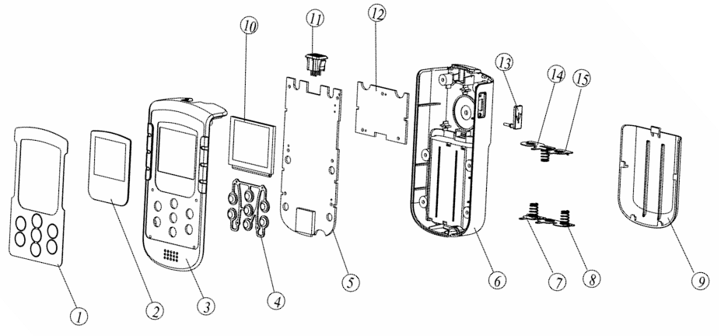
Fig. 1: Exploded View – VM-2160
For hardware compatibility of parts see section 4.1.3.
Order number (REF) | Part name | Description | Identifier  (Fig.1)
5020522001 | Front housing | Without keypad and display window. | 3, 4
2020522009 | Bottom housing | With battery cover and buzzer. | 6, 7, 8, 9, 13, 14, 15
2600522013 | Screw set housing | 2 long, 4 short | n/a
2020522056 | Battery cover | Dark blue | 9
2020522014SVM | Display window | Print to indicate use of SMARTsat® technology | 2
2020522015SVM | Keypad | Note that the keypad for ChipOx technology is darker | 1
9020522001 | 6 pin Minimed-Flex SpO₂ sensor socket | mounted on Main-PCB version SMC20141021033 | 11
2020522054 | Flat ribbon cable | connects Main-PCB and USB-PCB | n/a
2020522052 | USB-PCB cable | connects Main-PCB and USB-PCB | n/a
9020760001 | USB-PCB | USB-PCB version USBisolate_v1.5_20151130 | 12
10020522001S | Main-PCB | Main-PCB version SMC20141021033 (with TFT display) | 5
8110140011VM | Viamed SMARTsat OEM III | SpO₂ module compatible to VIAMED SMARTsat Sensors | n/a

Document History

Rev. | Date | Issued | Reviewed | Description of changes
0 | 30.01.2018 | HF | SH | Initial version
1 | 04.07.2018 | HF | JPB | Updated Sparepart list, Add Error code list to section 5.
2 | 06.08.2018 | HF | JPB | Update section 3: Maintenance based on statement for Resolution, Calibration, Service & Testing of the VM-2160 / VM-2160 (SMARTsat®) Pulse Oximeter and Accessories  Update section 5.2 Error codes and section 6: Part numbers

