Intrastats when no internet available.

In the event Viamed broadband goes down.

Open web browser and type in the address bar

https://192.168.1.2/login.php

you will some thing along the lines of:

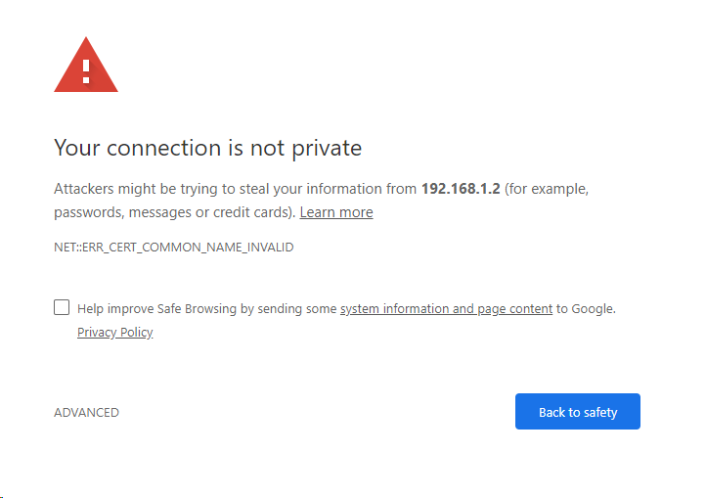
Click the ADVANCED Button and the click proceed to 192.168.1.2 ( unsafe )

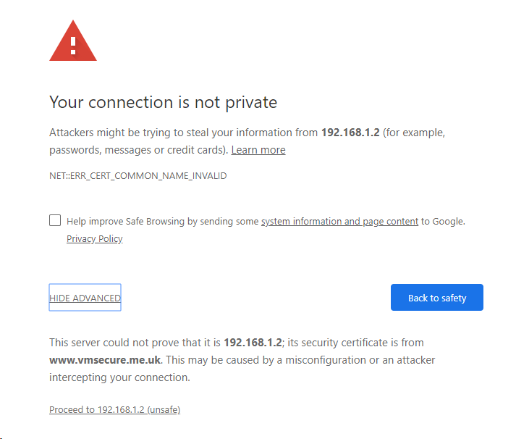
You should be taken to the Intrastats login page
you can ignore the warning
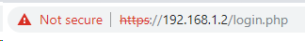

as the encryption certificate is checking for the www.vmsecure.me.uk/login.php address.

