Measurement Range: | 0 % ... 100 % oxygen
Output in Ambient Air: | 6.5 to 9 mV
Electrical Interface: | Flying leads with 3 pin female connector (Molex® 22-01-2037)
Repeatability: | < 1% vol. O₂ @ constant temperature and pressure
Linearity error: | 0.1 to 1.0 bar ppO₂ < 3% relative
Linearity error: | 0.1 to 2.5 bar ppO₂ < 5% relative (at ppO₂ > 1.0 bar after 1 h equilibration time)
Accuracy at constant temperature, pressure and humidity | Accuracy – Within + / - 3% of reading (or ±5 mBar Oxygen whichever is greater) up to specified range, when calibrated using 100% oxygen at known atmospheric pressure and 25°C  Acceptable limits are  Error mBar pO2  mBar pO2 Min Max  209 -4 4  1000 0 0 Calibration point  1500 -30 30  2000 -75 75 Specified Range  2300 -100 100 Over-range capability  Hysteresis after use at high pressure according to accuracy specification (Within + / - 3% of reading)
Response time: | < 5 sec. to 90% of final value
Zero Offset Voltage: | < 0.5% oxygen reading in 100% nitrogen @ 25°C after 36 seconds
Cross Interference: | < 0.5% vol. O2 response to: 5% CO2 balance N2
Influence of Humidity: | - 0.03% rel. per % RH at 25°C
Pressure Range: | 600 to 2500 mbar
Influence of Mechanical Shock: | < 1% relative after a fall from 1m
Operating Temperature: | 0°C to 50°C
Temperature Compensation: | Built-in NTC compensation
Effect of Temperature Compensation (steady state): | Between 0°C and +50°C: 5% relative error
Operating Humidity: | 0 - 99% RH non-condensing
Long Term Output Drift: | < 1% vol. oxygen per month, Typically < -15% relative over lifetime
Storage Temperature: | -20°C to +50°C
Recommended Storage: | +5°C to +15°C
Recommended Load: | ≥10 kOhms
Warm-Up Time: | < 30 minutes, after replacement of sensor
Nominal Sensor Lifetime: | 500,000% vol oxygen hours
Weight: | Approximately 28 grams
Warranty Period: | 15 months (including 3-month shelf life)
Typical Lifetime | 20 to 24 months from shipment (including shelf life) in air at 25°C.
Electrical output | 30-60 Microamperes in air @ 25 °C sea level
Packaging | In plastic bag
Part No.: | OOD103-JFD: 1002461 (REF DB200381)
All specifications are applicable at standard conditions: 1013 mbar, 25°C dry ambient air.

Mechanical draft:

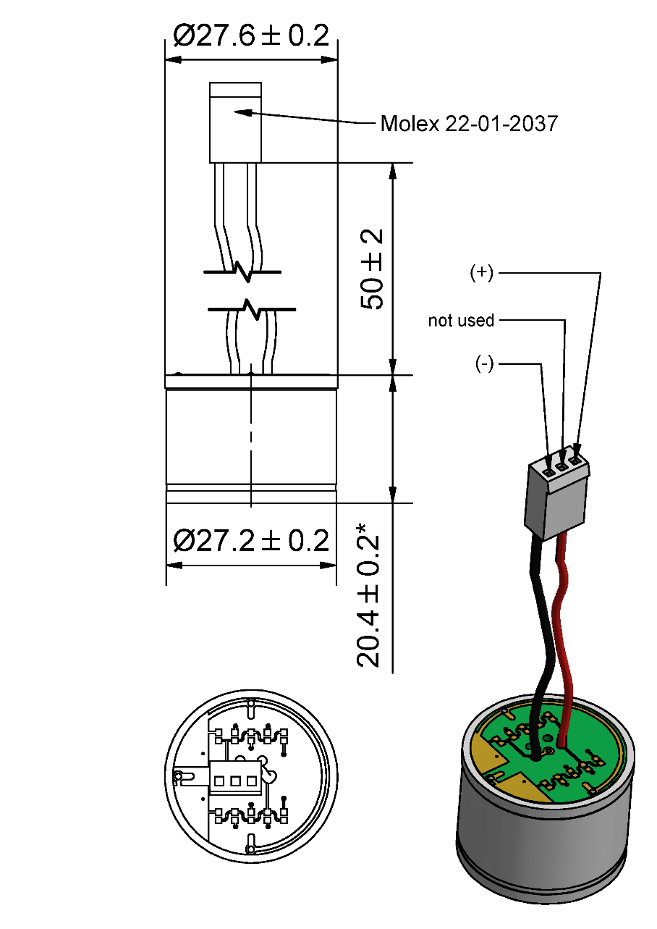

General tolerances ISO 2768-c
*Sensor housing without PCB

Customized Design Specification:

- Integration of additional Zitex membrane in sensor gas diffusion way
- using of non magnetic components for the sensor
- Conformal coating on the sensor PCB with PLASTIK 70
- 2 x 2mm holes drilled in the sensor PCB
- No information about EnviteC on PCB top / bottom sides, information for ordering process and traceability only.

PCB Layout:

Top | Bottom
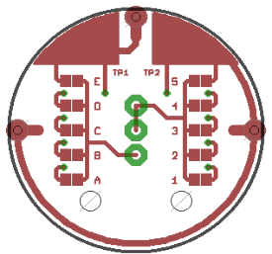 | 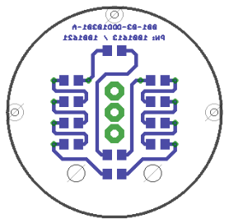

Product Labeling

OOD103-JFD: 1002461 (REF DB200381)
Label on Sensor (90x15) | Label on Blister- Card (63,5x46,6)
 | 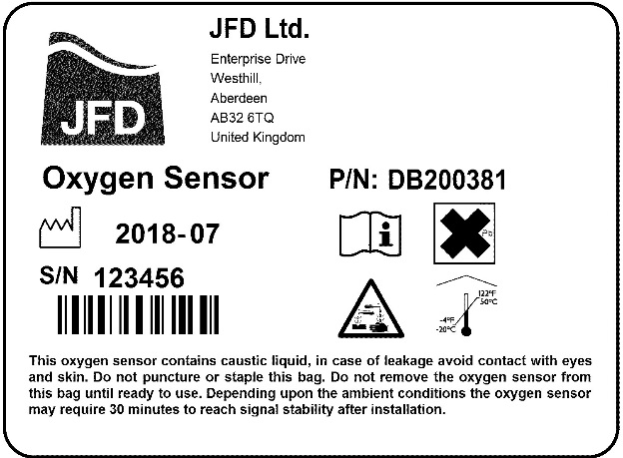

Customer Approval

Date:

Signature:

