Risk Management Policy & Definitions.
EN 14971 :2012 clauses 1-9 does not cover directly ER1 ( design & development)
EN 14971 :2012 clauses 1-9 does not cover directly ER2 ( design & development)
EN 14971 :2012 clauses 1-9 does not cover directly ER4 ( design & development)
EN 14971 :2012 clauses 6.4;6.5;7 does not cover directly ER5 ( design & development)
EN 14971 :2012 clauses 1-9 does not cover directly ER7.1 ( design & development)
See Standard EN14971 Annex ZA
This standard should therefore be used as a tool.

Viamed Policy on Risk Management.
Risk management takes several forms
- Risk on Products
- Risk on procedures
- ISO 9001
- ISO 13485
The end result is the same where applicable
Risk
Solution
Residual risk
Risk/Benefit analysis

Product Risk
Annex I, paras 1, 2 & 6 of the MDD/93/42 address risk management.
The old Annex A & Annex D prior to version 2012 can be applied to individual products
Annex F MEDDEV 2 12-1 rev 8 has been transcribed into Intrasts Risk Assessment and combines Annex A & Annex D into one document.

Definitions of hazard severity and event probability are :

Rating. | Hazard severity. | Possible Description | Event Rating | Event probability.
5 | Catastrophic | Results in Patient death | 5 | Frequent
4 | Critical. | Results in Permanent impairment or life threatening injury | 4 | Probable
3 | Serious | Results injury or impairment requiring medical intervention | 3 | Occasional
2 | Minor | Results injury or impairment requiring not medical intervention | 2 | Remote
1 | Negligible | Inconvenient or temporary discomfort | 1 | Improbable

Event probability is governed on a product by product basis and may be a collection of documents ;
Should contain
Evaluation of Risk at new product specification stage
Evaluation of risk at each design change/review
Evaluation of risk at product Validation stage
Location of where equipment is used;
Frequency of use eg. in regular use or emergency use only
Number of units in use
Event probability can be added as a note into Intrastats Post Market Surveillance
Annex D

Implementation of Risk Analysis
Solutions are implemented to reduce hazard severity from level 5 (catastrophic) identified at the conceptual stage to level 2 (minor) or lower.
If hazard severity cannot be reduced from level 4 (intolerable), the product is abandoned.
Hazard severity and event probability which cannot be reduced from level 2 (minor) and (remote) are reviewed by the MD and either :
- Signed off if considered acceptable when weighed against the benefits.
- The product abandoned
- effectiveness of implemented risk management solutions is implied by a reduction in ratings.
The overall risk rating formed by the product of hazard severity x event probability cannot alone be the deciding factor of whether product development continues or is abandoned; a low risk occurring
See below for action taken for hazard severity x event probability combinations :

Hazard Serverity | Level of Risk  Product
1 Improbable | No Action | No Action | No Action | Risk Benefits | Unacceptable
2 Remote | No Action | No Action | Risk Benefits | Unacceptable | Unacceptable
3 Occasional | No Action | Risk Benefits | Unacceptable | Unacceptable | Unacceptable
4 Probable | Risk Benefits | Unacceptable | Unacceptable | Unacceptable | Unacceptable
5 Frequent | Unacceptable | Unacceptable | Unacceptable | Unacceptable | Unacceptable
Event probability | 1 Negligible | 2 Minor | 3 Serious | 4 Critical | 5 Catastrophic

Risk analysis/management is reviewed periodically to ensure safety & users in the Post Market Surveilance
Design stage Risk Analysis
ISO 13485 7.3.3
7.3.3 Design and development inputs Inputs relating to product requirements shall be determined and records maintained (see 4.2.5). These inputs shall include:
a) functional, performance, usability and
safety requirements, according to the intended use;
b) applicable regulatory requirements and standards;
c) applicable output(s) of risk management;
d) as appropriate, information derived from previous similar designs;
e) other requirements essential for design and development of the product and processes. These inputs shall be reviewed for adequacy and approved
Requirements shall be complete, unambiguous, able to be verified or validated, and not in conflict with each other.
NOTE Further information can be found in IEC 62366–1.

Risk Analysis of Sub Processes (3.1)
All processes and sub processes shall include a risk analysis on a scale of 1-4
Level of risk
Chances of risk.
Example postage stamps or franking
If the wrong value stamps or franking is used the package could be returned delaying an urgent delivery The chances of this happening can be determined by the number of parcels returned pointing to carelessness on the behaviour of particular staff
Compliance is checked by inspection of the risk management file

Management responsibilities (3.2)
Top management shall provide evidence of its commitment to the risk management process by: ensuring the provision of adequate resources and ensuring the assignment of qualified personnel (see 3.3) for risk management. Top management shall: define and document the policy for determining criteria for risk acceptability; this policy shall ensure that criteria are based upon where applicable national or regional regulations and relevant International Standards, and take into account the review of suitability of the risk management process at planned intervals to ensure continuing effectiveness of the risk management process and document any decisions and actions taken; , this review may be part of the quality management system review.
NOTE The documents can be incorporated within the documents produced by the manufacturer’s quality management system and these documents can be referenced in the risk management file.
Compliance is checked by inspection of the appropriate documents.

Qualification of personne (3.3)
Persons performing risk management tasks shall have the knowledge and experience appropriate to the tasks assigned to them. These shall include, where appropriate, knowledge and experience of the particular medical device (or similar medical devices) and its use, the technologies involved or risk management techniques. Appropriate qualification records shall be maintained. Training
NOTE Risk management tasks can be performed by representatives of several functions, each contributing their specialist knowledge. E7
Compliance is checked by inspection of the appropriate records.
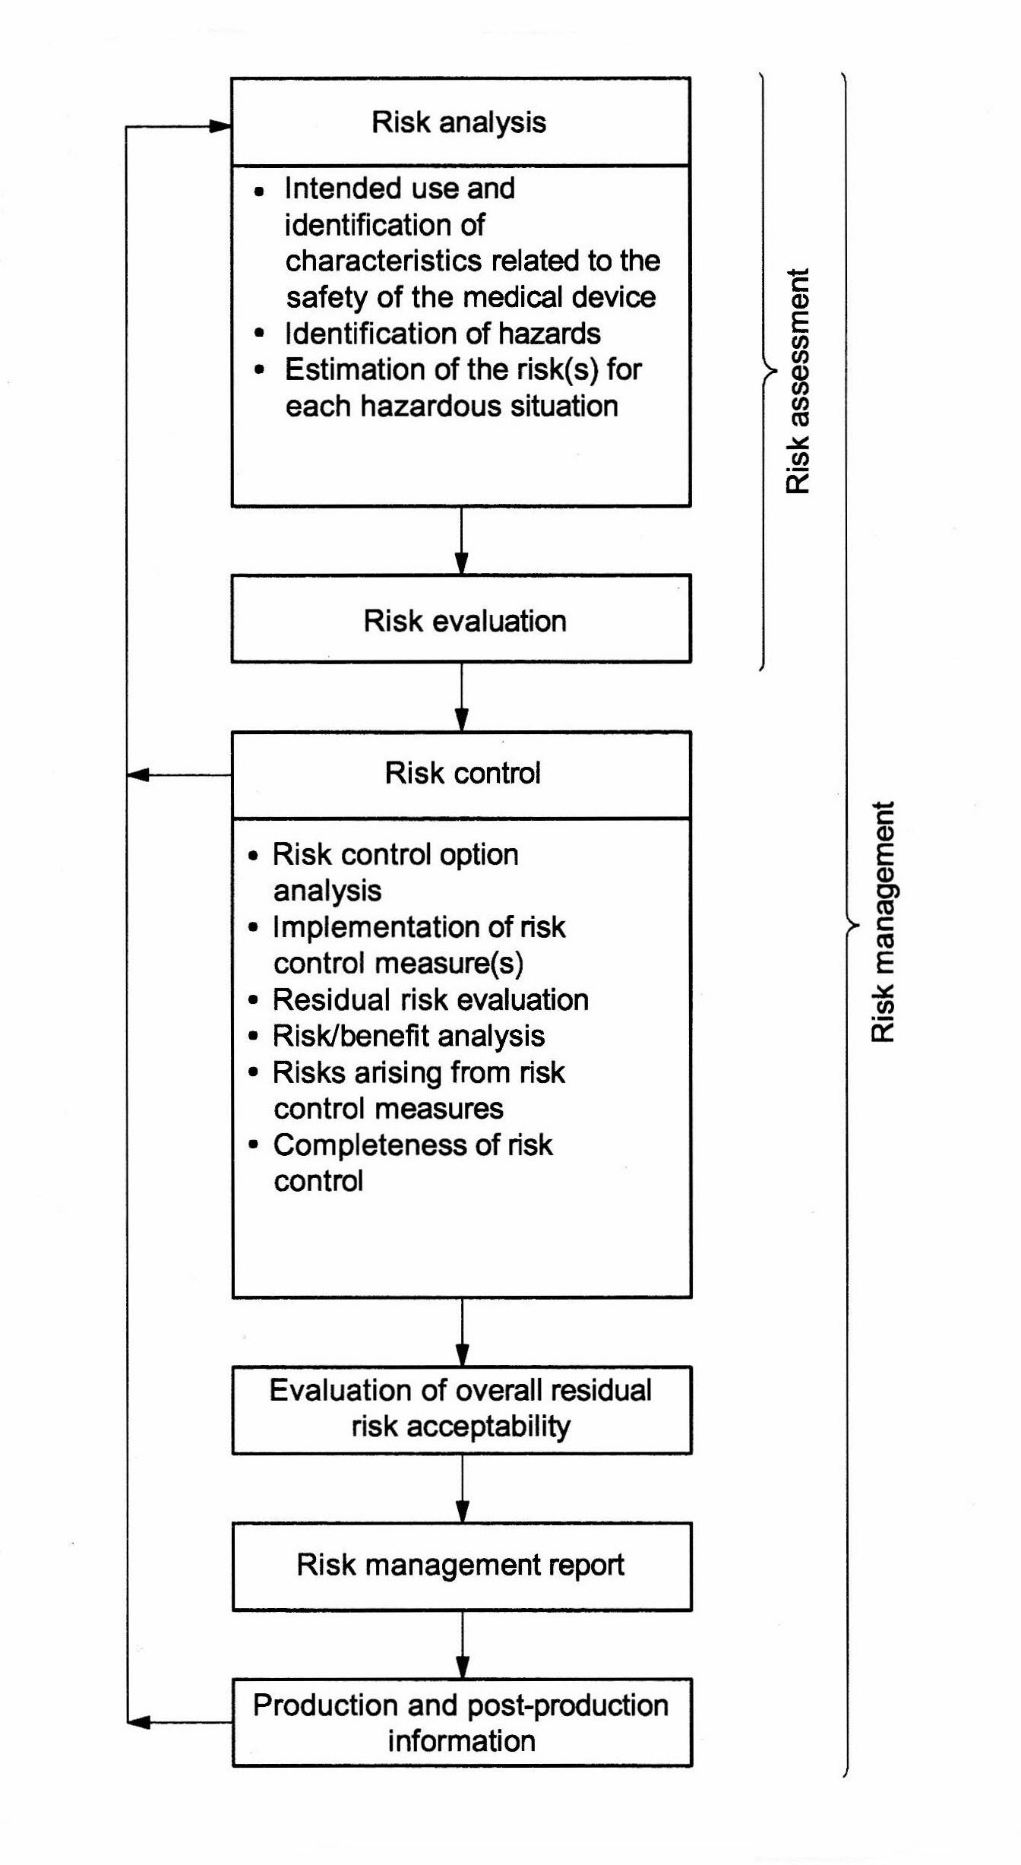

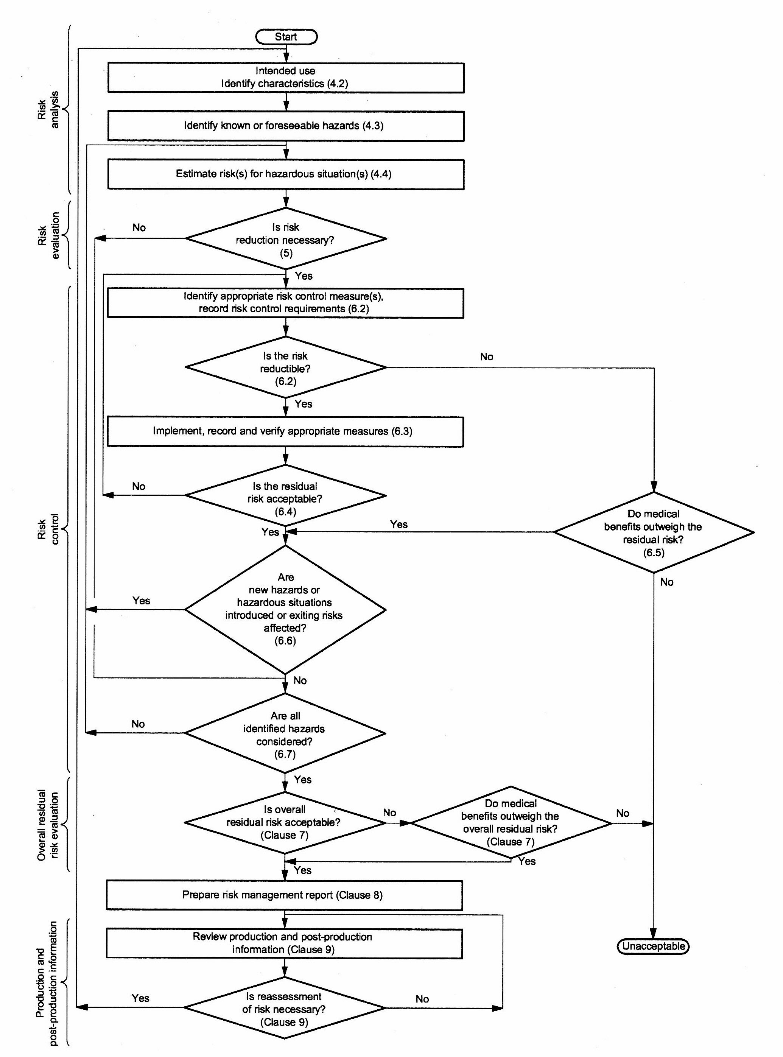

Risk Management Plan (3.4)
This plan shall include at least the following:
a) the scope of the planned risk management activities, identifying and describing the medical device and the life-cycle phases for which each element of the plan is applicable;

- Initial Pre-design and feasibility risk analysis DOCUMENT Y20
- Identification of possible hazards and risk in specification DOCUMENT M3
- Design Review DOCUMENT Y16 & QC24
- Repairs DOCUMENT Intrastats
- Production and test (incl. storage and shipping) Risk DOCUMENT ? & M2
- Stock DOCUMENT ?
- Transport DOCUMENT M2
- Installation, training and instruction DOCUMENT F9
- Application and customer feedback DOCUMENT H2
- User manual DOCUMENT F5 ?
- Life cycle DOCUMENT Post Market Surveillance H3
- Disposal DOCUMENT G8

b) assignment of responsibilities and authorities;
Doc ID 13119 E7
c) requirements for review of risk management activities;
Post Market Surveillance H3
d) criteria for risk acceptability, based on the manufacturer’s policy for determining acceptable risk, including criteria for accepting risks when the probability of occurrence of harm cannot be estimated;
e) verification activities;
Verifying the effectiveness of risk control measures can require the collection of clinical data, usability studies, etc. (see also 2.28) The risk management plan can detail the verification activities explicitly or by reference to the plan for other verification activities. DOCUMENT
f) activities related to collection and review of relevant production and post-production information.
collect information from various sources such as users, service personnel, training personnel, incident reports and customer feedback. While a reference to the quality management system procedures can suffice in most cases, any product-specific requirements should be directly added to the risk management plan. Appendix F
Compliance is checked by inspection of the risk management file
Risk Management File (3.5)
For the particular medical device being considered, the manufacturer a risk management file shall established and maintained. In addition to the requirements of other clauses of this International Standard, the risk management file shall provide traceability for each identified hazard to:
- the risk analysis;
- the risk evaluation;
- the implementation and verification of the risk control measures;
- the assessment of the acceptability of any residual risk(s). Document requires sign posts to documents

Risk analysis process 4.1
Risk analysis shall be performed for the particular medical device as described in 4.2 to 4.4. The implementation of the planned risk analysis activities and the results of the risk analysis shall be recorded in the risk management file.
This requires :
- a description and identification of the medical device
- Its use
- foreseeable misuse
- possible characteristics of the device effecting safety
- identification of the person(s) and organization who carried out the risk analysis; M3
- scope and date of the risk analysis
Compliance is checked by inspection of the risk management file

Intended use and identification of characteristics related to the safety of the medical device (4.2)
Intended use and identification of characteristics related to the safety of the medical device
For the particular medical device being considered, the intended use and reasonably foreseeable misuse shall be documented
Those qualitative and quantitative characteristics that could affect the safety of the medical device and, where appropriate, their defined limits shall be documented.
This documentation shall be maintained in the risk management file.
NOTE 1 In this context, misuse is intended to mean incorrect or improper use of the medical device.
NOTE 2 Annex C contains questions such as those relating to use that can serve as a useful guide in identifying medical device characteristics that could have an impact on safety.
Compliance is checked by inspection of the risk management file.

Identification of the hazards (4.3)
Annex E & Annex H2.4 & Risk Checklist Intrastats
Compliance is checked by inspection of the risk management file
Estimation of the risk(4.4)
Risk Checklist Intrastats
Information or data for estimating risks
a) published standards; Intrastats
b) scientific technical data; WEB
c) field data from similar medical devices already in use, including published reported incidents; WEB
d) usability tests employing typical users; H2
e) clinical evidence; H4.1
f) results of appropriate investigations;
g) expert opinion;
h) external quality assessment schemes.
Compliance is checked by inspection of the risk management file.
NOTE 2 Examples of hazardous situations are provided in H.2.4.5 and E.4.
NOTE 4 Risk estimation incorporates an analysis of the probability of occurrence and the consequences. Depending on the application, only certain elements of the risk estimation process might need to be considered. For example, in some instances it will not be necessary to go beyond an initial hazard and consequence analysis. See also D.3.
NOTE 5 Risk estimation can be quantitative or qualitative. Methods of risk estimation, including those resulting from systematic faults, are described in Annex D.
Risk Evaluation (5)
Each identified hazardous situation, shall be decided, using the criteria defined in the risk management plan, if risk reduction is required. If risk reduction is not required, the requirements given in 6.2 to 6.6 do not apply for this hazardous situation (i.e., proceed to 6.7). The results of this risk evaluation shall be recorded in the risk management file. Document
NOTE 1 Guidance for deciding on risk acceptability is given in D.4.
NOTE 2 Application of relevant standards, as part of the medical device design criteria, might constitute risk control activities, thus meeting the requirements given in 6.3 to 6.6.
Compliance is checked by inspection of the risk management file.
Risk control options (6.-2)
use one or more of the following risk control options in the priority order listed
a) inherent safety by design;
b) protective measures in the medical device itself or in the manufacturing process;
c) information for safety.

If it is determined that required risk reduction is not practicable, conduct a risk/benefit analysis of the residual risk (proceed to 6.5). E11
Compliance is checked by inspection of the risk management file

Implementation of risk control measure(s) (6.3)
Rrisk control measure(s) selected in 6.2. 6.3 shall be implemented
Implementation of each risk control measure shall be verified.
This verification shall be recorded in the risk management file.
The effectiveness of the risk control measure(s) shall be verified and the results shall be recorded in the risk management file. The verification of effectiveness can include validation activities.
Implementation of each risk control measure shall be verified. This verification shall be recorded in the risk management file.
Compliance is checked by inspection of the risk management file.

Residual risk evaluation (6.4)
After the risk control measures are applied, any residual risk shall be evaluated using the criteria defined in the risk management plan. The results of this evaluation shall be recorded in the risk management file.
If the residual risk is not judged acceptable using these criteria, further risk control measures shall be applied (see 6.2).
For residual risks that are judged acceptable, it will be decided which residual risks to disclose and what information is necessary to include in the accompanying documents in order to disclose those residual risks.
Compliance is checked by inspection of the risk management file and the accompanying documents.

Risk/benefit analysis 6.5
If the residual risk is not judged acceptable using the criteria established in the risk management plan and further risk control is not practicable, gather and review data and literature to determine if the medical benefits of the intended use outweigh the residual risk. If this evidence does not support the conclusion that the medical benefits outweigh the residual risk, then the risk remains unacceptable. If the medical benefits outweigh the residual risk, then proceed to 6.6.
For risks that are demonstrated to be outweighed by the benefits, decide which information for safety is necessary to disclose the residual risk.
The results of this evaluation shall be recorded in the risk management file.
NOTE See also D.6.
Compliance is checked by inspection of the risk management file.

Risks arising from risk control measures (6.6)
The effects of the risk control measures shall be reviewed with regard to:
a) the introduction of new hazards or hazardous situations;
b) whether the estimated risks for previously identified hazardous situations are affected by the introduction of the risk control measures.
Any new or increased risks shall be managed in accordance with 4.4 to 6.5.
The results of this review shall be recorded in the risk management file. Post Market Surveillance H3
Compliance is checked by inspection of the risk management file

Completeness of risk control (6.7)
All the risks from all identified hazardous situations should be considered.
The results of this activity shall be recorded in the risk management file.
Compliance is checked by inspection of the risk management file.

Evaluation of overall residual risk acceptability (7)
After all risk control measures have been implemented and verified, decide if the overall residual risk posed by the medical device is acceptable using the criteria defined in the risk management plan.
NOTE 1 For guidance on overall residual risk evaluation, see D.7.
If the overall residual risk is not judged acceptable using the criteria established in the risk management plan, gather and review data and literature to determine if the medical benefits of the intended use outweigh the overall residual risk. If this evidence supports the conclusion that the medical benefits outweigh the overall residual risk, then the overall residual risk can be judged acceptable. Otherwise, the overall residual risk remains unacceptable.
For an overall residual risk that is judged acceptable, decide which information is necessary to include in the accompanying documents in order to disclose the overall residual risk.
NOTE 2 Guidance on how residual risk(s) can be disclosed is provided in Annex J.
The results of the overall residual risk evaluation shall be recorded in the risk management file.
Document
Compliance is checked by inspection of the risk management file and the accompanying documents.

Risk management report (8)

Prior to release for commercial distribution of the medical device, the manufacturer shall carry out a review of the risk management process shall be reviewed. This review shall at least ensure that: the risk management plan has been appropriately implemented;
the overall residual risk is acceptable; appropriate methods are in place to obtain relevant production and post-production information. The results of this review shall be recorded as the risk management report and included in the risk management file. Document
The responsibility for review should be assigned in the risk management plan to persons having the appropriate authority [see 3.4 b)].
Compliance is checked by inspection of the risk management file.

Production and post-production information (9)
Document and maintain a system to collect and review information about the medical device or similar devices in the production and the post-production phases. Post Market Surveillance H3
When establishing a system to collect and review information about the medical device, the following should consider among other things:
a) the mechanisms by which information generated by the operator, the user, or those accountable for the installation, use and maintenance of the medical device is collected and processed;
or
b) new or revised standards.

The system should also collect and review publicly available information about similar medical devices on the market.
This information shall be evaluated for possible relevance to safety, especially the following:
if previously unrecognised hazards or hazardous situations are present or
if the estimated risk(s) arising from a hazardous situation is/are no longer acceptable.
If any of the above conditions occur:
1) the impact on previously implemented risk management activities shall be evaluated and shall be fed back as an input to the risk management process and
2) a review of the risk management file for the medical device shall be conducted; if there is a potential that the residual risk(s) or its acceptability has changed, the impact on previously implemented risk control measures shall be evaluated.
The results of this evaluation shall be recorded in the risk management file. Document
NOTE 1 Some aspects of post-production monitoring are the subject of some national regulations. In such cases, additional measures might be required (e.g., prospective post-production evaluations).
NOTE 2 See also 8.2 of ISO 13485:2003[8].
Compliance is checked by inspection of the risk management file and other appropriate documents.

