GDPR DATA REQUESTS

Export Personnel Data from Intrastats,

Find the Contact In Intrastats.
Click the Contact name
Click Export GDPR.
Copy the entire Page,
Paste into Spreadsheet. - NOTE have to paste special, and select HTML Format.
Save the Spreadsheet.

Export Personnel Data from Goldmine,

Step 1 Find the Contact:
Click File / Print a report
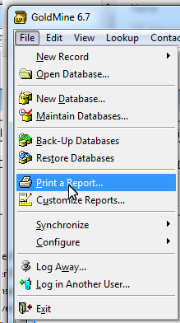
Click Print Report “Completed Activity List with notes Tab”
Send Report to Printer print as PDF

Save the PDF with the Spreadsheet.
This is all personnel data on the person requesting Information.

Before Sending confirm the data is legible and the correct Person

